Table of Contents
1.0 Introduction 7
General Information 7
Manufacturer And Product Number 8
General Description Of Equipment Function 8
GEM Messages Defined 8
Messages From The E220 8
Messages To The E220 9
Function Of The GEM Interface 11
Hardware Component 13
Software Component 13
Definitions, Acronyms, and Abbreviations 15
References 16
Software Revision Code 16
Changes from Previous Versions 17
2.0 Data Item Directory 18
Item Format Codes 19
ABS 19
ACHA 19
ACKC5 20
ACKC6 20
ACKC7 20
ACKC7A 20
ACKC10 21
ALCD 21
ALED 21
ALID 21
ALTX 21
CCODE 22
CEED 24
CEID 24
COMMACK 28
CPACK 28
CPNAME 28
CPVAL 28
DATAID 28
DATALENGTH 29
DRACK 29
DSPER 29
DVID 29
DVNAME 70
DVVAL 70
EAC 71
ECDEF 71
ECID 71
ECMAX 87
ECMIN 87
ECNAME 87
ECV 88
EDID 88
ERACK 88
ERRW7 88
ESID - Equipmet Port Number 88
FCNID 89
GRANT 89
GRANT6 89
HCACK 89
LENGTH 90
LIMITACK 90
LIMITID 90
LIMITMAX 90
LIMITMIN 90
LOTID - Material ID 91
LOWERDB 91
LRACK 91
LVACK 91
MDLN 91
MEXP 92
MHEAD 92
MID 92
OFLACK 92
ONLACK 92
PPARM 92
PPBODY 93
PPBODY1 93
PPBODY2 SHORT 94
PPBODY2 LONG 95
PPBODY3 95
PPGNT 103
PPID 104
RCMD 104
REPGSZ 115
RPTID 115
RSACK 116
RSDA 116
RSDC 116
SEQNUM 116
SFCD 116
SHEAD 116
SMPLN 117
SOFTREV 117
STIME 117
STRACK 117
STRID 117
SV 117
SVID 117
SVNAME 170
TEXT 170
TIAACK 171
TIACK 171
TID 171
TIME 171
TOTSMP 171
TRID 172
TSID 172
UNITS 172
UPPERDB 172
V 172
VLAACK 172
VID 173
VNAME 173
3.0 Message Detail 174
4.0 Message Scenarios 212
Host Attempts to Establish Communications 212
Operator Attempts to Establish Communications 214
Host Attempts to Establish Communications, Equipment Disabled 215
Remote Process Control Scenario (Unformatted Process Program) 215
Remote Process Control Scenario (Formatted Process Program) 219
Local Process Control Scenario 223
Off-Line Process Control Scenario 226
Host Requests Event Report 227
Host initiated On-line Identification 227
Message Fault due to Unrecognized Device ID 228
Message Fault due to Unrecognized Stream Type 228
Message Fault due to Unrecognized Function type 228
Message Fault due to Illegal data format 228
Message Fault due to Transaction Timer Timeout 229
Message Fault due to data too long 229
Host Accepts ON-LINE 229
Host denies ON-LINE 229
Operator Sets OFF-LINE 229
Operator Sets REMOTE 230
Operator Sets LOCAL 230
Host Requests Report 230
Host Initiates Trace Report 230
Zone Transition Event occurs in Equipment 231
Host defines Limit Attributes 231
Host queries Equipment for current limit 231
Request Equipment Status Report 231
Request Equipment Status Variable Namelist 231
Enable/Disable Alarms 232
Send Alarm Report 232
Host sends Remote Command 232
Host Sends Equipment Constants 232
Host Equipment Constants Request 233
Host Equipment Constant Namelist Request 233
Operator Changes Equipment Constant 233
Process Program Created, Edited, or Deleted by Operator 233
Process Program Deletion by Host 233
Process Program Directory Request 234
Host-Initiated Process Program Upload - Formatted 234
Host-Initiated Process Program Upload - Unformatted 234
Operator Initiated Process Program Upload - Formatted 234
Operator Initiated Process Program Upload - Unformatted 234
Host-Initiated Process Program Download - Formatted 235
Host initiated Process Program Download - Unformatted 235
Operator Initiated Process Program Download - Formatted 235
Operator Initiated Process Program Download - Unformatted 236
Material arrival/departs Equipment 236
Host sends information to an Equipment's display device 236
Host sends information to an Equipment's display device and then overwrites the information before operator recognizes message 237
Operator sends information to the host 237
Host sends a multi-block display message 238
Equipment Requests TIME 238
Host Instructs Equipment to Set Time 238
Host Requests Equipment's Current Time Value 239
VILL Remote Process Control Scenario (Formatted Process Program) 239
Effective Throughput Queue Process Control Scenario 247
Appendix A - GEM State Diagrams 254
Purpose 254
Communication state 255
Control state 258
Limit state Model 261
Port State Model 262
VILL Processing State 266
VILL Material State Model 268
Appendix B - E220 GEM Alarms 270
Purpose 270
Facilities and UCC Errors 270
Auto Vacuum Errors 271
Gases Errors 272
Manual Beam Setup Errors 272
Auto Scan Errors 273
End Station Initialization Errors 274
Auto-Setup Errors 275
Implant Supervisor Errors 277
Batch Status Errors 277
Vacuum Errors 277
Elevator Errors 281
IBM Gases Errors 281
Logging Errors 282
GasBox HP Errors 282
GasBox 3 Errors 282
GasBox 4 Errors 282
Factory Automation (ACH) Errors 282
Hardware Errors 283
Parametric Beam Setup Errors 283
GasBox 8 Errors 284
Implant Errors 284
GasBox 7 Errors 290
GasBox 5 Errors 290
GasBox 9 Errors 290
GEM / SECSII Errors 290
Asyst Smif Errors 290


E220/E500 HP, EHP, & EHPi
MEDUIM CURRENT
ION IMPLANTER
HOST COMMUNICATIONS MANUAL
(PART II: GEM)
Revision 7

Varian Semiconductor Equipment Associates, Inc.
35 Dory Road
Gloucester, MA 01930-2297

1.0 Introduction

1.0 General Information

This document contains the following documentation, arranged in three parts, in accordance with SEMI GEM standard E30-95, section 8:
General Information .
Manufacturer and product number
General description of equipment function
Function of the GEM interface
Software revision code
Changes from previous versions
Message Summary .
The message summary contains two lists of all messages understood and all messages sent by the equipment in terms of their stream and function codes. All messages not listed on the received side are implied to cause an error message to the host. All messages not listed on the sent side are assumed never to be sent from the equipment.
Message Detail
The message detail contains the details for every message listed in the message summary. Messages that appear on both the sent and received sides shall be detailed separately.

1.1 Manufacturer And Product Number

The purpose of this manual is to describe the GEM implementation for the E220HP / E500HP Ion Implanters.

1.2 General Description Of Equipment Function

The Varian E220HP / E500HP is a Medium Current Ion Implanter which processes one or two cassettes of wafers as a batch, a single wafer at a time. A LOT ID (Material ID) can be specified for each cassette.

1.2.1 GEM Messages Defined

The following sections define the messages that are required for the GEM sub-system. Information in these sections follow the SEMI documentation standard as defined in SEMI E5-95 section 8.

1.2.2 Messages From The E220

The following GEM SECS II transactions shall be implemented in GEM:

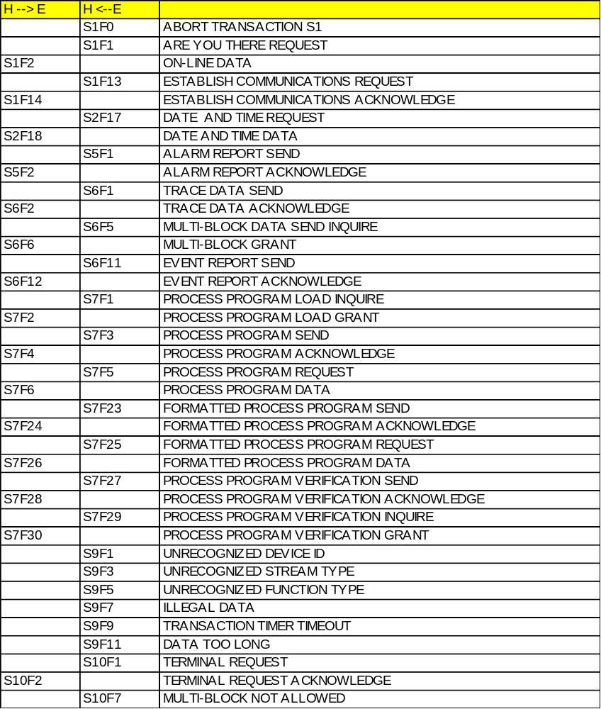

1.2.3 Messages To The E220

The following GEM SECS II transactions shall be implemented in GEM:

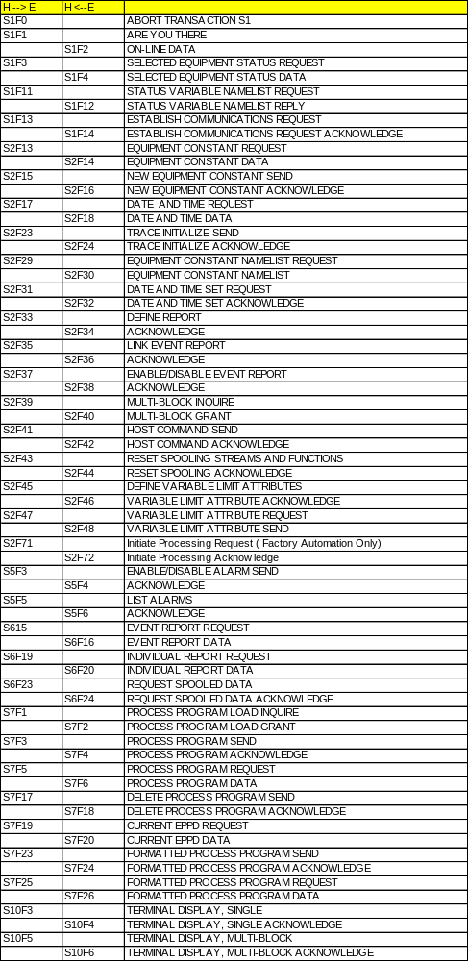

1.3 Function Of The GEM Interface

The GEM sub-system is composed of hardware and software. The hardware component is a SECS interface board, SIB-311. The software has five components:
FORTH based GEM interface software which is integrated into the E220HP / E500HP control program.
A multi-tasking operating system to provide data sharing and intertask communication for the E220HP / E500HP application and the GEM functions.
The GEM task, ‘C’ code to initialize the link between the E220HP / E500HP application and integrate the GWGEM function library.
GWGEM, a ‘C’ function library, a product from GW Associates.
SDR, driver interfacing the SIB-311 to DOS and the E220HP / E500HP application

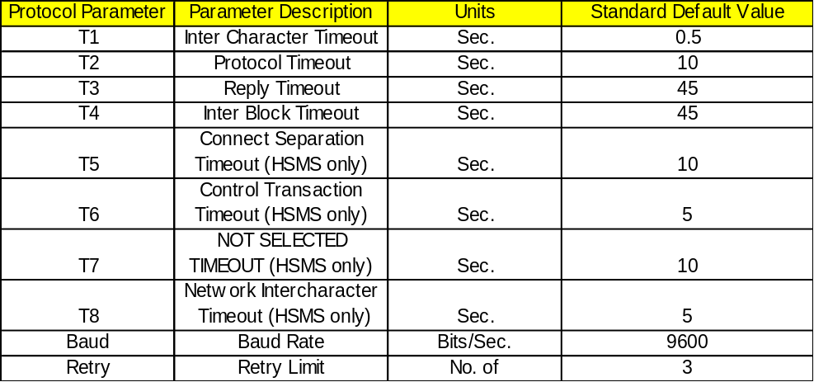

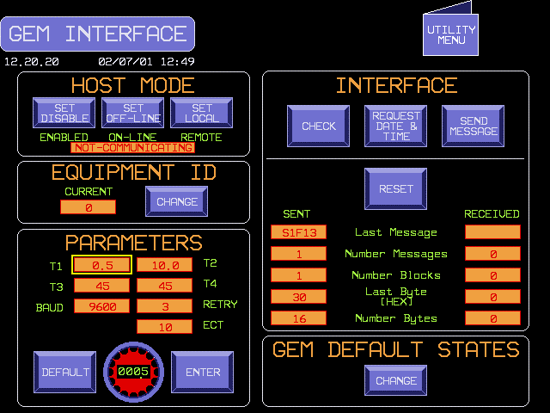

Figure 1 – SCREEN 1, HOST INTERFACE
The Host Mode section has two button icons that contain the present control state of the communications: ON-LINE or OFF-LINE, REMOTE or LOCAL. Touching the icon causes the control state to switch to the alternative state i.e.: REMOTE -> LOCAL, LOCAL -> REMOTE; ON-LINE -> OFF-LINE, OFF-LINE -> ON-LINE.
The MODE MENU screen, shown below in Screen 2, displays the HOST CONTROL button when the GEM option is active. Entry into the HOST CONTROL screen will be allowed if the equipment and Host have established communications. Upon entry into the HOST CONTROL screen the GEM control state will be set to on-line and remote.
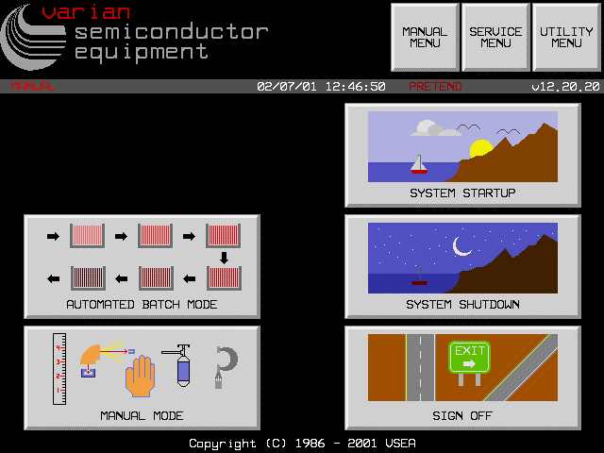
VERSION INTRODUCED: 12.20
Figure 2 - SCREEN 2, MODE MENU

1.3.1 Hardware Component

The hardware is a SECS interface board, SIB-311. The SIB-311 is a single printed circuit board occupying one expansion slot on the ISA bus of the PC. The SIB-311 provides the following hardware: on-board CPU, RAM, I/O ports, interrupt request signal, RS 232C interface with a DB37F connector. The SECS interface board contains its own microprocessor, memory, and performs the entire SECS I, independently of the Intel 486. The SIB-311 interface includes addressing of the memory and I/O port.
The customer host must be connected to port #1 of the SIB board connector located at the back of the PC.
Ports #2 and #3 are serial connections to the SMIF interface box. Port #2 provides the left SMIF serial connection while port #3 provides serial communication to the right SMIF.

1.3.2 Software Component

The software components of GEM are a sub-system within the E220HP / E500HP application, see figure below.

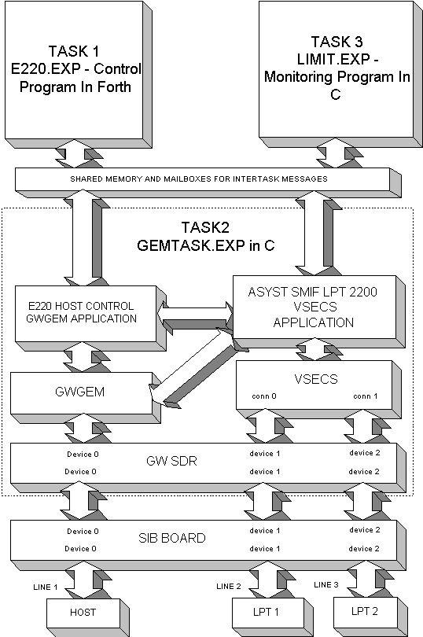

Figure 3 – SMIF Level 1 System Architecture

In E220/E500 software versions previous to Version 10, the main control computer was based on the IBM DOS (MS-DOS) operating system and the FORTH programming language. The SECS software was written completely in FORTH. This software handled the SECS I, SECS II and high level communications. Since it was interleaved with the other FORTH control software, the SECS I communications program and the control program of the implanter interfered with each other.
In Version 10, DOS has been replaced by a DOS compatible, preemtive multitasking operating system called TSX-32. This operating system was selected because of its ability to run 32 bit protected mode DOS programs (polyFORTH and the GEM tasks), its preemptive multitasking, intertask communications, shared memory support and built in realtime operating system features.
With this new architecture, the SIB board handles all of the SECS I protocol and timing. the GEM task (task 2 above) is a separate program written in the ‘C’ programming language which handles most of the SECS II message interpretation and creation. This allows the FORTH software (task 1) to independently control the implanter.
In Version 11.00.22, a multi-threader with an interface similar to PSOS, the VSECS component, and the Asyst SMIF LPT 2200 VSECS application was added to the TSX GEM task (task 2 above). This provides support for two Asyst SMIF LPT 2200 VSECS.

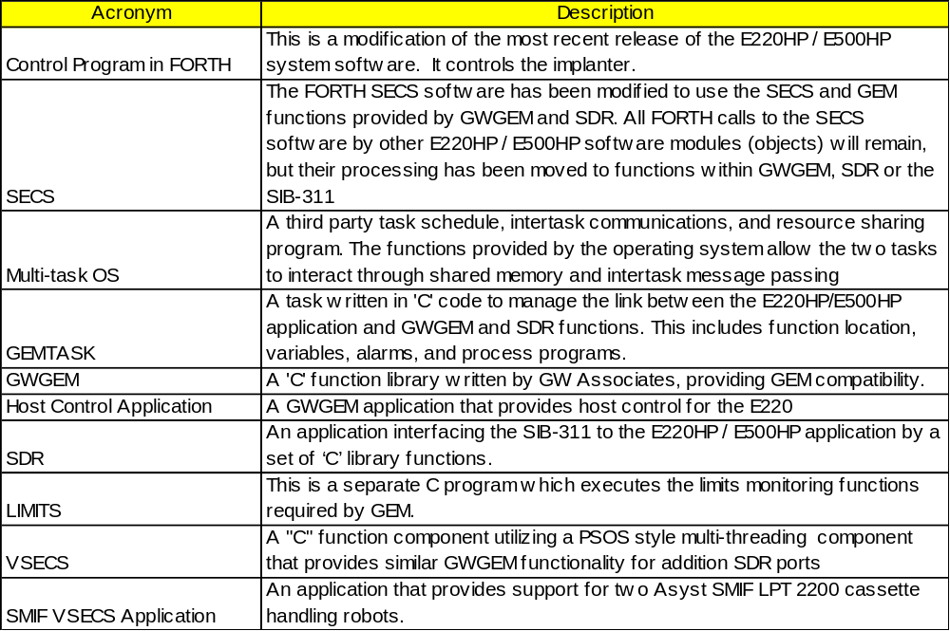
These components linked together with the E220HP / E500HP application and additional hardware comprise the entire E220HP / E500HP Ion Implanter system with GEM compatibility as specified within this document.

1.3.3 Definitions, Acronyms, and Abbreviations

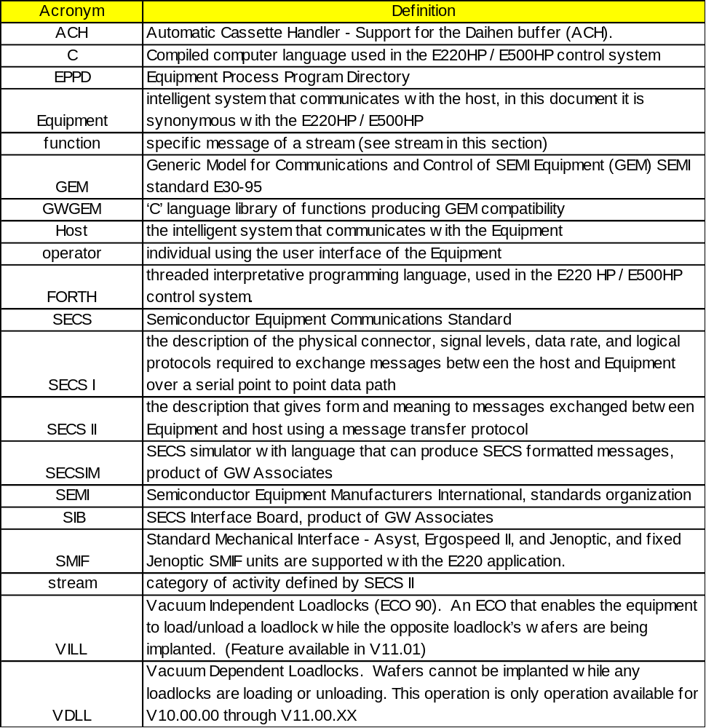

1.3.4 References

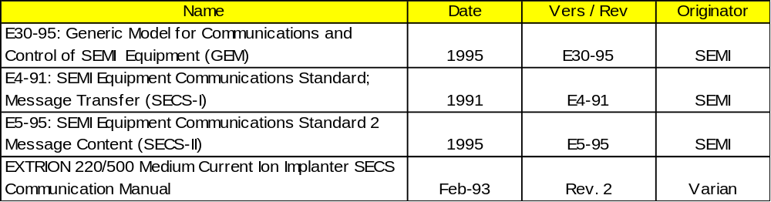

1.4 Software Revision Code

All major threads of the E220/E500 operating system incorporate added features to the GEM interface. This manual documents which revision certain features were added. To assist with a proper migration path, both a table and migration flowchart have been provided for reference. The table established the software version where major features which significantly impact the GEM interface were added. The flowchart provides a migration path to version 12 features.

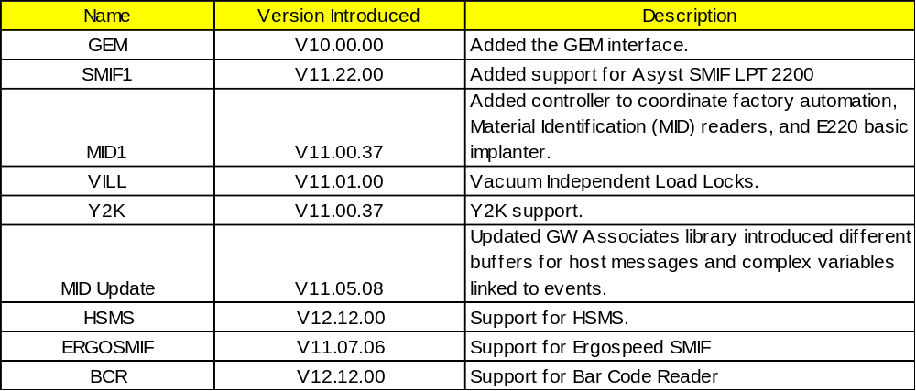

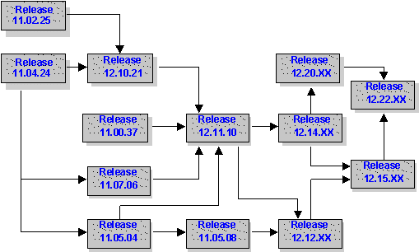

1.5 Changes from Previous Versions

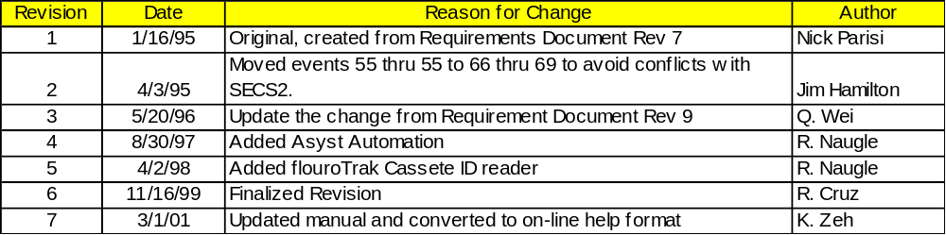

2.0 Data Item Directory

This section defines the data items used in the SECS II messages described in the Message Detail section. Each data item is defined by the following:
1. an unique mnemonic name
2. allowable item format code as complying to SEMI SECS-II E5-95 Section 6.2, Item Format Codes
3. a description of the specific values, and
4. the messages in which the data item is used.
An item is an information packet which has a length and format defined by the first 2, 3, or 4 bytes of the item. These first bytes are called the item header (IH). The item header consists of the format byte and the length byte(s) as shown in Figure 2. Bits one and two of the item header tell how many of the following bytes refer to the length of the item. This feature allows for long items without requiring the byte overhead for shorter items. The item length refers to the number of bytes following the item header, called the item body (IB), which is the actual data of the item. The item length refers only to the item body not including the item header, so the actual number of bytes in the message for one item is the item length plus 2, 3, or 4 bytes for the item header. All bytes in the item body are in the format specified in the format byte.
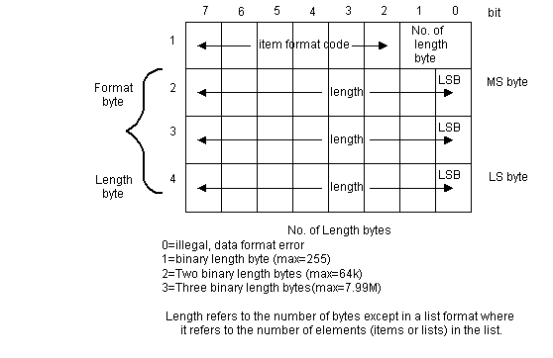
Item and List Header
A zero length in the format byte is illegal and produces an error. A zero length in the item length bytes has a special meaning as defined in the detailed message definitions.
Bits 3 through 8 of the format byte of the item header define the format of the data which follows. Of the 64 possible formats, fifteen are defined as shown in Table 1. Format code 0 is called a list and is defined in E5 6.3. The remaining 14 item formats define unspecified binary, code 10 (octal); Boolean, code 11 (octal); ASCII character strings, code 20 (octal); JIS-8 character strings, code 21 (octal) signed integer, codes 30, 31, 32, 34 (octal); floating point, codes 40, 44 (octal); and unsigned integer, codes 50, 51, 52, 54 (octal). These formats are used for groups of data which have the same representation in order to save repeated item headers. Signed integers will be two's complement values. Floating point numbers will conform to the IEEE standard 754. Boolean values will be byte quantities, with zero being equivalent to false, and non-zero being equivalent to true.

2.0.1 Item Format Codes

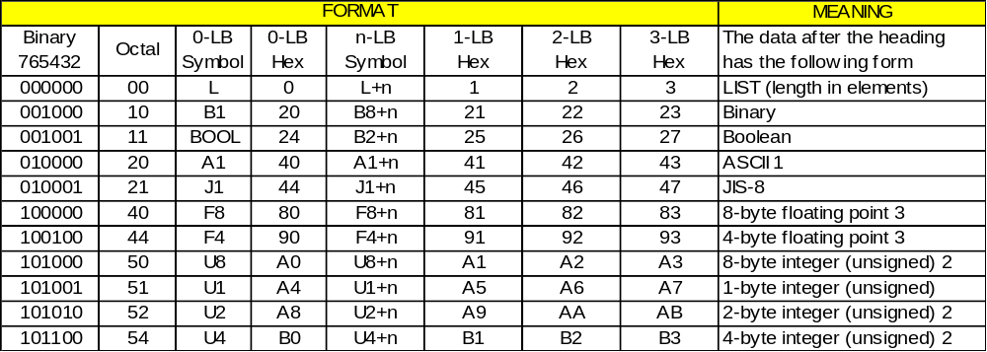
1 Non-printing characters are equipment specific.
2 Most significant byte sent first.
3 IEEE 754. The byte containing the sign bit is sent first.

ABS

ABS -- Any binary string Format: 10

Where Used: S2F25, S2F26

ACHA

ACHA -- ACH Acknowledge code Format: 10

0 = acknowledge, ok
1 = can not perform now
2 = requested recipe(PPID) not found
7 = Port is not enabled
10 = bad parameter in S2F71 left side list
11 = bad parameter in S2F71 right side list
12 = error in S2F71 message
13 = process parameter error
14 = cassette not loaded
15 = enqueue failed
16 = FA option or S2F71 queue disabled
Where Used: S2F72

ACKC5

ACKC5 -- Acknowledge code Format: 10

0 = accepted
>0 = error, not accepted
1-63 = reserved
Where Used: S5F2, S5F4

ACKC6

ACKC6 -- Acknowledge code Format: 10

0 = accepted
>0 = error, not accepted
1-63 = reserved
64 = Bad PPID
Where Used: S6F12, S6F14

ACKC7

ACKC7 -- Acknowledge code Format: 10

0 = Accepted
1 = Permission not granted
2 = Length error
3 = Matrix overflow
4 = PPID not found
6 = Recipe with same name exists and can not overwrite (S7F4).
6-63 = reserved
Where Used: S7F4, S7F18

ACKC7A

ACKC7A Format: 31, 51

0 = Accepted
1 = MDLN is inconsistent
2 = SOFTREV is inconsistent
3 = Invalid CCODE
4 = Invalid PPARM value
5 = Other error (described by ERRW7)
6-63 = reserved
Where Used: S7F27

ACKC10

ACKC10 -- Acknowledge Code Format: 10

0 = Accepted for display
1 = Message will not be displayed
2 = Terminal not available
3-63 reserved
64
Where Used: S10F2 , S10F4 , S10F6

ALCD

ALCD -- Alarm code byte Format: 10

bit 7 = 1 means alarm set
bit 7 = 0 means alarm cleared
bit 6-0 = alarm category
0 = not used
1 = Personal safety
2 = Equipment safety
3 = Parameter control warning
4 = Parameter control error
5 = Irrecoverable error
6 = Equipment status warning
7 = Attention flags
8 = Data integrity
>8 = other categories
9-63 = reserved
Where Used: S5F2, S5F6

ALED

ALED-- Alarm enable/disable code, 1 byte Format: 10

bit 7 = 1 means enable alarm
bit 7 = 0 means disable alarm
Where Used: S5F3

ALID

ALID – Alarm identification Format: 5( )

All alarm identifications can be found in Appendix B of this document.
Note: The format of ALID is 54 in S5F1
Where Used: S5F1, S5F3, S5F5, S5F6

ALTX

ALTX -- Alarm text limited to 40 characters Format: 20

All alarm text can be found in Appendix B of this document. Only the first 40 characters of the text is sent to the Host.
Where Used: S5F1

CCODE

CCODE -- Command Code Format: 32, 52

Each command code corresponds to a unique process operation the machine is capable of performing.

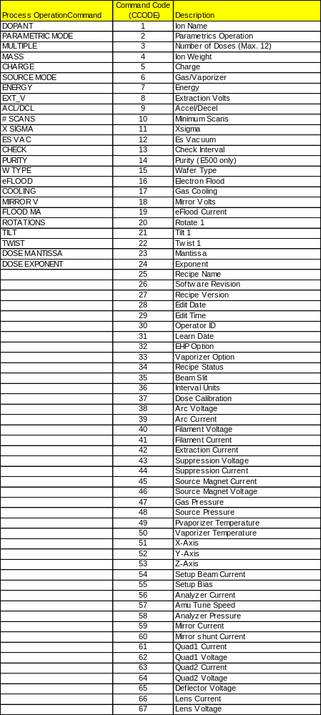
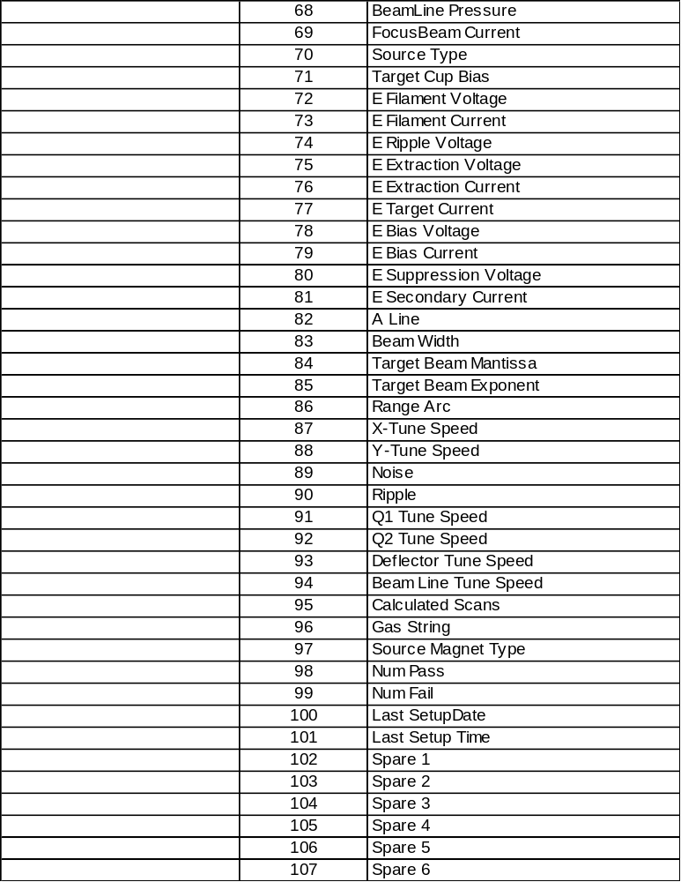

Where Used: S7F23, S7F26

CEED

CEED -- Collection event enable/disable code, 1 byte Format: 11

FALSE = Disable
TRUE = Enable
Where Used: S2F37

CEID

CEID -- Collected event ID Format: : 5( )

Identifies the event and report that is being sent. The format of CEID is 54 in S6F11. Supported Event ID's are:

CEID | Description
1 | Start up started
2 | Start up complete
3 | Shut down started
4 | Shut down complete
5 | Source setup started
6 | Source setup complete
7 | Beamline setup started
8 | Beamline setup complete
9 | Beamscan setup or check started
10 | Beamscan setup or check complete
11 | Batch started (GEM Compliant Process Started Started)
12 | Batch complete (GEM Compliant Process Started completed)
13 | Wafer started
14 | Wafer complete
15 | Alarm generated (GEM Compliant Alarmn Detected)
16 | Alarm silence button pressed (GEM Compliant Alarmn Cleared)
17 | Implant Held (GEM Compliant Processing Stopped)
18 | Implant Continued
19 | Abort started
20 | Abort complete
21 | Elevator vent started
22 | Elevator vent complete
23 | Door open started
24 | Door open complete
25 | Door close started
26 | Door close complete
27 | Elevator pump started
28 | Elevator pump completed
29 | Entering host control mode
30 | Entering host monitor mode (SECS-II only)
31 | High voltage enabled
32 | High voltage disabled
33 | Entering host ignore mode (SECS-II only)
34 | Unload Sequence Started Version available 12.20
35 | Pivot Retract Started Version available 12.20
36 | Pivot Retract Complete Version available 12.20
37 | Setup Only Complete
38 | Wafer mapping started
39 | Wafer mapping completed
40 | Processing started
41 | Cassette(s) removed
42 | Ready to Process
43 | Ready to Implant
44 | Port Availability change at ACH or Eqpt
45 | Cassette status change at ACH
46 | Cassette status change at equipment port
47 | Entering Factory Automation Off mode
48 | Entering Factory Automation Manual mode
49 | Entering Factory Automation Semi Auto mode
50 | Entering Factory Automation Full Auto mode
51 | Load/Unload ACH port Request
52 | Load/Unload ACH port Request Complete
53 | System Backup Started
54 | System Backup Complete
55 | Unused
56 | Unused
57 | Uniformity Precheck
58 | Unused
59 | Move Into ACH Port Request
60 | Move Out of ACH Port Request
61 | Move Into ACH Port Request Complete
62 | Move Out of ACH Port Request Complete
63 | Go Displayed
64 | Go or Cont Button Pressed or remote command START received from host
65 | Pivot Extend Complete
66 | Control State OFF-LINE
67 | Control State ON-LINE, Local
68 | Control State ON-LINE, Remote
69 | Unused
70 | Spool Activated
71 | Spool Deactivated
72 | Spool Transmit Failure
73 | Operator Command Issued
74 | Operator Command Complete
75 | Processing State Change
76 | Operator Changed Equipment Constant
77 | Upper Trace Limit Exceeded
78 | Lower Trace Limit Exceeded
79 | Process Program Change
80 | Process Program Selected
81 | Message Recognition
82 | Operator Log On
83 | Operator Log Off
84 | Ready to Receive Material
85 | Material Sensed at Port
86 | Host Command (Remote) Issued
87 | Host Command (Remote) Complete
88 | Job Created Version available 12.20
89 | Job Deleted Version available 12.20
90 | Job Completed Version available 12.20
91 | Queue Full
92 | Reserved for GW GEM
93 | Reserved for GW GEM
94 | Reserved for GW GEM
95 | Reserved for GW GEM
96 | Reserved for GW GEM
97 | Reserved for GW GEM
98 | Reserved for GW GEM
99 | Reserved for GW GEM
100 | SMIF LPT Manual Control Mode
101 | SMIF LPT Semi-Auto Control Mode
102 | SMIF LPT Full-Auto Control Mode
103 | SMIF LPT POD Placed
104 | SMIF LPT POD Removed
105 | SMIF LPT Load Ready
106 | SMIF LPT Load Start
107 | SMIF LPT Load Complete
108 | SMIF LPT Unload Ready
109 | SMIF LPT Unload Start
110 | SMIF LPT Unload Complete
111 | SMIF LPT Port Locked
112 | SMIF LPT Port Unlocked
113 | SMIF LPT Switched to Manual
114 | SMIF LPT Switched to Auto
115 | SMIF LPT Powered Up
116 | SMIF LPT Load Aborted
117 | SMIF LPT Unload Aborted
118 | SMIF LPT init Started
119 | SMIF LPT init Complete
120 | SMIF LPT init aborted
121 | SMIF LPT Cassette Placed on Equipment
122 | SMIF LPT Port lock/unlock failed
123 | Actual Smif Slot Map Available
124 | EMID Actual Cassette ID Available Version available 12.15
125 | EMID Actual Cassette ID Update Aborted Version available 12.15
126 | Discard Job Version available 12.15
127 | Actual SMIF Slot Map Validation Failed
128 | Actual Cassette ID Validation Failed Version available 12.15
129 | Actual Wafer ID Available
130 | Actual Wafer ID Update Abort
131 | Actual Wafer ID Validation Failed
132 | Actual Equipment Slot Map Validation Failed
133 | Actual Equipment Slot Map Update Aborted
134 | Reject Pod
135 | Actual Equipment Slot Map Validation Passed
136 | Actual Smif Slot Map Validation Passed
137 | EMID Validation Passed Version available 12.15
138 | Actual Wafer ID Validation Passed
139 | Actual Equipment Slot Map Validation Passed
140 | Job Done Version available 11.05.04
141 | Job Started Version available 11.05.04
142 | Equipment Count Validation Failed Version available 11.05.04
143 | Equipment Count Validation Passed Version available 11.05.04
144 | SMIF Count Available Version available 11.05.04
145 | SMIF Count Abort Version available 11.05.04
146 | Smif Count Validation Failed Version available 11.05.04
147 | SMIF Count Validation Passed Version available 11.05.04
160 | SMART Tag Data Lot-id Available
161 | SMART Tag File Data Available
162 | SMART Tag Status Available
200 | 200+ Used for Limits Zone Transition for Analogs
2000 | 2000+ Used for Alarm On / Off

In addition, each alarm ID, ALID , has two CEIDs associated with it, one for alarm clear and one for alarm set. The alarm IDs are calculated at initialization time based on the contents of the MESSAGES.USA file. The formulas for calculating the alarm IDs are as follow:
Alarm Off CEID = (Alarm ID *2) + 300
Alarm On CEID = Alarm Off CEID + 1
VARIAN RESERVES THE RIGHT TO ADD ADDITIONAL EVENT CEIDs
The Varian GEM uses the CEID number for the SFCD and accesses the reports associated with the CEID.
Where Used: S2F35, S2F37, S6F11, S6F13

COMMACK

COMMACK -- Establish Communications Acknowledge Code, 1 byte Format: 10

0 = Accepted
1 = Denied, Try Again
2-63 = Reserved
Where Used: S1F13, S1F14

CPACK

CPACK -- Command Parameter Acknowledge Code, 1 byte Format: 10

1 = Parameter Name (CPNAME) does not exist
2 = Illegal Value specified for CPVAL
3 = Illegal Format specified for CPVAL
>3 = Other equipment=specific error
4-63 = reserved
Where Used: S2F42

CPNAME

CPNAME -- Command Parameter Name Format: 20

These are used in the remote command to designate the parameter being sent with the command.
Where Used: S2F41

CPVAL

CPVAL -- Command Parameter Value Format: 10, 11, 20, 21, 3( ), 5( )

Where Used: S2F41

DATAID

DATAID -- Data ID Format: 5()

The data id is used to connect a multi- block request/grant message transaction with the actual multi- block message transaction. In messages which originate from the Equipment, which include DATAID but are not multi- block, the DATAID is undefined. In messages which originate from the Host and which are not multi- block but do contain DATAID, DATAID will be ignored.
Note: The format of DATAID is 54 in S6F11
Where Used: S2F33, S235, S239, S6F5, S6F11, S6F13

DATALENGTH

DATALENGTH -- Total bytes to be sent Format: 3( ),5( )

Where Used: S2F39, S6F5

DRACK

DRACK -- Define Report Acknowledge Code, 1 byte Format: 10

0 = Accept
1 = Denied. Insufficient space
2 = Denied. Invalid format
3 = Denied. At least one RPTID already defined
4 = Denied, At least VID does not exist
>4 = Other errors
5-63 = reserved
Where Used: S2F34

DSPER

DSPER -- Data sample period Format: 20

hhmmss, 6 bytes
Where Used: S2F23

DVID

DVID Format: 5( )

The data variables may also be access with a VID of equivalent value using the functions appropriate for VID. See VID for table showing relationship between data variables identifcation (DVID), equipment constant identifications(ECID), and status variable identifications( SVID) . The data variable IDs are as follows:

DVID | DVNAME | DVID | DVNAME
 | Implant And Machine Status Variables |  | Recipe Data Process Program Variables
100 | A(LLOT) | 200 | PPID
101 | A(RLOT) | 201 | ION- NAME
102 | LWAF# | 202 | ION- AMU
103 | RWAF# | 203 | DOSE- MANTISSA
104 | OP- NAME | 204 | DOSE- EXPONENT
105 | OPERATOR- ID | 205 | ENERGY
106 | WAFER- NUMBER | 206 | SCANS
107 | WAFER- START- TIME | 207 | COOLING
108 | WAFER- END- TIME | 208 | FLOOD
109 | BATCH- START- TIME | 209 | <TILT
110 | BATCH- END- TIME | 210 | <TWIST
111 | aXSIGMA | 211 | ION- CHARGE
112 | cSCANS | 212 | EST- VAC
113 | aDOSE | 213 | X- SIGMA
114 | aSCANS | 214 | Y- SIGMA
115 | aYSIGMA | 215 | CHK- INT
116 | MODE | 216 | Q- SOURCE
117 | STATUS | 217 | W- TYPE
118 | WAFER- HOLDS | 218 | F-LEARNED
119 | BATCH- HOLDS | 219 | #MULTIPLE
120 | LOT | 220 | GAS/VAPOR
121 | #WAFERS | 221 | EXTRACTION
122 | REMOTE- CONTROL | 222 | ACCEL/DECEL
123 | TARGET- I | 223 | PURITY
124 | BEAM- WIDTH | 224 | MIR-V
125 | HOST- CONTROL | 225 | FLOOD-CURRENT
126 | FAUTO | 226 | ROTATE
127 | ACH-STATUS | 227 | LEFT-PPID
128 | BPTN | 228 | RIGHT-PPID
129 | CSTATUS
130 | LPORT
131 | RPORT
132 | PORT-STATUS
133 | WFR_CYC_TOT_LEFT
134 | WFR_CYC_TOT_RIGHT
135 | WFR_CYC_TOT_L/R
136 | WFR_CYC_PM_LEFT
137 | WFR_CYC_PM_RIGHT
138 | WFR_CYC_PM_L/R
139 | WAFERS_IMPLANTED
140 | NUMBER_OF_SCANS
141 | GAS1_TOTAL
142 | GAS2_TOTAL
143 | GAS3_TOTAL
144 | GAS4_TOTAL
145 | GAS1_4_TOTAL
146 | GAS1_PM
147 | GAS2_PM
148 | GAS3_PM
149 | GAS4_PM
150 | GAS1_4_PM
151 | PORT-ID
152 | LPORT-STATUS
153 | RPORT-STATUS
154 | LMATERIAL-STATUS
155 | RMATERIAL-STATUS
156 | EXPECTED-SLOT-MAP(LLOT) (Not Implemented)
157 | EXPECTED-SLOT-MAP(RLOT) (Not Implemented)
158 | EXPECTED-WID(LLOT) (Not Implemented)
159 | EXPECTED-WID(RLOT) (Not Implemented)
160 | ACTUAL-MID(LLOT)
161 | ACTUAL-MID(RLOT)
162 | EQUIP-ACTUAL-SLOT-MAP(LLOT) (Not Implemented)
163 | EQUIP-ACTUAL-SLOT-MAP(RLOT) (Not Implemented)
164 | ACTUAL-WID(LLOT) (Not Implemented)
165 | ACTUAL-WID(RLOT) (Not Implemented)
166 | CURRENT-WAFER-ID (Not Implemented)
167 | ID-VALIDATIOD(LLOT) (Not Implemented)
168 | ID-VALIDATION(RLOT) (Not Implemented)
169 | ID-READERS (Not Implemented)
170 | ID STATS (Not Implemented)
171 | QUEUE-FULL
172 | LEFT_WAFERS_IMPLANTED
173 | RIGHT_WAFERS_IMPLANTED
174 | BATCH_WAFERS_IMPLANTED
175 | DI-WATER-FLOW (Not Implemented)
176 | WHEREIS(LLOT) (Not Implemented)
177 | WHEREIS(RLOT) (Not Implemented)
178 | JOB-QUEUE (Not Implemented)
179 | JOB-STATUS(LLOT) (Not Implemented)
180 | JOB-STATUS(RLOT) (Not Implemented)
181 | BEAM_STATUS (Not Implemented)
182 | LOT-ID(LLOT) (Not Implemented)
183 | LOT-ID(RLOT) (Not Implemented)
184 | BATCH-ID(LLOT) (Not Implemented)
185 | BATCH-ID(RLOT) (Not Implemented)
186 | EXPECTED-COUNT(LLOT) (Not Implemented)
187 | EXPECTED-COUNT(RLOT) (Not Implemented)
188 | DOSE_CALIBRATION_FACTOR
189 | JOB-QUEUE-SLOT (Not Implemented)
190 | OUTPUT-PORT-ID (Not Implemented)
191 | JOB-QUEUE-SIZE (Not Implemented)
192 | JOB-QUEUE-CAPACITY (Not Implemented)
195 | QUEUE (Not Implemented)
196 | QUEUE_FREE_SLOTS
197 | TAG-FILEDATA
198 | LTAG-BATSTAT
199 | RTAG-BATSTAT
 | GEM Compliant Data Variables |  | GEM System Data Variables
300 | PPChangeStatus | 500 | ABORTLEVEL
301 | PPChangeName | 501 | GemASer
302 | ProcessState | 502 | ALARMID
303 | PreviousProcessState | 503 | DATAID
304 | PPExecName | 504 | PREVIOUSCEID
305 | Clock | 505 | PREVIOUSCOMMAND
306 | EventsEnabled | 509 | SPOOLSTARTTIME
307 | AlarmsEnabled | 510 | SPOOLFULLTIME
308 | AlarmsSet | 511 | SPOOLCOUNTACTUAL
309 | ControlState | 512 | SPOOLCOUNTTOTAL
310 | PreviousControlState | 513 | GemSpoolState
311 | EventLimit | 514 | GemSpoolFull
312 | LimitVariable | 515 | GemSpoolLoadSubstate
313 | TransitionType | 516 | GemSpoolUnloadSubstate
 | IQDP Pump Status Variables
600 | a1ESTurboCommStatus[0]
601 | a1ESTurboState[0]
602 | a1ESTurboCommStatus[1]
603 | a1ESTurboState[1]
604 | 1OnBoardCommStatus
605 | a1OnBoardPumpStatus[0]
606 | a1OnBoardRegenStatus[0]
607 | a1OnBoardPurgeValveStatus[0]
608 | a1OnBoardRoughValveStatus[0]
609 | a1OnBoardDelayStart[0]
610 | a1OnBoardDelayRestart[0]
611 | a1OnBoardFastRoughTest[0]
612 | a1OnBoardExtendedPurge[0]
613 | a1OnBoardRepurgeTime[0]
614 | a1OnBoardRepurgeCycles[0]
615 | a1OnBoardRORLimit[0]
616 | a1OnBoardRORCycles[0]
617 | a1OnBoardPowerFailRecoveryTemp[0]
618 | a1OnBoardFirstStageTempSetpoint[0]
619 | a1OnBoardSecondStageTempSetpoint[0]
620 | a1OnBoardPumpStatus[1]
621 | a1OnBoardRegenStatus[1]
622 | a1OnBoardPurgeValveStatus[1]
623 | a1OnBoardRoughValveStatus[1]
624 | a1OnBoardDelayStart[1]
625 | a1OnBoardDelayRestart[1]
626 | a1OnBoardFastRoughTest[1]
627 | a1OnBoardExtendedPurge[1]
628 | a1OnBoardRepurgeTime[1]
629 | a1OnBoardRepurgeCycles[1]
630 | a1OnBoardRORLimit[1]
631 | a1OnBoardRORCycles[1]
632 | a1OnBoardPowerFailRecoveryTemp[1]
633 | a1OnBoardFirstStageTempSetpoint[1]
634 | a1OnBoardSecondStageTempSetpoint[1]
635 | a1OnBoardPumpStatus[2]
636 | a1OnBoardRegenStatus[2]
637 | a1OnBoardPurgeValveStatus[2]
638 | a1OnBoardRoughValveStatus[2]
639 | a1OnBoardDelayStart[2]
640 | a1OnBoardDelayRestart[2]
641 | a1OnBoardFastRoughTest[2]
642 | a1OnBoardExtendedPurge[2]
643 | a1OnBoardRepurgeTime[2]
644 | a1OnBoardRepurgeCycles[2]
645 | a1OnBoardRORLimit[2]
646 | a1OnBoardRORCycles[2]
647 | a1OnBoardPowerFailRecoveryTemp[2]
648 | a1OnBoardFirstStageTempSetpoint[2]
649 | a1OnBoardSecondStageTempSetpoint[2]
650 | lIqdpEndTask
651 | lIqdpEnabled
652 | alIqdpCommunicationsStatus[0]
653 | alIqdpPumpStatus[0]
654 | alIqdpPumpTemperature[0]
655 | alIqdpPumpPower[0]
656 | alIqdpPumpCurrent[0]
657 | alIqdpExhaustPressure[0]
658 | alIqdpWaterFlow[0]
659 | alIqdpRunningTime[0]
660 | alIqdpOilLevel[0]
661 | alIqdpBlowerStatus[0]
662 | alIqdpBlowerOilLevel[0]
663 | alIqdpBlowerMotorTemperature[0]
664 | alIqdpBlowerPower[0]
665 | alIqdpBlowerPhaseCurrent[0]
666 | alIqdpCommunicationsStatus[1]
667 | alIqdpPumpStatus[1]
668 | alIqdpPumpTemperature[1]
669 | alIqdpPumpPower[1]
670 | alIqdpPumpCurrent[1]
671 | alIqdpExhaustPressure[1]
672 | alIqdpWaterFlow[1]
673 | alIqdpRunningTime[1]
674 | alIqdpOilLevel[1]
675 | alIqdpBlowerStatus[1]
676 | alIqdpBlowerOilLevel[1]
677 | alIqdpBlowerMotorTemperature[1]
678 | alIqdpBlowerPower[1]
679 | alIqdpBlowerPhaseCurrent[1]
680 | alIqdpCommunicationsStatus[2]
681 | alIqdpPumpStatus[2]
682 | alIqdpPumpTemperature[2]
683 | alIqdpPumpPower[2]
684 | alIqdpPumpCurrent[2]
685 | alIqdpExhaustPressure[2]
686 | alIqdpWaterFlow[2]
687 | alIqdpRunningTime[2]
688 | alIqdpOilLevel[2]
689 | alIqdpBlowerStatus[2]
690 | alIqdpBlowerOilLevel[2]
691 | alIqdpBlowerMotorTemperature[2]
692 | alIqdpBlowerPower[2]
693 | alIqdpBlowerPhaseCurrent[2]
 | Left Ergospeed II SMIF Variables |  | Right Ergospeed II SMIF Variables
8300 | Not Used | 8400 | Not Used
8301 | Left ErgoSMIF Last Function | 8401 | Right ErgoSMIF Last Function
8302 | Left ErgoSMIF RCMD Compl State | 8402 | Right ErgoSMIF RCMD Compl State
8303 | Left ErgoSMIF Elevator State | 8403 | Right ErgoSMIF Elevator State
8304 | Left ErgoSMIF Pod Placed | 8404 | Right ErgoSMIF Pod Placed
8305 | Left ErgoSMIF Lock State | 8405 | Right ErgoSMIF Lock State
8306 | Left ErgoSMIF Home State | 8406 | Right ErgoSMIF Home State
8307 | Left ErgoSMIF Pneumatic Stroke State | 8407 | Right ErgoSMIF Pneumatic Stroke State
8308 | Left ErgoSMIF Gripper State | 8408 | Right ErgoSMIF Gripper State
8309 | Left ErgoSMIF Cassette in Gripper | 8409 | Right ErgoSMIF Cassette in Gripper
8310 | Left ErgoSMIF Low Load | 8410 | Right ErgoSMIF Low Load
8311 | Left ErgoSMIF Port Door State | 8411 | Right ErgoSMIF Port Door State
8312 | Left ErgoSMIF Pressure State | 8412 | Right ErgoSMIF Pressure State
8313 | Left ErgoSMIF FFU State | 8413 | Right ErgoSMIF FFU State
Where Used: S1F3, S1F11, S1F12, S2F23, S2F33, S2F45, S2F46, S2F47, S2F48; S6F13, S6F18, S6F22

DVID Variable Dictionary

#MULTIPLE Format: 20

If a recipe is a multi-line recipe, #MULTIPLE indicates the number of implant iterations. Significant only if it is 2 or larger.

#WAFER Format: 20

Number of wafers on the side being reported at the start or end of a batch implant.

<TILT Format: 20

Tilt angle of the wafer relative to the ion beam in degrees.

<TWIST Format: 20

Angle of rotation of the wafer flat or notch relative to the axis about which it is tilted in degrees.

A(LLOT) Format: 20

The MID of the left cassette, or the expected MID.

A(RLOT) Format: 20

The MID of the right cassette, or the expected MID.

a1OnBoardPumpStatus[0] Format : 20

The on board target chamber pump status.

a1ESTurboCommStatus[0] Format : 20

The left end station turbo communication status.

a1ESTurboState[0] Format : 20

The left end station turbo state.

a1ESTurboCommStatus[1] Format : 20

The right end station turbo communication status.

a1ESTurboState[1] Format : 20

The right end station turbo state.

1OnBoardCommStatus Format : 20

The on board communications status.

a1OnBoardDelayRestart[0] Format : 20

The on board target chamber pump delay restart in minutes.

a1OnBoardDelayStart[0] Format : 20

The on board target chamber pump delay start in minutes.

a1OnBoardExtendedPurge[0] Format : 20

The on board target chamber pump extended purge in minutes.

a1OnBoardFastRoughTest[0] Format : 20

The on board target chamber pump fast rough test in seconds.

a1OnBoardFirstStageTempSetpoint[0] Format : 20

The on board target chamber pump first stage temperature setpoint in Kelvin.

a1OnBoardPowerFailRecoveryTemp[0] Format : 20

The on board target chamber pump power fail recovery temperature in Kelvin.

a1OnBoardPurgeValveStatus[0] Format : 20

The on board target chamber pump purge valve status.

a1OnBoardRegenStatus[0] Format : 20

The on board target chamber pump regen status.

a1OnBoardRepurgeCycles[0] Format : 20

The on board target chamber pump repurge cycles.

a1OnBoardRepurgeTime[0] Format : 20

The on board target chamber pump repurge time in minutes.

a1OnBoardRORCycles[0] Format : 20

The on board target chamber pump ROR cycles.

a1OnBoardRORLimit[0] Format : 20

The on board target chamber pump ROR limit in microns.

a1OnBoardRoughValveStatus[0] Format : 20

The on board target chamber pump rough valve status.

a1OnBoardSecondStageTempSetpoint[0] Format : 20

The on board target chamber pump second stage temperature setpoint in Kelvin.

a1OnBoardPumpStatus[1] Format : 20

The on board left elevator pump status.

a1OnBoardRegenStatus[1] Format : 20

The on board left elevator pump regen status.

a1OnBoardPurgeValveStatus[1] Format : 20

The on board left elevator pump purge valve status.

a1OnBoardRoughValveStatus[1] Format : 20

The on board left elevator pump rough valve status.

a1OnBoardDelayStart[1] Format : 20

The on board left elevator pump delay start in minutes.

a1OnBoardDelayRestart[1] Format : 20

The on board left elevator pump delay restart in minutes.

a1OnBoardFastRoughTest[1] Format : 20

The on board left elevator pump fast rough test in seconds.

a1OnBoardExtendedPurge[1] Format : 20

The on board left elevator pump extended purge in minutes.

a1OnBoardRepurgeTime[1] Format : 20

The on board left elevator pump repurge time in minutes.

a1OnBoardRepurgeCycles[1] Format : 20

The on board left elevator pump repurge cycles.

a1OnBoardRORLimit[1] Format : 20

The on board left elevator pump ROR limit in microns.

a1OnBoardRORCycles[1] Format : 20

The on board left elevator pump ROR cycles.

a1OnBoardPowerFailRecoveryTemp[1] Format : 20

The on board left elevator pump power fail recovery temperature in Kelvin.

a1OnBoardFirstStageTempSetpoint[1] Format : 20

The on board left elevator pump first stage temperature setpoint in Kelvin.

a1OnBoardSecondStageTempSetpoint[1] Format : 20

The on board left elevator pump second stage temperature setpoint in Kelvin.

a1OnBoardPumpStatus[2] Format : 20

The on board right elevator pump status.

a1OnBoardRegenStatus[2] Format : 20

The on board right elevator pump regen status.

a1OnBoardPurgeValveStatus[2] Format : 20

The on board right elevator pump purge valve status.

a1OnBoardRoughValveStatus[2] Format : 20

The on board right elevator pump rough valve status.

a1OnBoardDelayStart[2] Format : 20

The on board right elevator pump delay start in minutes.

a1OnBoardDelayRestart[2] Format : 20

The on board right elevator pump delay restart in minutes.

a1OnBoardFastRoughTest[2] Format : 20

The on board right elevator pump fast rough test in seconds.

a1OnBoardExtendedPurge[2] Format : 20

The on board right elevator pump extended purge in minutes.

a1OnBoardRepurgeTime[2] Format : 20

The on board right elevator pump repurge time in minutes.

a1OnBoardRepurgeCycles[2] Format : 20

The on board right elevator pump repurge cycles.

a1OnBoardRORLimit[2] Format : 20

The on board right elevator pump ROR limit in microns.

a1OnBoardRORCycles[2] Format : 20

The on board right elevator pump ROR cycles.

a1OnBoardPowerFailRecoveryTemp[2] Format : 20

The on board right elevator pump power fail recovery temperature in Kelvin.

a1OnBoardFirstStageTempSetpoint[2] Format : 20

The on board right elevator pump first stage temperature setpoint in Kelvin.

a1OnBoardSecondStageTempSetpoint[2] Format : 20

The on board right elevator pump second stage temperature setpoint in Kelvin.

ABORTLEVEL Format : B

The abort levelfor the most recent abort. This DV is not supported.

ACCEL/DECEL Format: 20

Energy mode; Accel if 0, Decel if 1.

ACH-STATUS Format: 20

Complete cassette status of automatic cassette handler(2 bytes)

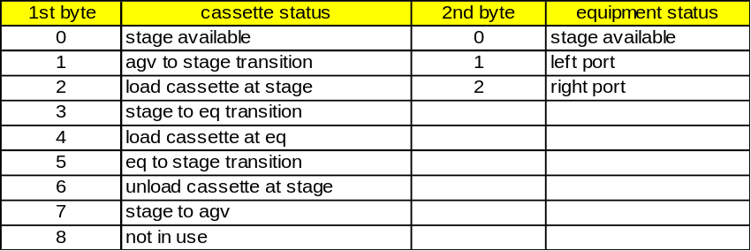

Note: 2nd byte data of 2 (middle port) is not applicable to E220/E500. The stages, stg5 to stg8, are not applicable to E220/E500.

ACTUAL-MID(LLOT) Format : 20

Left EMID.

ACTUAL-MID(RLOT) Format : 20

Right EMID.

aDOSE Format:20

Dose on the last wafer as a percentage of the recipe dose. .

AlarmID Format:3( ), 5( )

This variable is valid only upon the setting or clearing of an alarm condition and contains the current alarm identification (ALID ), regardless of whether that alarm is enabled for reporting.

AlarmsEnabled Format:: 0

A list of enabled alarms.
< L,n
<ALID1>
.
.
<ALIDn>
>
n= # of alarms enabled
Contains the list of alarms (ALIDs) enabled for reporting (via Stream 5 ).

AlarmsSet Format:: 0

A list of alarms set.
< L,n
< ALID1>
.
.
< ALIDn>
>
n= # of alarms set
Contents of this variable is a list of alarms (ALIDs) currently in the UNSAFE (alarm set) state, regardless whether the alarms are enabled for reporting.

alIqdpCommunicationsStatus[0] Format : 20

alIqdpPumpStatus[0] Format : 20

alIqdpPumpTemperature[0] Format : 20

alIqdpPumpPower[0] Format : 20

alIqdpPumpCurrent[0] Format : 20

allqdpExhaustPressure[0] Format : 20

alIqdpWaterFlow[0] Format : 20

alIqdpRunningTime[0] Format : 20

alIqdpOilLevel[0] Format : 20

alIqdpBlowerStatus[0] Format : 20

alIqdpBlowerOilLevel[0] Format : 20

alIqdpBlowerMotorTemperature[0] Format : 20

alIqdpBlowerPower[0] Format : 20

alIqdpBlowerPhaseCurrent[0] Format : 20

alIqdpCommunicationsStatus[1] Format : 20

alIqdpPumpStatus[1] Format : 20

alIqdpPumpTemperature[1] Format : 20

alIqdpPumpPower[1] Format : 20

alIqdpPumpCurrent[1] Format : 20

alIqdpExhaustPressure[1] Format : 20

alIqdpWaterFlow[1] Format : 20

alIqdpRunningTime[1] Format : 20

alIqdpOilLevel[1] Format : 20

alIqdpBlowerStatus[1] Format : 20

alIqdpBlowerOilLevel[1] Format : 20

alIqdpBlowerMotorTemperature[1] Format : 20

alIqdpBlowerPower[1] Format : 20

alIqdpBlowerPhaseCurrent[1] Format : 20

alIqdpCommunicationsStatus[2] Format : 20

alIqdpPumpStatus[2] Format : 20

alIqdpPumpTemperature[2] Format : 20

alIqdpPumpPower[2] Format : 20

alIqdpPumpCurrent[2] Format : 20

alIqdpExhaustPressure[2] Format : 20

alIqdpWaterFlow[2] Format : 20

alIqdpRunningTime[2] Format : 20

alIqdpOilLevel[2] Format : 20

alIqdpBlowerStatus[2] Format : 20

alIqdpBlowerOilLevel[2] Format : 20

alIqdpBlowerMotorTemperature[2] Format : 20

alIqdpBlowerPower[2] Format : 20

alIqdpBlowerPhaseCurrent[2] Format : 20

aSCANS Format:20

Number of mechanical scans used to implant the wafer. .

aXSIGMA Format:20

The variation in dose across the wafer as measured by the traveling Faraday during beamscan setup.

aYSIGMA Format:20

The uniformity controller keeps a record of the dose at each scan line position in Y. The line spacing is 0.1 in in normal mode and 0.05 in in X compressed mode. At the end of an implant or when on hold it calculates the sigma of the array of doses.

BATCH-END-TIME Format:20

Implant end time for one batch in the format yymmddhhmmss.

BATCH-HOLDS Format:20

Total number of normal hold conditions (retry conditions) during implant of the current batch. The units are the # of normal holds.

BATCH-START-TIME Format:20

Implant start time for one batch in the format yymmddhhmmss.

BATCH_WAFERS_IMPLANTED Format : 20

Version Introduced 11.05.08

The number of wafers for the last batch that were completely or partially implanted with the specified recipe. When a wafer that is partially implanted is on hold, this SVID will not be incremented. However, as soon as the implant is aborted, these variables will be incremented to reflect the partially implanted wafer.

BEAM-WIDTH Format:20

The width of the beam in the end station in units of millimeters.

BPTN Format:20

ACH stage number; ACH stage (port) is designated 1 to 4, left to right facing the equipment. Port information is no longer supported for DVID 128 with V12 and greater. DVID 151 should be used to send port information instead of DVID 128. BPTN is no longer supported in V12 since this is actually the port-id for an automatic cassette handler.

CHK-INT Format:20

Checking interval. The E220 will recheck the uniformity across the wafer periodically to ensure against beam drift when running long implants. CHK-INT is the time in minutes between checks. If the value is set to zero, checking will be performed only between batches of wafers.

CLOCK Format: 20

The value of the equipment's internal clock. This is a format requirement only and does not imply a precision or accuracy.
Format: YYYYMMDDhhmmsscc
YYYY=Year 0000 to 9999
MM=Month 01 to 12
DD=Day 01 to 31
hh=Hour 00 to 23
mm=Minute 00 to 59
ss=Second 00 to 59
cc=Centisecond 00 to 99

ControlState Format: 10

This status variable contains the code which identifies the current control state of the equipment. When reported related to a control state transition, its value should represent the state current after the transition.
1 = OFF-LINE/EQUIPMENT OFF-LINE
2 = OFF-LINE/ATTEMPT ON-LINE
3 = OFF-LINE/HOST OFF-LINE
4 = ON-LINE/LOCAL
5 = ON-LINE/REMOTE
6-63 Reserved

COOLING Format:20

Logical value = true if wafer cooling is to be used.

CSTATUS Format: 20

Cassette status at ACH stage; identical to the first byte of ACH-STATUS.

DATAID Format : 54

The data ID for the most recent event report.

DI-WATER-FLOW Format : 20

Version Introduced 12.14

Terminal DI water flow.
Possible values are:
0 - insufficient flow
1 - sufficient flow

DOSE-CALIBRATION-FACTOR Format : 20

The number is used to adjust the DOSE measurement system so that two ion implants with the same recipe (DOSE) will result in the same DOSE on the wafer when measured by Prometrix or Thermawave.

DOSE-EXPONENT Format: 20

Exponent of the desired dose.

DOSE-MANTISSA Format : 20

Mantissa of the desired dose.

ENERGY Format : 20

The total ion energy in units of Kev. In the case of doubly charged ions (P ++, etc) this is twice the total voltage used.

ErgoSMIF Cassette in Gripper Format : U1

Version Available : 11.07.06

Gripper Cassette Sensor
0 - no cassette in gripper
1 - cassette in gripper

ErgoSMIF Elevator State Format : U1

Version Available : 11.07.06

ErgoSpeed Elevator State
0 - not at home position
1 - at home position

ErgoSMIF FFU State Format : U1

Version Available : 11.07.06

Fan Filter Unit State (FFU)
0 - FFU not available
1 - FFU available

ErgoSMIF Gripper State Format : U1

Version Available : 11.07.06

Gripper
0 - undefined
1 - closed
2 - open

ErgoSMIF Home State Format : U1

Version Available : 11.07.06

Pneumatic Arm Position
0 - undefined
1 - at home
2 - at equipment position

ErgoSMIF Last Function Format : U1

Version Available : 11.07.06

Last Function Completed. Refer to Infab ErgoSpeed SECS II Interface Specification for possible values.

ErgoSMIF Lock State Format : U1

Version Available : 11.07.06

Pod State
0 - undefined
1 - locked
2 - unlocked

ErgoSMIF Low Load Format : U1

Version Available : 11.07.06

LowLoad Position
0 - not at load level
1 - at load level

ErgoSMIF Pneumatic Stroke State Format : U1

Version Available : 11.07.06

Pneumatic Stroke
0 - undefined
1 - raised
2 - lowered

ErgoSMIF Pod Placed Format : U1

Version Available : 11.07.06

Pod Presence
0 - not placed
1 - placed

ErgoSMIF Port Door State Format : U1

Version Available : 11.07.06

Port Door State
1 - locked
2 - unlocked

ErgoSMIF Pressure State Format : U1

Version Available : 11.07.06

Pressure State
0 - low pressure
1 - sufficient pressure

ErgoSMIF RCMD Compl State Format : U2

Version Available : 11.07.06

Return code of last remote command
1 - Success
>1 - Error (return code)

cSCANS Format:20

The number of mechanical scans that the beam scan setup program expects will be required to implant the wafer. .

EST-VAC Format : 20

Maximum end station vacuum allowed during an implant as a multiple of 1E-7 Torr. For example, 500 would coorespond to 5E-5 Torr.

EventsEnabled Format: U4

Structure:
< L,n
<CEID1>
.
.
<CEIDn>
>
n= # of events enabled
Contains the list of events (CEIDs) enabled for reporting (via Stream 6).

EventLimit Format : U1

Used with the Limits Monitoring capability, it contains the LIMITID of the limit reached or crossed by LimitVariable. Since multiple zone transitions for a variable may occur simultaneously (e.g., due to identical limit definitions or a slow data sampling rate), EventLimit has been defined to allow for a list of LIMITIDs.

EXTRACTION Format : 20

Extraction voltage; unit is 0.1 keV.

F-LEARNED Format : 20

Parametric recipe marker. If a recipe is marked as learned in the implanter recipe directory, this field returns 1, otherwise 0.

FAUTO Format : 20

Factory automation status variable:
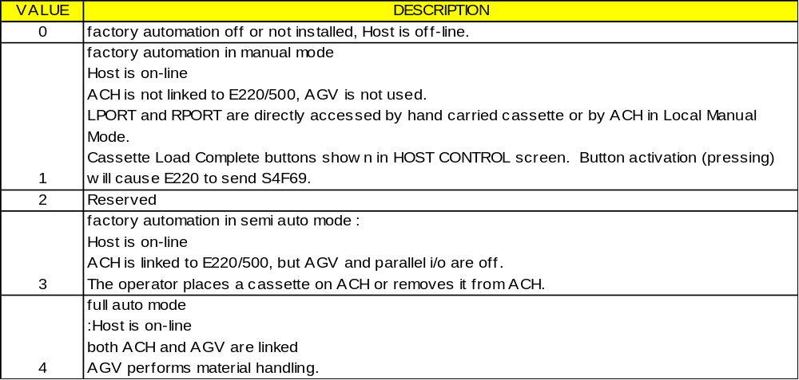

FLOOD Format : 20

Logical value = true if the electron flood gun is to be used for the implant.

FLOOD-CURRENT Format : 20

Electron flood current; unit is 0.1 mA.

GAS/VAPOR Format : 20

Ion source is gas if 0, vaporizer if 1.

GAS1_4_PM Format : 20

Sum of the total use times of Gasses 1-4 since the last periodic maintenance, expressed in hours and hundredths of hours.

GAS1_4_TOTAL Format : 20

Sum of the total use times of Gasses 1-4 expressed in hours and hudredths of hours.

GAS1_PM Format : 20

Total use time of Gas 1 since the last periodic maintenance, expressed in hours and hundredths of hours.

GAS1_TOTAL Format : 20

Total use time of Gas 1 expressed in hours and hundredths of hours.

GAS2_TOTAL Format : 20

Total use time of Gas 2 expressed in hours and hundredths of hours.

GAS2_PM Format : 20

Total use time of Gas 2 since the last periodic maintenance, expressed in hours and hundredths of hours.

GAS3_PM Format : 20

Total use time of Gas 3 since the last periodic maintenance, expressed in hours and hundredths of hours.

GAS3_TOTAL Format : 20

Total use time of Gas 3 expressed in hours and hundredths of hours.

GAS4_PM Format : 20

Total use time of Gas 4 since the last periodic maintenance, expressed in hours and hundredths of hours.

GAS4_TOTAL Format : 20

Total use time of Gas 4 expressed in hours and hundredths of hours.

GemASer Format : 54

The alarm serial number or number of transitions for the alarm. This DV is not supported.

GemSpoolFull Format : 51

If active, the entire spool file has been filled with messages.

GemSpoolLoadSubstate Format : 51

Writes new equipment initiated promary messages to the spool file. The current state is kept in GemSpoolLoad Substate and is one of the following:
6 – Spool Not Full – In this state, there is space in the spool file for writing new messages.
7 – Spool Full – In this state, the entire spool file has been filled with messages, and GWGEM is taking the appropriate action.

GemSpoolState Format : 51

Status variable GemSpoolState contains the current state of the spool finite state machine
1 – Spool Inactive
2 – Spool Active

GemSpoolUnloadSubstate Format : 51

Removes previously spooled equipment-initiated primary messages from the spool file and sends them to the host. The current state is kept in GemSpoolUnloadSubstate and is one of the following:
5 – No Spool Output – In this state, no messages are being removed from the spool file.
4 – Transmit Spool – In this state, messages are being removed from the spool file and transmitted to the host.
3 – Purge Spool – In this state, the equipment is erasing its spool file and not transmitting the messages to the host.

HOST-CONTROL Format : 20

(For SECS-II only)
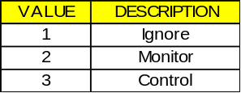

ION-AMU Format : 20

The atomic weight of the ion or molecule used for the implant.

ION-CHARGE Format : 20

The charge state of the ion: 1 for singly charged, 2 for doubly charged implants. The E220 will set up for doubly charged implants if the ENERGY exceeds the 200 KV rating of the implanter regardless of the value in ION-CHARGE.

ION-NAME Format : 20

The 2 character name of the ion to be used: Ar, B, As, etc. This name is used to search through the gas bottles and vaporizer for the one with the correct species.

LEFT_WAFERS_IMPLANTED Format : 20

Version Introduced 11.05.08

The number of wafers from the left loadlock that were completely or partially implanted with the specified recipe in the last batch. When a wafer that is partially implanted is on hold, this SVID will not be incremented. However, as soon as the implant is aborted, these variables will be incremented to reflect the partially implanted wafer.

LimitVariable Format : U4

This variable contains the VID for the variable whose value changed monitoring zones.

LMATERIAL-STATUS Format : 20

Side-specific material status for left side. Normal progression 0-1-2-3-0…

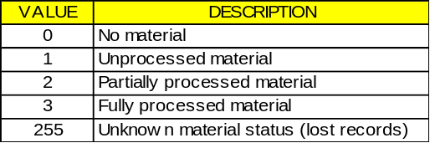

LOT Format: 20

Lot number of side being reported on start or end batch or wafer reports.

LEFT-PPID Format : U1

The 16 character name of the last recipe run on the left side.

lIqdpEnabled Format : 20

lIqdpEndTask Format : 20

LPORT Format : 20

Left side port status
0 - cassette not present
1 - cassette present
2 - not in use
Note: When FAUTO is either 1 or 0, 0 indicates the port is ready for load cassette, 1 not ready.
LPORT is valid with the cassette sense option.

LPORT-STATUS Format : 20

Side-specific port status for left side: Normal progression 0-1-2-3-4-5-6-7-0

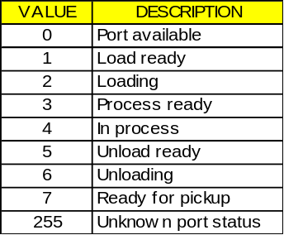

LTAG-BATSTAT Format : 51

Version Introduced 12.14

Battery Status of the left Tag.
0 = Battery check pass
FF = Battery check fail
Data is valid only when linked with CEID 162

LWAF# Format : 20

The number of wafers on the left side.

MIR-V Format : 20

Mirror voltage; unit is 0.1 keV.

MODE Format : 20

Not implemented.

NUMBER_OF_SCANS Format : 20

Total number of wafer scans.

OP-NAME Format : 20

The name of the operator running the implanter.

OPRATOR-ID Format : 20

The ID code of the operator.

PORT-ID Format: 20

Event identification by port number (side). This DVID should be used with V12 and greater for sending port information.

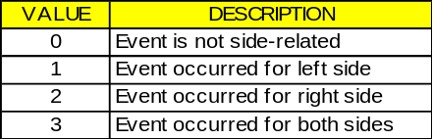

PORT-STATUS Format: 20

PORT-STATUS is in a 2-byte format. Feedback from port sensors. If a sensor is "made" the associated bit in PORT- STATUS =1. If a sensor is not installed, the associated bit always = 0.

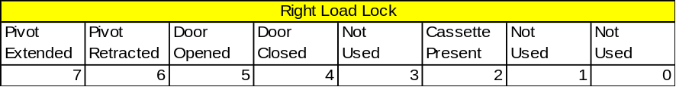

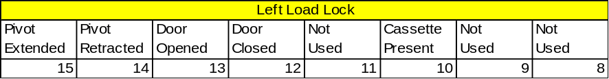

PPChangeName Format : A

The PPID which was affected upon the event of the creation, editing, or deletion of a Process Program local to the equipment.

PPChangeStatus Format : U1

The action taken on the Process Program named in PPChangeName. This variable is valid upon the event of the creation, editing, or deletion of a Process Program local to the equipment.
1 - Created
2 - Edited
3 - Deleted
4-63 - Reserved

PPID Format : 20

The 16 character name of the last recipe run on the machine.

PPExecName Format : A

The PPID(s) of the currently-selected Process Program(s). The selection of a new Process Program updates this variable. If multiple Process Programs can be selected, then this variable is a list of PPIDs.

PREVIOUSCEID Format : 54

PREVIOUSCEID is the most recent event report.

PREVIOUSCOMMAND Format : A

ASCII text string displaying the most recent operator command. This DV is not supported.

PreviousControlState Format : A

1=Off-Line
5=On-Line (Remote)
4=On-Line (Local)

PreviousProcessState Format : U1

The previous processing state of the equipment, before the most recent process state change.0=Not ready
1 - Ready
2 - (Unused)
3 - Setting up
4 - Implant ready
5 - Implanting
6 - Implant hold
7 - Aborting
255 - Unknown state

ProcessState Format : 51

The current processing state of the equipment.

0=Not ready
1=Ready
2=Unused
3=Setting up
4=Implant ready
5=Implanting
6=Implant hold
7=Aborting
255=Unknown state

PURITY Format: 20

For E500 only; unit is 0.01.

Q-SOURCE Format : 20

Obsolete.

QUEUE_FREE_SLOTS Format : 20

Version Introduced 12.20

Status variable #196 returns the number of job entries allowed from the host. As the lineup queue currently contains a maximum of 5 entries, a value of 0 to 5 will be returned dependant upon the number of jobs currently contained in the queue. A check of this ASCII SVID will allow the host to determine the number of jobs which can be sent to the tool.

QUEUE-FULL Format : A1

Version Introduced 12.10.21

Status variable #171 returns a value of 1 if the lineup queue is full.
Example:
Sending QUEUE-FULL S1F3 W <L <U2 171> >. MESSAGE SENT RECEIVED SECONDARY REPLY MESSAGE
S1F4
<L
<A '1'>
>.

REMOTE-CONTROL Format : 20

True if the E220 is in Host Control and will accept remote commands.

RIGHT-PPID Format : U1

The 16 character name of the last recipe run on the right side.
NOTE: 8000 - 8299 are reserved for SMIF LPT and are valid only if an SMIF LPT is installed, selected and the software supports SMIF LPT (V11.00.22 or later). If the E220 and the SMIF LPT are not communicating, these Status Variables return an empty list <L >.

RIGHT_WAFERS_IMPLANTED Format : 20

Version Introduced 11.05.08
The number of wafers from the right loadlock that were completely or partially implanted with the specified recipe in the last batch. When a wafer that is partially implanted is on hold, this SVID will not be incremented. However, as soon as the implant is aborted, these variables will be incremented to reflect the partially implanted wafer.

RMATERIAL-STATUS

Side-specific material status for right side. Normal progression 0-1-2-3-0… See LMATERIAL-STATUS for values.

RTAG-BATSTAT Format : 51

Version Introduced 12.14

Battery Status of the right Tag.
0 = Battery check pass
FF = Battery check fail
Data is valid only when linked with CEID 162

ROTATE Format : 20

For rotating platen option only, this DVID displays the number of rotations.
NOTE: 8000 - 8299 are reserved for SMIF LPT and are valid only if an SMIF LPT is installed, selected and the software supports SMIF LPT (V11.00.22 or later). If the E220 and the SMIF LPT are not communicating, these Status Variables return an empty list <L>.

RPORT Format : 20

Right side port status
0 - cassette not present
1 - cassette present
2 - not in use
Note: When FAUTO is either 1 or 0, 0 indicates the port is ready for load cassette, 1 is not ready. RPORT is valid with the cassette sense option.

RPORT-STATUS

Side-specific port status for right side: Normal progression 0-1-2-3-4-5-6-7-0… See LPORT-STATUS for values.

RWAF# Format : 20

The number of wafers on the right side.

SCANS Format : 20

The minimum number of mechanical scans to be used for the implant.

SPOOLCOUNT ACTUAL Format : 5()

Used to keep a count of the messages actually contained in the equipment's spool area. Multi-block inquire/grant messages are not spooled and not included in this count. Required for GEM compliance.

SPOOLCOUNTTOTAL Format : 5()

Used to keep a count of the total number of primary messages directed to the spool, regardless of whether placed or retained in the spool. Multi-block inquire/grant messages are not spooled and not included in this count.

SPOOLFULLTIME Format : 20

Contains the timestamp from the time the spool last became full. If the spool was not filled during the last spooling period, this will contain a time value prior to the current SpoolStartTime.
Format: YYYYMMDDHHMMSSCC
YYYY=Year 0000 to 9999
MM=Month 01 to 12
DD=Day 01 to 31
HH=Hour 00 to 23
MM=Minute 00 to 59
SS=Second 00 to 59
CC=Centisecond 00 to 99

SPOOLSTARTTIME Format: 0, 10, 11, 20, 21, 3(), 4(), 5()

Contains the timestamp from the time spooling last became active.
Format: YYYYMMDDHHMMSSCC
YYYY=Year 0000 to 9999
MM=Month 01 to 12
DD=Day 01 to 31
HH=Hour 00 to 23
MM=Minute 00 to 59
SS=Second 00 to 59
CC=Centisecond 00 to 99

STATUS Format : 20

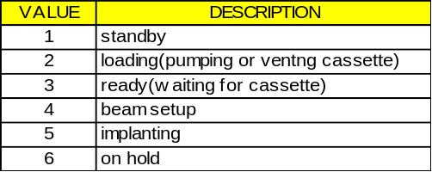

TAG-FILEDATA Format : 20

Version Introduced 12.14

This variable should be linked with CEID 161 to get the file data from the Tag on the side where the event occurred on.

TARGET-I Format : 20

The integrated beam current in the end station.

TransitionType Format : U1

Used with the Limits Monitoring capability, it defines the direction of the zone transition which has occurred.
0 - Transition from lower to upper zone.
1 - Transition from upper to lower zone.

W-TYPE Format : 20

Specifies the flat configuration on the wafer to allow the implanter to confirm that the right kind of wafers are being run. In addition, wafer type 5 is used for aemitransparent wafers such as silicon on sapphire or LCD display on glass.

WAFER-END-TIME Format : 20

Implant end time for wafer in the format yymmddhhmmss.

WAFER-HOLDS Format : 20

Total number of normal hold conditions (retry conditions) during implant of the current wafer.

WAFER-NUMBER Format : 20

Current wafer being implanted.

WAFER-START-TIME Format : 20

Implant start time for wafer in the format yymmddhhmmss.

WAFERS_IMPLANTED

Total number of wafers implanted.

WFR_CYC_PM_L/R Format : 20

Wafer cycles on the left and right sides since the last periodic maintenance.

WFR_CYC_PM_LEFT Format : 20

Wafer cycles on the left side since the last periodic maintenance.

WFR_CYC_PM_RIGHT Format : 20

Wafer cycles on the right side since the last periodic maintenance.

WFR_CYC_TOT_L/R Format : 20

Wafer cycles total for the left and right sides.

WFR_CYC_TOT_LEFT Format : 20

Wafer cycles total for the left side.

WFR_CYC_TOT_RIGHT Format : 20

Wafer cycles total for the right side.

X-SIGMA Format : 20

Maximum non-uniformity allowed across the wafer as measured during the scanner setup. Units are 0.1%.

DVNAME

DVNAME -- Data value name Format: 3( ),20,5( )

Where Used: S1F12

DVVAL

DVVAL -- Data value Format: 0, 10, 11, 20, 21, 3( ), 4( ), 5( )

Where Used:

EAC

EAC -- Equipment acknowledge code, 1 byte Format: 10

0 = Acknowledge
1 = Denied, At least one constant does not exist
2 = Denied, Busy
3 = Denied, At least one constant out of range
>3 = Other equipment-specific error
4-63 = reserved
Where Used: S2F16

ECDEF

ECDEF -- Equipment constant default value Format: 20, 5( )

Where Used: S2F30E5_S2F30_Equipment_Constant_Namelist

ECID

ECID -- Equipment Constant ID Format: 5( )

The equipment constants may also be access with a VID of equivalent value using the functions appropriate for VID. See VID for table showing relationship between data variables identification (DVID), equipment constant identifications(ECID), and status variable identifications(SVID). The Equipment constant IDs are as follows:

ECID | ECNAME | ECID | ECNAME
250 | T1 | 290 | Not Used
251 | T2 | 291 | EQUIPMENT IP ADR
252 | T3 | 292 | PASSIVE IP ADR
253 | RTY | 293 | PASSIVE IP PORT
254 | T4 | 294 | PASSIVE TCP PORT
255 | Obsolete (always set to 0) | 295 | T5
256 | FORMAT | 296 | T6
257 | MODES | 297 | T7
258 | Mirror-mode | 298 | T8
259 | Accel-mode | 299 | BCR Mode
260 | Extraction-volts | 350 | Connection Establishment
261 | TYPE-RCP | 351 | Circuit Assurance
262 | Establish-Comm-Timeout | 352 | TimeoutGrace
263 | FACTAUTO | 353 | MemoryStall
264 | PPTF | 354 | WriteStall
265 | GemInitCommState | 355 | Submask
266 | GemInitControlState | 356 | Router
267 | Baud-Rate | 357 | MidVersion (Not Supported)
268 | Equipment-ID
269 | DEVICENAME
270 | RPTYPE
271 | CONFIGALARMS
272 | CONFIGCONNECT
273 | CONFIGEVENTS
274 | WBITS5
275 | WBITS6
276 | WBITS10
277 | HEARTBEAT
278 | EQPORT_ENABLE
279 | ACHPORT_ENABLE
280 | GemConfigSpool
281 | GemMaxSpoolFileSize
282 | GemMaxSpoolTransmit
283 | GemOverWriteSpool
284 | GemSpoolFileName
285 | GemMsgInterLv
286 | MID-MODE
287 | SMIF-MODE
288 | GEMTASK LOG SIZE
289 | EC TIMEFORMAT

Constants 258, 259 and 260 are used for recipe conversion and should be treated as a set. They are only used when PPBODY1 recipes are used on version 9 software. These conversion numbers are ignored when using PPBODY2.
VARIAN RESERVES THE RIGHT TO ADD MORE EQUIPMENT CONSTANTS
Where Used: S1F3, S1F11, S1F12, S2F23, S2F13, S2F15, S2F29, S2F30, S2F33, S2F45, S2F46, S2F47, S2F48; S6F13, S6F18, S6F22

ECID Variable Dictionary

Accel-mode Format: 51

CEID’s 258, 259 and 260 are used for recipe conversion and should be treated as a set. They are only used when PPBODY1 recipes are used on version 9 software. These conversion numbers are ignored when using PPBODY2.
Note: Default value is set when performing a HOST_COMM_FACTORY_INIT as described in the software revision release notes.

ACHPORT_ENABLE Format:54

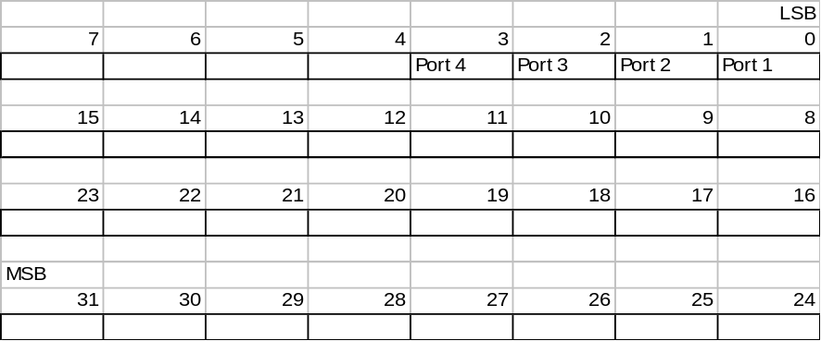

0: Disabled
1: Enabled

Baud-Rate Format: 54

Default Baud rate of the communications port in bps.
Note: Default value is set when performing a HOST_COMM_FACTORY_INIT as described in the software revision release notes.

BCR MODE Format: : 54

Set to flag if the BCR is enabled on each side (left and/or right). Aside from being host configurable, the operator shall be able to configure it in the Barcode Reader screen.
BCR Mode bits shall also be configurable using the GUI and its value shall be stored in permanent storage.
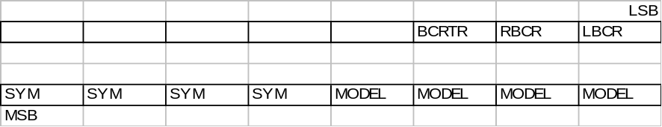

Field | Description | Value - Description
LBCR | Left Barcode Reader | 0 – Left BCR disabled  1 – Left BCR enabled
RBCR | Right Barcode Reader | 0 – Right BCR disabled  1 – Right BCR enabled
BCRTR | Barcode Reader Trigger  Specifies how Bar code reading is triggered by the operator.  Note: in this document, barcode reading for the E500 always refers to retracting the cassette and reading the barcode. | 0 - BCR read after operator touches LOAD (BCR Read) button. (default)  1 - BCR automatically read after cassette is sensed.  (Note: setting 1 will be implemented in a future software release. )
MODEL | Barcode Reader Model | The following Barcode hardware are supported:  0 - Sickoptic CLA430A (default)
SYM | Barcode Reader Symbology | 0 – Code 39 (default)

Circuit Assurance Format: : 54

Specify a value in seconds. This specifies the frequency at which SDR will initiate the HSMS Linktest control transaction to verify that the link is still functional. A smaller value means more frequent control messages. SDR sends Linktest transactions only during idle periods, when there is no normal Data Message traffic which indicates that the connection remains functional. If you specify the value 0, SDR initiates no Linktest transactions, and does not verify that the link remains active.

CONFIGALARMS Format:54

Determines what alarm report is sent.
0: S5F1 (default)
1: S5F71
2: S5F73
Note: Default value is set when performing a HOST_COMM_FACTORY_INIT as described in the software revision release notes.

CONFIGCONNECT Format:54

Determines what message will be used to establish communications.
0: S1F1
1: S1F65
2: S1F13 (default).
Note: Default value is set when performing a HOST_COMM_FACTORY_INIT as described in the software revision release notes.

CONFIGEVENTS Format:54

Controls whether event reports are sent in S6F11/S6F13 GEM format or S6F3/S6F9 SECS format.
0: S6F3/S6F9 (SECS Format)
1: S6F11 /S6F13 (GEM Format)
Note: Default value is set when performing a HOST_COMM_FACTORY_INIT as described in the software revision release notes.

CONNECTION ESTABLISHMENT Format: : 54

Specify a value in seconds. For a Port configured as ACTIVE, this parameter specifies the maximum time SDR will wait after issuing a TCP/IP connect command without receiving success or failure status from TCP/IP, before SDR gives up and assumes the connect attempt has failed. For certain complex networks with many routers, this can be long.

DEVICENAME Format: 20

Note: Default value is set when performing a HOST_COMM_FACTORY_INIT as described in the software revision release notes.

EC TIMEFORMAT Format : 51

This EC controls the date/time format for all applicable SECS II messages. See also TIME data item. Y2K feature.
0 - date/time format = YYMMDDHHMMSS
1 - date/time format = YYYYMMDDHHMMSSCC (Y2K compliant)

EQPORT_ENABLE Format : 54

1: Right Side Enabled
2: Left Side Enabled
3: Both Sides Enabled

Equipment-ID Format: 54

Note: Default value is set when performing a HOST_COMM_FACTORY_INIT as described in the software revision release notes.

EQUIPMENT IP ADR Format: : A

The passive IP address which is always set to the equipment internet IP address. This is a requirement for the passive (server) Connect Mode.

Establish-Comm-Timeout Format : 54

Establish communications timeout. The length of time in seconds of the interval between attempts to send S1F13 when establishing communications.
Note: Default value is set when performing a HOST_COMM_FACTORY_INIT as described in the software revision release notes.

Extraction-volts Format: : 51

CEID’s 258, 259 and 260 are used for recipe conversion and should be treated as a set. They are only used when PPBODY1 recipes are used on version 9 software. These conversion numbers are ignored when using PPBODY2.
Note: Default value is set when performing a HOST_COMM_FACTORY_INIT as described in the software revision release notes.

FACTAUTO Format: : 54

This equipment constant determines the factory automation configuration as follows:
0: Factory Automation is not installed
1: Host Communication is enabled, but no Cassette Handler or Automatic Guided Vehicle
2: Host Communication and Cassette Handler is enabled, no Automatic Guided Vehicle
3: All components of Factory Automation are enable, Host Commuication, Cassette Handler, and Automatic Guided Vehicle.
Note: Default value is set when performing a HOST_COMM_FACTORY_INIT as described in the software revision release notes.

FORMAT Format: : 54

Report data format

H : Set to one if a separate end of batch report is to be sent for each cassette in a batch when two cassettes are implanted at the same time.
Note: Default value is set when performing a HOST_COMM_FACTORY_INIT as described in the software revision release notes.

GemConfigSpool Format : 51

1: Spooling Enabled
0: Spooling Disabled

GemInitCommState Format: : 51

Specifies the Equipment’s default communications state after power on.
0 – DISABLED
1 - ENABLED
Note: Default value is set when performing a HOST_COMM_FACTORY_INIT as described in the software revision release notes.

GemInitControlState Format : 51

EQUIPMENT DEFAULT CONTROL STATE. Specifies the Equipment’s default control state after a power on.
0 - OFFLINE
1 - LOCAL
2 - REMOTE
Note: Default value is set when performing a HOST_COMM_FACTORY_INIT as described in the software revision release notes.

GemMaxSpoolFileSize Format : 54

Maximum size of the spool file, default is 10000 units. Units depend upon the operating system call to create the file.

GemMaxSpoolTransmit Format: 54

The maximum number of messages which the equipment will transmit from the spool in response to an S6F23 "Transmit Spooled Messages" request. If MaxSpoolTransmit is set to zero, no limit is placed on the messages sent from the spool. Multi-block inquire/grant messages are not counted in this total.

GemMsgInterLv Format : 51

This EC enables/disables the message interleaving capability.
0: Disabled (default)
1: Enabled
Where Used: S2F15

GemOverWriteSpool Format: : 51

This Equipment Constant is used to indicate to the equipment either to overwrite data in the spool area or to stop spooling whenever the spool area limits are exceeded.
TRUE- to overwrite spooled data
FALSE - to stop spooling when limits exceeded

GemSpoolFileName Format: : 20

This EC specifies which file to be used to hold the spooled data.

HEARTBEAT Format: : 54

Length of delay in the range of 0 - 99 seconds, between the S1F1 being sent to the Host. Setting to 0 disables heartbeat.
Note: Default value is set when performing a HOST_COMM_FACTORY_INIT as described in the software revision release notes.

GEMTASK LOG SIZE Format : 54

Version Introduced: 11.05.05
Logging files such as gemtask.log and forth.log continue to increase in size as the tool is run. The possibility exists that logging files can increase until virtually all hard disk space is utilized. 11.05.05 will now automatically zip all logs including machine.con. In order prevent filling the hard disk, only the last eight zipped logs files will be kept. The user is able to determine the file size at which the zipping process begins through the specification of new equipment constant 288. Setting EC288 to 4000000 limits gemtask.log and gemtask.old to 400K before compression. Compressed logs will be kept in the c:\data directory under the file names logs1.zip – logs8.zip. In addition to automatic zipping of all log files, gemtask.log now contains a time stamp as well as converting the SDR hex bytes to SML. To obtain current zip logs, the following procedure must be used:

[If running, hit any key, type BYE to shutdown to TSX]
cd \tsxutil
copy gemtest.cmd gemtask.cmd
E220
[run a test that highlights the failure]
[hit any key]
BYE
[IF you go into TSX]
sy
[IF gemtask is running, note its {job-id} say 12 ]
DBSTOP {job-id}
[ENDIF]
ZIPLOGS
[ELSE]
[wait five minutes for the log caches to flush reboot by pushing reset button in back of the computer (e220.cmd will automatically zip all logs)]
[ENDIF]
cd \tsxutil
copy gemrel.cmd gemtask.cmd
cd \data
[put a blank disk in drive a:]
copy LOGS1.ZIP
[email the factory LOGS1.ZIP]

Note: This ECID was changed from MAX-WAFERS in 11.05.05.

MemoryStall Format: : 54

Specify a value in seconds. This limits how long SDR will tolerate a situation where all SDR buffers are full and the other end of the link attempts to send more data. If the MEMORY STALL timeout expires, SDR will terminate the connection, to avoid clogging the TCP/IP network.

MID-MODE Format: : 54

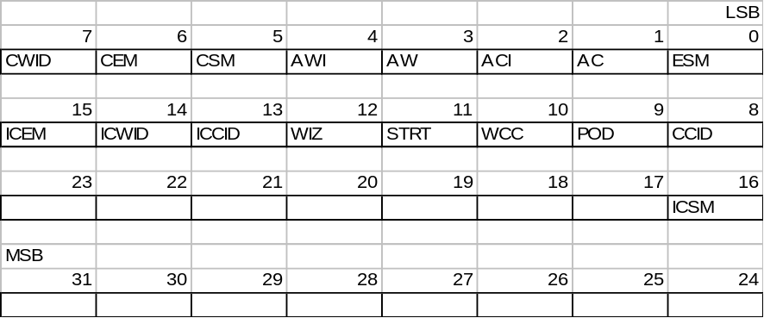

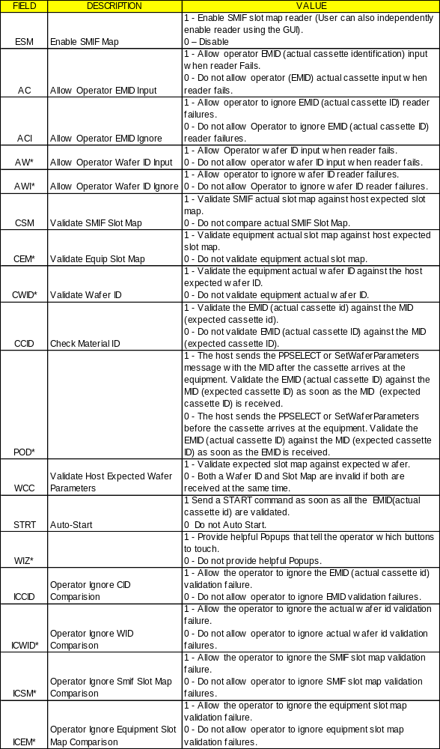

* These fields are reserved. They presently have no effect.
Note: Default value is set when performing a HOST_COMM_FACTORY_INIT as described in the software revision release notes.

Mirror-mode Format: : 51

CEID’s 258, 259 and 260 are used for recipe conversion and should be treated as a set. They are only used when PPBODY1 recipes are used on version 9 software. These conversion numbers are ignored when using PPBODY2.
Note: Default value is set when performing a HOST_COMM_FACTORY_INIT as described in the software revision release notes.

MODES Format: : 54

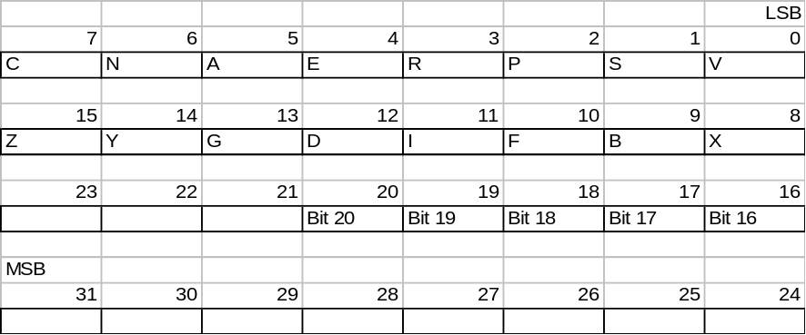
Modes control bits
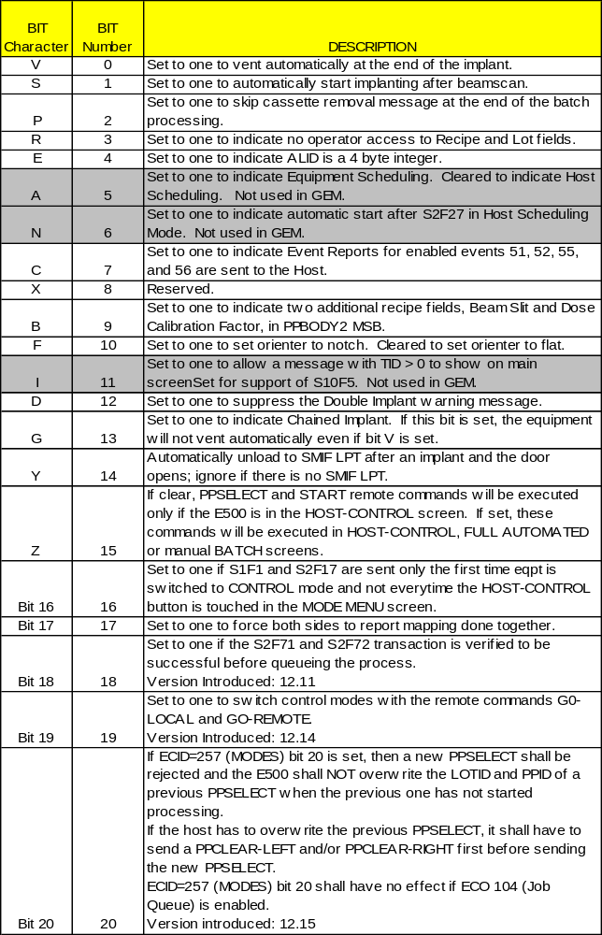

In GEM, the A, N, I bits are ignored (bits 5, 6, and 11).

Note: Default value is set when performing a HOST_COMM_FACTORY_INIT as described in the software revision release notes.

PASSIVE IP ADR Format: : 54

The passive IP address which is always set to the equipment internet IP address. This is a requirement for the passive (server) Connect Mode.

PASSIVE IP PORT Format: : A

Specify the IP Port Number at which the PASSIVE ENTITY waits for connection on this HSMS link. A typical TCP Port Number is 5000.

PASSIVE TCP PORT Format: : 54

Specify the TCP Port Number at which the PASSIVE ENTITY waits for connection on this HSMS link. A typical TCP Port Number is 5000.

PPTF Format: : 51

Process Program Transfer Format. Determines the type of process program transfer from the Equipment to the Host. Both types are available from the Host to the Equipment.
0 - Unformatted
1 - Formatted.
Note: Default value is set when performing a HOST_COMM_FACTORY_INIT as described in the software revision release notes.

Router Format: : A

Used to define a route to access a host that is not directly connected to the equipment. This specifies the internet address of the computer to which messages addressed to the host or to another intermediate computer on the path are to be routed.

RPTYPE Format: : 51

Controls whether Normal (S6F11) or Annotated (S6F13) event reports are used.
1: Annotated
0: Normal
Note: Default value is set when performing a HOST_COMM_FACTORY_INIT as described in the software revision release notes.

RTY Format: : 54

SECS retry count
Note: Default value is set when performing a HOST_COMM_FACTORY_INIT as described in the software revision release notes.

SMIF-MODE Format : 54

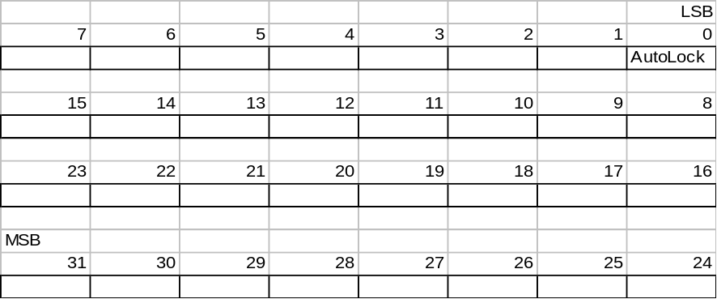

Mid 1 Feature.
AutoLock: 1 - Lock Pod as soon as placed on Asyst SMIF
0 - Do not Lock Pod when placed on Asyst SMIF
Note: Default value is set when performing a HOST_COMM_FACTORY_INIT as described in the software revision release notes.

Submask Format: : A

Used to define a route to access a host that is not directly connected to the equipment. The value is used to determine
whether a message goes to a computer that is on the same subnet as the computer that sent the message. The standard netmask for a class C network is 255.255.255.0 - basically the last octet, .0, says 'look here for the machine number, the rest (255) is network number'.

T1 Format : 54

SECS T1 timer timeout in .1 seconds.
Note: Default value is set when performing a HOST_COMM_FACTORY_INIT as described in the software revision release notes.

T2 Format: : 54

SECS T2 timer timeout in .1 seconds.
Note: Default value is set when performing a HOST_COMM_FACTORY_INIT as described in the software revision release notes.

T3 Format : 54

SECS transaction timer timeout in seconds
Note: Default value is set when performing a HOST_COMM_FACTORY_INIT as described in the software revision release notes.

T4 Format : 54

SECS II conversation timeout in seconds.
Note: Default value is set when performing a HOST_COMM_FACTORY_INIT as described in the software revision release notes.

T5 Format: : 54

Connect Separation Timeout
Specifies the amount of time which must elapse between successive attempts to connect to a given remote entry.

T6 Format: : 54

Control Transaction Timeout
Specifies the time which a control transaction may remain open before it is considered a communications failure.

T7 Format: : 54

NOT SELECTED Timeout
Time which a TCP/IP connection can remain in NOT SELECTED state (i.e., no HSMS activity) before it is considered a communications failure.

T8 Format: : 54

Network Intercharacter Timeout
Maximum time between successive bytes of a single HSMS message which may expire before it is considered a communications failure.

TimeoutGrace Format: : 54

Specify a value in seconds. While SDR is attempting to establish a connection (for example, immediately after your application calls SdrPortEnable), this specifies the ‘grace period’ during which SDR will accept message send operations (SdrRequest, SdrInquire, SdrResponse, etc.) and will cause messages to be buffered during connection establishment. The TGRACE interval ends with a timeout or successful connection establishment. If the connection is successfully established within the TGRACE interval, the messages will be sent. If a TGRACE timeout occurs, the buffered message will each be failed with F_DELV status. Each use of SdrPortEnable activates a single TGRACE interval.

TYPE-RCP Format : 54

Determines the type of the PPBODY to be one of the following:
1: PPBODY1 (48 bytes)
2: PPBODY2 short (66 bytes)
3: PPBODY2 long (242 bytes)
4: PPBODY3 (1518 bytes) The PPBODY returned with S7F6 will have the length specified by TYPE-RCP. If the PPID requested in S7F5 was PPBODY inappropriate with TYPE-RCP, the zero length list is returned.
Note: Default value is set when performing a HOST_COMM_FACTORY_INIT as described in the software revision release notes.

WBITS5 Format : 54

Controls whether the alarm report is sent with a W-Bit of "0" or "1".
0 : No ACK
1 : ACK
Note: Default value is set when performing a HOST_COMM_FACTORY_INIT as described in the software revision release notes.

WBITS6 Format : 54

Controls whether the event report is sent with a W-Bit of "0" or "1".
0 : No ACK
1 : ACK
Note: Default value is set when performing a HOST_COMM_FACTORY_INIT as described in the software revision release notes.

WBITS10 Format: : 54

Determines whether the W-Bit is set for the S10F1 message from the E220.
0 : No ACK
1 : ACK
Note: Default value is set when performing a HOST_COMM_FACTORY_INIT as described in the software revision release notes.

WriteStall Format: : 54

Specify a value in seconds. This limits how long SDR will wait for TCP/IP to accept data SDR is passing to TCP/IP. If a WRITE STALL timeout occurs, TCP/IP has a problem and SDR terminates the connection. In some systems, this can be caused if you allocate an insufficient number of data buffers to TCP/IP, and you can correct the problem by allocating more when you start TCP/IP.

ECMAX

ECMAX -- Equipment constant maximum value Format: 5( )

Where Used: S2F30

ECMIN

ECMIN -- Equipment constant minimum value Format: 5( )

Where Used: S2F30

ECNAME

ECNAME -- Equipment constant name Format: 20

See ECID for list of equipment constant names.
Where Used: S2F30

ECV

ECV -- Equipment Constant Value Format: 20, 5( )

See variable dictionary for a list for individual ECV format.
Where Used: S2F15

EDID

EDID -- Expected data Identification Format: 10, 20, 3( ), 5( )

Three possible responses.

MEXP EDID EDID
S02F03, <SPID> A[6]
S03Fl3, <PTN> B[1]
S07F03, <PPID> A[16], B[16]
Where Used: S9F13

ERACK

ERACK -- Enable/Disable Event Report Format: 10

Acknowledge Code, 1 byte
0 = Accepted
1 = Denied. At least one CEID does not exist
<1 = Other Errors
2-63 = reserved
Where Used: S2F38

ERRW7

ERRW7 Format: 20

Text string describing error found in process program
Where Used: S7F27

ESID - Equipmet Port Number

ESID - Equipment Port Number Format: 10

ESID designates the stage location of the Equipment Port Number

1 = Left
2 = Right

Note: Factory Automation Only
Where Used: S2F71

FCNID

FCNID -- Function Identification Format: 51

Where Used: S2F43, S2F44

GRANT

GRANT -- Grant code, 1 byte Format: 10

0 = Permission Granted
1 = Busy, Try Again
2 = No Space Available
3 = Duplicate DATAID
>3 = Equipment Specific Error Code
4-63 = reserved
Where Used: S2F40

GRANT6

GRANT6 -- Permission to send, 1 byte Format: 10

0 = Permission granted
1 = Busy, try again
2 = Not interested
>2 = Other errors
3-63 = reserved
Where Used: S6F6

HCACK

HCACK -- Host Command Parameter Acknowledge Code, 1 byte Format: 10

0 = Acknowledge, command has been performed
1 = Command does not exist
2 = Cannot perform now
3 = At least parameter is invalid
4 = Acknowledge, command will be performed with completion signaled later by an event
5 = Rejected, Already in Desired Condition
6-63 = reserved
64-127 = Left and right SMIF LPT (LPT must be present to occur)

 |  |  |  |  |  |  | LSB
7 | 6 | 5 | 4 | 3 | 2 | 1 | 0
0 | 1 | LPT1 | LPT1 | LPT1 | LPT2 | LPT2 | LPT2
MSB

bits 7 6 1
bits 5-3 LPT HCACK code for the left LPT1
bits 2-0 LPT HCACK code for the right LPT2

LPT HCACK code
0h: LPT Completed command
1h: LPT in manual mode
2h: No Pod in place
3h: Host not ready
4h: Limit not reached
5h: LPT already in desired state
6h: LPT does not understand command
7h: LPT cannot perform command or E220 cannot send command to LPT
Where Used: S2F42

LENGTH

LENGTH Format: 5( )

Length of the service program or process program in bytes
Where Used: S7F1

LIMITACK

LIMITACK Format: 10

Acknowledgment code for variable limit attribute set, 1 byte.
1 = LIMITID does not exist
2 = UPPERDB > LIMITMAX
3 = LOWERDB < LIMITMIN
4 = UPPERDB < LOWERDB
5 = Illegal format specified for UPPERDB or LOWERDB
6 = ASCII value cannot be translated to numeric
7 = Duplicate limit definition for this variable
>7 = Other equipment-specific error
8-63 = reserved
Where Used: S2F46

LIMITID

LIMITID Format: 10

The identifier of a specific limit in the set of limits (as defined by UPPERDB and LOWERDB) for a variable to which the corresponding limit attributes refer, 1 byte. The range of allowable Ids is 0 - 6.
Where used: S2F45, S2F46, S2F48

LIMITMAX

LIMITMAX Format: 20

Presently the highest possible value for the SV’s value (99.9, 9, 9.99999)
Where used: S2F48

LIMITMIN

LIMITMIN Format: 20

Presently the lowest possible value for the SV’s value (0 or 0.0000099)
Where used: S2F48

LOTID - Material ID

LOTID - Material ID 16 bytes maximum Format: 20

This is the lot number for 1 cassette of wafers to be processed.
Note: Factory Automation only
Where used: S2F71

LOWERDB

LOWERDB Format: 20

A variable limit attribute which defines the lower boundary of the deadband of a limit. The value applies to a single limit (LIMITID) for a specified VID. Thus, UPPERDB and LOWERDB as a pair define a limit.
Where used: S2F45, S2F48

LRACK

LRACK - Link Report Acknowledge Code, 1 byte Format: 10

0 = Accepted
1 = Denied. Insufficient space
2 = Denied. Invalid format
3 = Denied. At least one CEID link already defined
4 = Denied. At least one CEID does not exist
5 = Denied. At least one RPTID does not exist
>5 = Other errors
6-63 = reserved
Where Used: S2F36

LVACK

LVACK Format: 10

Variable limit definition acknowledge code, 1 byte. Defines the error with the limit attributes for the referenced VID.
1 = Variable does not exist
2 = Variable has no limits capability
3 = Variable repeated in message
4 = Limit value error as described in LIMITACK
5-63 = reserved
Where Used: S2F46

MDLN

MDLN -- Equipment Model Type, 6 bytes max Format: 20

The Equipment model type of the E220 is a 4 character string and will be "E220"
Where Used: S1F2; S1F13 , S1F14

MEXP

MEXP Format: 20

Message expected in the form SxxFyy where x is stream and y is function.
Where Used: S9F13

MHEAD

MHEAD Format: 10

SECS message block header associated with message block in error
Where Used: S9F1, S9F3, S9F5, S9F7, S9F11

MID

MID 16 Characters maximum Format: 20

This is the lot name for one cassette of wafers to be processed.
Where Used: S2F41, S2F71

OFLACK

OFLACK Format: 10

Acknowledge code for OFF-LINE request.
0 = OFF-LINE Acknowledge
1-63 Reserved
Where Used: S1F16

ONLACK

ONLACK -- Acknowledge code for ON-LINE request. Format: 10

0 = ON-LINE Accepted
1 = ON-LINE Not Allowed
2 = Equipment Already ON-LINE
3-63 = Reserved
Where Used: S1F18

PPARM

PPARM -- Process Parameter Format: 11, 20, 3( ), 4( ), 5( )

Numeric or Boolean SECS data item, single or multiple value, or text string which provides information required to complete the process command to which the parameter refers.

PPID used by the PPselect remote command.
Where Used: S7F23, S7F26

PPBODY

PPBODY -- Process program body Format: 10

The process program describes to the equipment, in its own language, the actions to be taken in processing the material it receives. . Four process program formats are supported. They are supported for the sake of compatibility with former models and software revisions of the equipment.

The equipment can receive any format and convert it to the most recent format for operator editing and equipment use. Parameters not available in older formats are set to default values.

The equipment will transmit the format set by the TYPE-RCP equipment constant.
Where Used: S7F3, S7F6, S7F18

PPBODY1

PPBODY1 -- Process program body (Version 8) Format: 10

This process program is made up of 24 fields for each pass. All fields are two bytes long. If a field should not change from one pass to the next, it must be given a value of 32768. All items in the body are 2 byte integers (format: 32) except for Ion Name which consists of 2 ASCII characters. Each 2 byte field should be given in reverse order, that is, LSB first, MSB second. In the case of the Ion Name, the two letters should be in reverse order.

The Fields are:
Ion Name
Ion Weight
Dose Mantissa
Dose Exponent
Energy
Minimum Scans
Gas Cooling
Flood
Tilt
Twist
Charge
ES Vacuum
X-Sigma
Y-Sigma if value = 0 then Accel Mode; if -1 the Decel Mode
Check Interval
Quality if value > 5 it will be stored as Mirror.
Wafer type
Unused1
Unused2
Unused3
Unused4
Unused5
Unused6
Unused7

The Unused space is reserved for future additions and should be space filled. Each process will be a multiple of 48 bytes long.
Where Used: S7F3, S7F6, S7F18

PPBODY2 SHORT

PPBODY2 Format: 10

All quantities are 16 bit format.

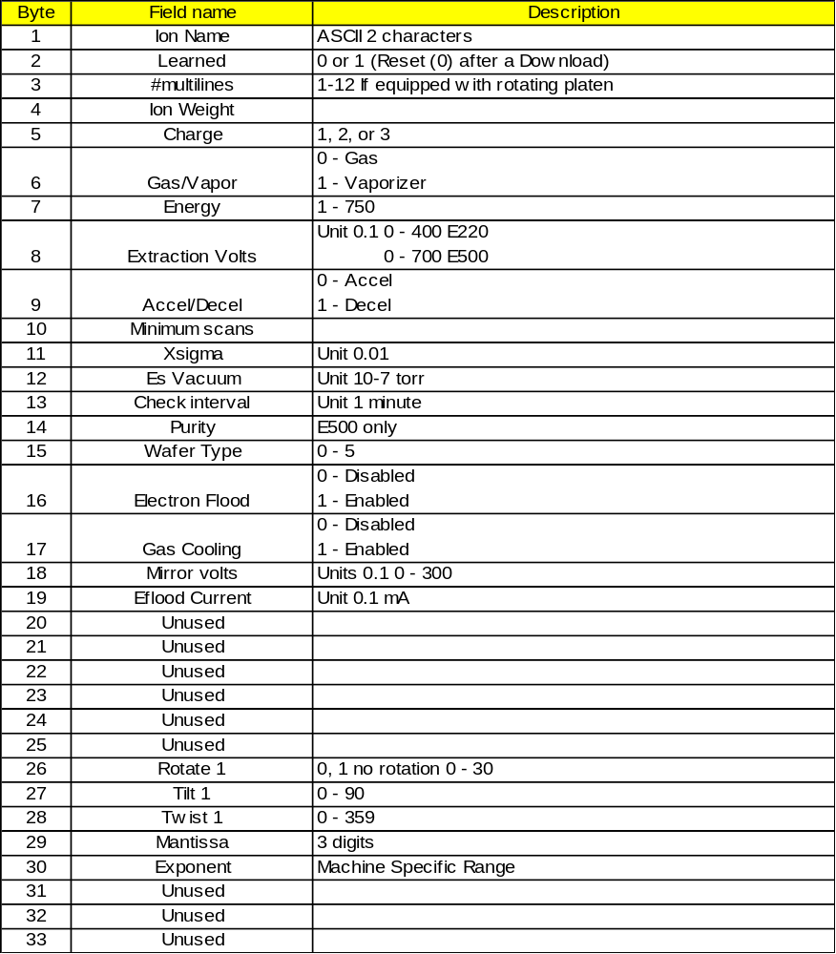

Where Used: S7F3, S7F6, S7F18

PPBODY2 LONG

PPBODY2 LONG Format: 10

Contains the data from a PPBODY2 SHORT in addition to the following:

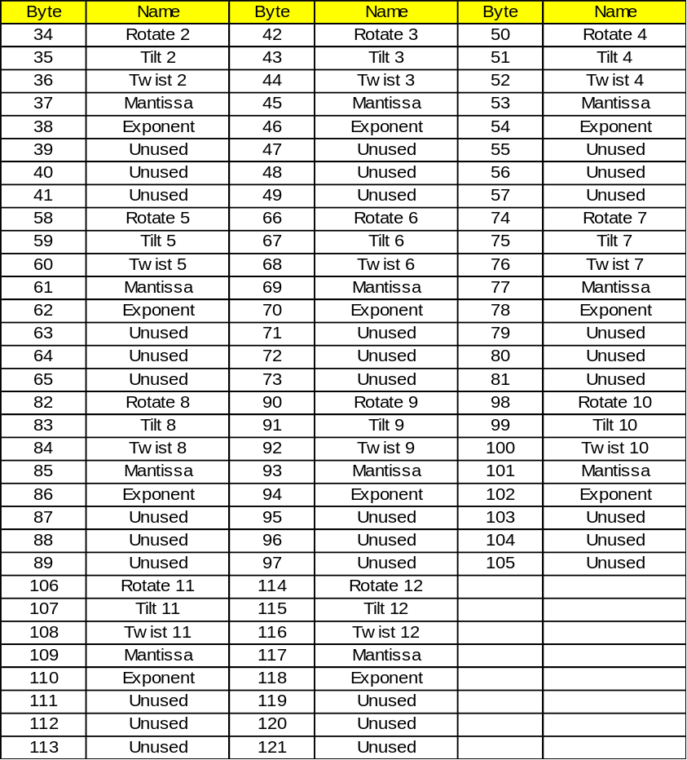

Where Used: S7F3, S7F6, S7F18

PPBODY3

PPBODY3 - High Performance Recipe Format: 10

PPBODY2 formatting contains all data from the PPBODY2 LONG format with the addition of learned parameters, maximum/minimum ranges for each parameter, and the type of interlock when a processing parameter exceeds the specified range. PPBODY3 is the recommended formatting for the E220/E500 medium current ion implanter
PPBODY3 has a total length of 1518 bytes. This lays out the length and possible values of each data item as it appears in SECS messages downloaded from or uploaded to the host. The possible data types used are:

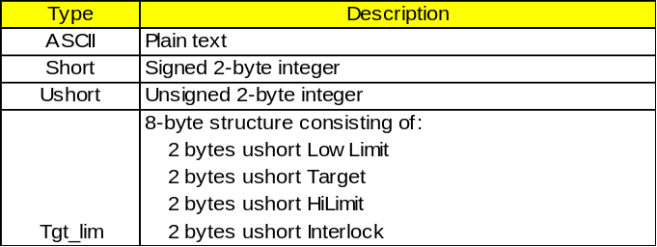

The possible values for Interlock are:
0 = Ignore
1 = Warning
2 = Critical

Scaler is also included in the Remarks column. This number is applied to the raw value to get the final value as displayed in the E220/500 recipe screen. For example, a raw value of 2000 with a scaler of 2 will be displayed as 20.00. For data items with the Tgt_lim type, scalar is only applied to the LowLimit, Target and HiLimit.

Data items with format marked as "(learned)" are filled in by the E220/500 after the recipe has been learned in parametric setup.

Header Parameters
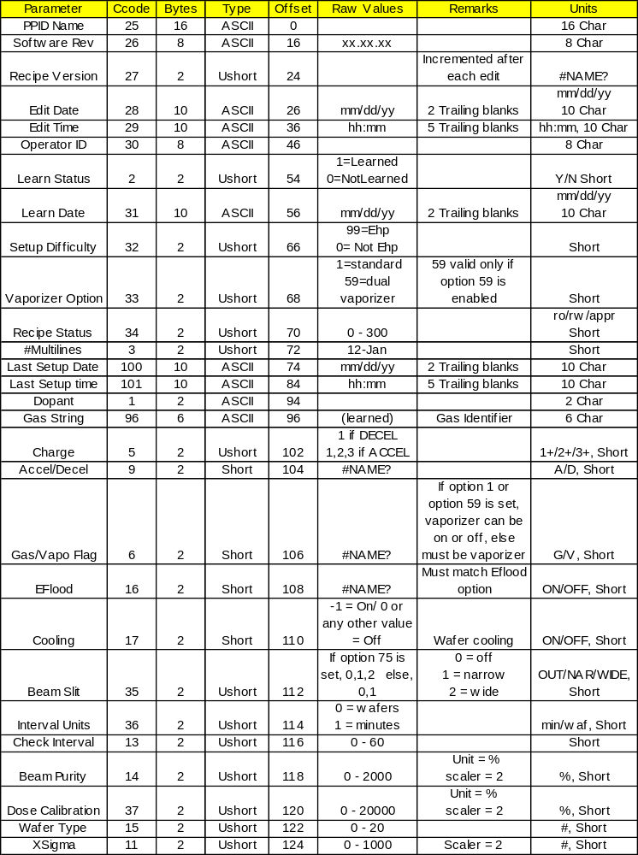
Source Parameters
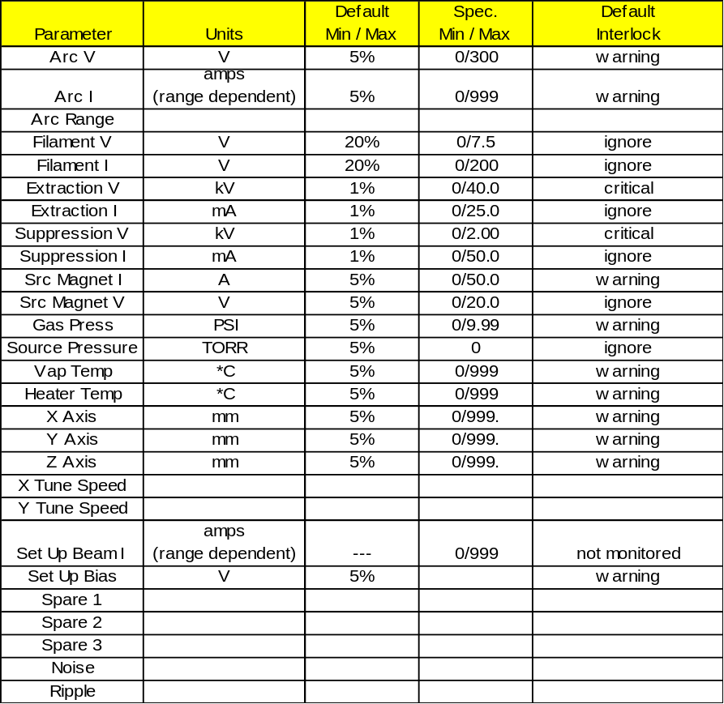

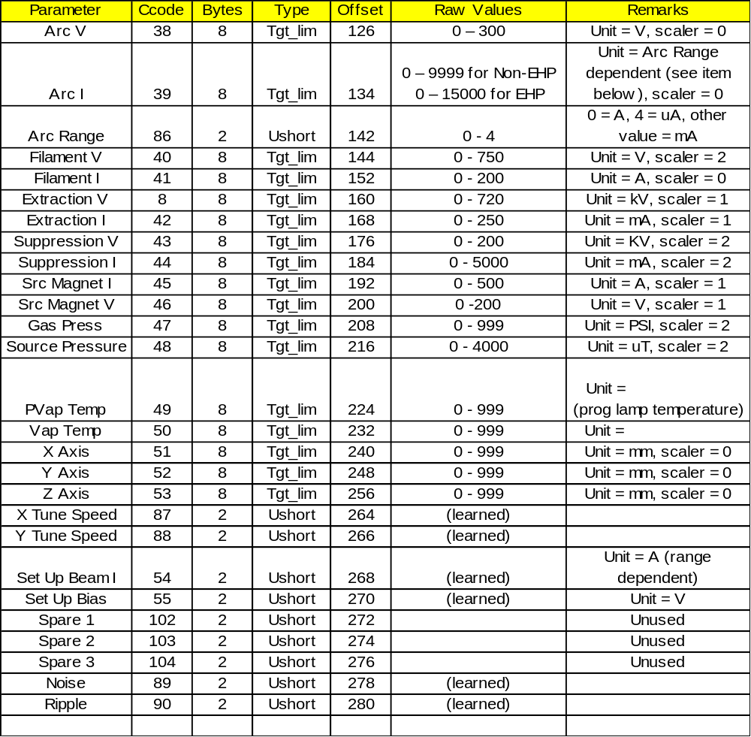

Beamline Parameters

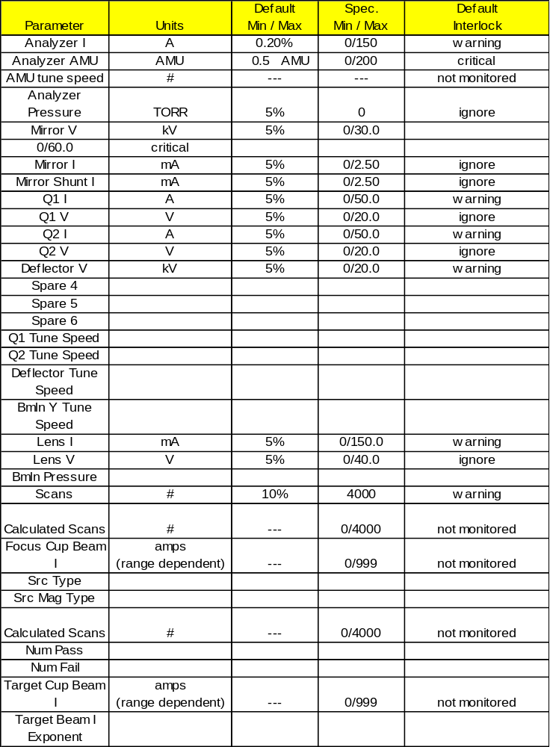

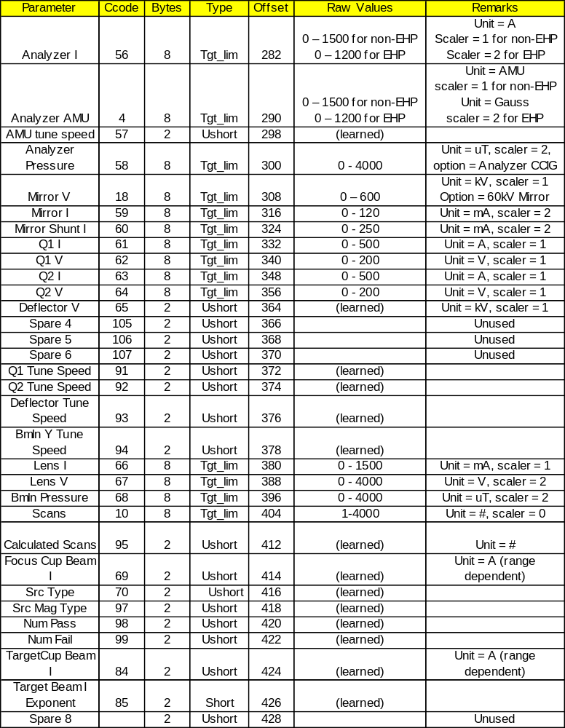

End Station Parameters

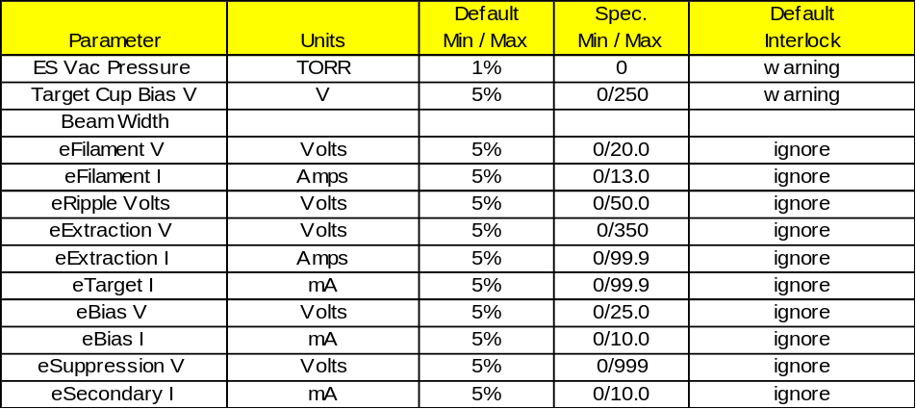

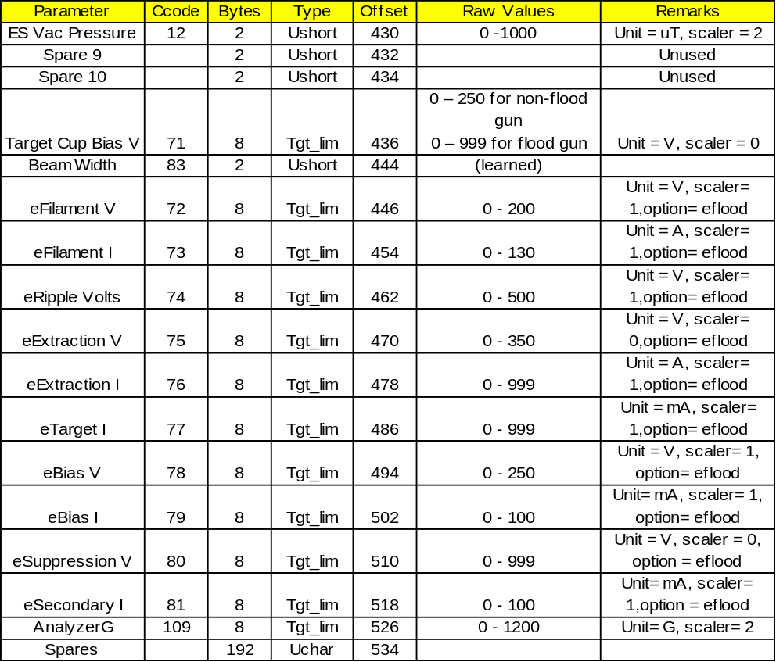

Multi-line Parameters

Note: There are 12 recipe lines, each consisting of data with the structure shown below.
CCODE 82 is the whole multi-line section, consisting of the parameters below.
CCODE 108 is one line.

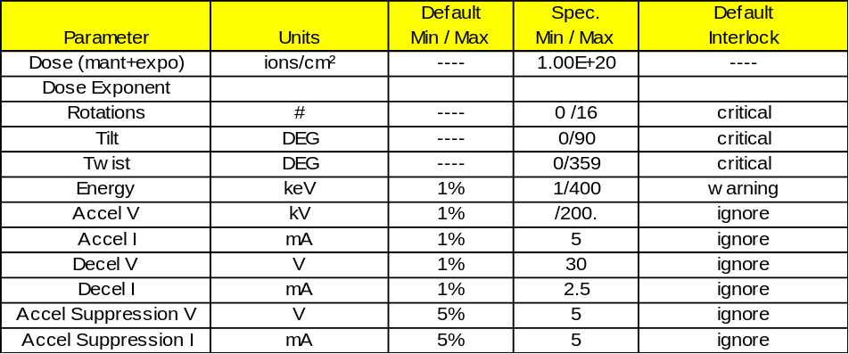

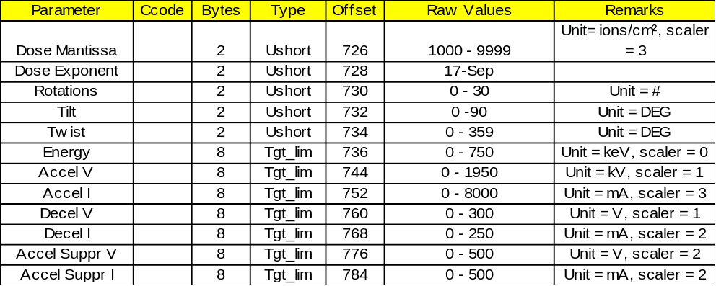

Multiline 2 offset = 792
Multiline 3 offset = 858
Multiline 4 offset = 924
Multiline 5 offset = 990
Multiline 6 offset = 1056
Multiline 7 offset = 1122
Multiline 8 offset = 1188
Multiline 9 offset = 1254
Multiline 10 offset = 1320
Multiline 11 offset = 1386
Multiline 12 offset = 1452
End of recipe offset = 1518

Where Used: S7F3, S7F6, S7F18

PPGNT

PPGNT -- Process program grant status, 1 byte Format: 10

0 = OK
1 = already have
2 = no space
3 = invalid PPID
4 = busy, try later
5 = will not accept
>5 = other error
6-63 = reserved
Where Used: S7F2

PPID

PPID -- Process program ID. Format: 20

The recipe name as it appears in the process screens of the E220. Maximum of 16 characters. Trailing spaces are ignored
Where Used: S7F1, S7F3, S7F5, S7F6, S7F17, S7F20

RCMD

RCMD Format: 20
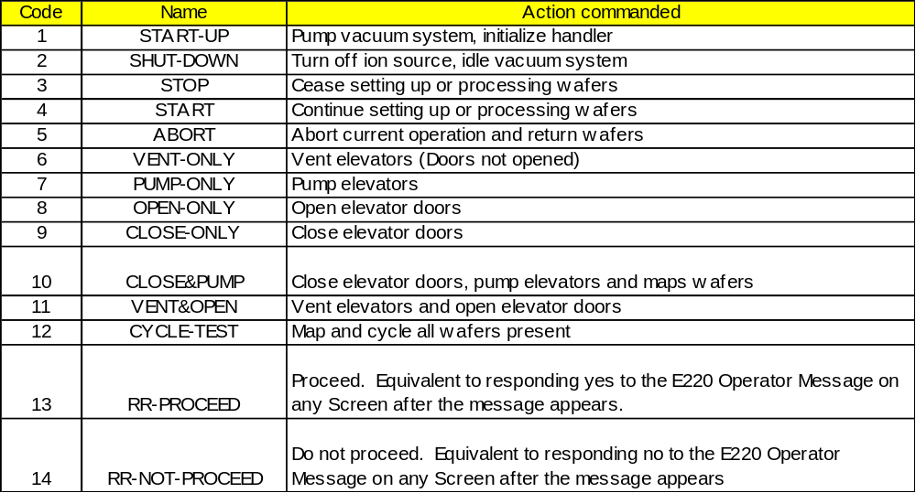
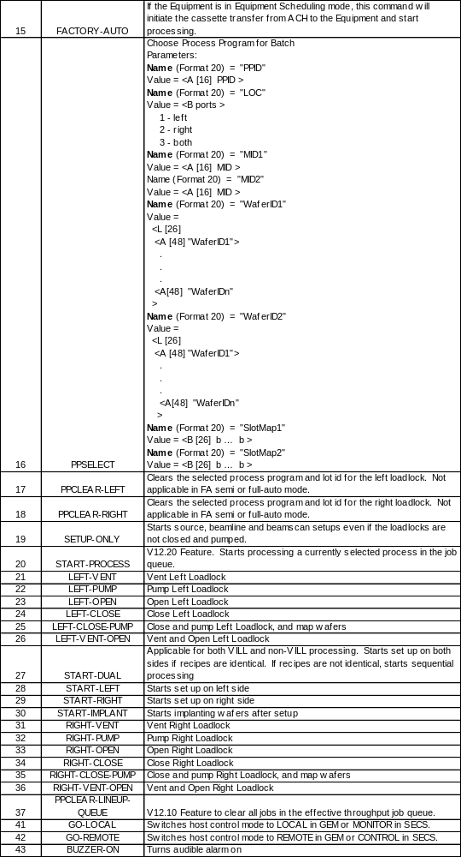
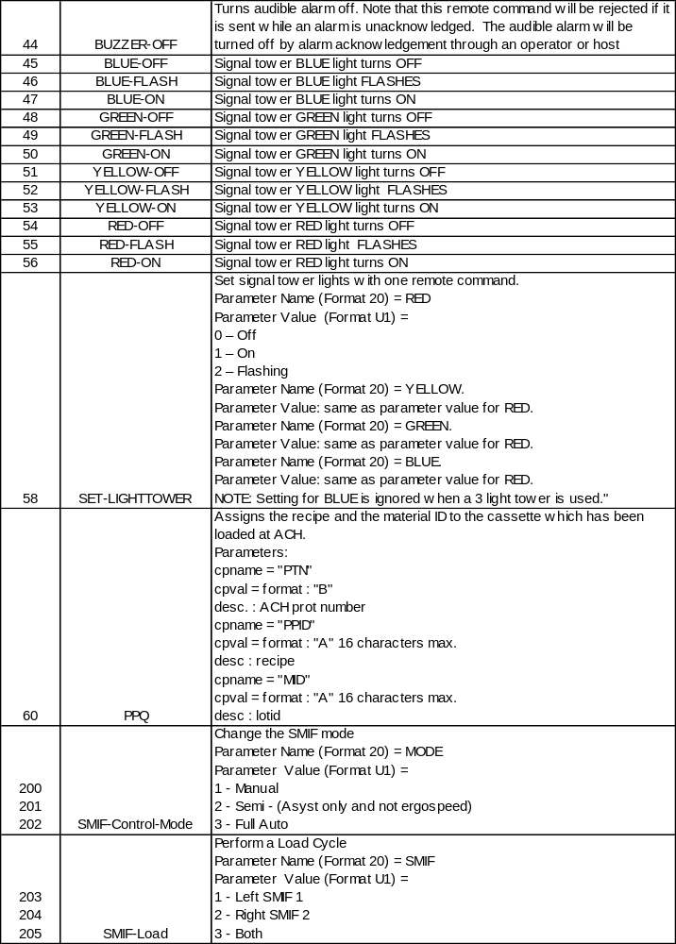
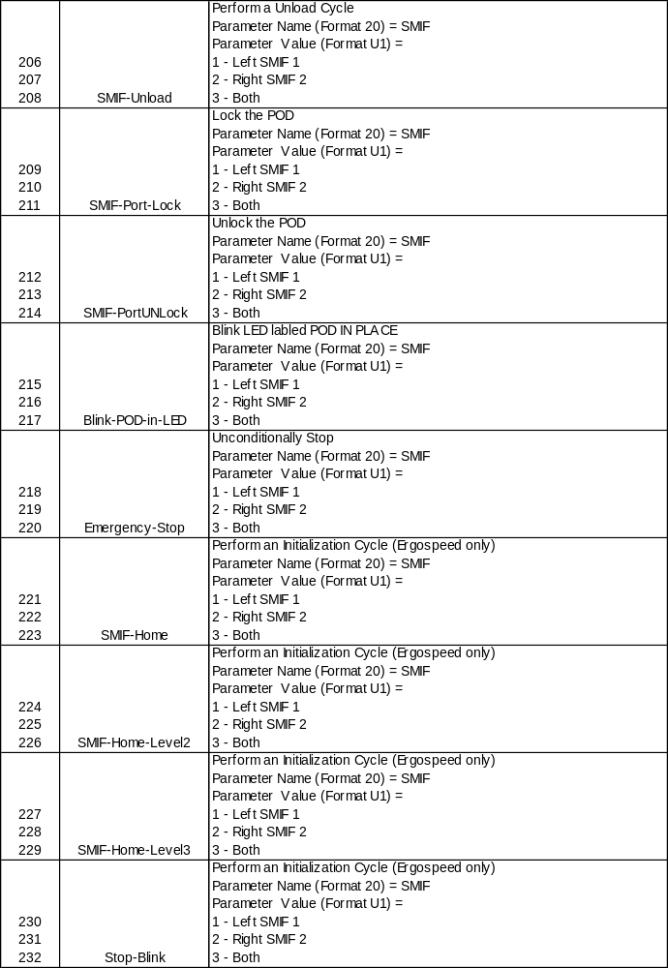
Notes:
The list of remote commands (RCMD) is supported by the E220 GEM application. The maximum length of the RCMD is 20 printable characters. No spaces are allowed.
Codes 200-220 were added in V11.00.22. They are used to command dual SMIF LPTs. The dual SMIF LPTs must be present, selected, and communcations established between the E220 and the SMIF LPTs before the E220 will accept these commands.
Codes 221-232 were added in V11.07.06. They are used to command dual Ergospeed SMIF.
Remote commands are not always available for execution due to the state of the E220. This is most notable by the displayed screen. The column labeled Screens denotes when a command will be executed. User’s must make sure the E220 is displaying the proper screen before leaving the machine. If a command cannot be executed the message will be NAKed.

Examples:
The structure for a dual sided PPSELECT will be as follows:
S2F41 W
<L [2]
<A ‘PPSELECT’>
<L [4]
<L [2]
<A ‘PPID’>
<A ‘PP01’>
>
<L [2]
<A ‘LOC’>
<B 03>
>
<L [2]
<A ‘MID1’>
<A ‘LEFT LOT ID’>
>
<L [2]
<A ‘MID2’>
<A ‘RIGHT LOT ID’>
>
>
>
The structure for a left single sided PPSELECT will be as follows:
S2F41 W
<L [2]
<A ‘PPSELECT’>
<L [4]
<L [2]
<A ‘PPID’>
<A ‘PP01’>
>
<L [2]
<A ‘LOC’>
<B 01>
>
<L [2]
<A ‘MID1’>
<A ‘LEFT LOT ID’>
>
<L [2]
<A ‘MID2’>
<A ‘ ’>
>
>
>
The structure for a dual sided PPSELECT with slotmap will be as follows (only wafers 1 and 2 have been specified):
S2F41 W
<L [2]
<A ‘PPSELECT’>
<L [6]
<L [2]
<A ‘PPID’>
<A ‘PP01’>
>
<L [2]
<A ‘LOC’>
<B 03>
>
<L [2]
<A ‘MID1’>
<A ‘LEFT LOT ID’>
>
<L [2]
<A ‘MID2’>
<A ‘RIGHT LOT ID’>
>
<L[2/1]
<A[8/1] "SlotMap1">
<B[25/1] 0x01 0x01 0x00 0x00 0x00 0x00 0x00 0x00 0x00 0x00 0x00
0x00 0x00 0x00 0x00 0x00 0x00 0x00 0x00 0x00 0x00 0x00
0x00 0x00 0x00>
>
<L[2/1]
<A[8/1] "SlotMap2">
<B[25/1] 0x01 0x01 0x00 0x00 0x00 0x00 0x00 0x00 0x00 0x00 0x00
0x00 0x00 0x00 0x00 0x00 0x00 0x00 0x00 0x00 0x00 0x00
0x00 0x00 0x00>
>

>
>
The structure for a left sided PPSELECT with slotmap will be as follows (only wafers 1 and 2 have been specified):
S2F41 W
<L [2]
<A ‘PPSELECT’>
<L [5]
<L [2]
<A ‘PPID’>
<A ‘PP01’>
>
<L [2]
<A ‘LOC’>
<B 01>
>
<L [2]
<A ‘MID1’>
<A ‘LEFT LOT ID’>
>
<L [2]
<A ‘MID2’>
<A ‘ ’>
>
<L[2/1]
<A[8/1] "SlotMap1">
<B[25/1] 0x01 0x01 0x00 0x00 0x00 0x00 0x00 0x00 0x00 0x00 0x00
0x00 0x00 0x00 0x00 0x00 0x00 0x00 0x00 0x00 0x00 0x00
0x00 0x00 0x00>
>
>
>
The structure for a dual sided PPSELECT with wafer ID map will be as follows (only wafers 1 and 2 have been specified):
S2F41 W
<L [2]
<A ‘PPSELECT’>
<L [6]
<L [2]
<A ‘PPID’>
<A ‘PP01’>
>
<L [2]
<A ‘LOC’>
<B 03>
>
<L [2]
<A ‘MID1’>
<A ‘LEFT LOT ID’>
>
<L [2]
<A ‘MID2’>
<A ‘RIGHT LOT ID’>
>
<L[2/1]
<A[8/1] "WaferID1">
<L[25/1]
<A[6/1] "Wafer1">
<A[6/1] "Wafer2">
<A[0/1]>
<A[0/1]>
<A[0/1]>
<A[0/1]>
<A[0/1]>
<A[0/1]>
<A[0/1]>
<A[0/1]>
<A[0/1]>
<A[0/1]>
<A[0/1]>
<A[0/1]>
<A[0/1]>
<A[0/1]>
<A[0/1]>
<A[0/1]>
<A[0/1]>
<A[0/1]>
<A[0/1]>
<A[0/1]>
<A[0/1]>
<A[0/1]>
<A[0/1]>
>
>
<L[2/1]
<A[8/1] "WaferID2">
<L[25/1]
<A[6/1] "Wafer1">
<A[6/1] "Wafer2">
<A[0/1]>
<A[0/1]>
<A[0/1]>
<A[0/1]>
<A[0/1]>
<A[0/1]>
<A[0/1]>
<A[0/1]>
<A[0/1]>
<A[0/1]>
<A[0/1]>
<A[0/1]>
<A[0/1]>
<A[0/1]>
<A[0/1]>
<A[0/1]>
<A[0/1]>
<A[0/1]>
<A[0/1]>
<A[0/1]>
<A[0/1]>
<A[0/1]>
<A[0/1]>
>
>

>
>
The structure for a left sided PPSELECT with Wafer ID map will be as follows (only wafers 1 and 2 have been specified):
S2F41 W
<L [2]
<A ‘PPSELECT’>
<L [5]
<L [2]
<A ‘PPID’>
<A ‘PP01’>
>
<L [2]
<A ‘LOC’>
<B 01>
>
<L [2]
<A ‘MID1’>
<A ‘LEFT LOT ID’>
>
<L [2]
<A ‘MID2’>
<A ‘ ’>
>
<L[2/1]
<A[8/1] "WaferID1">
<L[25/1]
<A[6/1] "Wafer1">
<A[6/1] "Wafer2">
<A[0/1]>
<A[0/1]>
<A[0/1]>
<A[0/1]>
<A[0/1]>
<A[0/1]>
<A[0/1]>
<A[0/1]>
<A[0/1]>
<A[0/1]>
<A[0/1]>
<A[0/1]>
<A[0/1]>
<A[0/1]>
<A[0/1]>
<A[0/1]>
<A[0/1]>
<A[0/1]>
<A[0/1]>
<A[0/1]>
<A[0/1]>
<A[0/1]>
<A[0/1]>
>
>
>
>
The structure for a left single sided PPSELECT with cassette slot and wafer ID map will be as follows (MID-MODE ECID 286 WCC bit must be set. Slot and wafer map comparison is made at the SMIF and not tool):
<S2F41 W
<L[2/1]
<A[8/1] "PPSELECT">
<L[6/1]
<L[2/1]
<A[4/1] "PPID">
<A[15/1] "PP01">
>
<L[2/1]
<A[3/1] "LOC">
<B[1/1] 0x01>
>
<L[2/1]
<A[4/1] "MID1">
<A[11/1] "LEFT LOT ID">
>
<L[2/1]
<A[4/1] "MID2">
<A[1/1] " ">
>
<L[2/1]
<A[8/1] "WaferID1">
<L[25/1]
<A[6/1] "Wafer1">
<A[6/1] "Wafer2">
<A[0/1]>
<A[0/1]>
<A[0/1]>
<A[0/1]>
<A[0/1]>
<A[0/1]>
<A[0/1]>
<A[0/1]>
<A[0/1]>
<A[0/1]>
<A[0/1]>
<A[0/1]>
<A[0/1]>
<A[0/1]>
<A[0/1]>
<A[0/1]>
<A[0/1]>
<A[0/1]>
<A[0/1]>
<A[0/1]>
<A[0/1]>
<A[0/1]>
<A[0/1]>
>
>
<L[2/1]
<A[8/1] "SlotMap1">
<B[25/1] 0x01 0x01 0x00 0x00 0x00 0x00 0x00 0x00 0x00 0x00 0x00
0x00 0x00 0x00 0x00 0x00 0x00 0x00 0x00 0x00 0x00 0x00
0x00 0x00 0x00>
>
>
>
>
The structure for a dual sided PPSELECT with cassette slot and wafer ID map will be as follows (MID-MODE ECID 286 WCC bit must be set. Slot and wafer map comparison is made at the SMIF and not tool):
<S2F41 W
<L[2/1]
<A[8/1] "PPSELECT">
<L[8/1]
<L[2/1]
<A[4/1] "PPID">
<A[15/1] "PP01">
>
<L[2/1]
<A[3/1] "LOC">
<B[1/1] 0x03>
>
<L[2/1]
<A[4/1] "MID1">
<A[11/1] "LEFT LOT ID">
>
<L[2/1]
<A[4/1] "MID2">
<A[12/1] "Right LOT ID">
>
<L[2/1]
<A[8/1] "WaferID1">
<L[25/1]
<A[6/1] "Wafer1">
<A[6/1] "Wafer2">
<A[0/1]>
<A[0/1]>
<A[0/1]>
<A[0/1]>
<A[0/1]>
<A[0/1]>
<A[0/1]>
<A[0/1]>
<A[0/1]>
<A[0/1]>
<A[0/1]>
<A[0/1]>
<A[0/1]>
<A[0/1]>
<A[0/1]>
<A[0/1]>
<A[0/1]>
<A[0/1]>
<A[0/1]>
<A[0/1]>
<A[0/1]>
<A[0/1]>
<A[0/1]>
>
>
<L[2/1]
<A[8/1] "WaferID2">
<L[25/1]
<A[6/1] "Wafer1">
<A[6/1] "Wafer2">
<A[0/1]>
<A[0/1]>
<A[0/1]>
<A[0/1]>
<A[0/1]>
<A[0/1]>
<A[0/1]>
<A[0/1]>
<A[0/1]>
<A[0/1]>
<A[0/1]>
<A[0/1]>
<A[0/1]>
<A[0/1]>
<A[0/1]>
<A[0/1]>
<A[0/1]>
<A[0/1]>
<A[0/1]>
<A[0/1]>
<A[0/1]>
<A[0/1]>
<A[0/1]>
>
>
<L[2/1]
<A[8/1] "SlotMap1">
<B[25/1] 0x01 0x01 0x00 0x00 0x00 0x00 0x00 0x00 0x00 0x00 0x00
0x00 0x00 0x00 0x00 0x00 0x00 0x00 0x00 0x00 0x00 0x00
0x00 0x00 0x00>
>
>
<L[2/1]
<A[8/1] "SlotMap2">
<B[25/1] 0x01 0x01 0x00 0x00 0x00 0x00 0x00 0x00 0x00 0x00 0x00
0x00 0x00 0x00 0x00 0x00 0x00 0x00 0x00 0x00 0x00 0x00
0x00 0x00 0x00>
>
>
>
>
IMPORTANT: All RCMD are case sensitive and to the screen displayed on the E220 operator’s monitor.
Where Used: S2F41

REPGSZ

REPGSZ -- Reporting group size Format: 5( )

Where Used: S2F23

RPTID

RPTID -- Report ID Format: 5( )

Identifier of a defined report. Either a default report or a report defined with S2F33 /S2F34 .
Where Used: S2F33, S2F35; S6F11, S6F13

RSACK

RSACK -- Ready to Send Acknowledge code, 1 byte Format: 10

0 = acknowledge, OK (note that 'OK' differs from 'ready')
1 = invalid port number
2 = port is already occupied
3 = busy, unable to move material at this time. Try again
4 = receiver does not have permission to perform this operation
5-63 = reserved
Where Used:

RSDA

RSDA -- Request Spool Data Acknowledge Format: 10

0 = OK
1 = Denied, busy try later
2 = Denied, spooled data does not exist
3-63 = Reserved
Where Used: S6F24

RSDC

RSDC -- Request Spool Data Code Format: 51

0 = Transmit Spooled Messages
1 = Purge Spooled Messages
2-63 = Reserved
Where Used: S6F23

SEQNUM

SEQNUM -- Command Number Format: 52

Value which identifies a unique process program command by its position in the list of commands relative to the first. For the first command of the process program, SEQNUM is l.
Where Used: S7F27

SFCD

SFCD -- Status form code, 1 byte Format: 10

Where Used:

SHEAD

SHEAD -- Stored header related to the transaction timer Format: 10

Where Used: S9F9

SMPLN

SMPLN -- Sample number Format: 5( )

Where Used: S6F1

SOFTREV

SOFTREV -- Software revision code 8 bytes maximum Format: 20

The software revision code for the E220 is a 4 to 8 character string of the form "10.00.00".
Where Used: S1F2, S1F13, S1F14

STIME

STIME -- Sample time, 12 bytes Format: 20

yymmddhhmmss
Where Used: S6F1

STRACK

STRACK -- Spool Stream Acknowledge Format: 10

1 = Spooling not allowed for stream (i.e., Stream 1)
2 = Stream unknown
3 = Unknown function specified for this stream
4 = Secondary function specified for this stream
Where Used: S2F44

STRID

STRID -- Stream Identification Format: 51

Where Used: S2F43, S2F44

SV

SV -- Status variable value Format: 20, 5( )

Where Used: S1F4, S6F1

SVID

SVID -- Status variable ID Format: 5( )

The status variables may also be access with a VID of equivalent value using the functions appropriate for VID. See VID for table showing relationship between data variables identifcation (DVID), equipment constant identifications(ECID), and status variable identifications( SVID) ). The status variable IDs are as follows:

SVID | SVNAME | SVID | SVNAME
 | Analog Readback Variables |  | Pump Analog Readback Variables
1 | TERMINAL- MEGOHMS | 400 | a1ESTurboSpeed[0]
2 | GROUND- MEGOHMS | 401 | a1ESTurboNormalizedSpeed[0]
3 | TERMINAL- WATER- TEMP | 402 | a1ESTurboCurrent[0]
4 | GROUND- WATER- TEMP | 403 | a1ESTurboVoltage[0]
5 | CITY- WATER- TEMP | 404 | a1ESTurboTempC[0]
6 | SOURCE- PRESSURE | 405 | a1ESTurboLifeHR[0]
7 | SCANNER- PRESSURE | 406 | a1ESTurboCycles[0]
8 | CHAMBER- PRESSURE | 407 | a1ESTurboCycleTimeMIN[0]
9 | SOURCE- TURBO- SPEED | 408 | a1ESTurboSpeed[1]
10 | SCANNER- TURBO- SPEED | 409 | a1ESTurboNormalizedSpeed[1]
11 | LEFT- CRYO- TEMP | 410 | a1ESTurboCurrent[1]
12 | CHAMBER- CRYO- TEMP | 411 | a1ESTurboVoltage[1]
13 | RIGHT- CRYO- TEMP | 412 | a1ESTurboTempC[1]
14 | LEFT- ELEVATOR- TC | 413 | a1ESTurboLifeHR[1]
15 | CHAMBER- CRYO- TC | 414 | a1ESTurboCycles[1]
16 | RIGHT- ELEVATOR- TC | 415 | a1ESTurboCycleTimeMIN[1]
17 | GAS | 416 | a1OnBoardRegenStep[0]
18 | G1- PRES | 417 | a1OnBoardFirstStageTemp[0]
19 | G2- PRES | 418 | a1OnBoardSecondStageTemp[0]
20 | G3- PRES | 419 | a1OnBoardTcGaugePress[0]
21 | G4- PRES | 420 | a1OnBoardTotalOperatingTime[0]
22 | FIL- I | 421 | a1OnBoardTempSinceLastFullRegen[0]
23 | FIL- VOLTS | 422 | a1OnBoardTempSinceLastFastRegen[0]
24 | ARC- I | 423 | a1OnBoardBasePressure[0]
25 | RANGE- ARC | 424 | a1OnBoardRegenStep[1]
26 | ARC- VOLTS | 425 | a1OnBoardFirstStageTemp[1]
27 | MAG- I | 426 | a1OnBoardSecondStageTemp[1]
28 | EXT- VOLTS | 427 | a1OnBoardTcGaugePress[1]
29 | EXT- I | 428 | a1OnBoardTotalOperatingTime[1]
30 | SUP- VOLTS | 429 | a1OnBoardTempSinceLastFullRegen[1]
31 | SUP- I | 430 | a1OnBoardTempSinceLastFastRegen[1]
32 | X- AXIS | 431 | a1OnBoardBasePressure[1]
33 | Y- AXIS | 432 | a1OnBoardRegenStep[2]
34 | Z- AXIS | 433 | a1OnBoardFirstStageTemp[2]
35 | AMU- I | 434 | a1OnBoardSecondStageTemp[2]
36 | AMU | 435 | a1OnBoardTcGaugePress[2]
37 | BIAS | 436 | a1OnBoardTotalOperatingTime[2]
38 | BEAM | 437 | a1OnBoardTempSinceLastFullRegen[2]
39 | BEAM- I- RANGE | 438 | a1OnBoardTempSinceLastFastRegen[2]
40 | MIR- VOLTS | 439 | a1OnBoardBasePressure[2]
41 | MIR- I
42 | MIR- SHUNT- I
43 | Q1- I
44 | Q2- I
45 | DEFLECTOR
46 | LENS- I
47 | ACCEL- VOLTS |  | GEM System Data Variables
48 | ACCEL- I | 506 | TIME
49 | DEC- VOLTS | 507 | MDLN
50 | DEC- I | 508 | SOFTREV
51 | ENERGY-PROBE | 517 | ALARMSTATE
52 | TARGET- BIAS
53 | VAP- TEMP
54 | COOLING
55 | eFIL- VOLTS
56 | eFIL- I
57 | eRPL- VOLTS
58 | eEXT- VOLTS
59 | eEXT- I
60 | eTARGET- I
61 | eBIAS- VOLTS
62 | eBIAS- I
63 | eSUP- VOLTS
64 | ANALYZER- PRESSURE
65 | DRY- PUMP- TC
66 | Not Used
67 | MAG-VOLTS
68 | Q1-VOLTS
69 | Q2-VOLTS
70 | LENS-VOLTS
71 | eSECOND-I
72 | HTR-TEMP
73 | DECEL-VOLTS
74 | DECEL-I
75 | AMU-G
76 | HELIUM-PRESSURE
77 | TERM-DI-RETURN-TEMP
78 | ES-DIFFER-TC
79 | DI-WATER-DELTA-TEMP
80 | ANALYZER-TC
81 | BEMLINE-TC
 | Low Analog Readback On Last Wafer |  | Highest Analog Readback On Last Wafer
1001 | lwTERMINAL- MEGOHMS | 2001 | hwTERMINAL- MEGOHMS
1002 | lwGROUND- MEGOHMS | 2002 | hwGROUND- MEGOHMS
1003 | lwTERMINAL- WATER- TEMP | 2003 | hwTERMINAL- WATER- TEMP
1004 | lwGROUND- WATER- TEMP | 2004 | hwGROUND- WATER- TEMP
1005 | lwCITY- WATER- TEMP | 2005 | hwCITY- WATER- TEMP
1006 | lwSOURCE- PRESSURE | 2006 | hwSOURCE- PRESSURE
1007 | lwSCANNER- PRESSURE | 2007 | hwSCANNER- PRESSURE
1008 | lwCHAMBER- PRESSURE | 2008 | hwCHAMBER- PRESSURE
1009 | lwSOURCE- TURBO- SPEED | 2009 | hwSOURCE- TURBO- SPEED
1010 | lwSCANNER- TURBO- SPEED | 2010 | hwSCANNER- TURBO- SPEED
1011 | lwLEFT- CRYO- TEMP | 2011 | hwLEFT- CRYO- TEMP
1012 | lwCHAMBER- CRYO- TEMP | 2012 | hwCHAMBER- CRYO- TEMP
1013 | lwRIGHT- CRYO- TEMP | 2013 | hwRIGHT- CRYO- TEMP
1014 | lwLEFT- ELEVATOR- TC | 2014 | hwLEFT- ELEVATOR- TC
1015 | lwCHAMBER- CRYO- TC | 2015 | hwCHAMBER- CRYO- TC
1016 | lwRIGHT- ELEVATOR- TC | 2016 | hwRIGHT- ELEVATOR- TC
1017 | lwGAS | 2017 | hwGAS
1018 | lwG1- PRES | 2018 | hwG1- PRES
1019 | lwG2- PRES | 2019 | hwG2- PRES
1020 | lwG3- PRES | 2020 | hwG3- PRES
1021 | lwG4- PRES | 2021 | hwG4- PRES
1022 | lwFIL- I | 2022 | hwFIL- I
1023 | lwFIL- VOLTS | 2023 | hwFIL- VOLTS
1024 | lwARC- I | 2024 | hwARC- I
1025 | lwRANGE- ARC | 2025 | hwRANGE- ARC
1026 | lwARC- VOLTS | 2026 | hwARC- VOLTS
1027 | lwMAG- I | 2027 | hwMAG- I
1028 | lwEXT- VOLTS | 2028 | hwEXT- VOLTS
1029 | lwEXT- I | 2029 | hwEXT- I
1030 | lwSUP- VOLTS | 2030 | hwSUP- VOLTS
1031 | lwSUP- I | 2031 | hwSUP- I
1032 | lwX- AXIS | 2032 | hwX- AXIS
1033 | lwY- AXIS | 2033 | hwY- AXIS
1034 | lwZ- AXIS | 2034 | hwZ- AXIS
1035 | lwAMU- I | 2035 | hwAMU- I
1036 | lwAMU | 2036 | hwAMU
1037 | lwBIAS | 2037 | hwBIAS
1038 | lwBEAM | 2038 | hwBEAM
1039 | lwBEAM- I- RANGE | 2039 | hwBEAM- I- RANGE
1040 | lwMIR- VOLTS | 2040 | hwMIR- VOLTS
1041 | lwMIR- I | 2041 | hwMIR- I
1042 | lwMIR- SHUNT- I | 2042 | hwMIR- SHUNT- I
1043 | lwQ1- I | 2043 | hwQ1- I
1044 | lwQ2- I | 2044 | hwQ2- I
1045 | lwDEFLECTOR | 2045 | hwDEFLECTOR
1046 | lwLENS- I | 2046 | hwLENS- I
1047 | lwACCEL- VOLTS | 2047 | hwACCEL- VOLTS
1048 | lwACCEL- I | 2048 | hwACCEL- I
1049 | lwDEC- VOLTS | 2049 | hwDEC- VOLTS
1050 | lwDEC- I | 2050 | hwDEC- I
1051 | lwENERGY-PROBE | 2051 | hwENERGY-PROBE
1052 | lwTARGET- BIAS | 2052 | hwTARGET- BIAS
1053 | lwVAP- TEMP | 2053 | hwVAP- TEMP
1054 | lwCOOLING | 2054 | hwCOOLING
1055 | lweFIL- VOLTS | 2055 | hweFIL- VOLTS
1056 | lweFIL- I | 2056 | hweFIL- I
1057 | lweRPL- VOLTS | 2057 | hweRPL- VOLTS
1058 | lweEXT- VOLTS | 2058 | hweEXT- VOLTS
1059 | lweEXT- I | 2059 | hweEXT- I
1060 | lweTARGET- I | 2060 | hweTARGET- I
1061 | lweBIAS- VOLTS | 2061 | hweBIAS- VOLTS
1062 | lweBIAS- I | 2062 | hweBIAS- I
1063 | lweSUP- VOLTS | 2063 | hweSUP- VOLTS
1064 | lwANALYZER- PRESSURE | 2064 | hwANALYZER- PRESSURE
1065 | lwDRY- PUMP- TC | 2065 | hwDRY- PUMP- TC
1066 | Not Used | 2066 | Not Used
1067 | lwMAG-VOLTS | 2067 | hwMAG-VOLTS
1068 | lwQ1-VOLTS | 2068 | hwQ1-VOLTS
1069 | lwQ2-VOLTS | 2069 | hwQ2-VOLTS
1070 | lwLENS-VOLTS | 2070 | hwLENS-VOLTS
1071 | lweSECOND-I | 2071 | hweSECOND-I
1072 | lwHTR-TEMP | 2072 | hwHTR-TEMP
1073 | lwDECEL-VOLTS | 2073 | hwDECEL-VOLTS
1074 | lwDECEL-I | 2074 | hwDECEL-I
1075 | lwAMU-G | 2075 | hwAMU-G
1076 | lwHELIUM-PRESSURE | 2076 | hwHELIUM-PRESSURE
1077 | lwTERM-DI-RETURN-TEMP | 2077 | hwTERM-DI-RETURN-TEMP
1078 | lwES-DIFFER-TC | 2078 | hwES-DIFFER-TC
1079 | lwDI-WATER-DELTA-TEMP | 2079 | hwDI-WATER-DELTA-TEMP
1080 | lwANALYZER-TC | 2080 | hwANALYZER-TC
1081 | lwBEMLINE-TC | 2081 | hwBEMLINE-TC
 | Ave. Analog Readback On Last Wafer |  | Lowest Analog Readback On Last Batch
3001 | awTERMINAL- MEGOHMS | 4001 | lbTERMINAL- MEGOHMS
3002 | awGROUND- MEGOHMS | 4002 | lbGROUND- MEGOHMS
3003 | awTERMINAL- WATER- TEMP | 4003 | lbTERMINAL- WATER- TEMP
3004 | awGROUND- WATER- TEMP | 4004 | lbGROUND- WATER- TEMP
3005 | awCITY- WATER- TEMP | 4005 | lbCITY- WATER- TEMP
3006 | awSOURCE- PRESSURE | 4006 | lbSOURCE- PRESSURE
3007 | awSCANNER- PRESSURE | 4007 | lbSCANNER- PRESSURE
3008 | awCHAMBER- PRESSURE | 4008 | lbCHAMBER- PRESSURE
3009 | awSOURCE- TURBO- SPEED | 4009 | lbSOURCE- TURBO- SPEED
3010 | awSCANNER- TURBO- SPEED | 4010 | lbSCANNER- TURBO- SPEED
3011 | awLEFT- CRYO- TEMP | 4011 | lbLEFT- CRYO- TEMP
3012 | awCHAMBER- CRYO- TEMP | 4012 | lbCHAMBER- CRYO- TEMP
3013 | awRIGHT- CRYO- TEMP | 4013 | lbRIGHT- CRYO- TEMP
3014 | awLEFT- ELEVATOR- TC | 4014 | lbLEFT- ELEVATOR- TC
3015 | awCHAMBER- CRYO- TC | 4015 | lbCHAMBER- CRYO- TC
3016 | awRIGHT- ELEVATOR- TC | 4016 | lbRIGHT- ELEVATOR- TC
3017 | awGAS | 4017 | lbGAS
3018 | awG1- PRES | 4018 | lbG1- PRES
3019 | awG2- PRES | 4019 | lbG2- PRES
3020 | awG3- PRES | 4020 | lbG3- PRES
3021 | awG4- PRES | 4021 | lbG4- PRES
3022 | awFIL- I | 4022 | lbFIL- I
3023 | awFIL- VOLTS | 4023 | lbFIL- VOLTS
3024 | awARC- I | 4024 | lbARC- I
3025 | awRANGE- ARC | 4025 | lbRANGE- ARC
3026 | awARC- VOLTS | 4026 | lbARC- VOLTS
3027 | awMAG- I | 4027 | lbMAG- I
3028 | awEXT- VOLTS | 4028 | lbEXT- VOLTS
3029 | awEXT- I | 4029 | lbEXT- I
3030 | awSUP- VOLTS | 4030 | lbSUP- VOLTS
3031 | awSUP- I | 4031 | lbSUP- I
3032 | awX- AXIS | 4032 | lbX- AXIS
3033 | awY- AXIS | 4033 | lbY- AXIS
3034 | awZ- AXIS | 4034 | lbZ- AXIS
3035 | awAMU- I | 4035 | lbAMU- I
3036 | awAMU | 4036 | lbAMU
3037 | awBIAS | 4037 | lbBIAS
3038 | awBEAM | 4038 | lbBEAM
3039 | awBEAM- I- RANGE | 4039 | lbBEAM- I- RANGE
3040 | awMIR- VOLTS | 4040 | lbMIR- VOLTS
3041 | awMIR- I | 4041 | lbMIR- I
3042 | awMIR- SHUNT- I | 4042 | lbMIR- SHUNT- I
3043 | awQ1- I | 4043 | lbQ1- I
3044 | awQ2- I | 4044 | lbQ2- I
3045 | awDEFLECTOR | 4045 | lbDEFLECTOR
3046 | awLENS- I | 4046 | lbLENS- I
3047 | awACCEL- VOLTS | 4047 | lbACCEL- VOLTS
3048 | awACCEL- I | 4048 | lbACCEL- I
3049 | awDEC- VOLTS | 4049 | lbDEC- VOLTS
3050 | awDEC- I | 4050 | lbDEC- I
3051 | awENERGY-PROBE | 4051 | lbENERGY-PROBE
3052 | awTARGET- BIAS | 4052 | lbTARGET- BIAS
3053 | awVAP- TEMP | 4053 | lbVAP- TEMP
3054 | awCOOLING | 4054 | lbCOOLING
3055 | aweFIL- VOLTS | 4055 | lbeFIL- VOLTS
3056 | aweFIL- I | 4056 | lbeFIL- I
3057 | aweRPL- VOLTS | 4057 | lbeRPL- VOLTS
3058 | aweEXT- VOLTS | 4058 | lbeEXT- VOLTS
3059 | aweEXT- I | 4059 | lbeEXT- I
3060 | aweTARGET- I | 4060 | lbeTARGET- I
3061 | aweBIAS- VOLTS | 4061 | lbeBIAS- VOLTS
3062 | aweBIAS- I | 4062 | lbeBIAS- I
3063 | aweSUP- VOLTS | 4063 | lbeSUP- VOLTS
3064 | awANALYZER- PRESSURE | 4064 | lbANALYZER- PRESSURE
3065 | awDRY- PUMP- TC | 4065 | lbDRY- PUMP- TC
3066 | Not Used | 4066 | Not Used
3067 | awMAG-VOLTS | 4067 | lbMAG-VOLTS
3068 | awQ1-VOLTS | 4068 | lbQ1-VOLTS
3069 | awQ2-VOLTS | 4069 | lbQ2-VOLTS
3070 | awLENS-VOLTS | 4070 | lbLENS-VOLTS
3071 | aweSECOND-I | 4071 | lbeSECOND-I
3072 | awHTR-TEMP | 4072 | lbHTR-TEMP
3073 | awDECEL-VOLTS | 4073 | lbDECEL-VOLTS
3074 | awDECEL-I | 4074 | lbDECEL-I
3075 | awAMU-G | 4075 | lbAMU-G
3076 | awHELIUM-PRESSURE | 4076 | lbHELIUM-PRESSURE
3077 | awTERM-DI-RETURN-TEMP | 4077 | lbTERM-DI-RETURN-TEMP
3078 | awES-DIFFER-TC | 4078 | lbES-DIFFER-TC
3079 | awDI-WATER-DELTA-TEMP | 4079 | lbDI-WATER-DELTA-TEMP
3080 | awANALYZER-TC | 4080 | lbANALYZER-TC
3081 | awBEMLINE-TC | 4081 | lbBEMLINE-TC
 | High Analog Readback On Last Batch |  | Average Analog Readback On Last Batch
5001 | hbTERMINAL- MEGOHMS | 6001 | abTERMINAL- MEGOHMS
5002 | hbGROUND- MEGOHMS | 6002 | abGROUND- MEGOHMS
5003 | hbTERMINAL- WATER- TEMP | 6003 | abTERMINAL- WATER- TEMP
5004 | hbGROUND- WATER- TEMP | 6004 | abGROUND- WATER- TEMP
5005 | hbCITY- WATER- TEMP | 6005 | abCITY- WATER- TEMP
5006 | hbSOURCE- PRESSURE | 6006 | abSOURCE- PRESSURE
5007 | hbSCANNER- PRESSURE | 6007 | abSCANNER- PRESSURE
5008 | hbCHAMBER- PRESSURE | 6008 | abCHAMBER- PRESSURE
5009 | hbSOURCE- TURBO- SPEED | 6009 | abSOURCE- TURBO- SPEED
5010 | hbSCANNER- TURBO- SPEED | 6010 | abSCANNER- TURBO- SPEED
5011 | hbLEFT- CRYO- TEMP | 6011 | abLEFT- CRYO- TEMP
5012 | hbCHAMBER- CRYO- TEMP | 6012 | abCHAMBER- CRYO- TEMP
5013 | hbRIGHT- CRYO- TEMP | 6013 | abRIGHT- CRYO- TEMP
5014 | hbLEFT- ELEVATOR- TC | 6014 | abLEFT- ELEVATOR- TC
5015 | hbCHAMBER- CRYO- TC | 6015 | abCHAMBER- CRYO- TC
5016 | hbRIGHT- ELEVATOR- TC | 6016 | abRIGHT- ELEVATOR- TC
5017 | hbGAS | 6017 | abGAS
5018 | hbG1- PRES | 6018 | abG1- PRES
5019 | hbG2- PRES | 6019 | abG2- PRES
5020 | hbG3- PRES | 6020 | abG3- PRES
5021 | hbG4- PRES | 6021 | abG4- PRES
5022 | hbFIL- I | 6022 | abFIL- I
5023 | hbFIL- VOLTS | 6023 | abFIL- VOLTS
5024 | hbARC- I | 6024 | abARC- I
5025 | hbRANGE- ARC | 6025 | abRANGE- ARC
5026 | hbARC- VOLTS | 6026 | abARC- VOLTS
5027 | hbMAG- I | 6027 | abMAG- I
5028 | hbEXT- VOLTS | 6028 | abEXT- VOLTS
5029 | hbEXT- I | 6029 | abEXT- I
5030 | hbSUP- VOLTS | 6030 | abSUP- VOLTS
5031 | hbSUP- I | 6031 | abSUP- I
5032 | hbX- AXIS | 6032 | abX- AXIS
5033 | hbY- AXIS | 6033 | abY- AXIS
5034 | hbZ- AXIS | 6034 | abZ- AXIS
5035 | hbAMU- I | 6035 | abAMU- I
5036 | hbAMU | 6036 | abAMU
5037 | hbBIAS | 6037 | abBIAS
5038 | hbBEAM | 6038 | abBEAM
5039 | hbBEAM- I- RANGE | 6039 | abBEAM- I- RANGE
5040 | hbMIR- VOLTS | 6040 | abMIR- VOLTS
5041 | hbMIR- I | 6041 | abMIR- I
5042 | hbMIR- SHUNT- I | 6042 | abMIR- SHUNT- I
5043 | hbQ1- I | 6043 | abQ1- I
5044 | hbQ2- I | 6044 | abQ2- I
5045 | hbDEFLECTOR | 6045 | abDEFLECTOR
5046 | hbLENS- I | 6046 | abLENS- I
5047 | hbACCEL- VOLTS | 6047 | abACCEL- VOLTS
5048 | hbACCEL- I | 6048 | abACCEL- I
5049 | hbDEC- VOLTS | 6049 | abDEC- VOLTS
5050 | hbDEC- I | 6050 | abDEC- I
5051 | hbENERGY-PROBE | 6051 | abENERGY-PROBE
5052 | hbTARGET- BIAS | 6052 | abTARGET- BIAS
5053 | hbVAP- TEMP | 6053 | abVAP- TEMP
5054 | hbCOOLING | 6054 | abCOOLING
5055 | hbeFIL- VOLTS | 6055 | abeFIL- VOLTS
5056 | hbeFIL- I | 6056 | abeFIL- I
5057 | hbeRPL- VOLTS | 6057 | abeRPL- VOLTS
5058 | hbeEXT- VOLTS | 6058 | abeEXT- VOLTS
5059 | hbeEXT- I | 6059 | abeEXT- I
5060 | hbeTARGET- I | 6060 | abeTARGET- I
5061 | hbeBIAS- VOLTS | 6061 | abeBIAS- VOLTS
5062 | hbeBIAS- I | 6062 | abeBIAS- I
5063 | hbeSUP- VOLTS | 6063 | abeSUP- VOLTS
5064 | hbANALYZER- PRESSURE | 6064 | abANALYZER- PRESSURE
5065 | hbDRY- PUMP- TC | 6065 | abDRY- PUMP- TC
5066 | Not Used | 6066 | Not Used
5067 | hbMAG-VOLTS | 6067 | abMAG-VOLTS
5068 | hbQ1-VOLTS | 6068 | abQ1-VOLTS
5069 | hbQ2-VOLTS | 6069 | abQ2-VOLTS
5070 | hbLENS-VOLTS | 6070 | abLENS-VOLTS
5071 | hbeSECOND-I | 6071 | abeSECOND-I
5072 | hbHTR-TEMP | 6072 | abHTR-TEMP
5073 | hbDECEL-VOLTS | 6073 | abDECEL-VOLTS
5074 | hbDECEL-I | 6074 | abDECEL-I
5075 | hbAMU-G | 6075 | abAMU-G
5076 | hbHELIUM-PRESSURE | 6076 | abHELIUM-PRESSURE
5077 | hbTERM-DI-RETURN-TEMP | 6077 | abTERM-DI-RETURN-TEMP
5078 | hbES-DIFFER-TC | 6078 | abES-DIFFER-TC
5079 | hbDI-WATER-DELTA-TEMP | 6079 | abDI-WATER-DELTA-TEMP
5080 | hbANALYZER-TC | 6080 | abANALYZER-TC
5081 | hbBEMLINE-TC | 6081 | abBEMLINE-TC
 | Analog Readback Non-ACSII Format |  | Asyst and Ergospeed II SMIF Common Variables
7001 | TERMINAL- MEGOHMS | 8000 | SMIF Port Id
7002 | GROUND- MEGOHMS | 8001 | SMIF1 Controls
7003 | TERMINAL- WATER- TEMP | 8002 | SMIF Tool
7004 | GROUND- WATER- TEMP
7005 | CITY- WATER- TEMP
7006 | SOURCE- PRESSURE
7007 | SCANNER- PRESSURE
7008 | CHAMBER- PRESSURE
7009 | SOURCE- TURBO- SPEED
7010 | SCANNER- TURBO- SPEED
7011 | LEFT- CRYO- TEMP
7012 | CHAMBER- CRYO- TEMP
7013 | RIGHT- CRYO- TEMP
7014 | LEFT- ELEVATOR- TC
7015 | CHAMBER- CRYO- TC
7016 | RIGHT- ELEVATOR- TC
7017 | GAS
7018 | G1- PRES
7019 | G2- PRES
7020 | G3- PRES
7021 | G4- PRES
7022 | FIL- I
7023 | FIL- VOLTS
7024 | ARC- I
7025 | RANGE- ARC
7026 | ARC- VOLTS
7027 | MAG- I
7028 | EXT- VOLTS
7029 | EXT- I
7030 | SUP- VOLTS
7031 | SUP- I
7032 | X- AXIS
7033 | Y- AXIS
7034 | Z- AXIS
7035 | AMU- I
7036 | AMU
7037 | BIAS
7038 | BEAM
7039 | BEAM- I- RANGE
7040 | MIR- VOLTS
7041 | MIR- I
7042 | MIR- SHUNT- I
7043 | Q1- I
7044 | Q2- I
7045 | DEFLECTOR
7046 | LENS- I
7047 | ACCEL- VOLTS
7048 | ACCEL- I
7049 | DEC- VOLTS
7050 | DEC- I
7051 | ENERGY-PROBE
7052 | TARGET- BIAS
7053 | VAP- TEMP
7054 | COOLING
7055 | eFIL- VOLTS
7056 | eFIL- I
7057 | eRPL- VOLTS
7058 | eEXT- VOLTS
7059 | eEXT- I
7060 | eTARGET- I
7061 | eBIAS- VOLTS
7062 | eBIAS- I
7063 | eSUP- VOLTS
7064 | ANALYZER- PRESSURE
7065 | DRY- PUMP- TC
7066 | Not Used
7067 | MAG-VOLTS
7068 | Q1-VOLTS
7069 | Q2-VOLTS
7070 | LENS-VOLTS
7071 | eSECOND-I
7072 | HTR-TEMP
7073 | DECEL-VOLTS
7074 | DECEL-I
7075 | AMU-G
7076 | HELIUM-PRESSURE
7077 | TERM-DI-RETURN-TEMP
7078 | ES-DIFFER-TC
7079 | DI-WATER-DELTA-TEMP
7080 | ANALYZER-TC
7081 | BEMLINE-TC
 | Left Asyst SMIF Variables |  | Right Asyst SMIF Variables
8100 | Left SMIF1 Full Status | 8200 | Right SMIF2 Full Status
8101 | Left SMIF1 Ctl Status | 8201 | Right SMIF2 Ctl Status
8102 | Left SMIF1 ARMTYPE | 8202 | Right SMIF2 ARMTYPE
8103 | Left SMIF1 ARM_SW | 8203 | Right SMIF2 ARM_SW
8104 | Left SMIF1 COLST | 8204 | Right SMIF2 COLST
8105 | Left SMIF1 COUNT | 8205 | Right SMIF2 COUNT
8106 | Left SMIF1 DIPSW | 8206 | Right SMIF2 DIPSW
8107 | Left SMIF1 ELDN | 8207 | Right SMIF2 ELDN
8108 | Left SMIF1 ELPOS | 8208 | Right SMIF2 ELPOS
8109 | Left SMIF1 ELUP | 8209 | Right SMIF2 ELUP
8110 | Left SMIF1 FUNC | 8210 | Right SMIF2 FUNC
8111 | Left SMIF1 GPST | 8211 | Right SMIF2 GPST
8112 | Left SMIF1 HOMEST | 8212 | Right SMIF2 HOMEST
8113 | Left SMIF1 LFUNC | 8213 | Right SMIF2 LFUNC
8114 | Left SMIF1 MARMDN | 8214 | Right SMIF2 MARMDN
8115 | Left SMIF1 MARMPOS | 8215 | Right SMIF2 MARMPOS
8116 | Left SMIF1 MARMUP | 8216 | Right SMIF2 MARMUP
8117 | Left SMIF1 SWITCH MODE | 8217 | Right SMIF2 SWITCH MODE
8118 | Left SMIF1 MOT | 8218 | Right SMIF2 MOT
8119 | Left SMIF1 MVSTAT | 8219 | Right SMIF2 MVSTAT
8120 | Left SMIF1 PIO_LOCK | 8220 | Right SMIF2 PIO_LOCK
8121 | Left SMIF1 PIO_LRDY | 8221 | Right SMIF2 PIO_LRDY
8122 | Left SMIF1 PIO_LU | 8222 | Right SMIF2 PIO_LU
8123 | Left SMIF1 PIO_URDY | 8223 | Right SMIF2 PIO_URDY
8124 | Left SMIF1 PIP | 8224 | Right SMIF2 PIP
8125 | Left SMIF1 PLDN | 8225 | Right SMIF2 PLDN
8126 | Left SMIF1 PLPOS | 8226 | Right SMIF2 PLPOS
8127 | Left SMIF1 PRTST | 8227 | Right SMIF2 PRTST
8128 | Left SMIF1 RDYST | 8228 | Right SMIF2 RDYST
8129 | Left SMIF1 SWPOS | 8229 | Right SMIF2 SWPOS
8130 | Left SMIF1 TLTDN | 8230 | Right SMIF2 TLTDN
8131 | Left SMIF1 TLTPOS | 8231 | Right SMIF2 TLTPOS
8132 | Left SMIF1 TLTUP | 8232 | Right SMIF2 TLTUP
8133 | Left SMIF1 XPOS | 8233 | Right SMIF2 XPOS
8134 | Left SMIF1 YPOS | 8234 | Right SMIF2 YPOS
8135 | Left SMIF1 Position | 8235 | Right SMIF2 Position
8136 | Left SMIF1 PIO Status | 8236 | Right SMIF2 PIO Status
8137 | Left SMIF1 Wafer Map | 8237 | Right SMIF2 Wafer Map
8138 | Left SMIF1 Wafer Count | 8238 | Right SMIF2 Wafer Count
8139 | Left SMIF1 PLUP | 8239 | Right SMIF2 PLUP
8140 | Left SMIF1 ECV | 8240 | Right SMIF2 ECV
8141 | Left SMIF1 ALED | 8241 | Right SMIF2 ALED
 | Left Ergospeed II SMIF Variables |  | Right Ergospeed II SMIF Variables
8314 | Left ErgoSMIF MDLN | 8414 | Right ErgoSMIF MDLN
8315 | Left ErgoSMIF SoftRev | 8415 | Right ErgoSMIF SoftRev
8316 | Left ErgoSMIF Control State | 8416 | Right ErgoSMIF Control State
8317 | Left ErgoSMIF Process State | 8417 | Right ErgoSMIF Process State
8318 | Left ErgoSMIF PIO State | 8418 | Right ErgoSMIF PIO State

Where Used: S1F3, S1F11, S1F12, S2F23, S2F33, S2F45, S2F46, S2F47, S2F48; S6F13, S6F18, S6F22

SVID Variable Dictionary
3.0 Variable Item Dictionary
This section defines variable items available to the Host for data collection.
Name: A unique mnemonic name for this variable data item. This name is provided for reference only.
Class: The variable data (V) type classification (SV , ECV , or DVVAL) of the item. Status values (SV's) always contain valid information, while data values (DVVAL's) may only be valid upon the occurrence of a particular event. All equipment constants (ECV's) are settable by the Host.
Format: The allowable item format codes which can be used for this variable data item.
ID The variable data identification, VID.
Description: A description of the variable data item, with the meanings of specific values. Also, specify validity for item of class DVVAL.
3.1 Min, Max, Average Data Variables and non-ASCII formatting
Status variables are organized according to the operator control "screen" on which they are displayed. The ASCII name matches the name of the program variable from which the value is derived whenever possible.
Status variable ID’s from 1 to 99 are reserved for analog readback which the E220 monitors several times a second. The maximum, minimum and average value of each status variable from 1 to 99 is calculated and stored for each wafer and batch. The ID’s of these discrete variables is the status variable numeric ID plus a multiple of 1000. The name is the same as the discrete variable name preceded by two characters. The first character indicates lowest/highest/average and the second one indicates per-wafer/per-batch.
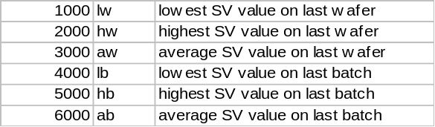
For example:
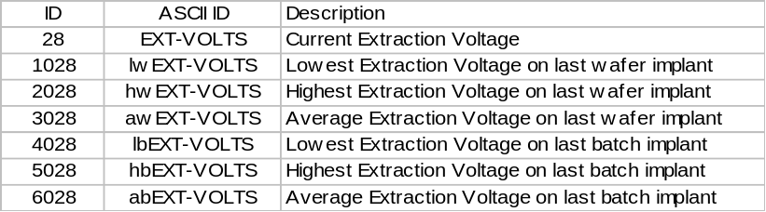
The same offset value and two character prefix is used for all of the first 99 status variables. The calculated values should be included in the end of wafer or end of batch event report. Otherwise they will be overwritten as soon as the next wafer or batch starts. The variable item dictionary lists all the status variables that are available on the E200 by SVID number and ASCII value.
Support for non-ASCII formatting is available for releases 11.05.05 and greater. These versions have added non ASCII formatting for all traceable analog readback values.
For example:
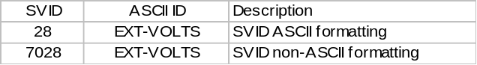
The same offset value and two character prefix (70) is used for all of the first 99 status variables. The variable item dictionary lists all the status variables that are available on the E200 by SVID number and ASCII value.

a1ESTurboSpeed[0] Format : 20

The left end station turbo speed in KRPM.

a1ESTurboNormalizedSpeed[0] Format : 20

The left end station turbo normalized speed.

a1ESTurboCurrent[0] Format : 20

The left end station turbo current in mA.

a1ESTurboVoltage[0] Format : 20

The left end station turbo voltage.

a1ESTurboTempC[0] Format : 20

The left end station turbo temperature in degrees C.

a1ESTurboLifeHR[0] Format : 20

The left end station turbo life in hours.

a1ESTurboCycles[0] Format : 20

The left end station turbo cycles.

a1ESTurboCycleTimeMIN[0] Format : 20

The left end station turbo cycle time in minutes.

a1ESTurboSpeed[1] Format : 20

The right end station turbo speed in KRPM.

a1ESTurboNormalizedSpeed[1] Format : 20

The right end station turbo normalized speed.

a1ESTurboCurrent[1] Format : 20

The right end station turbo current in mA.

a1ESTurboVoltage[1] Format : 20

The right end station turbo voltage.

a1ESTurboTempC[1] Format : 20

The right end station turbo temperature in degrees C.

a1ESTurboLifeHR[1] Format : 20

The right end station turbo life in hours.

a1ESTurboCycles[1] Format : 20

The right end station turbo cycles.

a1ESTurboCycleTimeMIN[1] Format : 20

The right end station turbo cycle time in minutes.

a1OnBoardRegenStep[0] Format : 20

The on board target chamber pump regen step number.

a1OnBoardFirstStageTemp[0] Format : 20

The on board target chamber pump first stage temperature in Kelvin.

a1OnBoardSecondStageTemp[0] Format : 20

The on board target chamber pump second stage temperature in Kelvin.

a1OnBoardTcGaugePress[0] Format : 20

The on board target chamber pump thermocouple gauge pressure in microns.

a1OnBoardTotalOperatingTime[0] Format : 20

The on board target chamber pump total operating time in hours.

a1OnBoardTempSinceLastFullRegen[0] Format : 20

The on board target chamber pump time since the last full regen in hours.

a1OnBoardTempSinceLastFastRegen[0] Format : 20

The on board target chamber pump time in hours.

a1OnBoardBasePressure[0] Format : 20

The on board target chamber pump base pressure in microns.

a1OnBoardRegenStep[1] Format : 20

The on board left elevator pump regen step number.

a1OnBoardFirstStageTemp[1] Format : 20

The on board left elevator pump first stage temperature in Kelvin.

a1OnBoardSecondStageTemp[1] Format : 20

The on board left elevator pump second stage temperature in Kelvin.

a1OnBoardTcGaugePress[1] Format : 20

The on board left elevator pump thermocouple gauge pressure in microns.

a1OnBoardTotalOperatingTime[1] Format : 20

The on board left elevator pump total operating time in hours.

a1OnBoardTempSinceLastFullRegen[1] Format : 20

The onboard left elevator pump total operating time in hours.

a1OnBoardTempSinceLastFastRegen[1] Format : 20

The on board left elevator pump time since the last fast regen in hours.

a1OnBoardBasePressure[1] Format : 20

The on board left elevator pump base pressure in microns.

a1OnBoardRegenStep[2] Format : 20

The on board right elevator pump regen step.

a1OnBoardFirstStageTemp[2] Format : 20

The on board right elevator pump first stage temperature in Kelvin.

a1OnBoardSecondStageTemp[2] Format : 20

The on board right elevator pump second stage temperature in Kelvin.

a1OnBoardTcGaugePress[2] Format : 20

The on board right elevator pump thermocouple gauge pressure in microns.

a1OnBoardTotalOperatingTime[2] Format : 20

The on board right elevator pump total operating time in hours.

a1OnBoardTempSinceLastFullRegen[2] Format : 20

The on board right elevator pump time since the last full regen in hours.

a1OnBoardTempSinceLastFastRegen[2] Format : 20

The on board right elevator pump time since the last fast regen in hours.

a1OnBoardBasePressure[2] Format : 20

The on board right elevator pump base pressure in microns.

ACCEL-I Format: 20

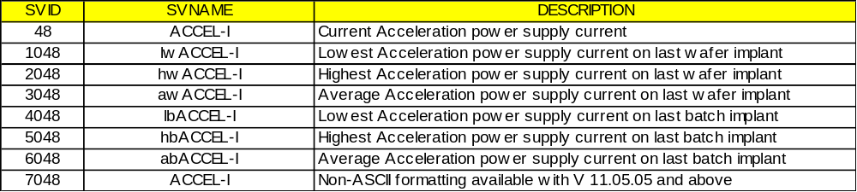
Acceleration power supply current.

ACCEL-VOLTS Format: 20

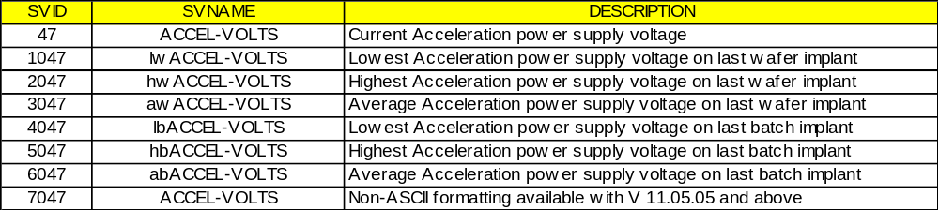

Acceleration power supply voltage in kilovolts.

ALARMSTATE Format : U1

ALARMSTATE is the GEM compliant format of reporting the alarm state of the most recent alarm ID. The default value of ALARMSTATE is 0.

AMU Format: 20

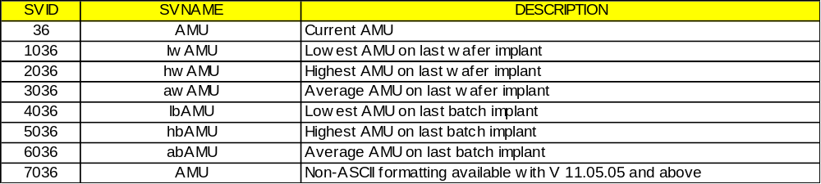

AMU value calculated from the extraction voltage, analyzer current, ion charge in the recipe and the analyzer magnet constant table.

AMU-I Format: 20

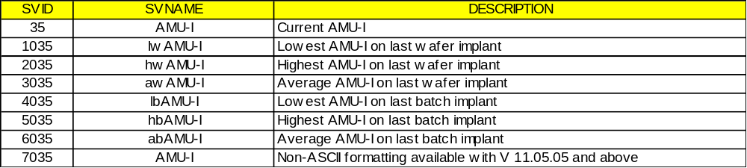

Analyzer magnet current in amperes.

AMU-G Format: 20

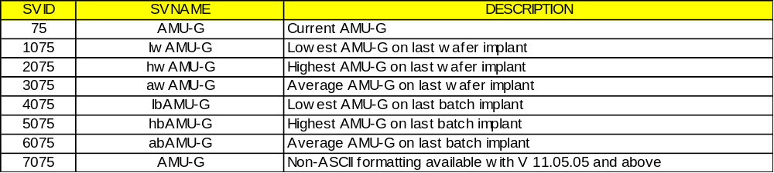

ANALYZER-PRESSURE Format: 20

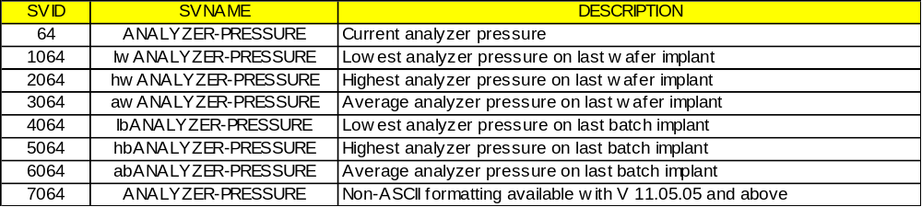

Read back from the CCIG near the resolving aperture.

ANALYZER-TC Format : 20

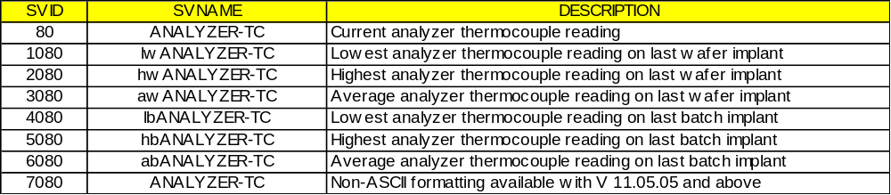

Analyzer thermocouple reading for the additional thermocouple gauge option.

ARC-I Format: 20

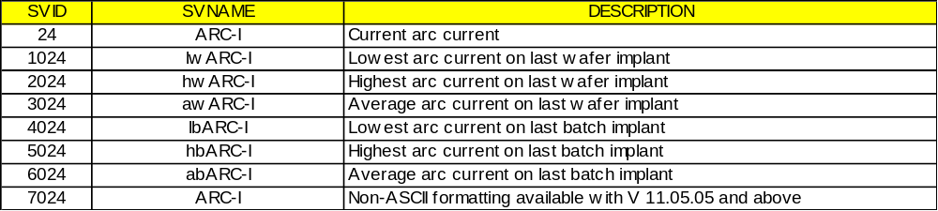

Arc current.

ARC-VOLTS Format: 20

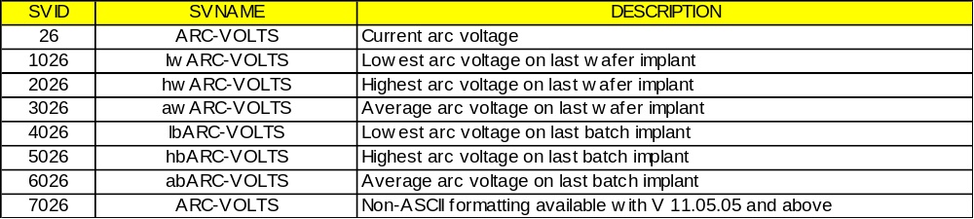

Arc voltage in volts.

BEAM Format: 20

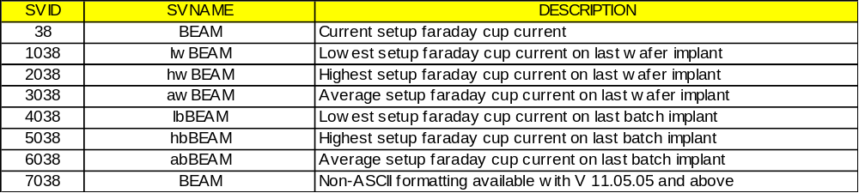

Setup Faraday cup current. See SVID 39 for unit. The Faraday cup is retracted during implant so the reading is only valid at the end of ion source setup and before beamline setup.

BEAM-I-RANGE Format: 20

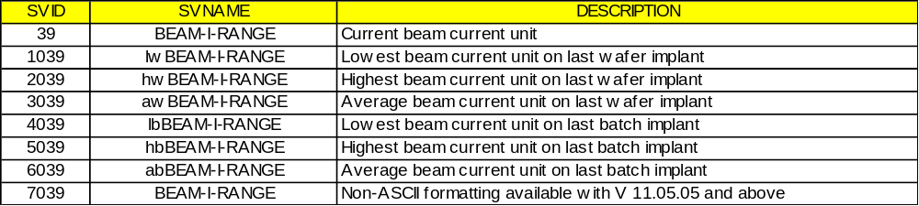

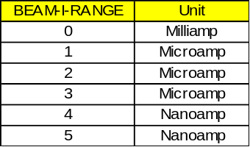

Unit for the BEAM current.

BEAMLINE-TC Format : 20

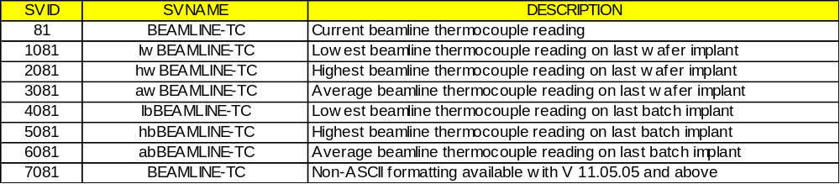

Beamline thermocouple reading for the additional thermocouple gauge option.

BIAS Format: 20

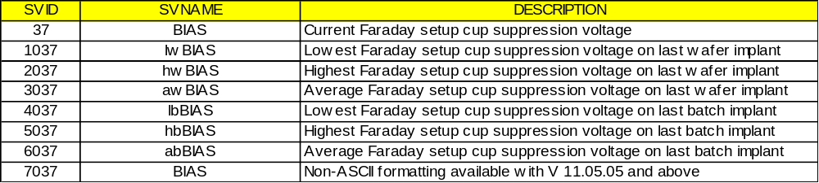

Setup Faraday cup suppression voltage in volts.

CHAMBER-CRYO-TC Format: 20

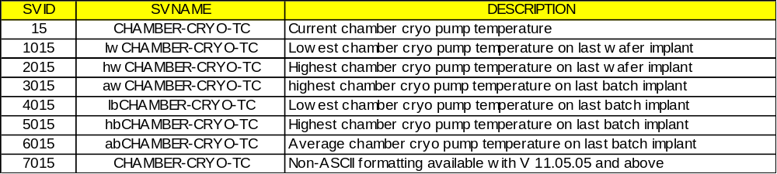

The pressure inside the chamber cryo pump as measured by its thermocouple gauge.

CHAMBER-CRYO-TEMP Format: 20

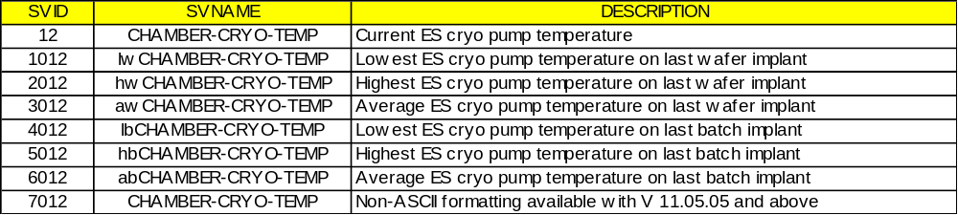

The temperature of the cryo pump for the main end station chamber.

CHAMBER-PRESSURE Format: 20

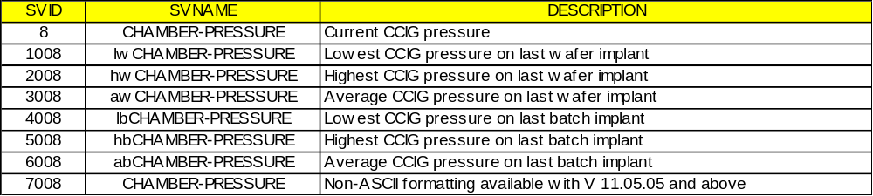

The readback from the CCIG mounted in the end station.

CITY-WATER-TEMP Format: 20

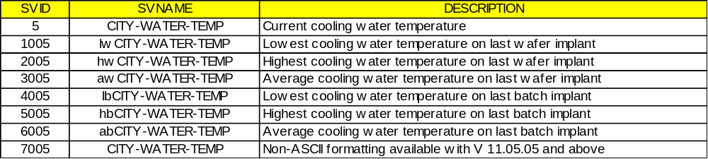

The temperature of the cooling water supplied to the implanter from facilities.

COOLING Format: 20

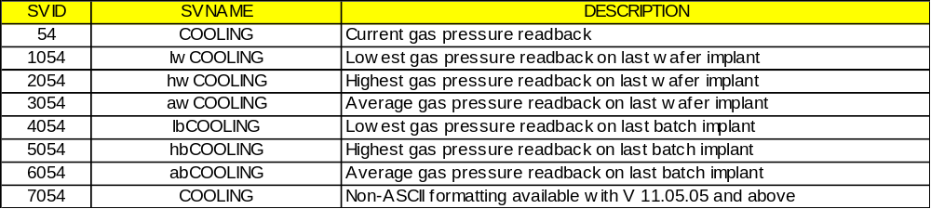

Gas pressure regulator readback in Torr.

DECEL-I Format: 20

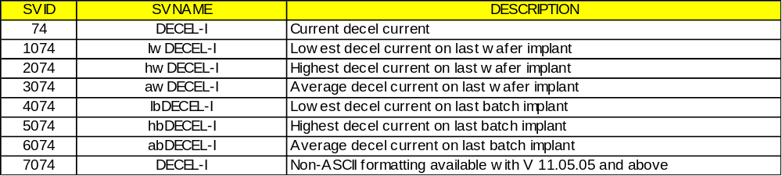

Deceleration power supply current in milliamps.

DECEL-VOLTS Format: 20

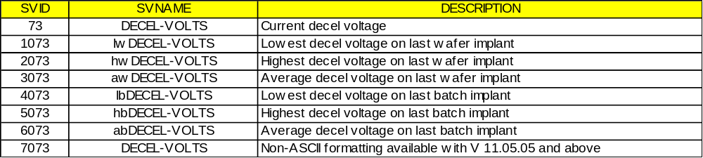

Deceleration power supply voltage in kilovolts.

DEC-I Format: 20

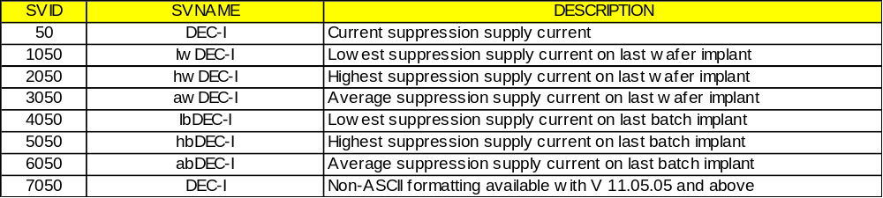

Accel column electron suppression supply current in milliamps.

DEC-VOLTS Format: 20

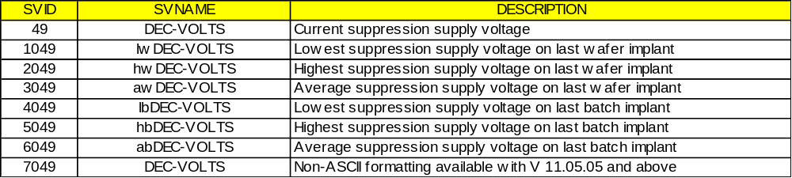

Accel column electron suppression supply voltage in kilovolts.

DEFLECTOR Format: 20

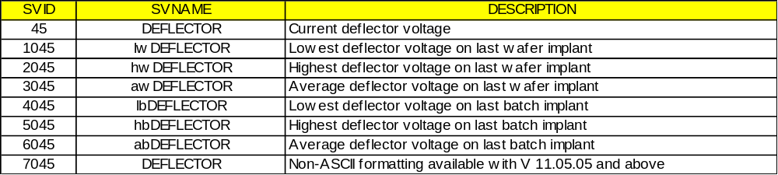

The voltage on the deflector electrode in kilovolts.

DI-WATER-DELTA-TEMP Format : 20

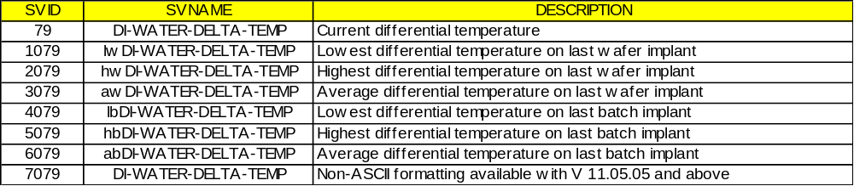

Differential temperature between the terminal and return DI cooling water supply in degrees Celsius.

DRY-PUMP-TC Format : 20

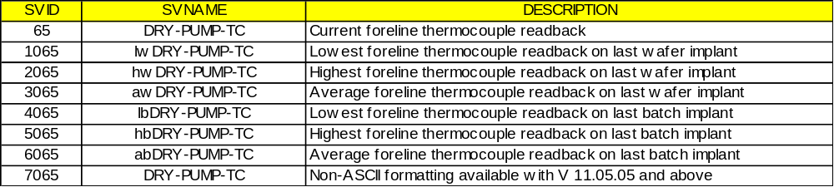

Readback from the thermocouple gauge on the foreline of the source dry pump in units of microns.

eBIAS-I Format : 20

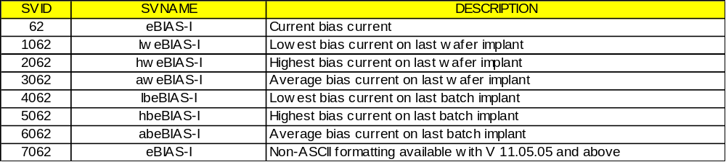

Bias current in milliamps (can be negative).

eBIAS-VOLTS Format : 20

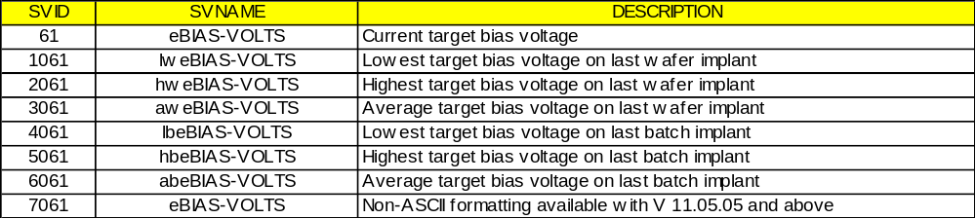

Target bias voltage in volts.

eEXT-I Format : 20

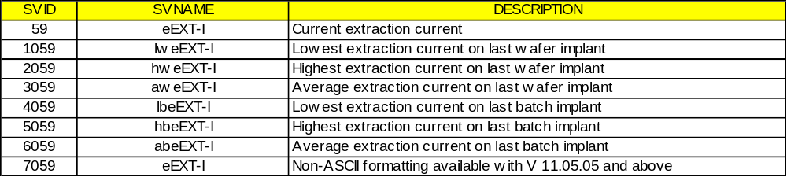

Extraction current in amps.

eFIL-I Format : 20

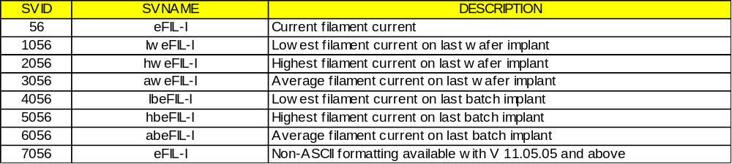

Filament current in amps.

eEXT-VOLTS Format : 20

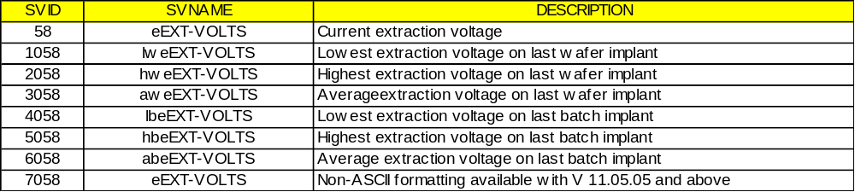

Extraction voltage in volts.

eFIL-VOLTS Format : 20

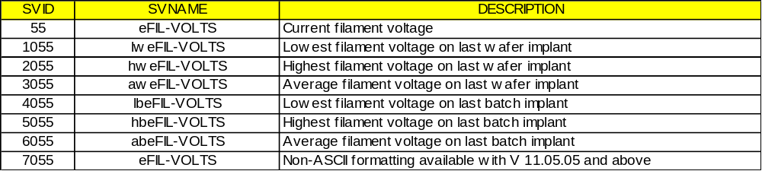

Filament voltage in volts.

ENERGY-PROBE Format : 20

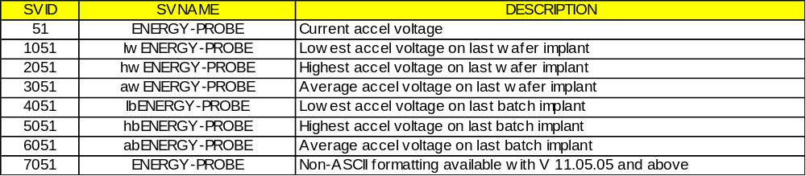

The total voltage used to accelerate the ion beam in kilovolts times the ion charge in the recipe. If the high voltage probe option is installed, this value comes from the probe. Otherwise, it is calculated from the extraction and accelerating voltages.

ErgoSMIF MDLN Format : A6

Version Available : 11.07.06

Equipment Model Type. The default is "ERGO 2"

ErgoSMIF SoftRev Format : A6

Version Available : 11.07.06

SMIF software revision V2.00 or higher. The default is "PID200"

ErgoSMIF Control State Format : U1

Version Available : 11.07.06

The current control state of the SMIF. The default is "4" (Local).
4 - local
5 - remote

ErgoSMIF Process State Format : U1

Version Available : 11.07.06

The process state of the SMIF. The default is "0" (Idle).
0 - idle
1 - loading
2 - unloading
3 - initializing
4 - service running
5 - load paused
6 - unload paused

ErgoSMIF PIO State Format : U2

Version Available : 11.07.06

The binary PIO State. The default is set as "0".

eRPL-VOLTS Format : 20

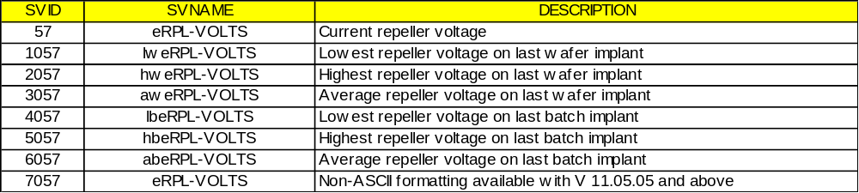

Repeller voltage in volts.

ES-DIFFER-TC Format : 20

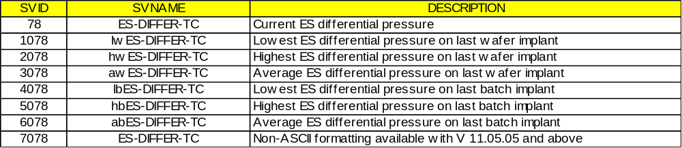

eSECOND-I Format : 20

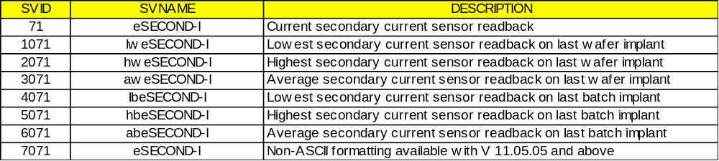

Secondary current sensor readback in milliamps if ECO Option # 44 is selected.

eSUP-VOLTS Format : 20

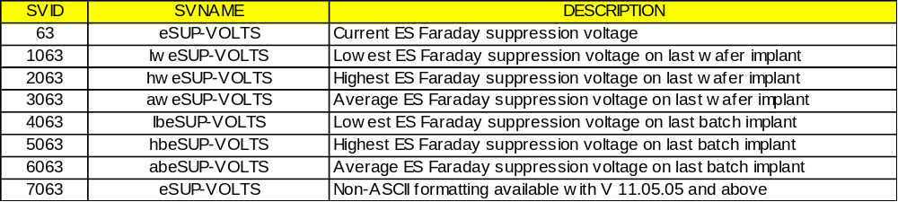

End station Faraday cup suppression voltage in volts.

eTARGET-I Format : 20

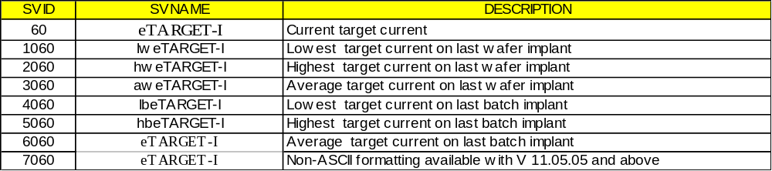

Target current in milliamps.

EXT-I Format: 20

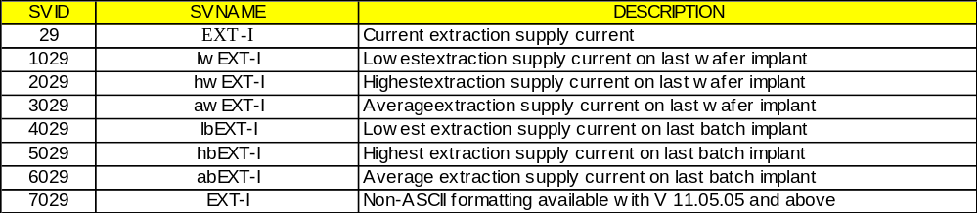

Extraction supply current in milliamps.

EXT-VOLTS Format : 20

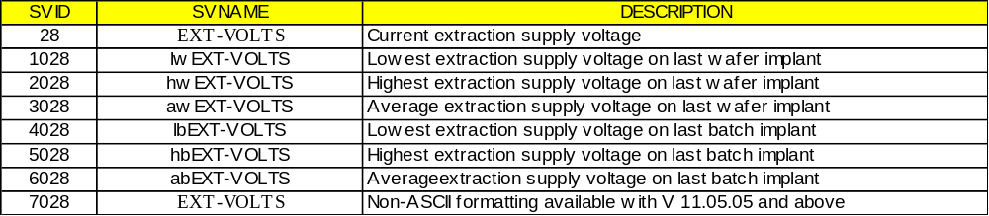

Extraction supply voltage in kilovolts.

FIL-I Format : 20

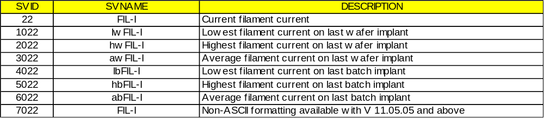

Filament current in amperes.

FIL-VOLTS Format : 20

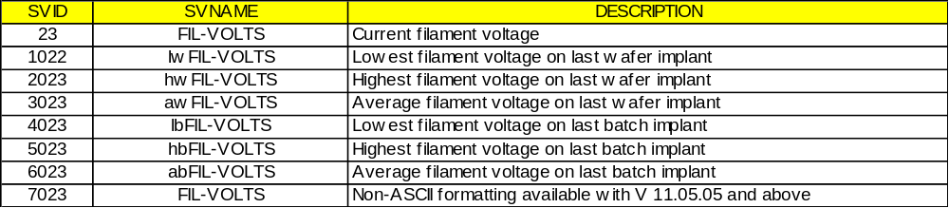

Filament voltage in volts.

G1-PRES Format : 20

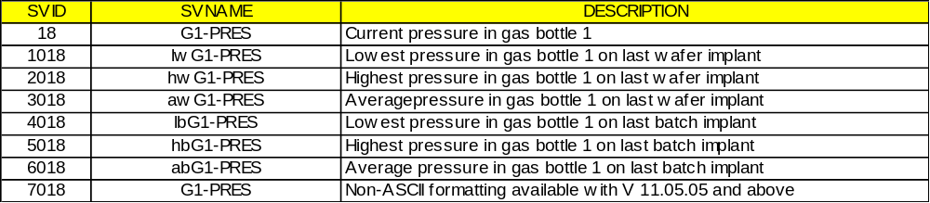

Pressure in gas bottle 1. Units are pounds per square inch with a full scale of 3000 psi. The gauge readings should not be used to determine when a bottle is empty since the pressure in most toxic gas bottles is only 300 psi when full and the gauges have significant zero offsets.

G2-PRES Format : 20

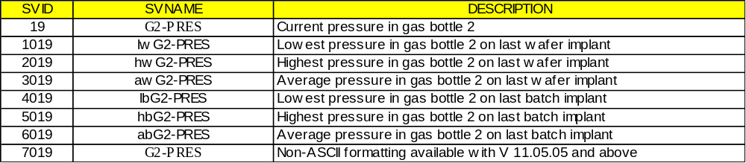

Pressure in gas bottle 2.

G3-PRES Format : 20

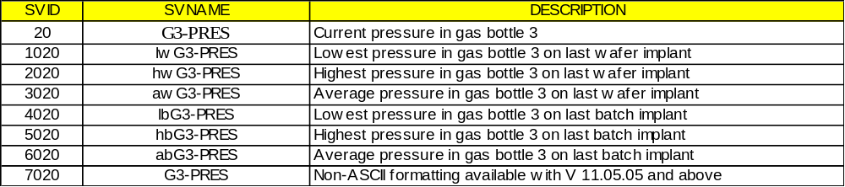

Pressure in gas bottle 3.

G4-PRES Format : 20

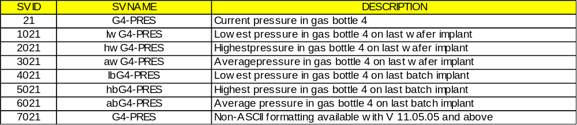

Pressure in gas bottle 4.
Note: Many special gas box configurations exist and the "bottle pressure" readings cited above may not apply to some custom configurations.

GAS Format : 20

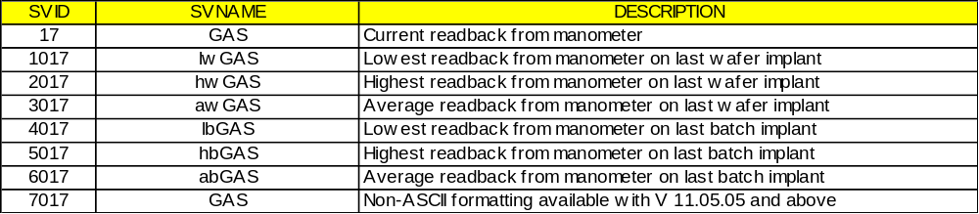

The readback from the capacitance manometer pressure gauge that is used to control the gas flow to the ion source.

GROUND-MEGOHMS Format : 20

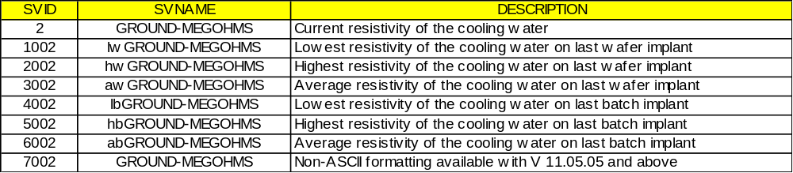

The resistivity of the cooling water at ground. The production machines do not use deionized cooling water at ground but this may change to support electrostatic clamping of the water so the variable is provided for future use.

GROUND-WATER-TEMP Format : 20

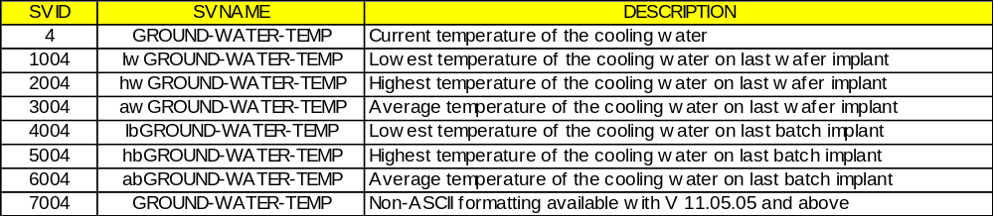

The temperature of the cooling water used to cool the end station.

HELIUM-PRESSURE Format : 20

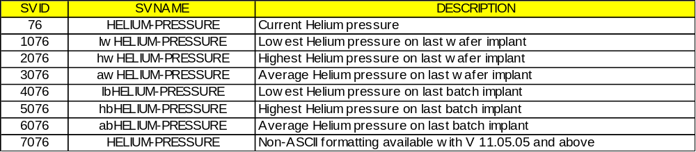
HTR-TEMP Format : 20

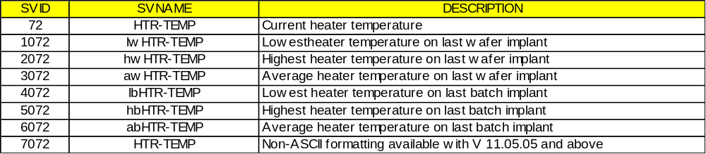

Temperature for the standard heater in degrees centigrade.

LEFT-CYRO-TEMP Format : 20

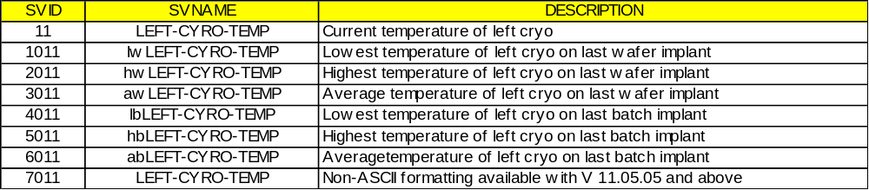

The temperature of the left elevator cryo pump in degrees Kelvin. Generally the pump must be colder than 20 degrees Kelvin to pump effectively.

LEFT-ELEVATOR-TC Format: 20

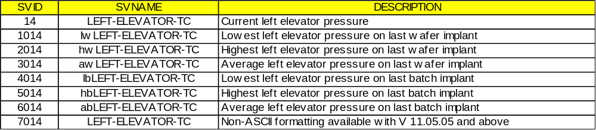

The left elevator pressure as measured by its thermocouple pressure gauge. Units are microns. Reading above 2000 microns should be considered unreliable because the gauge cannot reliably measure pressures between 2000 microns and atmosphere.

LENS-I Format: 20

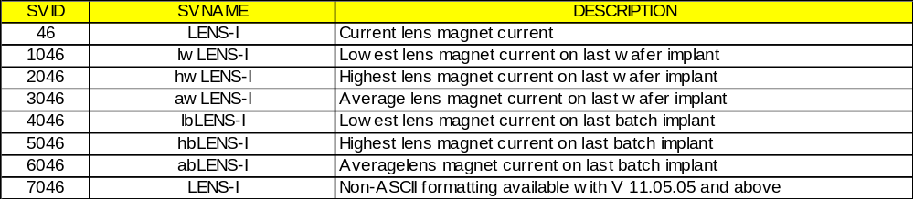

Current in the lens magnet in amps.

LENS-VOLTS Format: 20

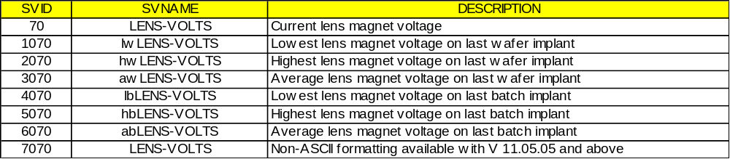

Lens magnet voltage in kilovolts.

LPT SMIF Ctl Status Format : U1

<U1[20]
MODE 8x17,
PIP 8x24,
HOMEST 8x12,
FUNC 8x10,
COLST 8x04,
LFUNC 8x13,
GPST 8x11,
PRTST 8x27,
ELUP 8x09,
PLDN 8x25,
MARMUP 8x16,
MARMDN 8x14,
TILUP 8x32,
ELDN 8x07,
PLUP 8x39,
SWPOS 8x29,
DIPSW 8x06,
ARMTYP 8x02,
ECV 8x40,
ALED 8x41
>
<L[0] > : Not available

LPT SMIF Ctl ARMTYPE Format : U1

Value | Arm Type
0 | Arm 1000 V
1 | Arm 1000 H Bar Towards
2 | Arm 1000 H Bar Away
3 | 2000 Outside Move
4 | 2000 Inside Move
5 | Arm 3000 V
6 | Arm 3000 H Bar Towards
7 | Arm 3000 H Bar Away
8 | ALU 2000
9 | Other Configuration
10 | ALU 2200
11 | Arm 2200 Outside V Move
12 | Arm 2200 Inside V Move
13 | Arm 2200 Outside H Move
14 | Arm 2200 Inside H Move

LPT SMIF ARM SW Format : A

LPT Arm software part number in 20 byte format.

LPT SMIF COLST Format : U1

Value | Collision Status
1 | No Collision
2 | Collision
3 | Improper squat in cassette pickup during load
4 | Improper squat in cassette place during load
5 | Improper squat in cassette pickup during unload
6 | Improper squat in cassette place during unload
7 | Improper wafer seating

LPT SMIF COUNT Format : U2

(RESERVED, NOT USED)
The LPT SMIF count for Move Distance (n).

LPT SMIF DIPSW Format : U1

Dip switch setting on the arm controller board.

LPT SMIF ELDN Format : U1

Elevator platform flag
0 - Elevator not at down limit
1 - Elevator at down limit
<L[0] > - Not available

LPT SMIF ELPOS Format : U2

Elevator position
0 - Elevator at home position
xx - steps away from the home position
<L[0] > - Not available

LPT SMIF ELUP Format : U1

Elevator UP flag
0 - Elevator not at UP limit
1 - Elevator at UP limit
<L[0] > - Not available

LPT SMIF FUNC Format : U1

Function being done by the arm
0 - Idle
1 - Load/Open in progress
2 - Unload/Close in progress
3 - Auto Home in progress
<L[0] > - Not available

LPT SMIF Full Status Format : 0

<L [5]
<U1[20]
MODE 8x17,
PIP 8x24,
HOMEST 8x12,
FUNC 8x10,
COLST 8x04,
LFUNC 8x13,
GPST 8x11,
PRTST 8x27,
ELUP 8x09,
PLDN 8x25,
MARMUP 8x16,
MARMDN 8x14,
TILUP 8x32,
ELDN 8x07,
PLUP 8x39,
SWPOS 8x29,
DIPSW 8x06,
ARMTYP 8x02,
ECV 08x40,
ALED 08x41
>
<U2[4] XPOS 8x33, YPOS 8x34, ELPOS 8x08, TLTPOS 8x31 >
<U1 RDYS 8x28 >
<A [20] ARM_SW 8x03 >
<U1[4] PIO_LU 8x22, PIO_LRDY 8x21, PIO_URDY 8x23, PIO_LOCK 8x20>
>
<L[0] > - Not available

LPT SMIF GPST Format : U1

Gripper Status
0 - Gripper Open
1 - Gripper Closed with Cassette
2 - Gripper Closed without Cassette
3 - None of the above
<L[0] > - Not available

LPT SMIF HOMEST Format : U1

Arm Home Status
0 - Arm not at home
1 - Arm at Home
<L[0] > - Not available

LPT SMIF LFUNC Format : U1

Last Function done
0 - Switched to manual/power up with manual
1 - Switched to auto/power up with auto mode
11 - Load/Open
12 - Unload/Close
13 - Auto Home
<L[0] > - Not available

LPT SMIF MARMDN Format : U1

Moving arm down flag
0 - Moving arm not at down limit
1 - Moving arm at down limit
<L[0] > - Not available

LPT SMIF MARMPOS Format : U2

(RESERVED, NOT USED)
Moving arm position
0 - Arm at home position
xx - Steps away from home position
<L[0] > - Not available

LPT SMIF MARMUP Format : U1

Moving arm up flag
0 - Moving arm not at UP limit
1 - Moving arm at UP limit
<L[0] > - Not available

LPT SMIF SWITCH MODE Format : U1

Switch Position on maintenance control panel
1- Auto mode
2 - Manual mode
<L[0] > - Not available

LPT SMIF MOT Format : U1

(RESERVED, NOT USED)
Motor id code
1 - Elevator motor
<L[0] > - Not available

LPT SMIF MVSTAT Format : U1

(RESERVED, NOT USED)
Motor move status
1 - Move motor
2 - Stop motor
<L[0] > - Not available

LPT SMIF PIO LOCK Format : U1

Parallel Interface Pod lock switch position
0 - Inactive
1 – Active
<L[0] > - Not available

LPT SMIF PIO LRDY Format : U1

Parallel Interface Host Ready to Load Line
0 - Inactive
1 – Active
<L[0] > - Not available

LPT SMIF PIO LU Format : U1

Parallel Interface Load / Unload Line
0 - Inactive
1 – Active
<L[0] > - Not available

LPT SMIF PIO URDY Format : U1

Parallel Interface Host Ready to Unload Line
0 - Inactive
1 – Active
<L[0] > - Not available

LPT SMIF PIP Format : U1

Pod in place state
0 - No pod present
1 - Pod present
<L[0] > - Not available

LPT SMIF PLDN Format : U1

Arm platform down flag
0 - Platform not at down limit
1 - Platform at down limit
<L[0] > - Not available

LPT SMIF PLPOS Format : U2

Arm platform position
0 - Arm platform at home position
xx - steps away from home position
<L[0] > - Not available

LPT SMIF PRTST Format : U1

SMIF Port Status
0 - port unlock
1 - port locked
2 - none of the above
<L[0] > - Not available

LPT SMIF RDYST Format : U1

Arm Ready status
0 - Arm not ready
1 - Arm ready to load/open
2 - Arm ready to unload/close
3 - Arm ready to load / unload
4 - Arm ready to auto home
<L[0] > - Not available

LPT SMIF SWPOS Format : U1

Load /unload switch position
0 - All positions
n - Position n
<L[0] > - Not available

LPT SMIF TLTDN Format : U1

(RESERVED, NOT USED)
Gripper tilt down flag
0 - Gripper tilt not at down limit
1 - Gripper tilt at down limit
<L[0] > - Not available

LPT SMIF TLTPOS Format : U2

Gripper tilt position
0 - Tilt at home position
xx - steps away from the home position
<L[0] > - Not available

LPT SMIF TLTUP Format : U1

Gripper tilt UP flag
0 - Gripper tilt not at UP limit
1 - Gripper tilt at UP limit
<L[0] > - Not available

LPT SMIF XPOS Format : U2

X Coordinate of gripper
0 - Horizontal position of gripper is at home
nn - gripper is nn mils (1/1000 of in.) away from home
<L[0] > - Not available

LPT SMIF YPOS Format : U2

Y Coordinate of gripper
0 - Horizontal position of gripper is at home
nn - gripper is nn mils(1/1000 of in.) away from home
<L[0] > - Not available

LPT SMIF Position Format : U2

<U2 [4] XPOS 8x33 , YPOS 8x34, ELPOS 8x08, TLTPOS 8x31>
<L[0] > - Not available

LPT SMIF PIO Status Format : U1

<U1[4] PIO_LU 8x22, PIO_LRDY 8x21, PIO_URDY 8x23, PIO_LOCK 8x20>
<L[0] > - Not available

LPT SMIF Wafer Map Format : U1

<U1 slot1_status ... slot25_status >
<L[0] > - Not available

The slotx_status value may be returned as one of the following values:
0x00 – No wafer detected
0x01 – Wafer detected
0x02 – Cross slot detected

LPT SMIF Wafer Count Format : U1

n - Wafer Count in Cassette handled by the SMIF LPT.
<L[0] > - Not available

LPT SMIF PLUP Format : U1

Vertical LPT positive over-travel status
0 - Vertical arm not at positive over-travel
1 - Vertical arm at positive over-travel
<L[0] > - Not available

LPT SMIF ECV Format : U1

ECV Equipment Constant Value
0 - Do not report
1 - Report
<L[0] > - Not available

LPT SMIF ALED Format : U1

Where used: S1F3, F11, F12, S2F23
ALED Alarm Enable/Disable Code
Bit 8 = 1: Enable Alarm
Bit 8 = 0: Disable Alarm
<L[0] > - Not available

MAG-I Format : 20

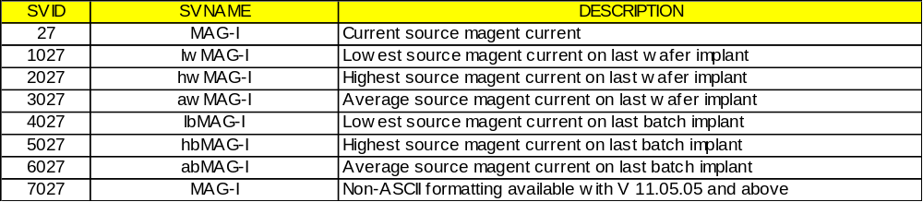

Source magnet current in amperes.

MAG-VOLTS Format : 20

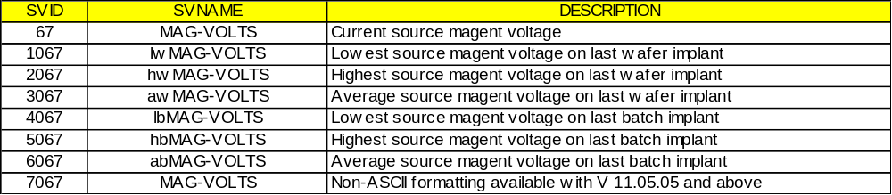

Source magnet voltage in kilovolts.

MDLN Format : A

GEM compliant equipment constant for the machine. This value is ‘E220’ by default.

MIR-I Format : 20

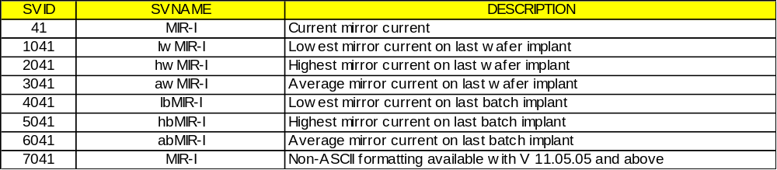

The current output of the mirror supply in milliamps.

MIR-SHUNT-I Format: 20

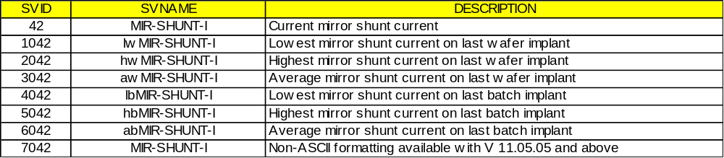

The current flowing into the shunt regulator in the mirror supply in milliamps. The net current in the supply is (MIR-I) minus (MIR-SHUNT-I) and can be negative when running decel mode.

MIR-VOLTS Format : 20

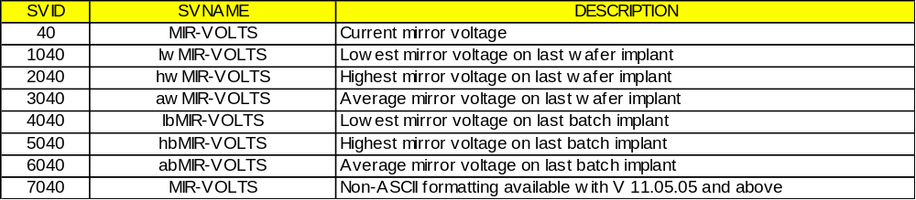

The voltage on the beam filter electrode(mirror) when running double charged ions. The same supply is connected to the accel column and used to decelerate the ion beam when running in decel mode.

Q1-I Format : 20

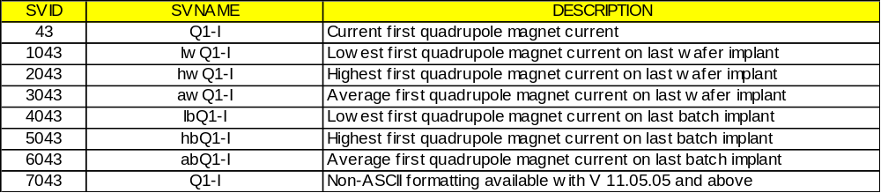

The current in the first quadrupole magnet in amps.

Q1-VOLTS Format : 20

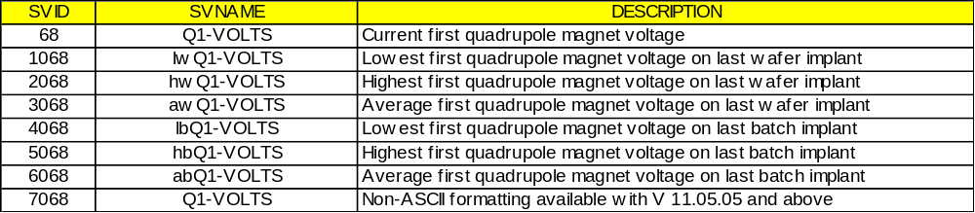

Quadrupole 1 magnet voltage in kilovolts.

Q2-I Format : 20

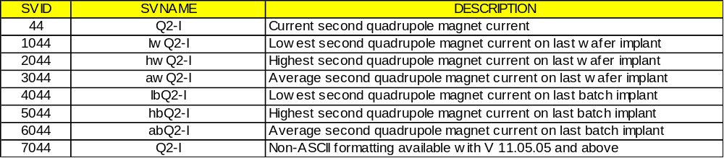

The current in the second quadrupole magnet in amps.

Q2-VOLTS Format : 20

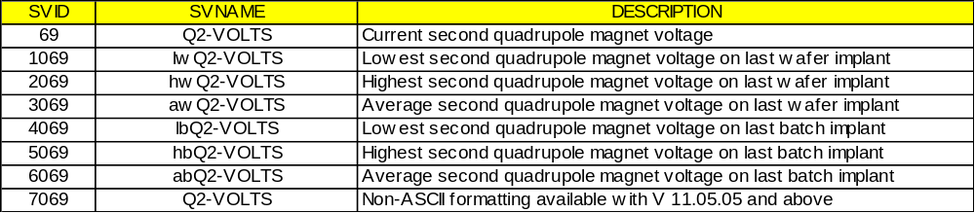

Quadrupole 2 magnet voltage in kilovolts.

RANGE-ARC Format : 20

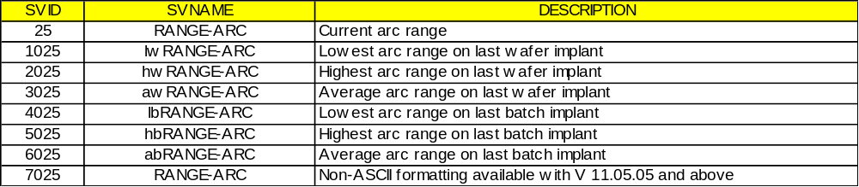

Arc current unit.
RANGE-ARC | Unit
0 | Amperes
1 | Milliamps
2 | Milliamps
3 | Milliamps
4 | Microamps

RIGHT-CRYO-TEMP Format : 20

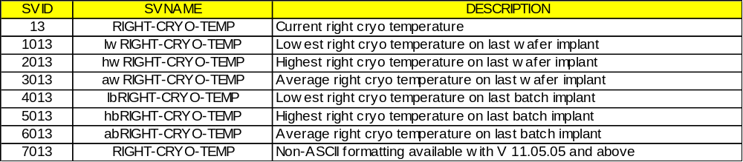

The temperature of the right elevator cryo pump.

RIGHT-ELEVATOR-TC Format : 20

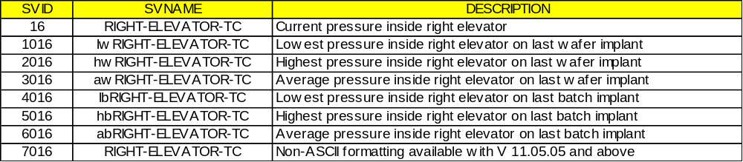

The pressure inside the right elevator.

SCANNER-PRESSURE Format : 20

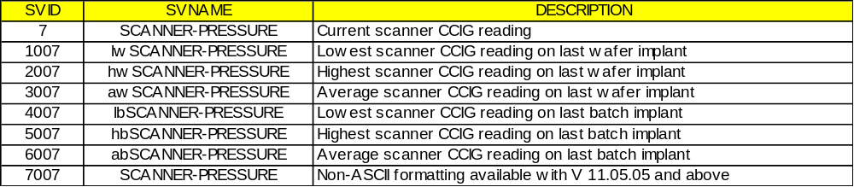

The readback from the CCIG mounted in the beamline just past the scan plates.

SCANNER-TURBO-SPEED Format : 20

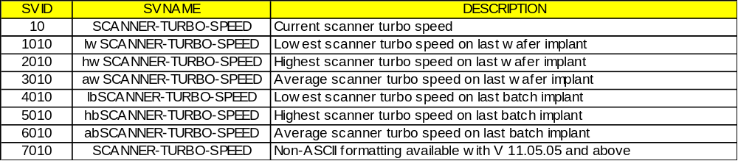

The speed of the scanner turbo pump.

SMIF1 Controls Format : U1

The control mode for LPT units.
1 Manual
2 SEMI-Auto
3 FULL AUTO

SMIF Port ID Format : U1

Defines the SMIF unit port ID. This variable may be linked to SMIF-related CEID event reports to determine which side the event was generated on.
1 – Left SMIF
2 – Right SMIF

This is also used for the material identification bar code reader. This SVID reports the side where the event occurs.
1 - left
2 - right

SMIF Tool Format : U1

The SMIF tool in use. Use these status variables in reports generated by a SMIF CEID to determine which tool originated the report.
1 tool 1
2 tool 2

SOFTREV Format : A

SOFTREV is the GEM compliant software version number. This will display the current software revision installed on the implanter.

SOURCE-PRESSURE Format : 20

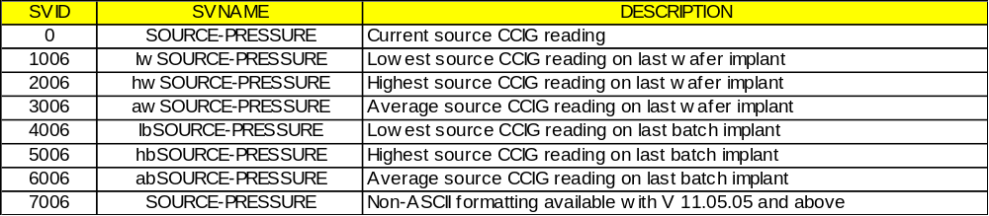

The readback from the source cold cathode ion gauge in units of Torr. The format: is either "X.XE- X" or "OFF" if the ion gauge is not operating.

SOURCE-TURBO-SPEED Format : 20

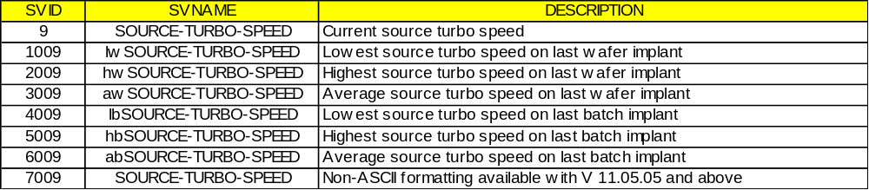

The speed of the source turbo pump as a percentage of full speed. The turbo speeds are used as an indicator of the roughing pressure and determine when the CCIG’s will be turned on.

SUP-VOLTS Format : 20

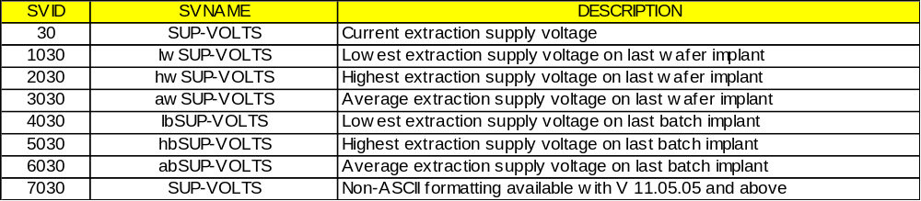

Extraction electron suppression supply voltage in kilovolts.

SUP-I Format : 20

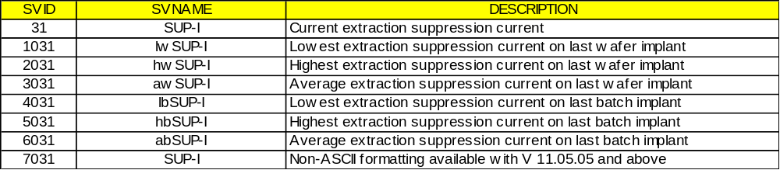

Extraction electron suppression supply current in milliamps.

TARGET-BIAS Format : 20

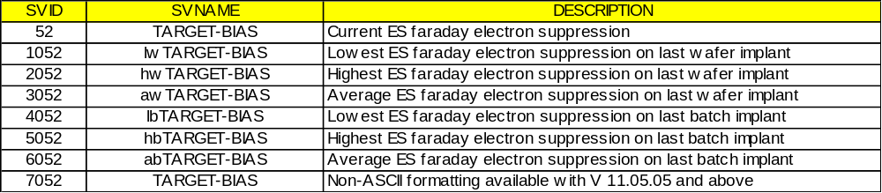

End station Faraday cup electron suppression voltage in volts. (only on machines without an electron flood gun!)
Note: The current readouts from the Faraday cups in the end station are hard to interpret because they are smaller than the beam and the beam would not ordinarily be pointed at them most of the time so they are not provided as a status variable.

TERM-DI-RETURN-TEMP Format : 20

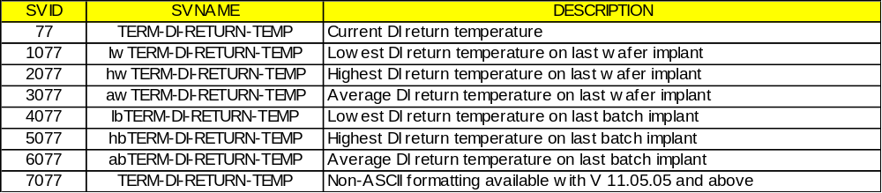

TERMINAL-MEGOHMS Format : 20

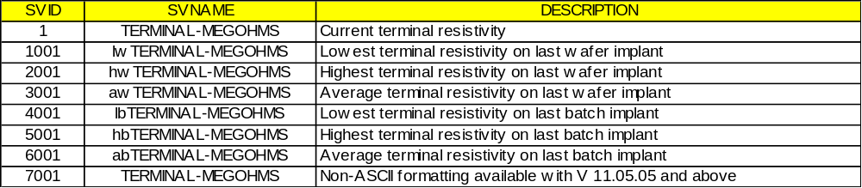

The resistivity of the cooling water used to cool the terminal in Mohm-cm. Generally the value must exceed 2.00 Mohm-cm. The water flows across the 180 KV gap to the terminal so high resistance is necessary to avoid drawing excessive current from the high voltage supplies. Full scale: 9.99.

TERMINAL-WATER-TEMP Format : 20

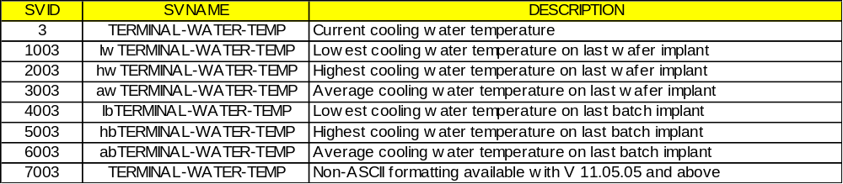

The temperature of the cooling water for the terminal in degrees centigrade. The control computer will shut down the implanter if this or any other water circuit becomes too hot.

TIME Format : A

GEM compliant time format. Time will be displayed in the format YYYYMMDDHHMMSSCC.

VAP-TEMP Format : 20

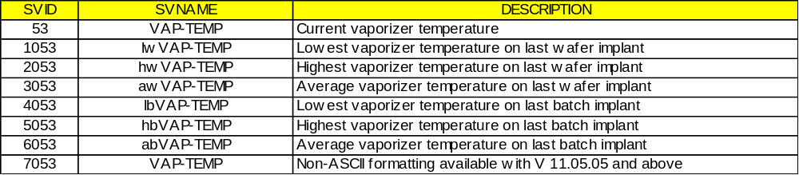

For the vaporizer option. Vaporizer temperature is in degrees centigrade.

X-AXIS Format : 20

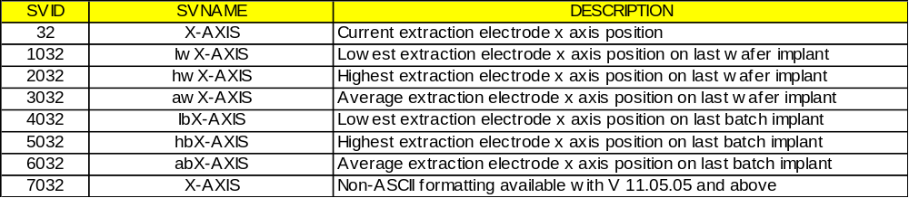

Extraction electrode x axis position. The units are arbitrary and the values run from 0 to 999. The value 500 is the approximate mechanical center.

Y-AXIS Format : 20

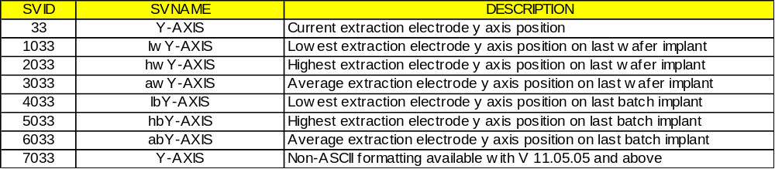

Extraction electrode y axis position. The units are arbitrary and the values run from 0 to 999. The value 500 is the approximate mechanical center.

Y-SIGMA Format : 20

Obsolete.

Z-AXIS Format : 20

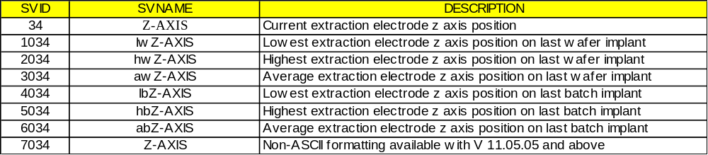

Extraction electrode z axis position. The units are arbitrary.

SVNAME

SVNAME -- Status Variable Name Format: 20

Defined in the SVID table above.
Where Used: S1F12

TEXT

TEXT -- A single line of characters. Format: 20

Where Used: S10F1, S10F3, S10E5

TIAACK

TIAACK -- Equipment acknowledgement code, 1 byte Format: 10

0 = everything correct
1 = too many SVIDs
2 = no more traces allowed
3 = invalid period
>3 = equipment specified error
4-63 reserved
Where Used: S2F24

TIACK

TIACK -- Time Acknowledge Code, 1 byte Format: 10

0 = OK
1 = Error, not done
2-63 = reserved
Where Used: S2F32

TID

TID -- Terminal number, 1 byte Format: 10

0 = single or main terminal
>0 = additional terminals at the same equipment
Where Used: S10F1, S10F3, S10F5, S10F7

TIME

TIME -- Time of day Format: 20

FOR the Y2K feature
IF EC 289 (TIMEFORMAT ) = 0,
TIME is 12 bytes: yymmddhhmmss

ELSE IF EC 289 (TIMEFORMAT ) = 1,
TIME is 16 bytes: yyyymmddhhmmsscc

OTHERWISE:
TIME is 12 bytes: yymmddhhmmss
Where Used: S2F18

TOTSMP

TOTSMP -- Total samples to be made Format: 20, 3( ), 5( )

Where Used: S2F23

TRID

TRID -- Trace Request ID Format: 20,.3( ), 5( )

Where Used: S2F23, S6F1

TSID

TSID - Material Port Number (ACH) Format: 20

It designates the stage location of the automatic cassette handler. The stage is numbered from left to right facing the equipment, 1 to 4.

Note: For Factory Automation Only
Where Used: S2F71 S2F71

UNITS

UNITS -- Units Identifier Format: 20

As allowed by E5 Section 9
Where Used: S1F12, S2F30, S2F48

UPPERDB

UPPERDB - Upper Dead Band Format: 20

A variable limit attribute which defines the upper boundary of the deadband of a limit. The value applies to a single limit (LIMITID) for a specified VID. Thus, UPPERDB and LOWERDB as a pair define a limit.
Where used: S2F45, S2F48

V

V -- Variable data Format: 20

Where Used: S6F11, S6F13

VLAACK

VLAACK -- Variable Limit Attribute Acknowledge Code, 1 byte Format: 10

0 = Acknowledge, command will be performed
1 = Limit attribute definition error
2 = Cannot perform now
>2 = Other equipment-specific error
3-63 = Reserved
Where Used: S2F46

VID

VID -- Variable ID Format: 20, 3( ), 5( )

The variable id will be the identification of one of the three classes of identifications: data variable identification (DVID), equipment constant identification (ECID), or status variable identification (SVID).

VID | Description | Class
1 – 99 | Analog readback variables  (available for tracing) | SVID
100 - 199 | Data variables (Implant and Machine Status)  (not available for tracing) | DVID
200 - 249 | Data process program variables (Recipe)  (not available for tracing) | DVID
250 - 299 | Equipment Constants | ECID
300 - 349 | GEM compliant data variables | DVID
350 - 399 | Equipment Constants | ECID
400 - 499 | Status Variables (Pump Analog Readback) | SVID
500 - 599 | GEM System data variables | DVID/ SVID
600 - 699 | Data Variables (IQDP Status) | DVID
1001-1099 | lowest analog readback SV value on last wafer | SVID
2001-2099 | highest analog readback SV value on last wafer | SVID
3001-3099 | average analog readback SV value on last wafer | SVID
4001-4099 | lowest analog readback SV value on last batch | SVID
5001-5099 | highest analog readback SV value on last batch | SVID
6001-6099 | average analog readback SV value on last batch | SVID
7000-7099 | Analog readback variables in a non-ASCII format.  (available for tracing) | SVID
8000-8099 | Asyst and Ergospeed common SMIF Variables | SVID
8100-8199 | Left Asyst SMIF Variables | SVID
8200-8299 | Right Asyst SMIF Variables | SVID
8300-8399 | Left Ergospeed SMIF Variables | SVID /DVID
8400-8499 | Right Ergospeed SMIF Variables | SVID /DVID

Where Used: S1F3, S1F11, S1F12, S2F23, S2F33, S2F45, S2F46, S2F47, S2F48; S6F13, S6F18, S6F22

VNAME

VNAME -- Variable Name Format: 20

Variable names are defined in the VID table above. The name will be the name of one of the three classes of variables: data variable name (DVNAME), equipment constant name (ECNAME), or status variable name (SVNAME).
Where Used: S1F3, S1F11, S1F12, S2F23

3.0 Message Detail
This section defines a number of specific functions in different streams to be used as the basis for the GEM communications between Equipment and Host. The functions are defined in the form of transaction message pairs.
The transactions are described in a standard form, as defined by SEMI E5-95 section 7, which involves specification of the number, name, single or multiple block, direction of communication, nature of reply required, description, variable definition, and the detailed structure of the message in terms of lists and items. Double lines separate streams and single lines separate transactions to aid in readability.
The functions are described in a standard form which involves specification of the number, name, single or multiple block, direction of communication, nature of reply required, description, variable definition, and the detailed structure of the message in terms of lists and items. Double lines separate streams, and single lines separate transactions to aid readability.
The abbreviations used in each transaction are as follows:
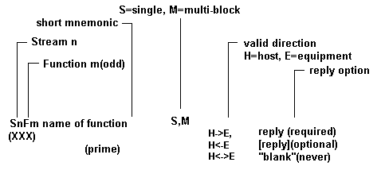

Description: A description of the action generated by the function.

Structure: Detailed structure showing lists and defined items. Lists are denoted by a capital L followed by the length separated by a comma. The individual elements in the list are numbered on separate lines. Nested lists are indented to emphasize the structure. The detailed form of the items is given in the define section at the beginning of the transaction. The symbols "<" and ">" are used to enclose each item in the structure data and imply that there is an item header. A detailed description of each data item as well as a list of the allowable data formats can be found in the Data Item Dictionary.

Exception: Special cases in the structure that have a different meaning.

SnFm+1 Name of function (same structure as above
(secondary) except never with reply)
Stream 1 Equipment Status
This stream provides a means for exchanging information about the status of the equipment, including its current mode, depletion of various consumable items, and the status of transfer operations.

S1F0 Abort Transaction (S1F0) S,H<->E

Description:
Used in lieu of an expected reply to abort a transaction. Function 0 is defined in every stream and has the same meaning in every stream.

Structure:
Header Only.

S1F1 Are You There Request (R) S,H<->E,reply

Description:
Establishes if the equipment is on-line. A function 0 response to this message means the communication is inoperative. In the equipment, a function 0 is equivalent to a timeout on the receive timer after issuing S1F1 to the host.

Structure:
Header only

S1F2 On Line Data (D) S,H<->E

Description:
Data signifying that the equipment is alive.

Structure:
[1] <L,2
[1][1] <MDLN>
[1][2] <SOFTREV>
>

Exception:
This will not change the ON-LINE/OFF-LINE state of the Equipment. The Host sends a zero length list to the Equipment.

S1F3 Selected Equipment Status Request (SSR) S,H->E,reply

Description:
A request to the equipment to report selected values of its status.

Structure:
The following structure is approved for all item formats and should be used by all new implementations:

[1] <L,n
[1][1] <VID1>
. .
. .
[1][n] <VIDn>
>

The following structure is included for compatibility with previous implementations and may only be used for items of format 3 ( ) and 5 ( ):

[1] <Ux,n VID1 … VIDn> or <Ix,n VID1 … VIDn>

Exception:
A zero-length for list item [1] or item [1][x] means report all VIDs.

S1F4 Selected Equipment Status Data (SSD) M,H<-E

Description:
The equipment reports the value of each SVID requested in the order requested. The host remembers the names of values requested.

Structure:
[1] <L,n
[1][1] <SV1>
. .
. .
[1][n] <SVn>
>

Exceptions:
A zero length for item [1] means no response can be made. A zero-length for item [1][x], SVx, means that SVIDx does not exist.

S1F11 Status Variable Namelist Request (SVNR) S,H->E,reply

Description:
A request to the equipment to identify certain status variables.

Structure:
[1] <L,n
[1][1] <VID1>
. .
. .
[1][n] <VIDn>
>

Exception:
A zero length for item [1] means report all VIDs.

S1F12 Status Variable Namelist Reply (SVNRR) M,H<-E

Description:
The equipment reports to the host the name and units of the requested SV s.

Structure:
[1] <L,n
[1][1] <L,3
[1][1][1] <VID1>
[1][1][2] <VNAME1>
[1][1][3] <UNITS1>
>
. .
. .
[1][n] <L,3
[1][n][1] <VIDn>
[1][n][2] <VNAMEn>
[1][n][3] <UNITSn>
>
>

S1F13 Establish Communications Request (CR) S,H<->E,reply

Description:
The purpose of this message is to provide a formal means of initializing communications at a logical application level both on power-up and following a break in commuications. It should be the first message sent following any period where host and Equipment SECS applications are unable to communicate. An attempt to send an Establish Communications Request (S1F13) should be repeated at programmable intervals until an Establish Communications Acknowledge (S1F14) is received within the transaction timeout period with an acknowledgement code accepting the establishment.

Structure:
[1] <L,2
[1][1] <MDLN>
[1][2] <SOFTREV>
>

Exception:
The host sends a zero-length list for item [1] to the equipment.

S1F14 Establish Communications Request Acknowledge (CRA) S,H<->E

Description:
Accept or deny Establish Communications Request (S1F13). MDLN and SOFTREV are on-line data and are valid only if COMMACK = 0.

Structure:
[1] <L,2
[1][1] <COMMACK>
[1][2] < L,2
[1][2][1] <MDLN>
[1][2][2] <SOFTREV>
>
>

Exception:
The host sends a zero-length for list item [1][2] to the equipment

S1F15 Request OFF-LINE (ROFL) S,H->E,reply

Description:
The host requests that the equipment transition to the OFF-LINE state.

Structure:
Header only.

S1F16 OFF-LINE Acknowledge (OFLA) S,H<-E

Description:
Acknowledge or error.

Structure:
[1] <OFLACK>

S1F17 Request ON-LINE (RONL) S,H->E,reply

Description:
The host requests that the equipment transition to the ON-LINE state.

Structure:
Header only

S1F18 ON-LINE Acknowledge (ONLA) S,H<-E

Description:
Acknowledge or error.

Structure:
[1] <ONLACK>

Stream 2 Equipment Control and Diagnostics
Messages which deal with control of the equipment from the host. This includes all remote operations and equipment self-diagnostics and calibration but specifically excludes the control operations which are associated with material transfer (see stream 4 ), loading of executive and boot programs (stream 8 ), and all file and operating system calls (stream 10 and stream 13 ).

S2F0 Abort Transaction S,H<->E

Description:
Same form as S1F0

S2F13 Equipment Constant Request (ECR) S,H->E,reply

Description:
Constants such as for calibration, servo gain, alarm limits, data collection mode and other values that are changed infrequently can be obtained using this message.

Structure:
[1] < L,n
[1][1] <ECID1>
. .
. .
[1][n] <ECIDn>
>

The following structure is included for compatibility with previous implementations and may only be used for items of format 3 ( ) and 5 ( ) :

[1] <Ux,n ECID1 ... ECIDn > or <Ix,n ECID1 ... ECIDn >

Exceptions:
A zero-length for list item [1] or item [1][x] means report all ECV 's according to a predefined order.

S2F14 Equipment Constant Data (ECD) M,H<-E

Description:
Data Response to S2F13 in the order requested.

Structure:
[1] <L,n
[1][1] <ECV1>
[1][2] <ECV2>
. .
. .
[1][n] <ECVn>
>

Exceptions:
A zero-length for list item [1] means no response exists. A zero-length for list item [1][x], ECVx , means that ECIDx does not exist.

S2F15 New Equipment Constant Send (ECS) S,H->E,reply

Description:
Change one or more equipment constants.

Structure:
[1] <L,n
[1][1] <L,2
[1][1][1] <ECID1>
[1][1][2] <ECV1>
>
[1][2] <L,2
[1][2][1] <ECID2>
[1][2][2] <ECV2>
>
. .
. .
. .
[1][n] <L,2
[1][n][1] <ECIDn>
[1][n][2] <ECVn>
>
>

S2F16 New Equipment Constant Acknowledge (ECA) S,H<-E

Description:
Acknowledge or error. If EAC contains a non-zero error code, the equipment should not change any of the ECIDs specified in S2F15.

Structure:
[1] <EAC>

Note:
Equipment constants cannot be changed if the E220 is displaying either the GEM SETUP or ECO & OPTION, and only can be changed when E220 is in the idle state. This is done to prevent conflict between operator and Host attempting to modify the same equipment constant and prevent a change during implanting.

S2F17 Date and Time Request (DTR) S,H<->E,reply

Description:
Useful to check equipment time base or for equipment to synchronize with the host time base.

Structure:
Header only.

S2F18 Data and Time Data (DTD) S,H<->E

Description
Actual time data.

Structure:
[1] <TIME>

Exceptions:
A zero-length item [1] means no time exists.

S2F23 Trace Initialize Send (TIS) S,H->E,reply

Description:
Status variables exist at all times. This function provides a way to sample a subset of those status variables as a function of time. The trace data is returned on S6F1 and is related to the original request by the TRID. Multiple trace requests may be made to that equipment allowing it. If equipment receives S2F23 with the same TRID as a trace function that is currently in progress, the equipment should terminate the old trace and then initiate the new trace. A trace function currently in progress may be terminated by S2F23 with TRID of that trace and TOTSMP=0.

Structure:
The following structure is approved for all item formats and should be used by all new implementations.

[1] <L,5
[1][1] <TRID>
[1][2] <DSPER>
[1][3] <TOTSMP>
[1][4] <REPGSZ>
[1][5] <L,n
[1][5][1] <SVID1>
. .
. .
[1][5][n] <SVIDn>
>
>

The following structure is included for compatibility with previous implementations and may only be used for items whose SVID is format 3 ( ) and 5 ( ):

[1] <L,5
[1][1] <TRID>
[1][2] <DSPER>
[1][3] <TOTSMP>
[1][4] <REPGSZ>
[1][5] <U,n SVID1,..., SVIDn> or <I,n SVID1,..., SVIDn>
>

S2F24 Trace Initialize Acknowledge (TIA) S,H<-E

Description:
Acknowledge or error.

Structure:
[1] <TIAACK>

S2F25 Loopback Diagnostic Request (LDR) S,H<->E,reply

Description:
A diagnostic message for checkout of protocol and communication circuits. The binary string sent is echoed back.

Structure:
[1] <ABS>

S2F26 Loopback Diagnostic Data (LDD) S,H<->E

Description:
The echoed binary string.

Structure:
[1] <ABS >

S2F29 Equipment Constant Namelist Request (ECNR) S,H->E,reply

Description:
This function allows the host to retrieve basic information about what equipment constants are available in the equipment.

Structure:
[1] <L,n
[1][1] <ECID1>
. .
. .
[1][n] <ECIDn>

Exception:
A zero-length list item [1] means send information for all ECIDs.

S2F30 Equipment Constant Namelist (ECN) M,H<-E

Description:
Data Response.

Structure:
[1] <L,n (number of equipment constants)
[1][1] <L,6
[1][1][1] <ECID1>
[1][1][2] <ECNAME1>
[1][1][3] <ECMIN1>
[1][1][4] <ECMAX1>
[1][1][5] <ECDEF1>
[1][1][6] <UNITS1>
>
. .
. .
[1][n] <L,6
[1][n][1] <ECIDn>
[1][n][2] <ECNAMEn>
[1][n][3] <ECMINn>
[1][n][4] <ECMAXn>
[1][n][5] <ECDEFn>
[1][n][6] <UNITSn>
>
>

S2F31 Date and Time Set Request (DTS) S,H->E,reply

Description:
Useful to synchronize the equipment time with the host time base.

Structure:
[1] <TIME>

S2F32 Date and Time Set Acknowledge (DTA) S,H<-E

Description:
Acknowledge the receipt of time and date.

Structure:
[1] <TIACK>

S2F33 Define Report (DR) M,H->E,reply

Description:
The purpose of this message is for the host to define a group of reports for the equipment.

The type of report to be transmitted is designated by a Boolean "Equipment Constant." An "Equipment Constant Value" of "False" means that an "Event Report" (S6F11) will be sent, and a value of "True" means that an "Annoted event Report" (S6F13) will be sent.

If S2F33 is Multi-block, it must be preceded by the S2F39/S2F40 Inquire/Grant transaction.

Structure:
[1] <L,2
[1][1] <DATAID>
[1][2] <L,n // n reports
[1][2][1] <L,2 // report 1
[1][2][1][1] <RPTID1>
[1][2][1][2] <L,m // m VIDs this report
[1][2][1][2][1] <VID1>
. .
. .
. .
[1][2][1][2][m] <VIDm>
>
>
. .
. .
. .
[1][2][n] <L,2 // report n
[1][2][n][1] <RPTID1>
[1][2][n][2] <L,k // k VIDs this report
[1][2][n][2][1] <VID1>
. .
. .
. .
[1][2][n][2][k] <VIDk>
>
>
>
>

Exceptions:
1. A zero-length list item [1][2] following <DATAID> [1][1] item deletes all report definitions and associated links. See S2F35 (Link Event/Report).

2. A zero-length list item [1][2][x][2] following <RPTIDx> [1][2][x][1] item deletes report type RPTID. All CEIDs linked to this RPTID are also deleted.

S2F34 Define Report Acknowledge (DRA) S,H<-E

Description:
Acknowledge or error. If an error condition is detected the entire message is rejected, i.e., partial changes are not allowed.

Structure:
[1] <DRACK>

S2F35 Link Event Report (LER) M,H->E,reply

Description:
The purpose of this message is for the host to link n reports to an event (CEID ). These linked event reports will default to 'disabled' upon linking. That is, the occurrence of an event would not cause the report to be sent until enabled. See S2F37 for enabling reports.

If S2F35 is Multi-block, it must be preceded by the S2F39/S2F40 Inquire/Grant transaction.

Structure:

[1] <L,2
[1][1] <DATAID>
[1][2] <L,n // n events
[1][2][1] <L,2 // event 1
[1][2][1][1] <CEID1>
[1][2][1][2] <L,m // m reports
[1][2][1][2][1] <RPTID1>
. .
. .
. .
[1][2][1][2][m] <RPTIDm>
>
>
. .
. .
. .
[1][2][n] <L,2 // event n
[1][2][n][1] <CEID1>
[1][2][n][2] <L,k // k reports
[1][2][n][2][1] <RPTID1>
. .
. .
. .
[1][2][n][2][k] <RPTIDk>
>
>
>
>
Exceptions:
A zero length list item [1][2][x][2] following <CEIDx > [1][2][x][1] deletes all report links to that event.

S2F36 Link Event Report Acknowledge (LERA) S,H<-E

Description:
Acknowledge or error. If an error condition is detected the entire message is rejected, i.e., partial changes are not allowed.

Structure:
[1] <LRACK>

S2F37 Enable/Disable Event Report (EDER) S,H->E,reply

Description:
The purpose of this message is for the host to enable or disable reporting for a group of events (CEIDs).

Structure:

[1] <L,2
[1][1] <CEED> enable/disable
[1][2] <L,n #CEIDs
[1][2][1] <CEID1>
. .
. .
. .
[1][2][n] <CEIDn>

Exceptions:
A zero length list item [1][2] following <CEED> item [1][] means all CEID s.

S2F38 Enable/Disable Event Report Acknowledge (EERA) S,H<-E

Description
Acknowledge or error. If an error condition is detected the entire message is rejected, i.e., partial changes are not allowed.

Structure:
[1] <ERACK>

S2F39 Multi-block Inquire (DMBI) S,H->E,reply

Description:
If a S2F33, S2F35, or S2F45message is more than one block, this transaction must precede the message.

Structure:
[1] <L,2
[1][1] <DATAID>
[1][2] <DATALENGTH>
>

S2F40 Multi-block Grant (DMBG) S,H<-E

Description:
Grant permission to send multi-block message.

Structure:
[1] <GRANT>

S2F41 Host Command Send (HCS)
S,H->E,reply

Descripton:

The Host requests the Equipment perform the specified remote command with the associated parameters.

Structure:
[1] <L,2
[1][1] <RCMD>
[1][2] <L,n // # of parameters
[1][2][1] <L,2
[1][2][1][1] <CPNAME1> // parameter 1 name
[1][2][1][2] <CPVAL1> // parameter 1 value
>
. .
. .
[1][2][n] <L,2
[1][2][n][1] <CPNAMEn> // parameter n name
[1][2][n][2] <CPVALn> // parameter n value
>
>
>

S2F42 Host Command Acknowledge (HCA) S,H<-E

Description:
Acknowledge Host command or error. If command is not accepted due to one or more invalid parameters. (i.e., HCACK=3), then a list of invalid parameters will be returned containing the parameter name and reason for being invalid.

Structure:
[1] <L,2
[1][1] <HCACK>
[1][2] <L,n // # of parameters
[1][2][1] <L,2
[1][2][1][1] <CPNAME1> // parameter 1 name
[1][2][1][2] <CPACK1> // parameter 1 reason
>
. .
. .
[1][2][n] <L,2
[1][2][n][1] <CPNAMEn> // parameter n name
[1][2][n][2] <CPACKn> // parameter n reason
>
>
>

Exception:
If there are no invalid parameters, then a list of zero-length will be sent for list item [1][2].

Note:
Remote commands will not be executed unless the machine is in the proper state denoted by the screen being displayed. Examples of all the screens can be found in the E220 Operator’s or Maintenance Manuals. See RCMD in the Data Item Dictionary section for further explanation

S2F43 Reset Spooling Streams and Functions (RSSF) S,H->E,reply

Description:
This message allows the host to select specific streams and functions to be spooled whenever spooling is active.

Structure:
[1] <L,m
[1][1] <L,2
[1][1][1] <STRID1>
[1][1][2] <L,n
[1][1][2][1] <FCNID1>
. .
. .
[1][1][2][n] <FCNIDn>
>
>
. .
. .
[1][n] <L,2
[1][n][1] <STRIDn>
[1][n][2] <L,k
[1][n][2][1] <FCNID1>
. .
. .
[1][n][2][k] <FCNIDk>
>
>
>
>

Exceptions:
1. A zero-length for list item[1], m=0, turns off spooling for all streams and functions.

2. A zero-length list item [1][x][2] after item [1][x][1], <STRIDx>, turns on spooling for all functions for the associated stream <STRIDx>.

Notes:
1. Turning off spooling for all functions for a specific stream is achieved by omitting reference to the stream from this message.

2. Spooling for Stream 1 is not allowed.

3. Equipment must allow host to spool all primary messages for a stream (except Stream 1 ).

4. A defined list of functions for a stream in this message will replace any previously selected functions.

S2F44 Reset Spooling Acknowledge (RSA) M,H<-E

Description:
Acknowledge or error.

Structure:
[1] <L,2
[1][1] <RSACK> // accept or reject
[1][2] <L,m // m=number of streams with errors
[1][2][1] <L,3
[1][2][1][1] <STRID1>
[1][2][1][2] <STRACK1> // error in stream
[1][2][1][3] <L,n // n = functions in error
[1][2][1][3][1] <FCNID1>
. .
. .
[1][2][1][3][n] <FCNIDn>
>
>
. .
. .
[1][2][m] <L,3
[1][2][m][1] <STRIDm>
[1][2][m][2] <STRACKm> // error in stream
[1][2][m][3] <L,k // k = functions in error
[1][2][m][3][1] <FCNID1>
. .
. .
[1][2][m][3][k] <FCNIDk>
>
>
>
>

Exceptions:
1. If item [1][1], RSACK, =0, list item [1][2] is always zero-length, m=0, indicating no streams or functions in error.

2. If zero-length list item [1][2][x][3] is zero-length, there are no functions in error for stream <STRIDx>

S2F45 Define Variable Limit Attributes (DVLA) M,H->E,reply

Structure:
[1] <L,2
[1][1] <DATAID>
[1][2] <L,m // # of variables
[1][2][1] <L,2
[1][2][1][1] <VID1>
[1][2][1][2] <L,n // # of limits
[1][2][1][2][1] <L,2
[1][2][1][2][1][1] <LIMITID1>
[1][2][1][2][1][2] <L,p // p=0 or 2
[1][2][1][2][1][2][1] <UPPERDB1>
[1][2][1][2][1][2][2] <LOWERDB1>
>
>
. .
. .
[1][2][1][2][n] <L,2
[1][2][1][2][n][1] <LIMITIDn>
[1][2][1][2][n][2] <L,q // q=0 or 2
[1][2][1][2][n][2][1] <UPPERDBn>
[1][2][1][2][n][2][2] <LOWERDBn>
>
>
>
>
. .
. .
[1][2][m] <L,2
[1][2][m][1] <VIDm>
[1][2][m][2] <L,k // # of limits
[1][2][m][2][1] <L,2
[1][2][m][2][1][1] <LIMITID1>
[1][2][m][2][1][2] <L,r // r=0 or 2
[1][2][m][2][1][2][1] <UPPERDB1>
[1][2][m][2][1][2][2] <LOWERDB1>
>
>
. .
. .
[1][2][m][2][k] <L,2
[1][2][m][2][k][1] <LIMITIDk>
[1][2][m][2][k][2] <L,s // s=0 or 2
[1][2][m][2][k][2][1] <UPPERDBk>
[1][2][m][2][k][2][2] <LOWERDBk>
>
>
>
>
>
>
Exceptions:
1. Zero-length, m=0, list item [1][2] means all deadband limits, UPPERDB and LOWERDB, for all monitored VIDs are "undefined."

2. Zero-length list item [1][2][x][2]for VIDx means all deadband limits, UPPERDB and LOWERDB for VIDx are "undefined."

3. Zero-length deadbands list item [1][2][x][2][y][2] means deadband limits UPPERDBy and LOWERDBy for VIDx are "undefined."

S2F46 Variable Limit Attribute Acknowledge (VLAA) M,H<-E

Description:
Acknowledge definition of variable limit attributes or report error. If S2F45 is not accepted due to one or more invalid parameters (e.g., LIMITACK=3), then a list of invalid parameters is returned containing the variable limit attribute and reason for rejection. If an error condition is detected, the entire message is rejected, i.e., partial changes are not allowed.

Structure:
[1] <L,2
[1][1] <VLAACK>
[1][2] <L,m // m=number of invalid parameters
[1][2][1] <L,3
[1][2][1][1] <VID1> // VID with error
[1][2][1][2] <LVACK1> // reason
[1][2][1][3] <L,p // p=0 or 2
[1][2][1][3][1] <LIMITID1> //limit in error
[1][2][1][3][2] <LIMITACK1> // reason
[1][2][1][3][0] >
[1][2][1][0] >
. .
. .
. .
[1][2][m] <L,3
[1][2][m][1] <VIDm> // VID with error
[1][2][m][2] <LVACKm> // reason
[1][2][m][3] <L,q // q=0 or 2
[1][2][m][3][1] <LIMITIDm> //limit in error
[1][2][m][3][2] <LIMITACKm> // reason
[1][2][m][3] >
[1][2][m] >
[1][2] >
[1] >

Exceptions:
1. Zero-length, m=0, list item [1][2] means no invalid variable limit attributes.
2. Zero-length list item [1][2][x][3] means no invalid limit values for that VIDx.

S2F47 Variable Limit Attribute Request (VLAR) S,H->E,reply

Description:
This message allows the host to query the equipment for current variable limit attribute definitions.

Structure:
[1] <L,m // m=# VIDs this request)
[1][1] <VID1>
. .
. .
[1][m] <VIDm>
>

Exceptions:
A zero-length list item [1], m=0, requests a list of all VID values that can have variable limit attributes.

S2F48 Variable Limit Attributes Send (VLAS) M,H<-E

Description:
Equipment sends values of requested variable limit attribute definitions in the order requested.

Structure:
[1] <L,m (m=# VIDs this request)
[1][1] <L,2
[1][1][1] <VID1>
[1][1][2] <L,p // p=0 or 4
[1][1][2][1] <UNITS1>
[1][1][2][2] <LIMITMIN1>
[1][1][2][3] <LIMITMAX1>
[1][1][2][4] <L,n //n=# limits defined
[1][1][2][4][1] <L,3
[1][1][2][4][1][1] <LIMITID1>
[1][1][2][4][1][2] <UPPERDB1>
[1][1][2][4][1][3] <LOWERDB1>
>
. .
. .
. .
[1][1][2][4][n] <L,3
[1][1][2][4][n][1] <LIMITIDn>
[1][1][2][4][n][2] <UPPERDBn>
[1][1][2][4][n][3] <LOWERDBn>
>
>
>
>
. .
. .
. .
[1][m] <L,2
[1][m][1] <VIDm>
[1][m][2] <L,q // q=0 or 4
[1][m][2][1] <UNITSm>
[1][m][2][2] <LIMITMINm>
[1][m][2][3] <LIMITMAXm>
[1][m][2][4] <L,r //r=# limits defined
[1][m][2][4][1] <L,3
[1][m][2][4][1][1] <LIMITID1>
[1][m][2][4][1][2] <UPPERDB1>
[1][m][2][4][1][3] <LOWERDB1>
>
. .
. .
. .
[1][m][2][4][r] <L,3
[1][m][2][4][r][1] <LIMITIDr>
[1][m][2][4][r][2] <UPPERDBr>
[1][m][2][4][r][3] <LOWERDBr>
>
>
>
>
>
>

Exceptions:
1. A zero-length list item [1][x][2] means that limits are not supported for the VIDx.

2. A zero-length list item [1][x][2][4] means no limits are currently defined for VIDx.

S2F71- AGV-ACH Automation Initiate Processing Request S,H->E,reply

Description:
Initiate Processsing for AGV-ACH automation.

Structure:
[1] <L, 2
[1][1] <L, 4
[1][1][1] <TSID1>
[1][1][2] <ESID1>
[1][1][3] <PPID1>
[1][1][4] <LOTID1>
>
[1][2] <L, 4
[1][2][1] <TSID2>
[1][2][2] <ESID2>
[1][2][3] <PPID2>
[1][2][4] <LOTID2>
>
>
Notes:
1. PPID1 and PPID2 must be same for one batch

2. The E220 shall queue S2F71 while the equipment is processing wafers. The queuing buffer shall hold up to four S2F71s.

3. In case that only one cassette is processed during one batch, the structure of S2F71 shall be
[1] <L, 2
[1][1] <L, 4
[1][1][1] <TSID1>
[1][1][2] <ESID1>
[1][1][3] <PPID1>
[1][1][4] <LOTID1>
>
[1][2] <L,4
[1][2][1] <0>
[1][2][2] <0>
[1][2][3] <’ ‘>
[1][2][4] <’ ‘>
>
>

S2F72 - ACH Initiate Processing Acknowledge M,H<-E

Description:
Acknowledge or error.

Structure:
[1] <ACHA >
Stream 3 Material Status

The functions of the material status stream are used to communicate material-in-process, time to completion information, and extraordinary material occurrences.

S3F0 Abort Transaction (S3F0) S,H<->E

Description:
Same form as S1F0
Stream 4 Material Control
The material control stream contains the original material control protocol and the newer protocol which supports the SEMI-E32 Material Movement Management Services standard.

S4F0 Abort Transaction (S4F0) S,H<->E

Description:
Same form as S1F0.
Stream 5 Exception Reporting
This stream contains messages regarding binary and analog equipment alarms. The alarms are generated by the equipment in response to changing conditions detected by the equipment. Alarms are divided into categories as follows:
1. Personal safety -- condition may be dangerous to people.
2. Equipment safety -- condition may harm equipment.
3. Parameter control warning -- parameter variation outside of preset limits -- may harm product.
4. Parameter control error -- parameter variation outside of reasonable control limits -- may indicate an equipment malfunction.
5. Irrecoverable error -- intervention required before normal use of equipment can resume.
6. Equipment status warning -- an unexpected condition has occurred, but operation can continue.
7. Attention flags -- a signal from a process program indicating that a particular step has been reached.
8. Data integrity -- a condition which may cause loss of data; usually related to Stream 6.

S5F0 Abort Transaction S,H<->E

Description:
Same form as S1F0.

S5F1 Alarm Report Send (ARS) S,H<-E,[reply]

Description:
This message reports a change in or presence of an alarm condition. One message will be issued when the alarm is set and one message will be issued when the alarm is cleared. Irrevocable errors and attention flags may not have a corresponding clear message.

Structure:
[1] <L,3
[1][1] <ALCD>
[1][2] <ALID>
[1][3] <ALTX>
>

S5F2 Alarm Report Acknowledge (ARA) S,H->E

Description:
Acknowledge or error.

Structure:
[1] <ACKC5>

S5F3 Enable/Disable Alarm Send (EAS) S,H->E,[reply]

Description:
This message will change the state of the enable bit in the equipment. The enable bit determines if the alarm will be sent to the host. Alarms which are not controllable in this way are unaffected by this message.

Structure:
[1] <L,2
[1][1] <ALED>
[1][2] <ALID>
>

Exception:
A zero-length item [1][2], ALID, means all alarms.

S5F4 Enable/Disable Alarm Acknowledge (EAA) S,H<-E

Description:
Acknowledge or error.

Structure:
[1] <ACKC5>

S5F5 List Alarms Request (LAR) S,H->E,reply

Description:
This message requests the equipment to send binary and analog alarm information to the host.

Structure:
[1] <ALID1,...,ALIDn>

Exception:
A zero-length item [1] means send all possible alarms regardless of the state of ALED.

S5F6 List Alarm Data (LAD) M,H<-E

Description:
This message contains the alarm data known to the equipment. There are "m" alarms in the list.

Structure:
[1] <L,m
[1][1] <L,3
[1][1][1] <ALCD1>
[1][1][2] <ALID1>
[1][1][3] <ALTX1>
>
. .
. .
[1][m] <L,3
[1][m][1] <ALCDm>
[1][m][2] <ALIDm>
[1][m][3] <ALTXm>
>
Exception:
A zero-length item [1], m=0, means no response can be made.

A zero-length item [1][x][1] ALCDx or item [1][x][2] ALIDx or item [1][x][3] ALTXx means that item does not exist.

S5F7 List Enabled Alarm Request (LEAR) S,H->E,reply

Description:
List alarms which are enabled.

Structure:
Header only.

S5F8 List Enabled Alarm Data (LEAD) M,H<-E

Description:
This message is similar to S5F6 except that it lists only alarms which
are enabled.

Structure:
Same as S5F6 .
Stream 6 Data Collection

This stream is intended to cover the needs of in-process measurements and equipment monitoring.

S6F0 Abort Transaction (S6F0) S,H<->E

Description:
Same form as S1F0.

S6F1 Trace Data Send (TDS) S,H<-E,[reply]

Description:
This function sends samples to the host according to the trace setup done by S2,F23. Trace is a time-driven form of equipment status.

Structure:
[1] <L,4
[1][1] <TRID>
[1][2] <SMPLN>
[1][3] <STIME>
[1][4] <L,n
[1][4][1] <SV1>
. .
. .
[1][4][n] <SVn>
>
>
Exception:

A zero-length [1][3] STIME item means no value is given and that the time is to be
derived from [1][2] SMPLN item along with knowledge of the request.

S6F2 Trace Data Acknowledge (TDA) S,H->E

Description:
Acknowledge or error.

Structure:
[1] <ACKC6>

S6F5 Multi-block Data Send Inquire (MBI) S,H<-E,reply

Description:
If the discrete data report S6F11 , S6F13, can involve more than one block, this transaction must precede the transmission.

Structure:
[1] <L,2
[1][1] <DATAID>
[1][2] <DATALENGTH>
>

S6F6 Multi-block Grant (MBG) S,H->E

Description:
Grant permission to send.

Structure:
[1] <GRANT6>

S6F11 Event Report Send (ERS) M,H<-E,reply

Description:
The purpose of this message is for the equipment to send a defined, linked, and enabled group of reports to the host upon the occurrences of an event (CEID).

If S6F11 is Multi-block, it must be preceded by the S6F5 /S6F6 Inquire/Grant transaction.

Structure:
[1] <L,3
[1][1] <DATAID>
[1][2] <CEID>
[1][3] <L,n
[1][3][1] <L,2
[1][3][1][1] <RPTID1>
[1][3][1][2] <L,p
[1][3][1][2][1] <V1>
. .
. .
[1][3][1][2][p] <Vp>
>
>
. .
. .
[1][3][n] <L,2
[1][3][n][1] <RPTID1>
[1][3][n][2] <L,r
[1][3][n][2][1] <V1>
. .
. .
[1][3][n][2][r] <Vr>
>
>
>
>

Exceptions:
A zero-length list item [1][3] for the number of reports means there are no reports linked
to the given CEID and a 'null' report is assumed.

S6F12 Event Report Acknowledge (ERA) S,H->E

Description:
Acknowledge or error.

Structure:
[1] <ACKC6>

S6F13 Annotated Event Report Send (AERS) M,H<-E,reply

Description:
This message is the same as S6F11 with the exception that VID's are sent with the data.
If S6F13 is Multi-block, it must be preceded by the S6F5 /S6F6 Inquire/Grant transaction.

Structure:
[1] <L,3
[1][1] <DATAID>
[1][2] <CEID>
[1][3] <L,n
[1][3][1] <L,2
[1][3][1][1] <RPTID1>
[1][3][1][2] <L,p
[1][3][1][2][1] <L,2
[1][3][1][2][1][1] <VID1>
[1][3][1][2][1][2] <V1>
>
. .
. .
[1][3][1][2][p] <L,2
[1][3][1][2][p][1] <VIDp>
[1][3][1][2][p][2] <Vp>
>
>
>
. .
. .
[1][3][n] <L,2
[1][3][n][1] <RPTIDn>
[1][3][n][2] <L,q
[1][3][n][2][1] <L,2
[1][3][n][2][1][1] <VID1>
[1][3][n][2][1][2] <V1>
>
. .
. .
[1][3][n][2][q] <L,2
[1][3][n][2][q][1] <VIDq>
[1][3][n][2][q][2] <Vq>
>
>
>
>
>

Exceptions:
A zero-length list item [1][3] for the number of reports means there are no reports linked
to the given CEID and a 'null' report is assumed.

S6F14 Annoted Event Report Acknowledge (AERA) S,H->E

Description
Acknowledge or error.

Structure:
[1] <ACKC6>

S6F15 Event Report Request (ERR) S,H->E,reply

Description:
The purpose of this messge is for the host to demand the report group from the equipment linked to event CEID

Structure:
[1] <CEID>

S6F16 Event Report Data M,H<-E

Description:
Equipment sends reports linked to given CEID to host.

Structure:
Identical to structure of S6F11.

S6F17 Annoted Event Report Request (AERR) S,H->E,reply

Description:
Same as S6F15 , but requests annotated reports.

Structure:
[1] <CEID>

S6F18 Annoted Event Report Data (AERD) M,H<-E

Description:
Equipment sends annotated reports linked to given CEID.

Structure:
Same as S6F13.

S6F19 Individual Report Request (IRR) S,H->E,reply

Description:
The purpose of this message is for the host to request a defined report
from the equipment.

Structure:
[1] <RPTID>

S6F20 Individual Report Data (IRD) M,H<-E

Description:
Equipment sends variable data defined for the given RPTID to the host.

Structure:
[1] <L,n # of variable data items
[1][1] <V1>
. .
. .
[1][n] <Vn>
>

Exceptions:
A zero-length list item [1] means RPTID is not defined.

S6F21 Annoted Individual Report Request (AIRR) S,H->E,reply

Description:
The purpose of this message is for the host to request an annotated defined
report from the equipment.

Structure:
<RPTID>

S6F22 Annoted Individual Report Data (AIRD) M,H<-E

Description:
Equipment sends annotated variable data defined for the given RPTID to the host.

Structure:
[1] <L,n // number of variable data items
[1][1] <L,2
[1][1][1] <VID1>
[1][1][2] <V1>
>
.
.
[1][n] <L,2
[1][n][1] <VIDn>
[1][n][2] <Vn>
>
>

Exceptions:
A zero-length for list item [1], n=0, means RPTID is not defined.

S6F23 Request Spooled Data (RSD) S,H->E,reply

Description:
The purpose of this message is for the host to request transmission or deletion of the messages currently spooled by the equipment.

Structure:
[1] <RSDC>

S6F24 Request Spooled Data Acknowledgement Send (RSDAS) S,H<-E

Description:
The purpose of this message is to acknowledge the receipt of the Request Spooled Data (S6F23) and to respond with an appropriate acknowledge code.

Structure:
[1] <RSDA>
Stream 7 Process Program Management
The functions in this stream are used to manage and transfer process programs. Process programs are the equipment-specific descriptions that determine the procedure to be conducted on the material by a single piece of equipment. Methods are provided to transfer programs as well as establish the link between the process program and the material to be processed with that program.

NOTE -- The equipment-to-host transfer of the process program, denoted by the R bit in the header (R=1), provides the mechanism for the host computer to receive process programs created on the equipment. This allows use of the equipment without having process program generation capabilities on the host.

NOTE -- M/PM defines the Material/Process Matrix. The Material/Process Matrix is a table which links the material to the process program to be used in processing the material.

NOTE -- The matrix structure allows the program linkages to be extablished for each MID or the multi-MID production plans for an extended period of time. The host system makes the choice of operating mode. By continuous updates to the equipment matrix, automatic system backup is achieved.

S7F0 Abort Transaction (S7F0) S,H<->E

Description:
Same form as S1F0

S7F1 Process Program Load Inquire S,H<->E,reply

Description:
This message is used to initiate the transfer of a process program or to select from stored programs. The message may be used to initiate the transfer of an unformatted process program (S7F3/S7F4) or a formatted process program (S7F23/S7F24).

Structure:
[1] <L,2
[1][1] <PPID>
[1][2] <LENGTH>
>

S7F2 Process Program Load Grant (PPG) S,H<->E

Description:
This message gives permission for the process program to be loaded.

Structure:
[1] <PPGNT>

S7F3 Process Program Send (PPS) M,H<->E,reply

Description:
The program is sent. If S7F3 is multi-block, it must be preceded by the S7F1/S7F2 Inquire/Grant transaction.

Structure:
[1] <L,2
[1][1] <PPID>
[1][2] <PPBODY>
>

S7F4 Process Program Acknowledge (PPA) S,H<->E

Description:
Acknowledge or error.

Structure:
[1] <ACKC7>

S7F5 Process Program Request S,H<->E,reply

Description:
This message is used to request the transfer of a process program.

Structure:
[1] <PPID>

S7F6 Process Program Data (PPD) M,H<->E

Description:
This message is used to transfer a process program.

Structure:
[1] <L,2
[1][1] <PPID>
[1][2] <PPBODY1>
>
or

[1] <L,2
[1][1] <PPID>
[1][2] <PPBODY2SHORT>
>
or

[1] <L,2
[1][1] <PPID>
[1][2] <PPBODY2LONG>
>
or

[1] <L,2
[1][1] <PPID>
[1][2] <PPBODY3>
>

S7F17 Delete Process Program Send (DPS) S,H->E,reply

Description:
This message is used by the host to request the equipment to delete process program from equipment storage.

Structure:
[1] <L,n (Number of process programs to be deleted)
[1][1] <PPID1>
. .
. .
[1][n] <PPIDn>
>

S7F18 Delete Process Program Acknowledge (DPA) S,H<-E

Description:
Acknowledge or error.

Structure:
[1] <ACKC7>

S7F19 Current EPPD Request (RER) S,H->E,reply

Description:
This message is used to request the transmission of the current equipment process program directory (EPPD). This is a list of all the PPID s of the process programs stored in the equipment.

Structure:
Header only

S7F20 Current EPPD Data (RED) M,H<-E

Description:
This message is used to transmit the current EPPD.

Structure:
[1] <L,n (number of process programs in the directory)
[1][1] <PPID1>
. .
. .
[1][n] <PPIDn>

S7F23 Formatted Process Program Send (FPS) M,H<->E,reply

Description:
This message allows movement of formatted process programs between a piece of equipment and its host system. The values of MDLN and SOFTREV are obtained from the PCD used to generate the process program. If S7F23 is multi-block, it must be preceded by the S7F1/S7F2 Inquire/Grant transaction.

Structure:
[1] <L,4
[1][1] <PPID>
[1][2] <MDLN>
[1][3] <SOFTREV>
[1][4] <L,n // n=Number of Process Commands)
[1][4][1] <L,2
[1][4][1][1] <CCODE1>
[1][4][1][2] <L,p (p=Number of Parameters)
[1][4][1][2][1] <PPARM1>
. .
. .
[1][4][1][2][p] <PPARMp>
>
>
. .
. .
[1][4][n] <L,2
[1][4][n][1] <CCODEn>
[1][4][n][2] <L,q // q=Number of Parameters)
[1][4][n][2][1] <PPARM1>
. .
. .
[1][4][n][2][q] <PPARMq>
>
>
>
>

S7F24 Formatted Process Program Acknowledge (FPA) S,H<->E

Description:
Acknowledges reception of a formatted process program at its destination and whether the process program was accepted by the interpreter. A returned status of "accepted" by the interpreter means only that the message is understood. The validity of the contents of the process program is determined through a separate transaction (S7F27/S728).

Structure:
[1] <ACKC7>

S7F25 Formatted Process Program Request (FPR) S,H<->E,reply

Description:
This message is used by either equipment or host to request a particular process program from the other.

Structure:
<PPID>

S7F26 Formatted Process Program Data (FPD) M,H<->E

Description:
This message transfers a process program in response to a request for the PPID. The values of MDLN and SOFTREV are obtained from the PCD used to generate the process program.

Structure:
[1] <L,4
[1][1] <PPID>
[1][2] <MDLN>
[1][3] <SOFTREV>
[1][4] <L,n // n=Number of Process Commands)
[1][4][1] <L,2
[1][4][1][1] <CCODE1>
[1][4][1][2] <L,p (p=Number of Parameters)
[1][4][1][2][1] <PPARM1>
. .
. .
[1][4][1][2][p] <PPARMp>
>
>
. .
. .
[1][4][n] <L,2
[1][4][n][1] <CCODEn>
[1][4][n][2] <L,q // q=Number of Parameters)
[1][4][n][2][1] <PPARM1>
. .
. .
[1][4][n][2][q] <PPARMq>
>
>
>
>

Exception:
A zero length for list item [1] means the request was denied.

S7F27 Process Program Verification Send (PVS) S,H<-E,reply

Description:
This message indicates to the host that a process program has been received and checked by the equipment. The result of the check is specified by the list of errors. An empty error list (list of zero-length) or a one-element list with ACKC7A having a value of zero (0) indicates no errors were found in the process program. The equipment may report as many errors as it seems appropriate. The equipment is responsible for sending a single copy of this message to the host after any reception of a formatted process program (S7F23 or S7F26). If S7F27 is multi-block, it must be preceded by the S7F29/S7F30 Inquire/Grant Transaction.

Structure:
[1] <L,2
[1][1] <PPID>
[1][2] <L,n // n=number of errors being reported)
[1][2][1] <L,3
[1][2][1][1] <ACKC7A1>
[1][2][1][2] <SEQNUM1>
[1][2][1][3] <ERRW71>
>

[1][2][n] <L,3
[1][2][n][1] <ACKC7An>
[1][2][n][2] <SEQNUMn>
[1][2][n][3] <ERRW7n>
>
>
>

S7F28 Process Program Verification Acknowledge (PVA) S,H->E

Description:
Reply by host to equipment acknowledging reception of Process Program Verification Send (PVS).

Structure:
Header only

S7F29 Process Program Verification Inquire (PVI) S,H<-E,reply

Description:
This message allows a piece of equipment to ask a host for permission to send a multi-block PVS.

Structure:
[1] <LENGTH>

S7F30 Process Program Verification Grant (PVG) S,H->E

Description:
Reply by host to equipment providing response to Process Program Verification Inquire (PVI).

Structure:
[1] <PPGNT>
Stream 8 Control Program Transfer
The purpose of this stream is to provide the method for transmitting the programs used in the equipment to perform the control function or to execute the transmitted process program.

S8F0 Abort Transaction (S8F0) S,H<->E

Description:
Same form as S1F0.
Stream 9 System Errors
This stream provides a method of informing the host that a message block has been received which cannot be handled or that a timeout on a transaction (receive) timer has occurred. The messages indicate either a Message Fault or a Communications Fault has occurred but do not indicate a Communications Failure has occurred.
Communications Failure -- A Communications Failure occurs in a SECS-I environment when, and only when, the RTY limit is exceeded. Note: In the event of a Communications Failure, no Stream 9 message is sent.
Communications Fault -- A Communications Fault occurs when the equipment does not receive an expected message (when a transaction timer or a conversation timer has expired).
Message Fault -- A message Fault occurs when the equipment receives a message which it cannot process because of a fault that arises from the content, context, or length of the message.

S9F0 Abort Transaction S,H<->E

Description:
Same form as S1F0.

S9F1 Unrecognized Device ID S,H<-E

Description:
The device ID in the message block header did not correspond to any known device ID in the node detecting the error.

Structure:
[1] <MHEAD>

S9F2 Not Used

S9F3 Unrecognized Stream Type (USN) S,H<-E

Description:
The equipment does not recognize the stream type in the message block header.

Structure:
[1] <MHEAD>

S9F4 Not Used

S9F5 Unrecognized Function Type (UFN) S,H<-E

Description:
This message indicates that the function in the message ID is not recognized by the receiver.

Structure:
[1] <MHEAD>

S9F6 Not Used

S9F7 Illegal Data (IDN) S,H<-E

Description:
This message indicates that the stream and function were recognized, but the associated data format could not be interpreted.

Structure:
[1] <MHEAD>

S9F8 Not Used

S9F9 Transaction Timer Timeout (TTN) S,H<-E

Description:
This message indicates that a transaction (receive) timer has timed out and that the corresponding transaction has been aborted. It is up to the host to respond to this error in an appropriate manner to keep the system operational.

Structure:
[1] <SHEAD>

S9F10 Not Used

S9F11 Data Too Long (DLN) S,H<-E

Description:
This message to the host indicates that the equipment has been sent more data than it can handle.

Structure:
[1] <MHEAD>

S9F12 Not Used

S9F13 Conversation Timeout (CTN) S,H<-E

Description:
Data were expected but none were received within a reasonable length of time. Resources have been cleared.

Structure:
[1] <L,2
[1][1] <MEXP>
[1][2] <EDID>
>

S9F14 Not Used
Stream 10 Terminal Services
The functions of this stream is to pass textual messages between operator terminals attached to processing and/or testing equipment and the host. The equipment makes no attempt to interpret the text of the message, but merely passes it from terminal keyboard to the host or from the host to the display of the terminal. Management of human response times to information displayed on terminals is the responsibility of the host.

S10F0 Abort Transaction S,H<->E

Description:
Same form as S1F0.

S10F1 Terminal Request (TRN) S,H<-E,[reply]

Description:
A terminal text message to the host.

Structure:
[1] <L,2
[1][1] <TID>
[1][2] <TEXT>
>

S10F2 Terminal Request Acknowledge S,H->E

Description:
Acknowledge or error

Structure:
[1] <ACKC10>

S10F3 Terminal Display, Single (VTN) S,H->E, [reply]

Description:
Data to be displayed.

Structure:
[1] <L,2
[1][1] <TID>
[1][2] <TEXT>
>

S10F4 Terminal Display, Single Acknowledge (VTA) S,H<-E

Description:
Acknowledge or error

Structure:
[1] <ACKC10>

S10F5 Terminal Display, Multi-Block (VTN) M,H->E,[reply]

Description:
Data to be displayed on the equipment's terminal.

Structure:
[1] <L,2
[1][1] <TID>
[1][2] <L,n
[1][2][1] <TEXT1>
. .
. .
[1][2][n] <TEXTn>
>
>

S10F6 Terminal Display, Multi-block Acknowledge (VMA) S,H<-E

Description:
Acknowledge or error

Structure:
[1] <ACKC10>

S10F7 Multi-block Not Allowed (MNN) S,H<-E

Description:
An error message from a terminal that cannot handle a multi-block message from S10F5.

Structure:
[1] <TID>

S10F8 Not Used
Stream 11 Deleted
Stream 11 has been deleted and will not appear again in this publication.
It is the consensus of the Communications Committee that Stream 11 is obsolete. Its use is discouraged, and it has been removed from the 1989 edition of the standard. The reasons for removal are three-fold:
1. The purpose of this stream, as it was originally envisioned, is perceived to be of little use and can best be accomplished by other means beyond the scope of this standard;
2. The functions in this stream have many technical problems that severely limit their use
There is a noticeable lack of implementations of this standard that utilize Stream11 in its originally intended form.
Note: Applications that need to transfer unformatted data between the host and equipment should use the facilities of Stream 13 .
Stream 12 Wafer Mapping
Messages which deal with coordinate positions and data associated with those positions. This includes functions such as wafer mapping with coordinates of die on a wafer and the associated binning information.

S12F0 Abort Transaction S,H<->E

Description:
Same form as S1F0.
Stream 13 Unformatted Data Set Transfers
This stream provides a protocol to transfer data sets between systems. It is not intended to provide a general file access mechanism.

S13F0 Abort Transaction (S13,F0) S,H<->E

Description:
Same form as S1F0
Stream 14 Object Services
The functions in this stream are used for generic functions concerning objects, including obtaining information about objects and setting values for an object

S14F0 Abort Transaction (S14F0) S,H<->E

Description:
Same form as S1F0.

4.0 Message Scenarios
The following scenarios demonstrate a possible sequence of messages when the Equipment is in a specific operational state. They are not the only sequence. A number of undeterministic conditions effect the sequences.
Note: The left margin has been extented to the furthest point to allow use of the entire page for the following scenarios.

Host Attempts to Establish Communications
The Equipment has completed initialization and is idle. The default communications states are ENABLED, OFF-LINE, and LOCAL.
COMMENT | HOST | EQUIPMENT
Communications state is Enabled (any substate)
Establish Communications Request | S1,F13-->
Reply COMMACK = Accept and Communications state = COMMUNICATING |  | <--S1,F14

Equipment Attempts to Establish Communications after Power-On
The Communications state is ENABLED. The Control state is ON-LINE/REMOTE. These setting were set as default.

COMMENT | HOST | EQUIPMENT
[LOOP]
[LOOP] -- SEND
Establish Communications Request |  | <--S1,F13
Reply COMMACK = Accept and Communications state = COMMUNICATING | S1,F14-->
[IF] S1,F14 received without
timeouts
[THEN] exit_loop -- SEND
[ELSE] Delay for interval in
Establish Communications
Timeout
[END_IF]
[END_LOOP] -- SEND

[IF] COMMACK = Accept
[THEN] Communication State =
Communicating exit_loop--
[ELSE] Reset timer for delay, and
delay for interval specified in
Establish Communication
Timeout
[END_IF]
[END_LOOP]
ARE YOU THERE? |  | <--S1,F1
Acknowledge | S1,F2-->
[IF ENABLED]  CEID = 68  CONTROL STATE IS REMOTE |  | <--S6,F11
Acknowledge | S6,F12-->
OPERATOR LOG ON SCREEN APPEARS
EQUIPMENT WAITS FOR OPERATOR LOG-ON
OPERATOR LOGS-ON
[IF ENABLED]  CEID = 82  OPERATOR LOG ON EVENT |  | <--S6,F11
Acknowledge | S6,F12-->
[IF] PRIVILEGE IS CORRECT
HOST CONTROL HOST
CONTROL SCREEN
[ELSE] LESSER PRIVILEGE

MODE MENU SCREEN
[IF ENABLED] AND LOADLOCK EMPTY  CEID = 84  READY TO RECEIVE MATERIAL |  | <--S6,F11
Acknowledge | S6,F12-->

Operator Attempts to Establish Communications
Operator switches to the Host Interface screen.
The Communications State is DISABLED. The Control state is ON-LINE. NOT COMMUNICATING is displayed in the status area of the Host Mode block. Operator touches button icon labeled DISABLE. The label changes from DISABLE to ENABLE.
COMMENT | HOST | EQUIPMENT | COMMENT
[LOOP]
[LOOP] -- SEND
 |  | <--S1,F13 | Establish Communications Request
Reply COMMACK = Accept and Communications state = COMMUNICATING | S1,F14-->
[IF] S1,F14 received without
timeouts
[THEN] exit_loop -- SEND
[ELSE] Delay for interval in
Establish Communications
Timeout
[END_IF]
[END_LOOP] -- SEND

[IF] COMMACK = Accept
[THEN] Communication State =
Communicating exit_loop--
[ELSE] Reset timer for delay, and
delay for interval specified in
Establish Communication
Timeout
[END_IF]
[END_LOOP]
Status area in the Host Mode Block of the Host Interface Screen displays COMMUNICATING

 |  | <--S1,F1 | ARE YOU THERE?
Acknowledge | S1,F2-->
 |  | <--S6,F11 | [IF ENABLED]  CEID= 67/68  COMMUNICATIONS STATE IS REMOTE or LOCAL
Acknowledge | S6,F12-->
 |  | <--S6,F11 | [IF ENABLED] AND LOADLOCK EMPTY  CEID= 84  READY TO RECEIVE MATERIAL
Acknowledge | S6,F12-->

Host Attempts to Establish Communications, Equipment Disabled
Equipment is powered on and the communication state is DISABLE.
COMMENT | HOST | EQUIPMENT | COMMENT
Establish Communications Request | S1,F13-->
HOST TIMEOUT

Remote Process Control Scenario (Unformatted Process Program)
Equipment’s Communications state is ENABLED and COMMUNICATING. The Control state is ON-LINE and REMOTE. The exchanges shown below may take place in a different sequence because of undeterministic timing between the various devices of the E220.
SCREEN 2
HOST CONTROL SCREEN
Operator switches to Host Control screen.
COMMENT | HOST | EQUIPMENT | COMMENT
 |  |  | Idle State - Waiting for command from operator or Host
[IF]Operator gives batch ID to Host,
[THEN] Process Program request from HOST initiated
[IF] Process Program not present in EPPD
[THEN]
Process Program Load Inquiry | S7,F1-->
 |  | <--S7,F2 | Process Program Load Grant
Process Program Send | S7,F3-->
[ENDIF] |  | <--S7,F4 | Process Program Acknowledge
[ELSE] Operator selects process from recipe index on E220.
[ENDIF]
Return to Idle State

REMOTE COMMAND with PPSELECT | S2,F41-->
 |  | <--S2,F42 | Host Command Acknowledge  Event Process Program Selected  [IF] Acknowledge Negative  [THEN] Return to Idle State  [ELSE]Equipment displays PPID on Host Control screen.
 |  |  | Operator verifies PPID
 |  | <--S6,F11 | Operator places wafers into loadlocks  [IF ENABLED]  CEID = 85  Material sensed at port
Event Report Acknowledge | S6,F12-->
 |  | <--S6,F11 | [IF] Operator touches GO icon on Host Control Screen  [THEN]  [IF ENABLED]  CEID = 73  Operator Command Issued
Event Report Acknowledge | S6,F12-->
 |  |  | [ELSE] Wait for command from Host
REMOTE COMMAND START | S2,F41-->
 |  | <--S2,F42 | Host Command Acknowledge  [IF] Acknowledge Negative  [THEN] Return to Idle State
 |  | <--S6,F11 | [IF ENABLED]  CEID = 86  Host command issued
Event Report Acknowledge | S6,F12-->
 |  | <--S6,F11 | Equipment begins setup for implanting wafer  [IF ENABLED]  CEID =75  Process state change
Event Report Acknowledge | S6,F12--> | <--S6,F11 | [IF ENABLED]  CEID = 27  Elevator pump started
Event Report Acknowledge | S6,F12-->
 |  | <--S6,F11 | [IF ENABLED]  CEID = 25  Door close started
Event Report Acknowledge | S6,F12-->
 |  | <--S6,F11 | [IF ENABLED]  CEID = 26  Door close completed
Event Report Acknowledge | S6,F12-->
 |  | <--S6,F11 | [IF ENABLED]  CEID = 38  Wafer mapping started
Event Report Acknowledge | S6,F12-->
 |  | <--S6,F11 | [IF ENABLED]  CEID = 39  Wafer mapping completed
Event Report Acknowledge | S6,F12-->
 |  | <--S6,F11 | [IF ENABLED]  CEID = 28  Elevator pump completed
Event Report Acknowledge | S6,F12--> | <--S6,F11 | [IF ENABLED]  CEID =75  Process state change
Event Report Acknowledge | S6,F12--> | <--S6,F11 | [IF ENABLED]  CEID = 5  Source setup started
Event Report Acknowledge | S6,F12-->
 |  | <--S6,F11 | [IF ENABLED]  CEID = 6  Source setup complete
Event Report Acknowledge | S6,F12-->
 |  | <--S6,F11 | [IF ENABLED]  CEID = 7  Beamline setup started
Event Report Acknowledge | S6,F12-->
 |  | <--S6,F11 | [IF ENABLED]  CEID = 8  Beamline setup complete
Event Report Acknowledge | S6,F12-->
 |  | <--S6,F11 | [IF ENABLED]  CEID = 9  Beamscan setup started
Event Report Acknowledge | S6,F12-->
 |  | <--S6,F11 | [IF ENABLED]  CEID = 10  Beamscan setup complete
Event Report Acknowledge | S6,F12-->
 |  | <--S6,F11 | [IF ENABLED]  CEID = 75  Process state change
Event Report Acknowledge | S6,F12-->
 |  |  | Equipment is idle waiting for Start Command
Host Command START Sent (RCMD = 4) | S2,F41-->
 |  | <--S2,F42 | Host Command Acknowledge  HCACK = 0 (assumes command can be performed).
 |  | <--S6,F11 | [IF ENABLED]  CEID = 86  Host command issued
Event Report Acknowledge | S6,F12-->
 |  |  | [IF] 1st Wafer
 |  | <--S6,F11 | [THEN]  [IF ENABLED]  CEID = 11  Batch started
Event Report Acknowledge | S6,F12--> |  | [ENDIF]
 |  |  | [LOOP]
 |  | <--S6,F11 | CEID = 13  Wafer started
Event Report Acknowledge | S6,F12-->
[IF] PAUSE RECEIVED FROM HOST OR OPERATOR
[THEN] EVENT PAUSE STATE
[WAIT]
[IF] HOST SEND S2,F41 OR OPERATOR PRESSES CONTINUE
[THEN]
EVENT EXECUTING
 |  | <--S6,F11 | CEID = 14  Wafer complete
[IF] PROCESS PROGRAM COMMAND IS SET TO PERIODICALLY CHECK THE BEAM AND TIMEOUT OCCURS
[THEN] BEAMCHECK IS DONE
[IF] FAILS
[THEN] BEAM SCAN
IS DONE
[IF] Last wafer
[THEN] Exit loop [END_LOOP]
[ENDIF]

Event Report Acknowledge | S6,F12-->
 |  | <--S6,F11 | CEID = 12  Batch complete
Event Report Acknowledge | S6,F12-->
 |  | <--S6,F11 | [IF ENABLED]  CEID = 21  Elevator vent started
Event Report Acknowledge | S6,F12-->
 |  | <--S6,F11 | [IF ENABLED]  CEID = 23  Door open started
Event Report Acknowledge | S6,F12-->
 |  | <--S6,F11 | [IF ENABLED]  CEID = 24  Door open completed
Event Report Acknowledge | S6,F12-->
 |  | <--S6,F11 | [IF ENABLED]  CEID = 22  Elevator vent completed
Event Report Acknowledge | S6,F12-->
 |  | <--S6,F11 | [IF ENABLED]  CEID =65  Pivot extend complete
Event Report Acknowledge  Event Report Acknowledge | S6,F12-->  S6,F12--> | <--S6,F11 | [IF ENABLED]  CEID= 75  Process state change
 |  | <--S6,F11 | [IF ENABLED]  CEID =41  Cassette(s) remved
Event Report Acknowledge  Event Report Acknowledge | S6,F12-->  S6, F12 --> |  | [IF ENABLED]  CEID =46  Cassette sense status change
 |  | <--S6,F11 | [IF ENABLED]  CEID = 84  Ready to receive material
Event Report Acknowledge | S6,F12-->
 |  |  | Waiting for command from operator or Host
 |  |  | SCREEN CHANGES TO HOST CONTROL
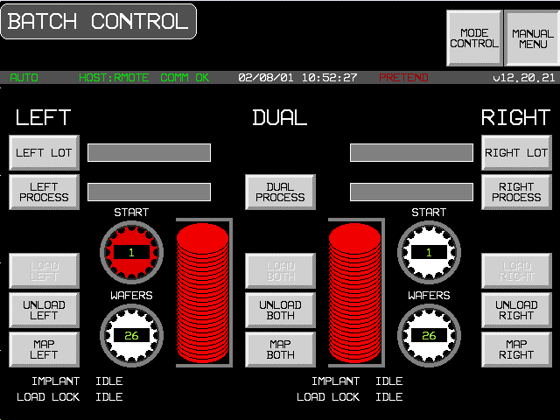
Version Introduced: 12.20

Remote Process Control Scenario (Formatted Process Program)
Equipment’s Communications state is ENABLED and COMMUNICATING. The Control state is ON-LINE and REMOTE. The exchanges shown below may take place in a different sequence because of undeterministic timing between the various devices of the E220.
Operator switches to Host Control screen.
COMMENT | HOST | EQUIPMENT | COMMENT
 |  |  | Idle State - Waiting for command from operator or Host
[IF]Operator gives batch ID to Host,
[THEN] Process Program request from HOST initiated
[IF] Process Program not present in EPPD
[THEN]
[IF] Process Program is multi-block
[THEN]
Process Program Load Inquire | S7,F1-->
 |  | <--S7,F2 | Process Program Load Grant
[END_IF]
Formatted Process Program Send | S7,F23-->
 |  | <--S7,F24 | Formatted Process Program Acknowledge
Verify Process Program
[IF]S7,F27 is multi-block
[THEN]
 |  | <--S7,F29 | Process Program Verification Inquire
Process Program Verification Grant | S7,F30--> |  | [END_IF]
 |  | <--S7,F27 | Process Program Verification Send
Process Program Verification Acknowledge | S7,F28-->
[ELSE] Operator selects process from recipe index on E220.
[ENDIF]
Return to Idle State

REMOTE COMMAND with PPSELECT | S2,F41-->
 |  | <--S2,F42 | Host Command Acknowledge  Event Process Program Selected  [IF] Acknowledge Negative  [THEN] Return to Idle State
 |  | <--S6,F11 | Operator places wafers into loadlocks  [IF ENABLED]  CEID = 85  Material Sensed at Port
Event Report Acknowledge | S6,F12-->
 |  | <--S6,F11 | [IF] Operator touches GO icon on Host Control Screen  [THEN]  [IF ENABLED]  CEID = 73  Operator Command Issued
Event Report Acknowledge | S6,F12-->
 |  |  | [ELSE] Wait for command from Host
REMOTE COMMAND START | S2,F41-->
 |  | <--S2,F42 | Host Command Acknowledge  [IF] Acknowledge Negative  [THEN] Return to Idle State
 |  | <--S6,F11 | [IF ENABLED]  CEID = 86  HOST COMMAND STARTED
Event Report Acknowledge | S6,F12-->
 |  | <--S6, F11 | Equipment begins setup for implanting wafer  [IF ENABLED]  CEID = 75  Process state change
Event Report Acknowledge | S6, F12--> | <--S6,F11 | [IF ENABLED]  CEID = 27  Elevator pump started
Event Report Acknowledge | S6,F12-->
 |  | <--S6,F11 | [IF ENABLED]  CEID = 25  Door close started
Event Report Acknowledge | S6,F12-->
 |  | <--S6,F11 | [IF ENABLED]  CEID = 26  Door close completed
Event Report Acknowledge | S6,F12-->
 |  | <--S6,F11 | [IF ENABLED]  CEID = 38  Wafer mapping started
Event Report Acknowledge | S6,F12-->
 |  | <--S6,F11 | [IF ENABLED]  CEID = 39  Wafer mapping completed
Event Report Acknowledge | S6,F12-->
 |  | <--S6,F11 | [IF ENABLED]  CEID = 28  Elevator pump completed
Event Report Acknowledge  Event Report Acknowledge | S6,F12-->  S6, F12--> | <--S6,F11 | [IF ENABLED]  CEID = 75  Process state change
 |  | <--S6,F11 | [IF ENABLED]  CEID = 5  Source setup started
Event Report Acknowledge | S6,F12-->
 |  | <--S6,F11 | [IF ENABLED]  CEID = 6  Source setup complete
Event Report Acknowledge | S6,F12-->
 |  | <--S6,F11 | [IF ENABLED]  CEID = 7  Beamline setup started
Event Report Acknowledge | S6,F12-->
 |  | <--S6,F11 | [IF ENABLED]  CEID = 8  Beamline setup complete
Event Report Acknowledge | S6,F12-->
 |  | <--S6,F11 | [IF ENABLED]  CEID = 9  Beamscan setup started
Event Report Acknowledge | S6,F12-->
 |  | <--S6,F11 | [IF ENABLED]  CEID = 10  Beamscan setup complete
Event Report Acknowledge | S6,F12-->
 |  | <--S6,F11 | [IF ENABLED]  CEID =75  Process State Change
Event Report Acknowledge | S6,F12-->
 |  |  | Equipment is idle waiting for Start Command
Host Command START Sent (RCMD = 4) | S2,F41-->
 |  | <--S2,F42 | Host Command Acknowledge  HCACK = 0 (assumes command can be performed).
 |  | <--S6,F11 | [IF ENABLED]  CEID = 86  Host command issued
Event Report Acknowledge | S6,F12-->
 |  | <--S6,F11 | [IF ENABLED]  CEID = 75  Process state change
Event Report Acknowledge | S6,F12-->
 |  |  | [IF] 1st Wafer
 |  | <--S6,F11 | [THEN]  [IF ENABLED]  CEID = 11  Batch started
Event Report Acknowledge | S6,F12--> |  | [ENDIF]
 |  |  | [LOOP]
 |  | <--S6,F11 | CEID = 13  Wafer started
Event Report Acknowledge | S6,F12-->
[IF] PAUSE RECEIVED FROM HOST OR OPERATOR
[THEN] EVENT PAUSE STATE
[WAIT]
[IF] HOST SEND S2,F41 OR OPERATOR PRESSES CONTINUE
[THEN]
EVENT EXECUTING
 |  | <--S6,F11 | CEID = 14  Wafer complete
[IF] PROCESS PROGRAM COMMAND IS SET TO PERIODICALLY CHECK THE BEAM AND TIMEOUT OCCURS
[THEN] BEAMCHECK IS DONE
[IF] FAILS
[THEN] BEAM SCAN
IS DONE
[IF] Last wafer
[THEN] Exit loop [END_LOOP]
[ENDIF]

Event Report Acknowledge | S6,F12-->
 |  | <--S6,F11 | CEID = 12  Batch complete
Event Report Acknowledge | S6,F12-->
 |  | <--S6,F11 | [IF ENABLED]  CEID = 21  Elevator vent started
Event Report Acknowledge | S6,F12-->
 |  | <--S6,F11 | [IF ENABLED]  CEID = 23  Door open started
Event Report Acknowledge | S6,F12-->
 |  | <--S6,F11 | [IF ENABLED]  CEID = 24  Door open completed
Event Report Acknowledge | S6,F12-->
 |  | <--S6,F11 | [IF ENABLED]  CEID = 22  Elevator vent completed
Event Report Acknowledge  Event Report Acknowledge | S6,F12-->  S6,F12--> | <--S6,F11 | [IF ENABLED]  CEID = 65  Pivot extend complete
 |  | <--S6,F11 | [IF ENABLED]  CEID = 75  Process state change
Event Report Acknowledge | S6,F12-->
 |  | <--S6,F11 | [IF ENABLED]  CEID = 41  Cassette removed
Event Report Acknowledge | S6,F12-->
 |  | <--S6,F11 | [IF ENABLED]  CEID = 84  Ready to receive material
Event Report Acknowledge | S6,F12-->
 |  |  | Waiting for command from operator or Host

Local Process Control Scenario
Equipment’s Communications state is ENABLE and COMMUNICATING. The Equipment’s Control state is ON-LINE and LOCAL. The Host shall be prohibited from the use of remote commands that cause physical movement or initiate processing by operator switching to LOCAL mode. Also, the Host shall not modify Equipment constants that could affect a process in progress. The exchanges shown below may not take place in the order shown because of timing considerations between the various devices which are part of the E220.
Operator switches to Batch Status screen.
COMMENT | HOST | EQUIPMENT | COMMENT
 |  |  | Idle State - Waiting for command from operator
 |  |  | Operator selects PPID from the Recipe Index screen. Operator switches to Batch status screen.
 |  | <--S6,F11 | Operator presses Go button  [IF ENABLED]  CEID = 73  Operator Command Issued
Event Report Acknowledge | S6,F12--> |  | Equipment begins setup for implanting wafer
 |  | <--S6,F11 | [IF ENABLED]  CEID = 75  Process state change
Event Report Acknowledge | S6,F12-->
 |  |  | Equipment begins setup for implanting wafer
 |  | <--S6,F11 | [IF ENABLED]  CEID = 27  Elevator pump started
Event Report Acknowledge | S6,F12-->
 |  | <--S6,F11 | [IF ENABLED]  CEID = 25  Door close started
Event Report Acknowledge | S6,F12-->
 |  | <--S6,F11 | [IF ENABLED]  CEID = 26  Door close completed
Event Report Acknowledge | S6,F12-->
 |  | <--S6,F11 | [IF ENABLED]  CEID = 38  Wafer mapping started
Event Report Acknowledge | S6,F12-->
 |  | <--S6,F11 | [IF ENABLED]  CEID = 39  Wafer mapping completed
Event Report Acknowledge | S6,F12-->
 |  | <--S6,F11 | [IF ENABLED]  CEID = 28  Elevator pump completed
Event Report Acknowledge  Event Report Acknowledge | S6,F12-->  S6, F12--> | <--S6,F11 | [IF ENABLED]  CEID = 75  Process state change
 |  | <--S6,F11 | [IF ENABLED]  CEID = 5  Source setup started
Event Report Acknowledge | S6,F12-->
 |  | <--S6,F11 | [IF ENABLED]  CEID = 6  Source setup complete
Event Report Acknowledge | S6,F12-->
 |  | <--S6,F11 | [IF ENABLED]  CEID = 7  Beamline setup started
Event Report Acknowledge | S6,F12-->
 |  | <--S6,F11 | [IF ENABLED]  CEID = 8  Beamline setup complete
Event Report Acknowledge | S6,F12-->
 |  | <--S6,F11 | [IF ENABLED]  CEID = 9  Beamscan setup started
Event Report Acknowledge | S6,F12-->
 |  | <--S6,F11 | [IF ENABLED]  CEID = 10  Beamscan setup complete
Event Report Acknowledge | S6,F12--> |  | [IF ENABLED]  CEID = 75  Process state change
 |  | <--S6,F11
Event Report Acknowledge | S6,F12-->
Operator presses Go button
[IF ENABLED]
CEID = 73
Operator command issued

 |  | <--S6,F11 | [IF ENABLED]  CEID = 75  Process state change
Event Report Acknowledge | S6,F12-->
 |  |  | [IF] 1st Wafer
 |  | <--S6,F11 | [THEN]  [IF ENABLED]  CEID = 11  Batch started
Event Report Acknowledge | S6,F12--> |  | [ENDIF]
 |  |  | [LOOP]
 |  | <--S6,F11 | CEID = 13  Wafer started
Event Report Acknowledge | S6,F12-->
[IF] PAUSE RECEIVED FROM HOST OR OPERATOR
[THEN] EVENT PAUSE STATE
[WAIT]
[IF] HOST SEND S2,F41 OR OPERATOR PRESSES CONTINUE
[THEN]
EVENT EXECUTING
 |  | <--S6,F11 | CEID = 14  Wafer complete
[IF] PROCESS PROGRAM COMMAND IS SET TO PERIODICALLY CHECK THE BEAM AND TIMEOUT OCCURS
[THEN] BEAMCHECK IS DONE
[IF] FAILS
[THEN] BEAM SCAN
IS DONE
[IF] Last wafer
[THEN] Exit loop [END_LOOP]
[ENDIF]

Event Report Acknowledge | S6,F12-->
 |  | <--S6,F11 | CEID = 12  Batch complete
Event Report Acknowledge  Event Report Acknowledge | S6,F12-->  S6,F12--> | <--S6, F11 | [IF ENABLED]  CEID = 75  Process state change
 |  | <--S6,F11 | [IF ENABLED]  CEID = 21  Elevator vent started
Event Report Acknowledge | S6,F12-->
 |  | <--S6,F11 | [IF ENABLED]  CEID = 23  Door open started
Event Report Acknowledge | S6,F12-->
 |  | <--S6,F11 | [IF ENABLED]  CEID = 24  Door open completed
Event Report Acknowledge | S6,F12-->
 |  | <--S6,F11 | [IF ENABLED]  CEID = 22  Elevator vent completed
Event Report Acknowledge  Event Report Acknowledge | S6,F12-->  S6, F12 | <--S6, F11 | [IF ENABLED}  CEID = 65  Pivot extend complete
 |  | <--S6,F11 | [IF ENABLED]  CEID = 75  Process state change
Event Report Acknowledge | S6,F12-->
 |  | <--S6,F11 | [IF ENABLED]  CEID =41  Cassette removed
Event Report Acknowledge | S6,F12-->
 |  | <--S6,F11 | [IF ENABLED]  Event report, CEID = 84  Ready to receive material
Event Report Acknowledge | S6,F12-->
 |  |  | Idle State - Waiting for operator command

Off-Line Process Control Scenario
Equipment’s Communications state is DISABLED
COMMENT | HOST | EQUIPMENT | COMMENT
 |  |  | Idle State - Waiting for operator command
Operator enters batch ID
Selects Process Program from Recipe index screen
Process Program load
 |  |  | Operator presses Go button
 |  |  | Equipment begins setup for implanting wafer
 |  |  | Elevator pump started
 |  |  | Pivot retract started
 |  |  | Pivot retract completed
 |  |  | Door close started
 |  |  | Door close completed
 |  |  | Wafer mapping started
 |  |  | Wafer mapping completed
 |  |  | Elevator pump completed
 |  |  | Source setup complete
 |  |  | Beamline setup started
 |  |  | Beamline setup complete
 |  |  | Beamscan setup started
 |  |  | Beamscan setup complete
 |  |  | [IF] 1st Wafer
 |  |  | [THEN] Batch started
 |  |  | [ENDIF]
 |  |  | [LOOP]
 |  |  | Wafer started
 |  |  | Wafer complete
[IF] Last wafer
[THEN] Exit loop
[END_LOOP]
 |  |  | Elevator vent started
 |  |  | Door open started
 |  |  | Door open completed
 |  |  | Elevator vent completed
[IF] Last cassette
[THEN] Exit loop
[ELSE IF] 2nd cassette loaded
[THEN] Continue processing
[ELSE] Load 2nd cassette, continue processing
[ENDIF]
 |  |  | Batch complete
 |  |  | Idle State - Waiting for operator to enter new batch ID

Host Requests Event Report
The Equipment’s Communication state is ENABLE and COMMUNICATING. The Equipment’s Control state is ON-LINE.
COMMENT | HOST | EQUIPMENT | COMMENT
Host requests an event report | S6,F15-->
 |  | <--S6,F16 | Equipment sends Event Report

Host initiated On-line Identification
The Equipment’s Communications state is ENABLE and COMMUNICATING; the Control state is ON-LINE. This does not change the label of the LOCAL button or switch modes.
COMMENT | HOST | EQUIPMENT | COMMENT
Are you there? | S1,F1-->
 |  | <--S1,F2 | Equipment replies with MDLN and SOFTREV.

Message Fault due to Unrecognized Device ID
The Equipment’s Communications state is ENABLE and COMMUNICATING; the Control state is ON-LINE.
COMMENT | HOST | EQUIPMENT | COMMENT
Host sends a message | Sx,Fx-->
 |  |  | Equipment detects an unrecognized device ID within message from the host.
 |  | <--S9,F1 | Equipment reports to the host that an "unrecognized device ID" was detected in the received message

Message Fault due to Unrecognized Stream Type
The Equipment’s Communications state is ENABLE and COMMUNICATING; the Control state is ON-LINE.
COMMENT | HOST | EQUIPMENT | COMMENT
Host sends a message | Sx,Fx-->
 |  |  | Equipment detects an unrecognized stream type within message from the host.
 |  | <--S9,F3 | Equipment reports to the host that an "unrecognized stream type" was detected in the receive message

Message Fault due to Unrecognized Function type
The Equipment’s Communications state is ENABLE and COMMUNICATING; the Control state is ON-LINE.
COMMENT | HOST | EQUIPMENT | COMMENT
Host sends a message | Sx,Fy-->
 |  |  | Equipment detects an unrecognized function type within message from the host.
 |  | <--S9,F5 | Equipment reports to the host that an "unrecognized function type" was detected in the receive message

Message Fault due to Illegal data format
The Equipment’s Communications state is ENABLE and COMMUNICATING; the Control state is ON-LINE.
COMMENT | HOST | EQUIPMENT | COMMENT
Host sends a message | Sx,Fy-->
 |  |  | Equipment detects an illegal data format within message from the host.
 |  | <--S9,F7 | Equipment reports to the host that an "illegal data format" was detected in the receive message

Message Fault due to Transaction Timer Timeout
The Equipment’s Communications state is ENABLE and COMMUNICATING; the Control state is ON-LINE..
COMMENT | HOST | EQUIPMENT | COMMENT
 |  | <--Sx,Fy | Equipment sends a message that requires a reply from the host.
 |  |  | Equipment does not receive an expected reply message from the host and a transaction timeout occurs.
 |  | <--S9,F9 | Equipment reports to the host that a transaction timer timeout occurred.

Message Fault due to data too long
The Equipment has established communication and is ON-LINE.
COMMENT | HOST | EQUIPMENT | COMMENT
Host sends a message | Sx,Fy-->
 |  |  | Equipment detects that the message from the host contains more data than it can handle.
 |  | <--S9,F11 | Equipment reports to the host that "data too long" was detected in the receive message.

Host Accepts ON-LINE
The Equipment’s Communications state is ENABLE and COMMUNICATING; the Control state is OFF-LINE.
Operator switches to Host Interface screen. Operator touches switch labeled OFF-LINE.
COMMENT | HOST | EQUIPMENT | COMMENT
 |  | <--S1,F1 | Equipment requests ON-LINE
Host grants ON-LINE | S1,F2-->
 |  | <--S6,F11 | "Control State LOCAL (or REMOTE)" event, CEID= 67/68
Acknowledge | S6,F12-->
Button’s label changes to ON-LINE.

Host denies ON-LINE
The Equipment’s Communications state is ENABLE and COMMUNICATING; the Control state is OFF-LINE.
Operator switches to Host Interface screen. Operator touches switch labeled OFF-LINE.
COMMENT | HOST | EQUIPMENT | COMMENT
 |  | <--S1,F1 | Equipment requests ON-LINE
Host denies ON-LINE | S1,F0-->
 |  |  | Equipment displays message to operator "HOST DENIES ON-LINE"

Operator Sets OFF-LINE
The Equipment’s Communications state is ENABLE and COMMUNICATING; the Control state is ON-LINE.
Operator switches to Host Interface screen. Operator touches switch labeled OFF-LINE.
COMMENT | HOST | EQUIPMENT | COMMENT
 |  | <--S6,F11 | Equipment sends Control state change event, CEID = 66
Acknowledge | S6,F12--> |  | An invalid response doesn’t prevent the Equipment from changing state.
Button’s label changes to OFF-LINE

Operator Sets REMOTE
The Equipment’s Communications state is ENABLE and COMMUNICATING; the Control state is ON-LINE (LOCAL).
Operator switches to Host Interface screen. Operator touches switch labeled REMOTE.
COMMENT | HOST | EQUIPMENT | COMMENT
 |  | <--S6,F11 | Equipment sends Control state change event, CEID = 68
Acknowledge | S6,F12-->
Button’s label changes to REMOTE.

Operator Sets LOCAL
The Equipment’s Communications state is ENABLE and COMMUNICATING; the Control state is ON-LINE (REMOTE).
Operator switches to Host Interface screen. Operator touches switch labeled REMOTE.
COMMENT | HOST | EQUIPMENT | COMMENT
 |  | <--S6,F11 | Equipment sends Control state change event, CEID = 67
Acknowledge | S6,F12--> |  | An invalid response doesn’t prevent the Equipment from changing state.
Button’s label changes to LOCAL

Host Requests Report
The Equipment’s Communications state is ENABLE and COMMUNICATING; the Control state is ON-LINE.
COMMENT | HOST | EQUIPMENT | COMMENT
Host requests data variables contained in report RPTID | S6,F19-->
 |  | <--S6,20 | Equipment responds with a list if variable data for the given RPTID

Host Initiates Trace Report
The Equipment’s Communications state is ENABLE and COMMUNICATING; the Control state is ON-LINE.
COMMENT | HOST | EQUIPMENT | COMMENT
Trace Data Initialization requested | S2,F23-->
 |  | <--S2,F24 | Acknowledge, trace initiated
[DO] TOTSMP REPGSZ times
[DO] REPSGZ many times:
collect SVID1....SVIDn data,
delay time by DSPER.
[END_DO]
 |  | <--S6,F1 | Send SV1....SVn
Acknowledge receipt | S6,F2-->
 |  |  | [END_DO]
OPTIONAL:
Request trace termination prior to completion (TOTSMP = 0) | S2,F23-->
 |  | <--S2,F24 | Acknowledge premature termination

Zone Transition Event occurs in Equipment
The Equipment’s Communications state is ENABLE and COMMUNICATING; the Control state is ON-LINE.
COMMENT | HOST | EQUIPMENT | COMMENT
 |  | <--S6,F5 | [IF] Event Report is Multi-block  [THEN] send Multi-block inquire
Multi-block Grant | S6,F6-->
 |  |  | [ENDIF]
 |  | <--S6,F11 | [IF ENABLED]  Equipment sends Event Report
Host Acknowledges Event Report | S6,F12-->

Host defines Limit Attributes
The Equipment’s Communications state is ENABLE and COMMUNICATING; the Control state is ON-LINE.
COMMENT | HOST | EQUIPMENT | COMMENT
[IF] S2,F45 is Multi-block  [THEN] Send Multi-block inquire | S2,F39-->
 |  | <--S2,F40 | Multi-block Grant
[ENDIF]
Host defines variable limit attributes. | S2,F45-->
 |  | <--S2,F46 | Equipment acknowledges host request.

Host queries Equipment for current limit
The Equipment’s Communications state is ENABLE and COMMUNICATING; the Control state is ON-LINE.
COMMENT | HOST | EQUIPMENT | COMMENT
Host queries Equipment for current variable limit attribute definitions. | S2,F47-->
 |  | <--S2,F48 | Equipment returns report containing requested variable limit attribute values/

Request Equipment Status Report
The Equipment’s Communications state is ENABLE and COMMUNICATING; the Control state is ON-LINE.
COMMENT | HOST | EQUIPMENT | COMMENT
Host requests report of selected status variable values | S1,F3-->
 |  | <--S1,F4 | Equipment responds with the requested status variable data.

Request Equipment Status Variable Namelist
The Equipment’s Communications state is ENABLE and COMMUNICATING; the Control state is ON-LINE.
COMMENT | HOST | EQUIPMENT | COMMENT
Host requests Equipment to identify selected status variables | S1,F11-->
 |  | <--S1,F12 | Equipment responds with the requested status variable descriptions.

Enable/Disable Alarms
The Equipment’s Communications state is ENABLE and COMMUNICATING; the Control state is ON-LINE.
COMMENT | HOST | EQUIPMENT | COMMENT
Enable/disable Alarm | S5,F3-->

Upload Alarm Information
The Equipment’s Communications state is ENABLE and COMMUNICATING; the Control state is ON-LINE.
COMMENT | HOST | EQUIPMENT | COMMENT
Request alarm data/text | S5,F5-->
 |  | <--S5,F6 | Send alarm data/text

Send Alarm Report
The Equipment’s Communications state is ENABLE and COMMUNICATING; the Control state is ON-LINE.
Alarm occurrence is detected by the Equipment
COMMENT | HOST | EQUIPMENT | COMMENT
 |  | <--S5,F1 | [IF ENABLED]  Send alarm report
Acknowledge | S5,F2-->
 |  | <--S6,F11 | [IF ENABLED]  Send event report.
Acknowledge | S6,F12-->

Host sends Remote Command
The Equipment’s Communications state is ENABLE and COMMUNICATING; the Control state is ON-LINE.
COMMENT | HOST | EQUIPMENT | COMMENT
Host Command Send | S2,F41-->
 |  | <--S2,F42 | Host Command Acknowledge  HCACK = 0 (assumes command can be performed).
 |  | <--S6,F11 | [IF ENABLED]  Event Report - state change or other collection event occurrence
Event Report Acknowledge | S6,F12-->

Host Sends Equipment Constants
The Equipment’s Communications state is ENABLE and COMMUNICATING; the Control state is ON-LINE. Note: In order for E220 to accept the change, E220 is in the idle state and touch screen is not in GEM interface.
COMMENT | HOST | EQUIPMENT | COMMENT
Host sends Equipment constants | S2,F15-->

Host Equipment Constants Request
The Equipment’s Communications state is ENABLE and COMMUNICATING; the Control state is ON-LINE.
COMMENT | HOST | EQUIPMENT | COMMENT
Host constant request | S2,F13-->
 |  | <--S2,F14 | Equipment constants data

Host Equipment Constant Namelist Request
The Equipment’s Communications state is ENABLE and COMMUNICATING; the Control state is ON-LINE.
COMMENT | HOST | EQUIPMENT | COMMENT
Host constant namelist request | S2,F29-->
 |  | <--S2,F30 | Equipment constant namelist

Operator Changes Equipment Constant
The Equipment’s Communications state is ENABLE and COMMUNICATING; the Control state is ON-LINE.
COMMENT | HOST | EQUIPMENT | COMMENT
 |  |  | Operator changes Equipment constant at Equipment’s operator console
 |  | <--S6,F11 | [IF ENABLED]  Equipment reports Equipment constant change, CEID = 76
Host acknowledges event | S6,F12-->

Process Program Created, Edited, or Deleted by Operator
The Equipment’s Communications state is ENABLE and COMMUNICATING; the Control state is ON-LINE.
COMMENT | HOST | EQUIPMENT | COMMENT
New process program created, edited, or deleted by operator at Equipment.
PPChangeName = PPID
PPChangeStatus = 1 (Created)
= 2 (Edited)
= 3 (Deleted)
[IF] CEID for Process Program Change Event enabled
[THEN]
 |  | <--S6,F11 | [IF ENABLED]  Event report, CEID = 79  Process program change
Event Report Acknowledge | S6,F12--> |  | [END_IF]

Process Program Deletion by Host
The Equipment’s Communications state is ENABLE and COMMUNICATING; the Control state is ON-LINE.
COMMENT | HOST | EQUIPMENT | COMMENT
Delete Process Program Send | S7,F17-->
 |  | <--S7,F18 | Delete Process Program Acknowledge. The process program is removed from non-volatile storage.

Process Program Directory Request
The Equipment’s Communications state is ENABLE and COMMUNICATING; the Control state is ON-LINE.
COMMENT | HOST | EQUIPMENT | COMMENT
Current EPPD Request | S7,F19-->
 |  | <--S7,F20 | Current EPPD Data

Host-Initiated Process Program Upload - Formatted
The Equipment’s Communications state is ENABLE and COMMUNICATING; the Control state is ON-LINE.
COMMENT | HOST | EQUIPMENT | COMMENT
Formatted Process Program Request | S7,F25-->
 |  | <--S7,F26 | Formatted Process Program Data

Host-Initiated Process Program Upload - Unformatted
The Equipment’s Communications state is ENABLE and COMMUNICATING; the Control state is ON-LINE. The Equipment is NOT PROCESSING.
COMMENT | HOST | EQUIPMENT | COMMENT
Process Program Request | S7,F5-->
 |  | <--S7,F6 | Process Program Data (if process program does not exist zero-length list is sent).

Operator Initiated Process Program Upload - Formatted
The Equipment’s Communications state is ENABLE and COMMUNICATING; the Control state is ON-LINE. The Equipment is idle.
The operator switches to the Recipe Index screen, selects a process program, and presses the button labeled UPLOAD to HOST.
COMMENT | HOST | EQUIPMENT | COMMENT
[IF] Process program is multi-block
[THEN]
 |  | <--S7,F1 | Process Program Load Inquire
Process Program Load Grant | S7,F2--> |  | [END_IF]
 |  | <--S7,F23 | Formatted Process Program Send
Formatted Process Program Acknowledge | S7,F24-->

Operator Initiated Process Program Upload - Unformatted
The Equipment’s Communications state is ENABLE and COMMUNICATING; the Control state is ON-LINE.
The operator switches to the Recipe Index screen(see screen 2), selects a process program, and presses the button labeled UPLOAD to HOST.
COMMENT | HOST | EQUIPMENT | COMMENT
[IF] Process program is multi-block
[THEN]
 |  | <--S7,F1 | Process Program Load Inquire
Process Program Load Grant | S7,F2--> |  | [END_IF]
 |  | <--S7,F3 | Process Program Send
Process Program Acknowledge | S7,F4-->

Host-Initiated Process Program Download - Formatted
The Equipment’s Communications state is ENABLE and COMMUNICATING; the Control state is ON-LINE.
COMMENT | HOST | EQUIPMENT | COMMENT
[IF] Process Program is multi-block
[THEN]
Process Program Load Inquire | S7,F1-->
 |  | <--S7,F2 | Process Program Load Grant
[END_IF]
Formatted Process Program Send | S7,F23-->
 |  | <--S7,F24 | Formatted Process Program Acknowledge
Verify Process Program
[IF] S7,F27 is multi-block
[THEN]
 |  | <--S7,F29 | Process Program Verification Inquire
Process Program Verification Grant | S7,F30--> |  | [END_IF]
 |  | <--S7,F27 | Process Program Verification Send
Process Program Verification Acknowledge | S7,F28-->

Host initiated Process Program Download - Unformatted
The Equipment’s Communications state is ENABLE and COMMUNICATING; the Control state is ON-LINE.
COMMENT | HOST | EQUIPMENT | COMMENT
[IF] Process program is multi-block
[THEN]
Process Program Load Inquire | S7,F1-->
[END_IF] |  | <--S7,F2 | Process Program Load Grant
Process Program Send | S7,F3-->
 |  | <--S7,F4 | Process Program Acknowledge

Operator Initiated Process Program Download - Formatted
The Equipment’s Communications state is ENABLE and COMMUNICATING; the Control state is ON-LINE.
The operator switches to the Recipe Edit screen, selects a process program, and presses the button labeled DOWNLOAD from Host.
COMMENT | HOST | EQUIPMENT | COMMENT
 |  | <--S7,F25 | Formatted Process Program Request
Formatted Process Program Data | S7,F26-->
[IF] S7,F27 is multi-block
[THEN]
 |  | <--S7,F29 | Process Program Verification Inquire
Process Program Verification Grant | S7,F30--> |  | [END_IF]
 |  | <--S7,F27 | Process Program Verification Send
Process Program Verification Acknowledge | S7,F28-->
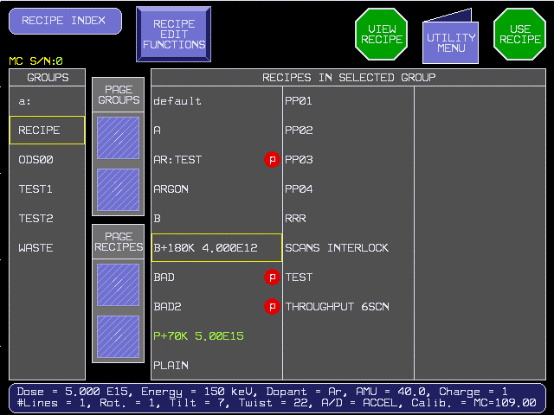

Operator Initiated Process Program Download - Unformatted
The Equipment’s Communications state is ENABLE and COMMUNICATING; the Control state is ON-LINE.
The operator switches to the Recipe IEdit screen (see screen 3), enters a process program, and pressesthe button labeled DOWN from HOST.
COMMENT | HOST | EQUIPMENT | COMMENT
 |  | <--S7,F5 | Process Program Request
Process Program Send | S7,F6-->

Material arrival/departs Equipment
The Equipment’s Communications state is ENABLE and COMMUNICATING; the Control state is ON-LINE.
COMMENT | HOST | EQUIPMENT | COMMENT
 |  |  | Material is sent or received at an Equipment Loadlock.
 |  | <--S6,F11 | [IF ENABLED]  CEID = 85  Material sensed at port
Host acknowledges | S6,F12-->

Host sends information to an Equipment's display device
The Equipment’s Communications state is ENABLE and COMMUNICATING; the Control state is ON-LINE.
COMMENT | HOST | EQUIPMENT | COMMENT
Host sends textual information to Equipment for display to the operator on terminal x. | S10,F3-->
 |  | <--S10,F4 | Equipment acknowledges request to display text. (Equipment sets unrecognized message indicator.)  Operator indicates message recognition. (Equipment clears unrecognized message indicator.)
 |  | <--S6,F11 | [IF ENABLED]  Event report, CEID = 81  Message recognition event.
Host acknowledges | S6,F12-->
Optional:
 |  | <--S10,F1 | Operator responds with text via terminal x.
Host acknowledges receipt of operator text. | S10, F2

Host sends information to an Equipment's display device and then overwrites the information before operator recognizes message
The Equipment’s Communications state is ENABLE and COMMUNICATING; the Control state is ON-LINE.
COMMENT | HOST | EQUIPMENT | COMMENT
Host sends textual information to Equipment for display to the operator on terminal x. | S10,F3-->
 |  | <--S10,F4 | Equipment acknowledges request to display text. (Equipment sets unrecognized message indicator.)
Host sends textual information to Equipment for display to the operator on terminal x. This message overwrites the first one sent by the host since it is still unrecognized. | S10,F3-->
 |  | <--S10,F4 | Equipment acknowledges request to display text. (Equipment sets unrecognized message indicator.)  Operator indicates message recognition. (Equipment clears unrecognized message indicator.)
 |  | <--S6,F11 | [IF ENABLED]  Event report, CEID=81  Message recognition event.
Host acknowledges | S6,F12

Operator sends information to the host
The Equipment’s Communications state is ENABLE and COMMUNICATING; the Control state is ON-LINE.
COMMENT | HOST | EQUIPMENT | COMMENT
 |  | <--S10,F1 | Operator sends textual information via Equipment terminal x.
Host acknowledges receipt of operator initiated message. | S10,F2-->
Optional:  Host responds with information for display to the operator on terminal x. | S10,F3-->
 |  | <--S10,F4 | Equipment acknowledges receipt of request to display text. (Equipment sets unrecognized message indicator.)  Operator indicates message recognition.  [IF ENABLED]  Event report, CEID =81
 |  | <--S6,F11 | Message recognition event.
Host acknowledges | S6,F12

Host sends a multi-block display message
The Equipment’s Communications state is ENABLE and COMMUNICATING; the Control state is ON-LINE.
COMMENT | HOST | EQUIPMENT | COMMENT
Send information | S10,F5-->
 |  | <--S10,F6 | Accepted or denied.  [IF]  Message from host is multi-block and multi-block is not supported by the Equipment,  [THEN]
 |  | <--S10,F7 | Send Multi-block Not Allowed.  [END_IF]

Equipment Requests TIME
The Equipment’s Communications state is ENABLE and COMMUNICATING; the Control state is ON-LINE.
COMMENT | HOST | EQUIPMENT | COMMENT
 |  | <--S2,F17 | Equipment requests a time value from the host
Host responds with a time value | S2,F18-->
 |  |  | Equipment sets its internal time reference to the value of TIME received from the host.

Host Instructs Equipment to Set Time
The Equipment’s Communications state is ENABLE and COMMUNICATING; the Control state is ON-LINE.
COMMENT | HOST | EQUIPMENT | COMMENT
Host instructs Equipment to set its time | S2,F31-->
 |  | <--S2F32 | Equipment sets its internal time reference to the value of TIME received from the host and acknowledges completion.

Host Requests Equipment's Current Time Value
The Equipment’s Communications state is ENABLE and COMMUNICATING; the Control state is ON-LINE.
COMMENT | HOST | EQUIPMENT | COMMENT
Host requests Equipment time. | S2,F17-->
 |  | <--S2,F18 | Equipment returns its internal time reference value to the host.

VILL Remote Process Control Scenario (Formatted Process Program)
Vacuum Independent Loadlocks (ECO 90) is selected.
Equipment’s Communications State is ENABLED and COMMUNICATING.
The Control State is ON-LINE and REMOTE.
Note: Because left and right processes are interleaved, completion event sequence will differ. Completion events in the following scenario are grouped by the side on which they occurred.
Operator switches to Host Control screen.
COMMENT | HOST | EQUIPMENT | COMMENT
 |  |  | Idle State - Waiting for command from operator or Host
[IF]Operator gives batch ID to Host,
[THEN] Process Program request from HOST initiated
Download Left Process Program if it does not exist on the equipment.
[IF] Process Program not present in EPPD
[THEN]
Process Program Load Inquiry | S7,F1-->
 |  | <--S7,F2 | Process Program Load Grant
Process Program Send | S7,F3-->
[ENDIF] |  | <--S7,F4 | Process Program Acknowledge
[ELSE] Operator selects process from recipe index on E220.
[ENDIF]
Return to Idle State

REMOTE COMMAND with PPSELECT | S2,F41-->
 |  | <--S2,F42 | Host Command Acknowledge  Event Process Program Selected  [IF] Acknowledge Negative  [THEN] Return to Idle State  [ELSE]Equipment displays PPID on Host Control screen.
 |  | <--S6,F11 | [IF ENABLED]  CEID = 80  Process Program Selected  SVID 151 = 1  SVID 228 = LEFT-PPID
Event Report Acknowledge | S6,F12-->
 |  | <--S6,F11 | [IF ENABLED]  CEID = 42  Ready to process  SVID 151 (PORT-ID) =1  Svid 227 (left-ppid) = left PPID
Event Report Acknowledge | S6,F12-->
 |  |  | Operator verifies PPID
At this point, another PPSELECT REMOTE COMMAND with a different PPID on the right side MAY be issued.

After the PPSELECT, if the Right Go button is pressed or a START-RIGHT REMOTE COMMAND is issued, the process will be queued if another process on the left side has already been started. The queued process will start after the left side is done.

If a PPSELECT remote command with the PPID same as that of the left side is issued, processing may either be started on the right side only (by pressing the Right Go button or issuing a START-RIGHT remote command) or on both sides (by pressing the Go button or issuing a START remote command).

In this scenario, PPSELECT on the right side will be initiated after the left process is started.
 |  | <--S6,F11 | Operator places wafers into left loadlock  [IF ENABLED]  CEID = 85  Material sensed at port  SVID 151 = 1
Event Report Acknowledge | S6,F12-->
 |  | <--S6,F11 | [IF] Operator touches GO icon on Host Control Screen  [THEN]  [IF ENABLED]  CEID = 73  Operator Command Issued
Event Report Acknowledge | S6,F12-->
 |  | <--S6,F11 | [IF ENABLED]  CEID = 64  Go button pressed or Host  START command received
Event Report Acknowledge | S6,F12-->
 |  |  | [ELSE] Wait for command from Host
REMOTE COMMAND START-LEFT | S2,F41-->
 |  | <--S2,F42 | Host Command Acknowledge  [IF] Acknowledge Negative  [THEN] Return to Idle State
 |  | <--S6,F11 | [IF ENABLED]  CEID = 86  Host command issued
Event Report Acknowledge | S6,F12-->
 |  | <--S6,F11 | [IF ENABLED]  CEID = 64  Host START command issued
Event Report Acknowledge | S6,F12-->
 |  | <--S6,F11 | Equipment begins setup for implanting wafer  [IF ENABLED]  CEID =75  Process state change
Event Report Acknowledge | S6,F12-->
 |  | <--S6,F11 | [IF ENABLED]  CEID = 27  Elevator pump started  SVID 151 = 1
Event Report Acknowledge | S6,F12-->
 |  | <--S6,F11 | [IF ENABLED]  CEID = 25  Door close started  SVID 151 = 1
Event Report Acknowledge | S6,F12-->
 |  | <--S6,F11 | [IF ENABLED]  CEID = 26  Door close completed  SVID 151 = 1
Event Report Acknowledge | S6,F12-->
 |  | <--S6,F11 | [IF ENABLED]  CEID = 38  Wafer mapping started  SVID 151 = 1
Event Report Acknowledge | S6,F12-->
 |  | <--S6,F11 | [IF ENABLED]  CEID = 39  Wafer mapping completed  SVID 151 = 1
Event Report Acknowledge | S6,F12-->
 |  | <--S6,F11 | [IF ENABLED]  CEID = 28  Elevator pump completed  SVID 151 = 1
Event Report Acknowledge | S6,F12-->
While the left side is setting up, the right process may be initiated and queued.
PPSELECT REMOTE COMMAND on the right side with Process Program that may be different from left side | S2,F41-->
 |  | <--S2,F42 | Host Command Acknowledge  [IF] Acknowledge is negative  [THEN] Right side returns to Idle state.  [ELSE] Equipment displays right PPID on HOST Control screen.
 |  | <--S6,F11 | [IF ENABLED]  CEID = 80  Process Program Selected  SVID 151 = 2  SVID 228 = RIGHT-PPID
Event Report Acknowledge | S6,F12-->
 |  | <--S6,F11 | [IF ENABLED]  CEID = 42  Ready to process  SVID 151 = 2
Event Report Acknowledge | S6,F12-->
 |  | <--S6,F11 | Operator places wafers into right loadlock  [IF ENABLED]  CEID = 85  Material sensed at port  SVID 151 = 2
 | S6,F12-->
 |  | <--S6,F11 | [IF] Operator touches RIGHT GO icon on Host Control Screen  [THEN]  [IF ENABLED]  CEID = 73  Operator Command Issued
Event Report Acknowledge | S6,F12-->
 |  | <--S6,F11 | [IF ENABLED]  CEID = 64  Go button pressed
Event Report Acknowledge | S6,F12-->
 |  |  | [ELSE] Wait for command from Host while continuing to process left side.
REMOTE COMMAND START or START-RIGHT | S2,F41-->
 |  | <--S2,F42 | Host Command Acknowledge  [IF] Acknowledge is negative  [THEN] Right side returns to Idle State
 |  | <--S6,F11 | [IF ENABLED]  CEID = 86  Host command issued
Event Report Acknowledge | S6,F12-->
 |  | <--S6,F11 | [IF ENABLED]  CEID = 64  Host START command issued
Event Report Acknowledge | S6,F12-->
 |  | <--S6,F11 | [IF ENABLED]  CEID = 27  Elevator pump started  SVID 151 = 2
Event Report Acknowledge | S6,F12-->
 |  | <--S6,F11 | [IF ENABLED]  CEID = 25  Door close started  SVID 151 = 2
Event Report Acknowledge | S6,F12-->
 |  | <--S6,F11 | [IF ENABLED]  CEID = 26  Door close completed  SVID 151 = 2
Event Report Acknowledge | S6,F12-->
 |  | <--S6,F11 | [IF ENABLED]  CEID = 38  Wafer mapping started  SVID 151 = 2
Event Report Acknowledge | S6,F12-->
 |  | <--S6,F11 | [IF ENABLED]  CEID = 39  Wafer mapping completed  SVID 151 = 2
Event Report Acknowledge | S6,F12-->
 |  | <--S6,F11 | [IF ENABLED]  CEID = 28  Elevator pump completed  SVID 151 = 2
Event Report Acknowledge | S6,F12-->
Setup for left process continues while the right process waits in the queue.
 |  | <--S6,F11 | [IF ENABLED]  CEID =75  Process state change
Event Report Acknowledge | S6,F12--> | <--S6,F11 | [IF ENABLED]  CEID = 5  Source setup started
Event Report Acknowledge | S6,F12-->
 |  | <--S6,F11 | [IF ENABLED]  CEID = 6  Source setup complete
Event Report Acknowledge | S6,F12-->
 |  | <--S6,F11 | [IF ENABLED]  CEID = 7  Beamline setup started
Event Report Acknowledge | S6,F12-->
 |  | <--S6,F11 | [IF ENABLED]  CEID = 8  Beamline setup complete
Event Report Acknowledge | S6,F12-->
 |  | <--S6,F11 | [IF ENABLED]  CEID = 9  Beamscan setup started
Event Report Acknowledge | S6,F12-->
 |  | <--S6,F11 | [IF ENABLED]  CEID = 10  Beamscan setup complete
Event Report Acknowledge | S6,F12-->
 |  | <--S6,F11 | [IF ENABLED]  CEID = 75  Process state change
Event Report Acknowledge | S6,F12-->
[IF ECID 257 (MODES) bit S is not set (non-auto start after beamscan)]
[THEN]
Equipment is idle waiting for Start Command
[IF ECID 257 (MODES) bit S is not set]  [THEN]  Host Command  START-IMPLANT (RCMD  = 30) or  START (RCMD = 4) sent | S2,F41-->
 |  | <--S2,F42 | Host Command Acknowledge  HCACK = 0 (assumes command can be performed).
 |  | <--S6,F11 | [IF ENABLED]  CEID = 86  Host command issued
Event Report Acknowledge | S6,F12-->
[ENDIF ECID 257 bit S is not set]
 |  |  | [ENDIF ECID 257 bit S is not set]
 |  |  | [IF] 1st Wafer
 |  | <--S6,F11 | [THEN]  [IF ENABLED]  CEID = 11  Batch started
Event Report Acknowledge | S6,F12--> |  | [ENDIF]
 |  |  | [LOOP]
 |  | <--S6,F11 | CEID = 13  Wafer started
Event Report Acknowledge | S6,F12-->
[IF] PAUSE RECEIVED FROM HOST OR OPERATOR
[THEN] EVENT PAUSE STATE
[WAIT]
[IF] HOST SEND START OR OPERATOR PRESSES CONTINUE
[THEN]
EVENT EXECUTING
 |  | <--S6,F11 | CEID = 14  Wafer complete
[IF] PROCESS PROGRAM COMMAND IS SET TO PERIODICALLY CHECK THE BEAM AND TIMEOUT OCCURS
[THEN] BEAMCHECK IS DONE
[IF] FAILS
[THEN] BEAM SCAN
IS DONE
[IF] Last wafer
[THEN] Exit loop [END_LOOP]
[ENDIF]

Event Report Acknowledge | S6,F12-->
 |  | <--S6,F11 | CEID = 12  Batch complete
Event Report Acknowledge | S6,F12-->
 |  |  | SCREEN CHANGES TO HOST CONTROL
At this point, while the left side starts its vent sequence, the right side starts setting up.

Messages from the left and right sides will be interleaved.

Note: Right side setup, implant and vent sequences will not be shown here.
 |  |  | IF ECID 257 bit V is set, unloading is initiated automatically, else, an explicit LEFT-VENT-OPEN remote command or an UNLOAD must be issued to start unloading.
 |  |  | [IF ECID 257 bit V is not set]
 |  | <--S6,F11 | [IF] Operator touches LEFT  UNLOAD button on the  Host Control Screen  [THEN]  [IF ENABLED]  CEID = 73  Operator Command Issued
Event Report Acknowledge | S6,F12-->
[ELSE] Wait for command from
Host while continuing to
process right side.
REMOTE COMMAND  LEFT-VENT-OPEN | S2,F41-->
 |  | <--S2,F42 | Host Command Acknowledge  [IF] Acknowledge is negative  [THEN] Return to Idle State
 |  | <--S6,F11 | [IF ENABLED]  CEID = 86  Host command issued
Event Report Acknowledge | S6,F12-->
 |  |  | [ENDIF ECID 257 bit V is not set]
 |  | <--S6,F11 | [IF ENABLED]  CEID = 21  Elevator vent started  SVID 151 = 1
Event Report Acknowledge | S6,F12-->
 |  | <--S6,F11 | [IF ENABLED]  CEID = 23  Door open started  SVID 151 = 1
Event Report Acknowledge | S6,F12-->
 |  | <--S6,F11 | [IF ENABLED]  CEID = 24  Door open completed  SVID 151 = 1
Event Report Acknowledge | S6,F12-->
 |  | <--S6,F11 | [IF ENABLED]  CEID = 22  Elevator vent completed  SVID 151 = 1
Event Report Acknowledge | S6,F12-->
 |  | <--S6,F11 | [IF ENABLED]  CEID =65  Pivot extend complete  SVID 151 = 1
Event Report Acknowledge  Event Report Acknowledge | S6,F12-->  S6,F12--> | <--S6,F11 | [IF ENABLED]  CEID= 75  Process state change
 |  | <--S6,F11 | [IF ENABLED]  CEID =41  Cassette(s) removed  SVID 151 = 1
Event Report Acknowledge  Event Report Acknowledge | S6,F12-->  S6, F12 --> |  | [IF ENABLED]  CEID =46  Cassette sense status change  SVID 151 = 1
 |  | <--S6,F11 | [IF ENABLED]  CEID = 84  Ready to receive material  SVID 151 = 1
Event Report Acknowledge | S6,F12-->
As the left side vents, the right side continues to setup, implant and eventually vent.

Note: Right side setup, implant and vent sequences are the same as that of the left side and will not be shown here.

.
.
.
Right side sets up, implants and vents
.
.
.
Equipment goes back to idle.
Waiting for command from operator or Host

Effective Throughput Queue Process Control Scenario
Host scenario with and without SMIF
VILL Remote Process with Process Job Queue Control Scenario (Formatted Process Program)
Process Job Queue (ECO 104) is selected.
Vacuum Independent Loadlocks (ECO 90) is selected.
Clear PPID after Implant (ECO 39) is deselected.
Equipment’s Communications State is ENABLED and COMMUNICATING.
The Control State is ON-LINE and REMOTE.
Note: Because left and right processes are interleaved, completion event sequence will differ.
Operator switches to Host Control screen.
COMMENT | HOST | EQUIPMENT | COMMENT
 |  |  | Idle State - Waiting for command from operator or Host
[IF]Operator gives batch ID to Host,
[THEN] Process Program request from HOST initiated
Download Left Process Program if it does not exist on the equipment.
[IF] Process Program not present in EPPD
[THEN]
Process Program Load Inquiry | S7,F1-->
 |  | <--S7,F2 | Process Program Load Grant
Process Program Send | S7,F3-->
[ENDIF] |  | <--S7,F4 | Process Program Acknowledge
[ELSE] Operator selects process from recipe index on E220.
[ENDIF]
Return to Idle State

REMOTE COMMAND with PPSELECT  dual batch will be used in this scenario, but may be single batch. | S2,F41-->
 |  | <--S2,F42 | Host Command Acknowledge  Event Process Program Selected  [IF] Acknowledge Negative  [THEN] Return to Idle State  [ELSE]Equipment displays PPID on Host Control screen.
 |  | <--S6,F11 | [IF ENABLED]  CEID = 80  Process Program Selected
Event Report Acknowledge | S6,F12-->
 |  | <--S6,F11 | [IF ENABLED]  CEID = 42  Ready to process
Event Report Acknowledge | S6,F12-->
 |  |  | Operator verifies PPID
 |  | <--S6,F11 | Operator places wafers into left loadlock  [IF ENABLED]  CEID = 85  Material sensed at port  SVID 151 = 1
Event Report Acknowledge | S6,F12-->
 |  | <--S6,F11 | Operator places wafers into right loadlock  [IF ENABLED]  CEID = 85  Material sensed at port  SVID 151 = 2
Event Report Acknowledge | S6,F12-->
START Remote Command Trigger

If the Equipment has SMIFs the host can use events such as ‘SMIF LOADING COMPLETE’ as trigger in sending the START remote command.

If the Equipment is loaded by an operator, the host can use CEID = 85 as trigger in sending the START remote command.

If the host sent a PPSELECT with LOC = 3 (dual-sided), it should wait for the trigger events for both loadlocks. For single-sided PPSELECT, the host should wait for the trigger event on the processing side.

(see S6,F11 with CEID = 85 above)
REMOTE COMMAND START | S2,F41-->
 |  | <--S2,F42 | Host Command Acknowledge  [IF] Acknowledge Negative  [THEN] Return to Idle State
 |  | <--S6,F11 | [IF ENABLED]  CEID = 86  Host command issued
Event Report Acknowledge | S6,F12-->
 |  | <--S6,F11 | [IF ENABLED]  CEID = 64  Host START command issued
Event Report Acknowledge | S6,F12-->
 |  | <--S6,F11 | Equipment begins setup for implanting wafer  [IF ENABLED]  CEID =75  Process state change
Event Report Acknowledge | S6,F12-->
 |  | <--S6,F11 | [IF ENABLED]  CEID = 27  Elevator pump started  two events for both sides
Event Report Acknowledge | S6,F12-->
 |  | <--S6,F11 | [IF ENABLED]  CEID = 25  Door close started  two events for both sides
Event Report Acknowledge | S6,F12-->
 |  | <--S6,F11 | [IF ENABLED]  CEID = 38  Wafer mapping started  two events for both sides
Event Report Acknowledge | S6,F12-->
 |  | <--S6,F11 | [IF ENABLED]  CEID = 39  Wafer mapping completed  two events for both sides
Event Report Acknowledge | S6,F12-->
 |  | <--S6,F11 | [IF ENABLED]  CEID = 28  Elevator pump completed  two events for both sides
Event Report Acknowledge | S6,F12-->
While this batch is setting up, the next recipe may be queued.
REMOTE COMMAND with PPSELECT | S2,F41-->
 |  | <--S2,F42 | Host Command Acknowledge  [IF] Acknowledge Negative  [THEN] Lineup queue might already be full. SVID 171 may be checked to verify this.  [ELSE] Equipment accepts the recipe in the lineup queue and displays PPID if HOST Control screen is active.
 |  | <--S6,F11 | [IF ENABLED]  CEID = 80  Process Program Selected
Event Report Acknowledge | S6,F12-->
Setup for the first process continues while the next recipe waits in the lineup queue.
 |  | <--S6,F11 | [IF ENABLED]  CEID =75  Process state change
Event Report Acknowledge | S6,F12--> | <--S6,F11 | [IF ENABLED]  CEID = 5  Source setup started
Event Report Acknowledge | S6,F12-->
 |  | <--S6,F11 | [IF ENABLED]  CEID = 6  Source setup complete
Event Report Acknowledge | S6,F12-->
 |  | <--S6,F11 | [IF ENABLED]  CEID = 7  Beamline setup started
Event Report Acknowledge | S6,F12-->
 |  | <--S6,F11 | [IF ENABLED]  CEID = 8  Beamline setup complete
Event Report Acknowledge | S6,F12-->
 |  | <--S6,F11 | [IF ENABLED]  CEID = 9  Beamscan setup started
Event Report Acknowledge | S6,F12-->
 |  | <--S6,F11 | [IF ENABLED]  CEID = 10  Beamscan setup complete
Event Report Acknowledge | S6,F12-->
 |  | <--S6,F11 | [IF ENABLED]  CEID = 75  Process state change
Event Report Acknowledge | S6,F12-->
[IF ECID 257 (MODES) bit S is not set (non-auto start after beamscan)]
[THEN]
Equipment is idle waiting for Start Command
[IF ECID 257 (MODES) bit S is not set]  [THEN]  Host Command  START-IMPLANT (RCMD  = 30) or  START (RCMD = 4) sent | S2,F41-->
 |  | <--S2,F42 | Host Command Acknowledge  HCACK = 0 (assumes command can be performed).
 |  | <--S6,F11 | [IF ENABLED]  CEID = 86  Host command issued
Event Report Acknowledge | S6,F12-->
[ENDIF ECID 257 bit S is not set]
 |  |  | [ENDIF ECID 257 bit S is not set]
 |  |  | [IF] 1st Wafer
 |  | <--S6,F11 | [THEN]  [IF ENABLED]  CEID = 11  Batch started
Event Report Acknowledge | S6,F12--> |  | [ENDIF]
 |  |  | [LOOP]
 |  | <--S6,F11 | CEID = 13  Wafer started
Event Report Acknowledge | S6,F12-->
[IF] PAUSE RECEIVED FROM HOST OR OPERATOR
[THEN] EVENT PAUSE STATE
[WAIT]
[IF] HOST SEND START OR OPERATOR PRESSES CONTINUE
[THEN]
EVENT EXECUTING
 |  | <--S6,F11 | CEID = 14  Wafer complete
[IF] PROCESS PROGRAM COMMAND IS SET TO PERIODICALLY CHECK THE BEAM AND TIMEOUT OCCURS
[THEN] BEAMCHECK IS DONE
[IF] FAILS
[THEN] BEAM SCAN
IS DONE
[IF] Last wafer
[THEN] Exit loop [END_LOOP]
[ENDIF]
Event Report Acknowledge | S6,F12-->
 |  | <--S6,F11 | CEID = 12  Batch complete
Event Report Acknowledge | S6,F12-->
 |  |  | Equipment switches to HOST CONTROL screen.
 |  |  | At this point, while the previous batch starts its vent sequence, the next recipe in the lineup queue starts setting up.
 |  | <--S6,F11 | [IF ENABLED]  CEID =75  Process state change
Event Report Acknowledge | S6,F12--> | <--S6,F11 | [IF ENABLED]  CEID = 5  Source setup started
Event Report Acknowledge | S6,F12-->
Source, Beamline and Beamscan Setup continues…
Setup events are the same as that of the previous batch and will not be shown here.
 |  |  | Previous batch starts unloading. IF ECID 257 bit V is set, unloading is initiated automatically, else, an explicit LEFT-VENT-OPEN remote command or an UNLOAD must be issued to start unloading.
 |  |  | [IF ECID 257 bit V is not set]
[IF ECID
[ELSE] Wait for command from
Host while continuing to
process right side.
REMOTE COMMAND  LEFT-VENT-OPEN | S2,F41-->
 |  | <--S2,F42 | Host Command Acknowledge  [IF] Acknowledge is negative  [THEN] Return to Idle State
 |  | <--S6,F11 | [IF ENABLED]  CEID = 86  Host command issued
Event Report Acknowledge | S6,F12-->
 |  |  | [ENDIF ECID 257 bit V is not set]
 |  | <--S6,F11 | [IF ENABLED]  CEID = 21  Elevator vent started  two events for both sides
Event Report Acknowledge | S6,F12-->
 |  | <--S6,F11 | [IF ENABLED]  CEID = 23  Door open started  two events for both sides
Event Report Acknowledge | S6,F12-->
 |  | <--S6,F11 | [IF ENABLED]  CEID = 24  Door open completed  two events for both sides
Event Report Acknowledge | S6,F12-->
 |  | <--S6,F11 | [IF ENABLED]  CEID = 22  Elevator vent completed  two events for both sides
Event Report Acknowledge | S6,F12-->
 |  | <--S6,F11 | [IF ENABLED]  CEID =65  Pivot extend complete  two events for both sides
Event Report Acknowledge  Event Report Acknowledge | S6,F12-->  S6,F12--> | <--S6,F11 | [IF ENABLED]  CEID= 75  Process state change
 |  | <--S6,F11 | [IF ENABLED]  CEID =41  Cassette(s) removed  two events for both sides
Event Report Acknowledge  Event Report Acknowledge | S6,F12-->  S6, F12 --> |  | [IF ENABLED]  CEID =46  Cassette sense status change  two events for both sides
 |  | <--S6,F11 | [IF ENABLED]  CEID = 84  Ready to receive material  two events for both sides
Event Report Acknowledge | S6,F12-->
 |  | <--S6,F11 | Operator places wafers into left loadlock  [IF ENABLED]  CEID = 85  Material sensed at port  SVID 151 = 1
Event Report Acknowledge | S6,F12-->
 |  | <--S6,F11 | Operator places wafers into right loadlock  [IF ENABLED]  CEID = 85  Material sensed at port  SVID 151 = 2
Event Report Acknowledge | S6,F12-->
The Host waits for cassette loading completion as discussed in ‘START Remote Command Trigger’.
REMOTE COMMAND START | S2,F41-->
 |  | <--S2,F42 | Host Command Acknowledge  [IF] Acknowledge Negative  [THEN] Return to Idle State
 |  | <--S6,F11 | [IF ENABLED]  CEID = 86  Host command issued
Event Report Acknowledge | S6,F12-->
 |  | <--S6,F11 | [IF ENABLED]  CEID = 64  Host START command issued
Event Report Acknowledge | S6,F12-->
 |  | <--S6,F11 | Equipment begins setup for implanting wafer  [IF ENABLED]  CEID =75  Process state change
 |  |  | After the current batch performs source, beamline and beamscan setup.
 |  |  | The current batch implants and vents.
Equipment goes back to idle.
Waiting for command from operator or Host
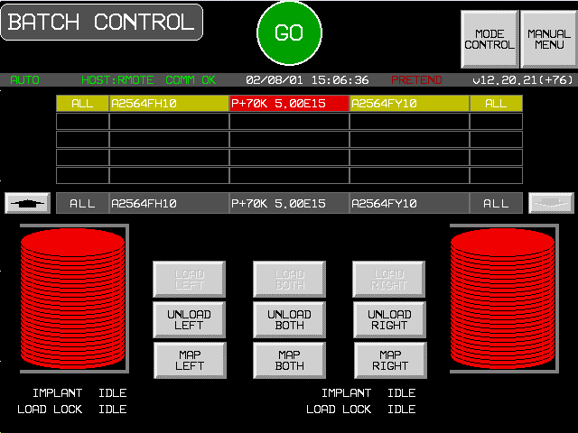

Appendix A - GEM State Diagrams

Purpose
These state models describe the behavior of equipment from a host perspective in a graphical format. In compliance to the GEM standard the following diagrams document the operational behavior of the E220. The documentation includes:
- A state diagram - using Harel notation
- A transition table - listing each transition
- A definition of each state - specifying system behavior when the state is active.

Communication state
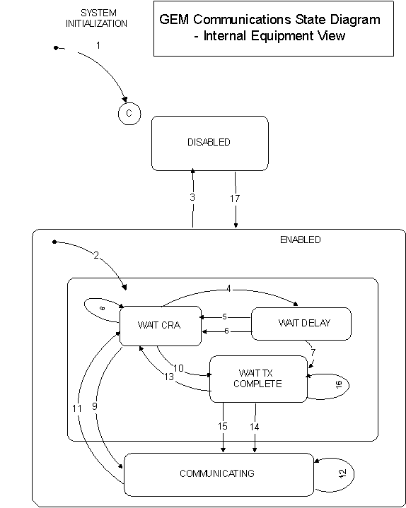
Table 1. Communication State Transitions
Current State | Trigger | New State | Action | Comment
(Entry to Communication) | System Initialization. | System Default | None
(Entry to Enabled | Any entry to ENABLED state. | WAIT CRA | Initialize communications Set CommDelay timer "expired" Send S1,F13. | May enter from system initialization to ENABLED or through operator touching switch
DISABLED | Operator switches from Disabled to ENABLED. | WAIT CRA | Initialize communications Set CommDelay timer "expired." Send S1,F13.
WAIT CRA | Connection transaction failure. | WAIT DELAY | Initialize CommDelay  timer | Wait for timer to expire.
WAIT DELAY | CommDelay timer expired | WAIT CRA | Send S1,F13 | Wait for S1,F14. May receive S1,F13 from Host
WAIT DELAY | Received a message other than S1,F13. | WAIT CRA | Discard message. No reply. Set CommDelay timer "expired" Send S1,F13. | Indicates opportunity to establish communications
WAIT DELAY | Received S1,F13 | WAIT TX COMPLETE | Send S1,F14 with COMMACH = 0. | Equipment received S1,F13 and has no open S1,F13 transaction.
WAIT CRA | Received a message other than an S1,F13 or an expected S1,F14. | WAIT CRA | Discard message no reply. | Continue to wait for S1,F14.
WAIT CRA | Received expected S1,F14 with COMMACK = 0. | COMMUNICATING | None. | Communications established. Normal Path.
WAIT CRA | Received S1,F13. | WAIT TX COMPLETE | Send S1,F14 with COMMACK = 0. | Equipment sent S1,F13 and Host sends S1,F13 (connect collision)
COMMUNICATING | Communications failure. | WAIT CRA | Set CommDelay timer "expired" Send S1,F13 (connect collision) | Discard all messages queued to send.
COMMUNICATING | Receive any message. | COMMUNICATING | If S1,F13 received. send S1,F14 | Normal Conditions
WAIT TX COMPLETE | Communications failure. | WAIT CRA | Discard all messages queued to send. Set timer "expired." Send S1,F13. | Equipment attempt to send S1,F14 failed.
WAIT TX COMPLETE | S1,F14 transmission completed successfully. | COMMUNICATING | Status of Host Interface screen displays "COMMUNICATING." | Normal path to completion. Communications established.
WAIT TX COMPLETE | Received expected S1,F14 with COMMACK = 0. | COMMUNICATING | Status of Host Interface screen displays "COMMUNICATING."
WAIT TX COMPLETE | Receive message other than S1,F14 | WAIT TX COMPLETE | Discard message. No reply.

Control state
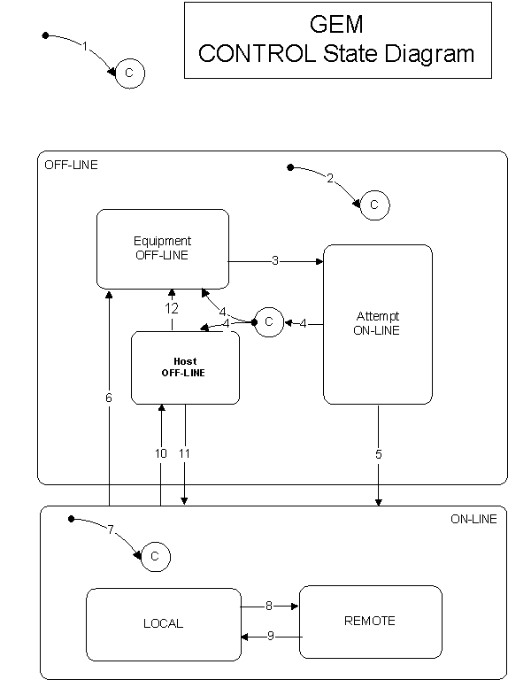
Table 2. Control State Transitions
Current State | Trigger | New State | Action | Comment
Undefined - System Initialization | Entry into CONTROL state (System Initialization) | CONTROL (Substate conditional on configuration) | Display of Host Interface screen  Highlights default states | Equipment Constant used at initialization
Undefined | Entry into OFF-LINE state | OFF-LINE (Substate conditional on configuration:  OFF-LINE DISABLED = EQUIPMENT OFF-LINE  ON-LINE DISABLED = HOST OFF-LINE ) | Display of Host Interface screen  Highlights OFF-LINE | Equipment Constants used at initialization
EQUIPMENT OFF-LINE | Operator ENABLES communication and ON-LINE | ATTEMPT ON-LINE | Host interface screen highlights active states.  S1,F1 sent to Host. | Default Control state = OFF-LINE  Default Communication state = DISABLE
ATTEMPT ON-LINE | S1,F2 Not received or Receipt of S1,F0 | EQUIPMENT OFF-LINE or HOST OFF-LINE | Host interface screen highlights active states | None
ATTEMPT ON-LINE | Equipment receives expected S1,F2 from the Host. | ON-LINE | Host interface screen highlights active states | Host is notified of transition to ON-LINE at transition 7.
ON-LINE | Operator touches OFF-LINE switch | EQUIPMENT OFF-LINE | Host interface screen highlights active states | Equipment OFF-LINE event is sent to Host.
Undefined | Entry to ON-LINE state | ON-LINE (Substate conditional on REMOTE/LOCAL equipment constant | Host interface screen highlights active states | Control state LOCAL or Control state REMOTE event is to Host.
LOCAL | Operator touches REMOTE switch | REMOTE | Host interface screen highlights active states | Control state REMOTE event is to Host
REMOTE | Operator touches LOCAL switch | LOCAL | Host interface screen highlights active states | Control state LOCAL event is to Host
ON-LINE | Equipment accepts OFF-LINE message from Host | HOST OFF-LINE | Host interface screen highlights active states | Equipment OFF-LINE event occurs
HOST OFF-LINE | Equipment accepts host request to go  ON-LINE | ON-LINE | None | Host is notified of transition to ON-LINE at transition 7.
HOST OFF-LINE | Operator acuates  OFF-LINE switch | EQUIPMENT  OFF-LINE | None | Equipment  OFF_LINE event occurs

Alarm state Model
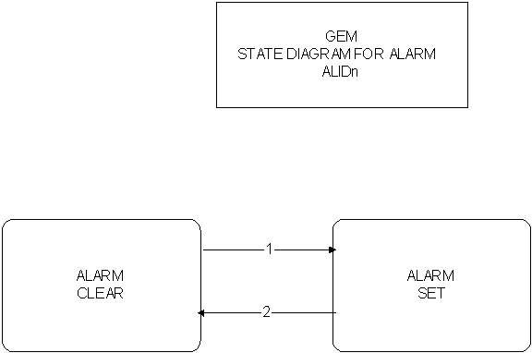
Table 10. Alarm State Transitions
# | Current State | Trigger | New State | Actions | Comments
1 | ALARMn CLEAR | Alarmn is detected on the equipment. | ALARMn SET | Initiate local actions (if any) to ensure safety.  Update AlarmsSet and SLCDn values.  Generate and issue alarm message if enabled. | Inhibited activities require operator or Host intervention prior to resuming.
2 | ALARMn SET | Alarmn is no longer detected on the equipment | ALARMn CLEAR | Update AlarmsSet and ALCDn values.  Generate and issue alarm message if enabled. | Inhibited activities require operator or Host intervention prior ro resuming.

Limit state Model
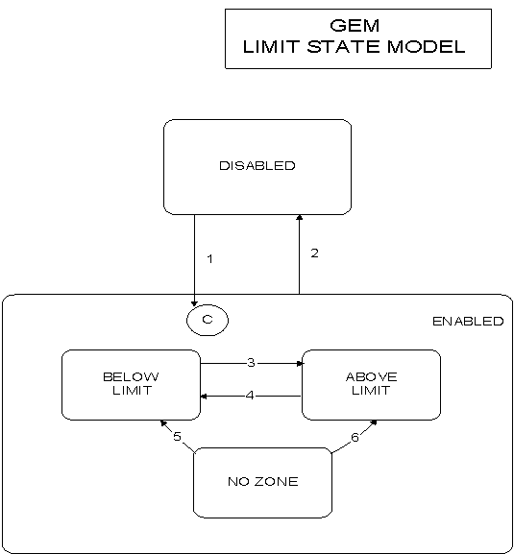
Table 9. Limit State Transitions
# | Current State | Trigger | New State | Actions | Comments
 | DISABLED | Limit attributes defined x/S2,F45. | ENABLED | None | The substate is determined by the current value of the monitored variable.
 | ENABLED | Limit attributes set undefined w/S2,F45. | DISABLED | None | None
 | BELOW LIMIT | Variable Increases to > UPPERDB. | ABOVE LIMIT | None | Zone Transition.
 | ABOVE LIMIT | Variable Decreases to < LOWERDB | BELOW LIMIT | None | Zone Transition
 | NO ZONE | Variable Decreases to < LOWERDB | BELOW LIMIT | None | Zone Transition
 | NO ZONE | Variable Increases to > UPPERDB. | ABOVE LIMIT | None | Zone Transition.

Port State Model
This section describes the Port State Model of the equipment. LPORT refers to the Left Loadlock, which is also called Port 1. RPORT refers to the Right Loadlock, which is also called Port 2.
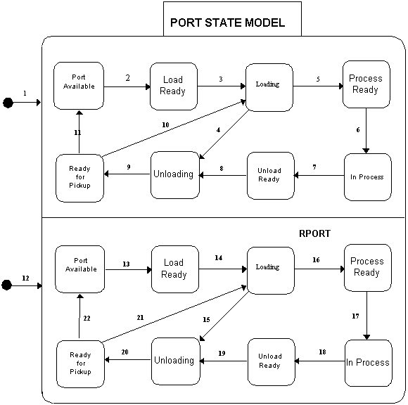
Table 3. VILL Port State Definition
State | Definition
PORT AVAILABLE (LPORT) | The door of the Left Loadlock is open and there is no material in the Left Loadlock.
LOAD READY (LPORT) | The Left Loadlock door is open and material is present in the Left Loadlock.
LOADING (LPORT) | The equipment performs the following:  The Left Loadlock door is closed.  The Left Loadlock is roughed.  The wafers in the Left Loadlock cassette are mapped.  The Left Loadlock is pumped to hi-vac.
PROCESS READY (LPORT) | The Left Loadlock has been pumped to hi-vac, but implanting of the batch has not yet started.
IN PROCESS (LPORT) | The wafers in the Left Loadlock are being implanted.
UNLOAD READY (LPORT) | The wafers in the Left Loadlock have been implanted, and they are waiting for the left elevator venting to be started.
UNLOADING (LPORT) | The Left Loadlock elevator venting has begun.
READY FOR PICKUP (LPORT) | The pivot extend has been completed. The Left Loadlock door is open and the cassette is ready to be removed.
PORT AVAILABLE (RPORT) | The door of the Right Loadlock is open and there is no material in the Right Loadlock.
LOAD READY (RPORT) | The Right Loadlock door is open and material is present in the Right Loadlock.
LOADING (RPORT) | The equipment performs the following:  The Right Loadlock door is closed.  The Right Loadlock is roughed.  The wafers in the Right Loadlock cassette are mapped.  The Right Loadlock is pumped to hi-vac.
PROCESS READY (RPORT) | The Right Loadlock has been pumped to hi-vac, but implanting of the batch has not yet started.
IN PROCESS (RPORT) | The wafers in the Right Loadlock are being implanted.
UNLOAD READY (RPORT) | The wafers in the Right Loadlock have been implanted, and they are waiting for the right elevator venting to be started.
UNLOADING (RPORT) | The Right Loadlock elevator venting has begun.
READY FOR PICKUP (RPORT) | The pivot extend has been completed. The Right Loadlock door is open and the cassette is ready to be removed.
Table 4. VILL Port State Transitions
# | Current State | Trigger | New State | Action | Comment
1. | Undefined | The machine has been started up. | LPORT State Model | The Left Loadlock may be loaded with a cassette. | "Ready to Receive Material, Port-ID 1" (CEID 84)
2. | LPORT/Port Available | Cassette sensed at LPORT. | LPORT/Load Ready | Operator, AGV, or SMIF places cassette in LPORT. | "Material Sensed at Port, Port-ID 1" (CEID 85)
3. | LPORT/Load Ready | The left LOAD or GO button is touched, or an appropriate RCMD is received from the host.. | LPORT/Loading | Close LPORT door, rough LPORT, map wafers in LPORT cassette, and hi-vac LPORT. | "Door Close Started, Port-ID 1"  (CEID 25)  "Door Close Complete, Port-ID 1"  (CEID 26)  "Elevator Pump Started, Port-ID 1" (CEID27)  "Wafer Mapping Started, Port-ID 1" (CEID 38)  "Wafer Mapping Complete, Port-ID 1" (CEID 39)
4. | LPORT/Loading | The load has failed. | LPORT/Unloading |  | "Elevator Vent Started, Port-ID 1"  (CEID 21)  "Elevator Vent Complete, Port-ID 1 (CEID 22)  "Door Open Started, Port-ID 1" (CEID 23)  "Door Open Complete, Port ID 1"  (CEID 24)
5. | LPORT/Loading | The Left Loadlock has been pumped to hi-vac. | LPORT/Process Ready |  | "Elevator Pump Complete, Port-ID 1" (CEID 28)
6. | LPORT/Process Ready | The GO button has been touched or a START command has been received from the host. | LPORT/In Process |  | "Batch Started, Port-ID 1" (CEID 11)  "Wafer Started, Port-ID 1" (CEID 13)  "Wafer Complete, Port ID 1" (CEID 14)
7. | LPORT/In Process | All LPORT wafers have been implanted. | LPORT/Unload Ready | All wafers have been implanted. | "Batch Complete, Port-ID 1" (CEID 12)
8. | LPORT/Unload Ready | Venting of the left elevator has started. | LPORT/Unloading | The left elevator is vented, the door is opened, and the pivot starts to extend. | "Elevator Vent Started, Port-ID 1"  (CEID 21)  "Elevator Vent Complete, Port-ID 1 (CEID 22)  "Door Open Started, Port-ID 1" (CEID 23)  "Door Open Complete, Port ID 1"  (CEID 24)
9. | LPORT/Unloading | The left pivot is extended. | LPORT/Ready for Pickup |  | "Pivot Extend Complete, Port-ID 1"  (CEID 65)
10. | LPORT/Ready for Pickup | The LOAD or GO button has been touched or an RCMD has been received from the host. | LPORT/Loading | A new implant has been requested.
11. | LPORT/Ready for Pickup | The cassette is not sensed at the Left Loadlock. | LPORT/Port Available | The left cassette has been removed by the operator, AGV, or SMIF. | "Cassette Removed, Port-ID 1"  (CEID 41)
12. | Undefined | The machine has been started up. | RPORT State Model | The Right Loadlock may be loaded with a cassette. | "Ready to Receive Material, Port-ID 2" (CEID 84)
13. | RPORT/Port Available | Cassette sensed at RPORT. | RPORT/Load Ready | Operator, AGV, or SMIF places cassette in RPORT. | "Material Sensed at Port, Port-ID 2" (CEID 85)
14. | RPORT/Load Ready | The right LOAD or GO button is touched, or an appropriate RCMD is received from the host. | RPORT/Loading | Close RPORT door, rough RPORT, map wafers in RPORT cassette, and hi-vac RPORT. | "Door Close Started, Port-ID 2"  (CEID 25)  "Door Close Complete, Port-ID 2"  (CEID 26)  "Elevator Pump Started, Port-ID 2" (CEID27)  "Wafer Mapping Started, Port-ID 2" (CEID 38)  "Wafer Mapping Complete, Port-ID 2" (CEID 39)
15. | RPORT/Loading | The load has failed. | RPORT/Unloading |  | "Elevator Vent Started, Port-ID 2"  (CEID 21)  "Elevator Vent Complete, Port-ID 2" (CEID 22)  "Door Open Started, Port-ID 2" (CEID 23)  "Door Open Complete, Port ID 2"  (CEID 24)
16 | RPORT/Loading | The Right Loadlock has been pumped to hi-vac. | RPORT/Process Ready |  | "Elevator Pump Complete, Port-ID 2" (CEID 28)
17. | RPORT/Process Ready | The GO button has been touched or a START command has been received from the host. | RPORT/In Process |  | "Batch Started, Port-ID 2" (CEID 11)  "Wafer Started, Port-ID 2" (CEID 13)  "Wafer Complete, Port ID 2" (CEID 14)
18. | RPORT/In Process | All RPORT wafers have been implanted. | RPORT/Unload Ready | All wafers have been implanted. | "Batch Complete, Port-ID 2" (CEID 12)
19. | RPORT/Unload Ready | Venting of the right elevator has started. | RPORT/Unloading | The right elevator is vented, the door is opened, and the pivot starts to extend. | "Elevator Vent Started, Port-ID 2"  (CEID 21)  "Elevator Vent Complete, Port-ID 2"  (CEID 22)  "Door Open Started, Port-ID 2" (CEID 23)  "Door Open Complete, Port ID 2"  (CEID 24)
20. | RPORT/Unloading | The right pivot is extended. | RPORT/Ready for Pickup |  | "Pivot Extend Complete, Port-ID 2"  (CEID 65)
21. | RPORT/Ready for Pickup | The LOAD or GO button has been touched or an RCMD has been received from the host. | RPORT/Loading | A new implant has been requested.
22. | RPORT/Ready for Pickup | The cassette is not sensed at the Right Loadlock. | RPORT/Port Available | The right cassette has been removed by the operator, AGV, or SMIF. | "Cassette Removed, Port-ID 2"  (CEID 41)

VILL Processing State
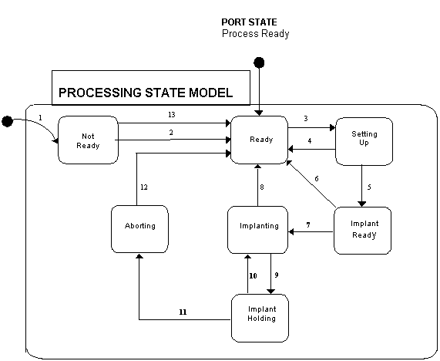
Table 5. VILL Processing State Definition
State | Definition
NOT READY | The machine has been initialized and Start Up has not completed, or Shut Down has started.
READY | Processing is ready to begin. Start Up has completed, a batch has been completed, or an Abort has been completed.
SETTING UP | Source, Beamline, or Beamscan setup is under way, and material is being readied.
IMPLANT READY | Recipe has been set up and material is present. The GO is displayed and awaiting action.
IMPLANTING | Implanting is under way.
IMPLANT HOLDING | The Implant has been held.
ABORTING | An Abort procedure has been started, but has not yet completed.
Table 6. VILL Processing State Transitions
# | Current State | Trigger | New State | Actions | Comments
1. | Undefined | The machine is initialized. | Not Ready | Machine performs software initialization.
2 | Not Ready | Operator touches System Startup button. | Ready | The Start Up procedure has been completed successfully. | "Start Up Started" (CEID 1)  "Start Up Complete" (CEID 2)
3. | Ready | Operator touches GO on Host Control screen or RCMD received from host. | Setting Up | Source, Beamline, or Beamscsn setup is executed. | "Source Setup Started" (CEID 5)  "Beamline Setup Started" (CEID 7)  "Beamscan Setup or Check Started" (CEID 9)  "Implant Started" (CEID 40)
4. | Setting Up | Setup fails. | Ready
5. | Setting Up | Completion of Beamscan Setup or Check. | Implant Ready |  | "Source Setup Complete" (CEID 6)  "Beamline Setup Complete" (CEID 8)  "Beamscan Setup or Check Complete"  (CEID 10)  "GO Displayed’ (CEID 63)
6. | Implant Ready | STOP command from operator or host RCMD. | Ready
7. | Implant Ready | The GO button on Implant Monitor is touched or RCMD from host is received. | Implanting | Implanting of the wafers is started. | "Batch Started" (CEID 11)  "Wafer Started" (CEID 13)  "Wafer Complete (CEID 14)
8. | Implanting | The implant for the batch has been completed. | Ready |  | "Batch Complete" (CEID 12)
9. | Implanting | Operator touches HOLD button on Implant Monitor screen. | Implant Holding | Implanting of the wafer is held. | "Implant Held" (CEID 17)
10. | Implant Holding | Operator touches the CONTINUE button on the Implant Monitor screen. | Implanting | The held implant has been resumed. | "Implant Continued" (CEID 18)
11. | Implant Holding | Operator touches STOP button on the Implant Monitor screen and then chooses Abort at the prompt, or host sends Abort RCMD. | Aborting | An Abort of the implant is started. | "Abort Started" (CEID 19)
12. | Aborting | An Abort process has been completed. | Ready |  | "Abort Complete" (CEID 20)
13. | Ready | Operator touches System Shut Down button. | Not Ready | A Shutdown from the Ready is carried out. | "Shut Down Started" (CEID 3)  "Shut Down Complete" (CEID 4)

VILL Material State Model
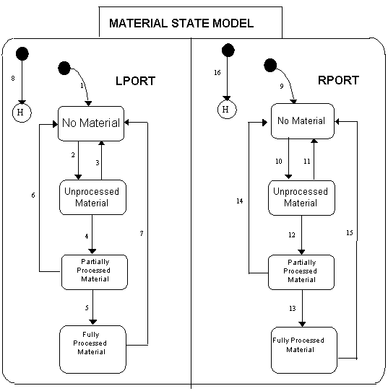
Table 7. VILL Material State Definition
State | Definition
LPORT | Material State for the Left Loadlock.
LPORT/No Material | There is no cassette in the Left Loadlock.
LPORT/Unprocessed Material | None of the wafers in the Left Loadlock cassette have been processed.
LPORT/Partially Processed Material | At least one wafer in the Left Loadlock cassette has been processed.
LPORT/Fully Processed Material | All wafers in the Left Loadlock cassette have been processed.
RPORT | Material State for the Right Loadlock.
RPORT/No Material | There is no cassette in the Right Loadlock.
RPORT/Unprocessed Material | None of the wafers in the Right Loadlock cassette have been processed.
RPORT/Partially Processed Material | At least one wafer in the Right Loadlock cassette has been processed.
RPORT/Fully Processed Material | All wafers in the Right Loadlock cassette have been processed.
Table 8. VILL Material State Transitions
# | Current State | Trigger | New State | Action | Comment
1. | Undefined | Software initialized. | No Material |  | "Ready to Receive Material, Port-ID 1"  (CEID 84)
2. | LPORT/No Material | Cassette placed into Left Loadlock by Operator, AGV, or SMIF. | Unprocessed Material |  | "Material Sensed at Port, Port-ID 1"  (CEID 85)
3. | LPORT/  Unprocessed Material | Cassette removed from Left Loadlock by Operator, AGV, or SMIF before any wafer was processed. | No Material |  | "Cassette Removed, Port-ID 1" (CEID 41)  "Ready to Receive Material, Port-ID 1"  (CEID 84)
4. | LPORT/  Unprocessed Material | Implant started by Operator or Host, and at least one wafer implanted. | Partially Processed Material |  | "Wafer Started, Port-ID 1" (CEID 13)  "Batch Started, Port-ID 1" (CEID 11)
5. | LPORT/Partially Processed Material | Implant completed. | Fully Processed Material |  | "Batch Complete, Port-ID 1" (CEID 12)
6. | LPORT/Partially Processed Material | Cassette removed from Left Loadlock by Operator, AGV, or SMIF after implant is aborted. | No Material |  | "Cassette Removed, Port-ID 1" (CEID 41)  "Ready to Receive Material, Port-ID 1"  (CEID 84)
7. | LPORT/Fully Processed Material | Cassette removed from Left Loadlock by Operator, AGV, or SMIF after implant is completed. | No Material |  | "Cassette Removed, Port-ID 1" (CEID 41)  "Ready to Receive Material, Port-ID 1"  (CEID 84)
8 | LPORT/Undefined | One of the following situations:  Reset or power failure. | Previous LPORT state.
9. | Undefined | Software initialized. | No Material |  | "Ready to Receive Material, Port-ID 2"  (CEID 84)
10. | RPORT/No Material | Cassette placed into Right Loadlock by Operator, AGV, or SMIF. | Unprocessed Material |  | "Material Sensed at Port, Port-ID 2"  (CEID 85)
11. | RPORT/  Unprocessed Material | Cassette removed from Right Loadlock by Operator, AGV, or SMIF before any wafer was processed. | No Material |  | "Cassette Removed, Port-ID 2" (CEID 41)  "Ready to Receive Material, Port-ID 2"  (CEID 84)
12. | RPORT/  Unprocessed Material | Implant started by Operator or Host, and at least one wafer implanted. | Partially Processed Material |  | "Wafer Started, Port-ID 2" (CEID 13)  "Batch Started, Port-ID 2" (CEID 11)
13. | RPORT/Partially Processed Material | Implant completed. | Fully Processed Material |  | "Batch Complete, Port-ID 2" (CEID 12)
14. | RPORT/Partially Processed Material | Cassette removed from Right Loadlock by Operator, AGV, or SMIF after implant is aborted. | No Material |  | "Cassette Removed, Port-ID 2" (CEID 41)  "Ready to Receive Material, Port-ID 2"  (CEID 84)
15. | RPORT/Fully Processed Material | Cassette removed from Right Loadlock by Operator, AGV, or SMIF after implant is completed. | No Material |  | "Cassette Removed, Port-ID 2" (CEID 41)  "Ready to Receive Material, Port-ID 2"  (CEID 84)
16 | RPORT/Undefined | One of the following situations:  Reset or power failure. | Previous RPORT state.

Appendix B - E220 GEM Alarms

Purpose
The following tables contain the alarm Ids, codes, and text sent within stream 5 messages. Only alarms considered irrecoverable are sent to the host.
A convention in the text is $ denotes a value filled in before the message is sent.
A ‘|’ character denotes a new line.

Facilities and UCC Errors
2302 2303 | 1001 | 510 | Do you want to try downloading UCC program again?|| Press YES to retry| Press NO to quit to the manual menu.
2304 2305 | 1002 | 505 | UCC ERROR:| Uniformity Controller powered down or disconnected from link.| Do you want to bypass downloading the UCC program?| Press YES to bypass.| Press NO and you will be given the choice to quit or retry.
2306 2307 | 1003 | 505 | UCC ERROR:| Uniformity Controller data error.| Do you want to bypass downloading the UCC program?| Press YES to bypass.| Press NO and you will be given the choice to quit or retry.
2308 2309 | 1004 | 505 | UCC ERROR:| Uniformity Controller communication timeout.| Do you want to bypass downloading the UCC program?| Press YES to bypass.| Press NO and you will be given the choice to quit or retry.
2310 2311 | 1005 | 505 | Facilities are not ok.| Correct conditions in red or yellow|| Press YES to continue anyway| Press NO to retry.
2602 2603 | 1151 | 507 | Doors opened with high voltage on
2604 2605 | 1152 | 507 | No purge nitrogen pressure for source turbo pump
2606 2607 | 1153 | 507 | Source vacuum failure while running source
2608 2609 | 1154 | 507 | Beamline vacuum failure
2610 2611 | 1155 | 507 | Source cooling failure while running source
2698 2699 | 1199 | 507 | There is no water flow to the Stage pumps => Stage pumps have been| shutdown!
2708 2709 | 1204 | 507 | Cryo temperature exceeded interlock. Initiating Auto Cryo Regeneration.

Auto Vacuum Errors
4304 4305 | 2002 | 507 | To pump down the elevators | - The elevator cryos' temperatures must be | __less than $ degrees K, and the| __elevator cryos are not being regenerated.
4312 4313 | 2006 | 507 | To pump down the beamline | - The chamber cryo temperature must be| __less than 20 degrees K, and the| __chamber cryo is not being regenerated.
4338 4339 | 2019 | 507 | System startup cannot perform pump down. Cryopump temperatures indicate that the cryos are too warm. Please check them.
4342 4343 | 2021 | 507 | System pump down has been aborted.| Check the following:| - Cryo temperatures must be less than| __20 degrees K.| - Handlers must be at the safe position.| - Travelling faraday cup must be at the| __home position.
4344 4345 | 2022 | 507 | System startup cannot perform pump down. Traveling faraday status indicates that the faraday is not initialized. Please check it.
4346 4347 | 2023 | 507 | System startup cannot perform pump down. Handler status indicates that one or both of the handlers are not initialized Please check them.
4348 4349 | 2024 | 507 | System startup has failed to attain high| vacuum. Check the following:| - Source and beamline turbo speeds must be| __greater than 80%| - Source isolation, left isolation, and | __right isolation valves must be open.
4350 4351 | 2025 | 507 | System Start Up has failed to achieve high| vacuum before a 60 second timeout.
4532 4533 | 2116 | 515 | The elevator isolation valve(s) did not close within the allocated time (20seconds).
4536 4537 | 2118 | 515 | The beamline chamber cannot be pumped down to hi vacuum. The stage pumps and the beamline pumps have been shut off and the beamline foreline valve has been closed. Please check the chamber for any leaks.
4540 4541 | 2120 | 515 | The auto elevator cryo regen procedure has been aborted and the cryo purge valves have been closed.| The reason is because:| -- both cryo cold heads did not warm up to $ or greater within the allotted time of $ mins as per the current Regen parameters.
4542 4543 | 2121 | 515 | The auto elevator Aisin cryo regen procedure has been aborted and the cryo purge valves have been closed. The reason is because,| -- both cryo cold heads did not warm up to 280K or greater within 90 mins.
4550 4551 | 2125 | 505 | The Source turbopump(s) failed to spin up.| The stage pumps and the beamline pumps have been shut off and the vent valve has been opened.| Please check for pump failures or vacuum leaks.
4620 4621 | 2160 | 515 | CRYO PUMP REGENERATION FAILURE.| The rate of rise test has exceeded the $ micron rise in one minute criteria even after trying to rough the elevator cryos $ times according to the current parameters.|| Corrective Maintenance Suggestions: |1. Check the seating of the pressure relief valve, and ensure it has reseated correctly.| 2. Check that the N2 purge heater is working correctly.| 3. Check that you have not run out of N2.|
4624 4625 | 2162 | 515 | FAILURE TO PUMP DOWN THE ELEVATOR CRYO CHAMBERS TO $ MICRONS IN THE ALLOTED TIME OF $ MINUTES. ||Please check the following: |-- The elevator doors. Ensure that they are properly closed. | -- The pop-off valve on the cryo pump is sealing properly.
4628 4629 | 2164 | 515 | FAILURE TO CHILL DOWN THE ELEVATOR CRYO COLD HEADS TO $ KELVIN IN THE ALLOTTED TIME OF $ MINUTES. |Please check the compressor and the cryo cold heads for proper operation.
4632 4633 | 2166 | 515 | FAILURE TO PUMP DOWN BELOW $ MICRONS AFTER PASSING RATE OF RISE TEST.
4634 4635 | 2167 | 515 | FAILURE TO WARM UP CHAMBER CRYO COLD HEAD TO 280 KELVIN WITHIN ALLOTTED TIME OF $ .
4636 4637 | 2168 | 515 | FAILURE TO PUMP DOWN THE CRYO CHAMBER AFTER TWO PURGE AND PUMP DOWN RETRIES.
4638 4639 | 2169 | 515 | CHAMBER CRYO REGENERATION FAILURE.| The rate of rise test has exceeded the $ micron rise in one minute criteria even after trying to rough the main cryo $ times according to the current parameters.|| Corrective Maintenance Suggestions:|1. Check the seating of the pressure relief valve, and ensure it has reseated correctly.| 2. Check that the N2 purge heater is working correctly.| 3. Check that you have not run out of N2.|
4642 4643 | 2171 | 515 | FAILURE TO PUMP DOWN THE CHAMBER CRYO CHAMBER BELOW 50 MICRONS AFTER PASSING THE RATE OF RISE TEST.
4644 4645 | 2172 | 515 | FAILURE TO CHILL DOWN THE CHAMBER CRYO COLD HEAD TO $ KELVIN IN THE ALLOTTED TIME OF $ MINUTES. |Please check the compressor and the cryo cold head for proper operation.

Gases Errors
6564 6565 | 3132 | 515 | *** WARNING: CRITICAL ERROR **** | The gas bottle valve is still open or has failed. Please get immediate and experienced help.

Manual Beam Setup Errors
10360 10361 | 5030 | 505 | Remove target faraday cup from beam path.
10362 10363 | 5031 | 505 | Unable to find an initial beam in the focus cup of at least 0.5% of the beam in the setup cup. Automatic beam setup cannot proceed.
10364 10365 | 5032 | 505 | The $ power supply is shorted out (either internally or externally.)
10366 10367 | 5033 | 505 | The $ power supply is at $, and can't reach its setpoint of $.
10368 10369 | 5034 | 505 | Less than 10 nanoamps of beam in the setup cup: setup cannot continue.
10370 10371 | 5035 | 505 | The requested energy of $ KeV cannot be achieved on the E-220 with an ion charge of $.
10388 10389 | 5044 | 505 | The accel voltage is shorted out.|| Possible causes:| 1. The drop bars are down.| 2. The terminal grounding hook is on.
10390 10391 | 5045 | 505 | The offset between the deflector programmed voltage and readback exceeds 5%. Automatic setup cannot continue.
10402 10403 | 5051 | 515 | Switched over to DECEL mode, but| DECEL static continuity test has failed! Check auto decel hardware.
10404 10405 | 5052 | 515 | Switched over to ACCEL mode, but| ACCEL static continuity test has failed! Check auto decel hardware.
10408 10409 | 5054 | 505 | BEAM ENERGY PROBE FAILURE,| The beam energy varies by more than $.$%. The beam energy probe reads back $$$.$ KV.
10412 10413 | 5056 | 505 | The requested energy of $ KeV cannot be achieved on the E-500 with an ion charge of $.
10414 10415 | 5057 | 505 | The requested energy of $ KeV with an ion charge of $ cannot be achieved using the automatic source setup because it is too low.
10416 10417 | 5058 | 505 | Automatic source setup cannot be achieved using the requested extraction voltage of $ kV because it exceeds $ kV which is the maximum allowable extraction based on calculations that use the kamu magnetic constants table.
10418 10419 | 5059 | 515 | Continuity check on auto accel/decel switching cannot be done because enclosure doors are open and high voltage cannot be turned on.
10420 10421 | 5060 | 515 | Continuity check on auto accel/decel switching cannot be done because the high voltage is not enabled.
10422 10423 | 5061 | 515 | Enclosure doors are open. Do you still want to switch?| IF YES, ENSURE THAT ALL PERSONS ARE CLEAR OF AUTO-DECEL BAR BEFORE PROCEEDING.
10426 10427 | 5063 | 515 | Continuity check on auto accel/decel switching cannot be done because the source or beamline is vented.
10428 10429 | 5064 | 505 | BEAM CURRENT TOO HIGH FOR MIRROR SUPPLY OPERATION.| Cannot allow mirror to be turned on for single charged, accel mode as requested in the recipe.| Either set the MIRROR parameter in the recipe to 0 kV, or use a lower beam current specification.

Auto Scan Errors
12302 12303 | 6001 | 505 | VOLTAGE CALIBRATION FAILED.
12304 12305 | 6002 | 505 | CAUTION: MIN-SLOPE = 0 | optic link between uniformity controller and scanner carrying SLOPE and SPOT-MODE may be damaged or disconnected.
12306 12307 | 6003 | 505 | CAUTION: MIN-SLOPE ($) < 512 | wire inside scanner connecting PROBE signal to capacitance sense board may be broken.
12308 12309 | 6004 | 505 | CAUTION: MIN-SLOPE ($) > 2048 | Scanner has inadequate dynamic range to perform dose correction properly.
12310 12311 | 6005 | 505 | CAUTION: negative zero offset on dose integrator. | This will result in dose errors during implant!! Check the dose integrator and preamplifier.
12312 12313 | 6006 | 505 | CAUTION: input signal to dose integrator exceeded full scale. | This will cause dose errors during implant!! Check the dose integrator and the preamplifier.
12314 12315 | 6007 | 505 | CAUTION: DOSE = 0 | optic link carrying INTEGRATE and DOSE between uniformity controller and dose integrator may be damaged.
12316 12317 | 6008 | 505 | CAUTION: DOSE = 0 | single optic link carrying SCAN-STATUS from scanner to uniformity controller may be disconnected or exchanged with ACCEL-OK link.
12318 12319 | 6009 | 505 | CAUTION: scan ratio ($) > 20 | Scanner performance inadequate for implants. Tubes or linear optic link may be weak.
12320 12321 | 6010 | 505 | CAUTION: uniformity poor when scanning at full speed | If there is only a single peak on the orange plot, set the MIRROR supply to 28 kV, otherwise check the scanner.
12324 12325 | 6012 | 507 | The center to side ratio is inconsistent.| Press PROCEED to enter the Manual Menu screen.
12328 12329 | 6014 | 505 | FAST SCAN FAILURE| Beam setup was > $.$ times XSIGMA for fast scan test.
12340 12341 | 6020 | 505 | SCANNER SETUP FAILED| The beam stability may not be adequate.
12344 12345 | 6022 | 507 | SETUP CALLS FOR TOO MANY SCANS| The computed number of scans is $, which exceeds the allowed maximum of 16383. It is not possible to implant.
12346 12347 | 6023 | 507 | COMPUTED NUMBER OF SCANS IS LESS THAN THE NUMBER OF SCANS ASKED FOR IN THE RECIPE.| DO YOU WISH TO IMPLANT THE WAFERS WITH| $ SCANS ?| Recipe calls for a minimum of $ scans.
12400 12401 | 6050 | 507 | The bearing is not initialized properly. Go to the end station initialization screen to correct this problem.
12402 12403 | 6051 | 507 | The head is not initialized properly. Go to the end station initialization screen to correct this problem.
12404 12405 | 6052 | 507 | The traveling faraday is not initialized properly. Go to the end station initialization screen to correct this problem.
12406 12407 | 6053 | 507 | The traveling faraday cup stopped in the wrong position. Go to the end station initialization screen to correct this problem.
12408 12409 | 6054 | 507 | Beam purity check failed.
12420 12421 | 6060 | 507 | The required number of scans ($) differs more than 40% from the recipe value ($).|| Hit 'YES' to continue, 'NO' to abort.
12424 12425 | 6062 | 507 | The arc current is outside of legal limits.|| (1) Auto setup has to be run to use ECO 26.| (2) ECO 26 must be turned off to run manually.
12452 12453 | 6076 | 507 | The 10% scans interlock (ECO 26) is selected and the calculated number of scans falls outside this range. Options: | 1. Adjust arc and try SETUP again. | 2. Press GO on the batch screen. | 3. Deselect ECO 26.
12462 12463 | 6081 | 505 | Batch completed, scanner recheck FAILED. | Process Information: | (%) XSIGMA * $ = $$.$$| Measured (%) XSIGMA = $$.$$| (%) PEAK TO PEAK * $ = $$.$$| Measured (%) PEAK TO PEAK = $$.$$| Recipe Name: $| Left Lot Number: $| Right Lot Number $|
12466 12467 | 6083 | 505 | Scanner recheck FAILED. | Process check indicates not all wafers in this batch have been implanted. Please check Implant Log.| Process Information: | (%) XSIGMA * $ = $$.$$| Measured (%) XSIGMA = $$.$$| (%) PEAK TO PEAK * $ = $$.$$| Measured (%) PEAK TO PEAK = $$.$$| Recipe Name: $| Left Lot Number: $| Right Lot Number: $| }
12470 12471 | 6085 | 505 | Batch Pre-Implant scanner check FAILED. | Process Information: | (%) XSIGMA * $ = $$.$$| Measured (%) XSIGMA = $$.$$| (%) PEAK TO PEAK * $ = $$.$$| Measured (%) PEAK TO PEAK = $$.$$| Recipe Name: $| Left Lot Number: $| Right Lot Number: $|
12472 12473 | 6086 | 505 | The Platen is not at the safe position.| Move the Platen to the safe position | before moving or using the Target Faraday.
12476 12477 | 6088 | 505 | TARGET FARADAY CUP BIAS VOLTAGE ERROR. READBACK VOLTAGE IS TOO LOW OR DOES NOT MATCH THE PROGRAM VOLTAGE. CHECK BIAS FEED CONNECTIONS.
12478 12479 | 6089 | 505 | Integrated beam found unstable. | The Center to Side measurement exceeds $%.
12480 12481 | 6090 | 505 | Integrator offset check error! The offset | measurement difference has shown greater than | 1% between the side and center Faraday positions. | Possible causes are : | 1. Failure on the current integrator | 2. Excessive noise on the target Faraday | 3. Excessive impurity, neutral beam or energy | contamination.

End Station Initialization Errors
16716 16717 | 8208 | 505 | There is a Wafer Walkout Detected.| The RIGHT SIDE cassette has a walkout. The wafer may be extending into the iso-valve, the Beamline and Elevator may have to be vented manually. Visually inspect the iso-valve to determine if is safe to close. Vent the system as necessary to correct the condition using the ES-MANUAL functions.
16718 16719 | 8209 | 505 | There is a Wafer Walkout Detected.| The LEFT SIDE cassette has a walkout. The wafer may be extending into the iso-valve, the Beamline and Elevator may have to be vented manually. Visually inspect the iso-valve to determine if is safe to close. Vent the system as necessary to correct the condition using the ES-MANUAL functions.
16720 16721 | 8210 | 505 | The RIGHT HANDLER did not return to the HOME position!| The Handler did not reach the home position as commanded. Insure the position of the handler, or insure the correct function of the position sensor.
16722 16723 | 8211 | 505 | The LEFT HANDLER did not return to the HOME position!| The Handler did not reach the home position as commanded. Insure the position of the handler, or insure the correct function of the position sensor.
16724 16725 | 8212 | 505 | The RIGHT ELEVATOR CAN'T BE INITIALIZED!| The Right Handler has not been initialized. It is unsafe to move the elevator with the Handler in an unknown location.
16726 16727 | 8213 | 505 | The LEFT ELEVATOR CAN'T BE INITIALIZED!| The Left Handler has not been initialized. It is unsafe to move the elevator with the Handler in an unknown location.
16728 16729 | 8214 | 505 | The RIGHT ELEVATOR CAN'T BE INITIALIZED!| The Right Handler is extended into the cassette. It is unsafe to move the elevator with the Handler extended.
16730 16731 | 8215 | 505 | The LEFT ELEVATOR CAN'T BE INITIALIZED!| The Left Handler is extended into the cassette. It is unsafe to move the elevator with the Handler extended.

Auto-Setup Errors
18300 18301 | 9000 | 505 | Remote $ does not respond.
18308 18309 | 9004 | 505 | The extraction supply has been turned off because of overloading.|| Suggestion:| This failure may be caused by an arc in the source. Turn off the filament power for a few seconds. Then light the arc again and try to turn on the extraction manually.
18312 18313 | 9006 | 505 | The source gas control failed to settle.|| Suggestion:| If the gas readback is fluctuating, the gas control feedback circuit needs to be adjusted or replaced.|| If the gas readback does not change and is much lower than the setpoint, either the gas control feedback circuit needs to be adjusted, or the valve is stuck shut.
18314 18315 | 9007 | 505 | The source magnet power supply failed to settle.|| Suggestion:| Gain access to the source magnet power supply and check the front panel readings.
18316 18317 | 9008 | 505 | The Z-axis motor failed to settle.
18318 18319 | 9009 | 505 | The source extraction power supply failed to settle.
18320 18321 | 9010 | 505 | The AMU magnet power supply failed to settle.|| Suggestion:| Gain access to the AMU magnet power supply and check the front panel readings.
18342 18343 | 9021 | 505 | The arc is glitching too much for automatic source setup to proceed.
18344 18345 | 9022 | 505 | The source extractor is sparking too much for automatic source setup to proceed.|| Additional possibilities:|| 1.__UNSTABLE SUPPLY:| the extraction power supply may be unstable.|| 2.__CORONA:| there is corona discharge between part of the source or source cabinet and other parts of the terminal.
18346 18347 | 9023 | 505 | The source arc has gone out.|| Suggestion:| Press the SETUP button to try lighting the source automatically, or set up the source manually.
18348 18349 | 9024 | 505 | The extraction power supply has lost voltage. The most common cause of this condition is an arc between a dirty source and the extraction suppressor plate.|| Suggestion:| Turn off the filament and extractor for a few seconds to extinquish the arc. Move the Z-axis farther out, re-light the source, and turn on the extractor again. Press "SETUP" to continue setting up automatically, or set up manually.|| If the extraction supply loses voltage again, you may need to clean the ion source. Also scrape off any deposits on the side of the extraction suppressor plate that faces the source.
18354 18355 | 9027 | 505 | Unable to continue automatic source setup because the mirror supply is shorted.
18364 18365 | 9032 | 505 | The source cabinet does not respond, even though the door interlocks are made and the high voltage supplies are armed.|| Suggestion: Open the enclosure and terminal doors, and check whether the supplies have power.
18400 18401 | 9050 | 505 | Unable to continue automatic source setup because of unstable beam. Check the arc, filament, and extraction power supplies.
18402 18403 | 9051 | 505 | The source arc can't reach the setpoint.|| Suggestion:| This condition may be caused by a filament voltage limit set too low, an extremely old filament, or inadequate gas flow or vapor production.
18500 18501 | 9100 | 505 | The automatic source setup program can't get a low enough beam to achieve the minimum number of scans specified.|| Do you want to continue anyway?
18502 18503 | 9101 | 505 | The automatic source setup program can't get a low enough beam to achieve the minimum number of scans specified in the recipe. Automatic setup halted.
18504 18505 | 9102 | 505 | Unable to continue automatic source setup because of excessive suppression current.
18506 18507 | 9103 | 505 | Unable to continue automatic source setup because of excessive suppression current when tuning Z axis.
18520 18521 | 9110 | 505 | The mirror supply must be turned on to run multiply-charged ions.
18522 18523 | 9111 | 505 | The 100-degree magnet current is set outside the calculated AMU window for the designated species. Implant is not allowed under these conditions.|| Suggestion:| If the peak is correct, use the SERVICE screen to add an AMU magnet calibration point in this vicinity.
18524 18525 | 9112 | 505 | The specified extraction voltage of $ V is not achieved. Please check the extraction power supply.
18526 18527 | 9113 | 505 | The target faraday cup is in the wrong position; the head cannot be moved. Go to the manual BEAMSCAN screen to move it out of the way.
18528 18529 | 9114 | 505 | The faraday cup suppression supply is too low for accurate beam current measurement. Check it on the manual BEAMSCAN screen.
18530 18531 | 9115 | 505 | The requested beam energy of $ keV cannot be achieved with an ion charge of $.
18532 18533 | 9116 | 505 | TOTAL BEAM ENERGY MISMATCH WITH RECIPE. |Desired Energy (keV) = $ |Calculated Energy = $ |Probe Readback = $
18534 18535 | 9117 | 505 | The Filament Current indicates that the Filament is worn to the point of breakage. It may burn through during the implant of a wafer, do you wish to continue ?
18536 18537 | 9118 | 505 | Dipole lens magnet does not match correct setting for desired amu.
18538 18539 | 9119 | 505 | The flood gun secondary emission current is more than $% different from the value specified in the recipe.
18540 18541 | 9120 | 505 | Accel power supply is turned off.
18542 18543 | 9121 | 505 | Decel power supply is turned off.
18544 18545 | 9122 | 505 | The Mirror readback does not match the value selected in the RECIPE. |Please adjust the recipe value to match the readback value.
18584 18585 | 9142 | 505 | PRESSURE OF SDS BOTTLE SELECTED IS BELOW THE EMPTY BOTTLE DETECTOR SETTING. THE GAS BOX HAS BEEN SHUTDOWN. TO CONTINUE, REPLACE BOTTLE, TURN OFF EMPTY BOTTLE DETECTOR, OR RESET THE DETECTOR SETTING.
18960 18961 | 9330 | 505 | Remove target faraday cup from beam path.
18962 18963 | 9331 | 505 | Unable to find an initial beam in the focus cup of at least 0.5% of the beam in the setup cup. Automatic beam setup cannot proceed.
18964 18965 | 9332 | 505 | The $ power supply is shorted out (either internally or externally.)
18966 18967 | 9333 | 505 | The $ power supply is at $, and can't reach its setpoint of $.
18968 18969 | 9334 | 505 | Less than 10 nanoamps of beam in the setup cup: setup cannot continue.
18970 18971 | 9335 | 505 | The requested energy of $ KeV cannot be achieved on the E-220 with an ion charge of $.
18988 18989 | 9344 | 505 | The accel voltage is shorted out.|| Possible causes:| 1. The drop bars are down.| 2. The terminal grounding hook is on.
18990 18991 | 9345 | 505 | The offset between the deflector programmed voltage and readback exceeds 5%. Automatic setup cannot continue.
19002 19003 | 9351 | 515 | Switched over to DECEL mode, but| DECEL static continuity test has failed! Check auto decel hardware.
19004 19005 | 9352 | 515 | Switched over to ACCEL mode, but| ACCEL static continuity test has failed! Check auto decel hardware.
19006 19007 | 9353 | 505 | BEAM ENERGY PROBE FAILURE,| Check power to energy probe.
19008 19009 | 9354 | 505 | BEAM ENERGY PROBE FAILURE,| The beam energy varies by more than $.$%. The beam energy probe reads back $$$.$ KV.
19010 19011 | 9355 | 505 | BEAM CURRENT TOO HIGH,| This will cause too much power in end station resulting in focus cup over heating.| Please reduce arc current.
19012 19013 | 9356 | 505 | The requested energy of $ KeV cannot be achieved on the E-500 with an ion charge of $.
19014 19015 | 9357 | 505 | The requested energy of $ KeV with an ion charge of $ cannot be achieved using the automatic source setup because it is too low.
19016 19017 | 9358 | 505 | Automatic source setup cannot be achieved using the requested extraction voltage of $ kV because it exceeds $ kV which is the maximum allowable extraction based on calculations that use the kamu magnetic constants table.
19018 19019 | 9359 | 515 | Continuity check on auto accel/decel switching cannot be done because enclosure doors are open and high voltage cannot be turned on.
19020 19021 | 9360 | 515 | Continuity check on auto accel/decel switching cannot be done because the high voltage is not enabled.
19022 19023 | 9361 | 515 | Enclosure doors are open. Do you still want to switch?| IF YES, ENSURE THAT ALL PERSONS ARE CLEAR OF AUTO-DECEL BAR BEFORE PROCEEDING.
19026 19027 | 9363 | 515 | Continuity check on auto accel/decel switching cannot be done because the source or beamline is vented.
19028 19029 | 9364 | 505 | BEAM CURRENT TOO HIGH FOR MIRROR SUPPLY OPERATION.| Cannot allow mirror to be turned on for single charged, accel mode as requested in the recipe.| Either set the MIRROR parameter in the recipe to 0 kV, or use a lower beam current specification.

Implant Supervisor Errors
24346 24347 | 12023 | 510 | No parametric setup has been learned for the $ recipe. Press 'YES' to switch to Version 8 algorithmic setup. Press 'NO' to set up the beam manually.

Batch Status Errors
26306 26307 | 13003 | 515 | In Fully Automated Batch Mode it is not allowed to enter number of wafers (WAFERS) or starting slot number (START#). In this mode all wafers that are present in the cassettes will be implanted.
26328 26329 | 13014 | 515 | Left Side:| There is no wafer mapped in slot $.| Please choose a different starting slot.
26330 26331 | 13015 | 515 | Right Side:| There is no wafer mapped in slot $.| Please choose a different starting slot.
26344 26345 | 13022 | 515 | The tilt angle cannot be greater than 13 degrees| with the electron flood gun in position.
26360 26361 | 13030 | 515 | LEFT SIDE WAFER MAPPER PROBLEM|| Specified first wafer ($) is not there.
26362 26363 | 13031 | 515 | RIGHT SIDE WAFER MAPPER PROBLEM|| Specified first wafer ($) is not there.
26364 26365 | 13032 | 515 | LEFT SIDE WAFER MAPPER PROBLEM|| Wafers specified before start: $ | Wafers found after start:_____$
26366 26367 | 13033 | 515 | RIGHT SIDE WAFER MAPPER PROBLEM|| Wafers specified before start: $ | Wafers found after start:_____$
26368 26369 | 13034 | 515 | LEFT SIDE WAFER MAPPER PROBLEM|| No wafers found.|| Automatic venting of elevator started.
26370 26371 | 13035 | 515 | RIGHT SIDE WAFER MAPPER PROBLEM|| No wafers found.|| Automatic venting of elevator started.
26386 26387 | 13043 | 515 | LEFT SIDE WAFER MAPPER PROBLEM|| No wafers found in the range starting from slot $ to ending slot $.
26388 26389 | 13044 | 515 | RIGHT SIDE WAFER MAPPER PROBLEM|| No wafers found in the range starting from slot $ to ending slot $.
26392 26393 | 13046 | 515 | The wafer count sent by the host does not match| the mapped count.

Vacuum Errors
35200 35201 | 17450 | 515 | Door open command unsuccessful.| - because the elevator is under vacuum; i.e., door motor stalled.
35202 35203 | 17451 | 507 | A timeout occurred while the door was opening;| - i.e., the door motor never stalled.
35204 35205 | 17452 | 507 | A timeout occurred while the door was closing;| -i.e., the door motor never stalled.
35206 35207 | 17453 | 507 | A timeout occurred while the tilter was extending;| - i.e., the tilter motor never stalled.
35208 35209 | 17454 | 507 | A timeout occurred while the tilter was retracting; | -i.e., the tilter motor never stalled.
35210 35211 | 17455 | 507 | A timeout occurred while the tilter was initializing, -i.e., the tilter motor never stalled.
35212 35213 | 17456 | 507 | A timeout occurred while the door was initializing;| i.e., the door motor never stalled.
35340 35341 | 17520 | 507 | One of the elevator isolation valves initialized into an error state, because the iso closed and iso open flags both were false. The valve has malfunctioned or is partially open. To clear the error, open or close the valve from the manual vacuum screen.
35342 35343 | 17521 | 507 | One of the elevator isolation valves initialized into an error state, because the iso closed and iso open flags both were true. The valve may have malfunctioned. To clear the error, try opening or closing the valve from the manual vacuum screen.
35344 35345 | 17522 | 507 | A timeout error occurred while the isolation valve was opening, and the valve is now in an unknown state. The valve may have malfunctioned. To clear the error, try opening or closing the valve.
35346 35347 | 17523 | 507 | A timeout error occurred while the isolation valve was closing, and the valve is now in an unknown state. The valve may have malfunctioned. To clear the error, try opening or closing the valve.
35348 35349 | 17524 | 507 | A pumpdown sequence has been aborted, because the tilter timed out while it was retracting.
35350 35351 | 17525 | 507 | A pumpdown sequence has been aborted, because the tilter failed while it was retracting.
35352 35353 | 17526 | 507 | A pumpdown sequence has been aborted, because the wafer handler was extended at the time the tilter was to be retracted.
35354 35355 | 17527 | 507 | A pumpdown sequence has been aborted, because the door/tilter state was unknown at the time the tilter was to be retracted. To proceed, initialize the elevator from the End-Station Init screen.
35356 35357 | 17528 | 507 | A pumpdown sequence has been aborted, because a door/tilter interlock was tripped during the time the tilter was to be retracted. Check door and tilter status.
35358 35359 | 17529 | 507 | A pumpdown sequence has been aborted, because the door timed out while it was closing.
35360 35361 | 17530 | 507 | A pumpdown sequence has been aborted, because the door failed to close.
35362 35363 | 17531 | 507 | A pumpdown sequence has been aborted, because a door/tilter interlock was tripped while the door was closing. Check door and tilter status.
35364 35365 | 17532 | 507 | A pumpdown sequence has been aborted, because the end-station rough pump was off at the time roughing was to begin.
35366 35367 | 17533 | 507 | A pumpdown sequence has been aborted, because the elevator did not reach rough pressure in the alloted time (300 sec).
35368 35369 | 17534 | 507 | A pumpdown sequence has been aborted, because the elevator pressure rose beyond ~2000 266.6~ ~microns Pa~ between the closing of the rough valve and the opening of the hi-vac valve. The elevator may have a vacuum leak.
35370 35371 | 17535 | 507 | A pumpdown sequence has been aborted, because the elevator hi-vac pump was not ready. Check the hi-vac pump status.
35372 35373 | 17536 | 507 | A pumpdown sequence has been aborted, because the beamline turbopump was off or not up to speed at the time the isolation valve was to open.
35374 35375 | 17537 | 507 | A pumpdown sequence has been aborted, because the isolation valve timed out while it was opening. The isolation valve is now in an unknown state. To clear the error, the valve must be opened or closed from the Manual Vacuum screen.
35376 35377 | 17538 | 507 | A vent sequence has been aborted, because the isolation valve timed out while it was closing. The isolation valve is now in an unknown state. To clear the error, the valve must be opened or closed from the Manual Vacuum screen.
35378 35379 | 17539 | 507 | A vent sequence has been aborted, because an door/tilter interlock was tripped while the door was opening. Check door and tilter status.
35380 35381 | 17540 | 507 | A vent sequence has been aborted, because the door timed out while it was opening.
35382 35383 | 17541 | 507 | A vent sequence has been aborted, because a door/tilter error occured while the door was opening.
35384 35385 | 17542 | 507 | A vent sequence has been aborted, because the wafer handler was extended at the time the tilter was to be extended.
35386 35387 | 17543 | 507 | A vent sequence has been aborted, because the door/tilter state was unknown at the time the tilter was to be extended. To proceed, initialize the elevator from the End-Station Init screen.
35388 35389 | 17544 | 507 | A vent sequence has been aborted, because a door/tilter interlock was tripped during the time the tilter was to be extended. Check door and tilter status.
35390 35391 | 17545 | 507 | A vent sequence has been aborted, because the tilter timed out while it was extending.
35392 35393 | 17546 | 507 | A vent sequence has been aborted, because the tilter failed while it was extending.
35394 35395 | 17547 | 507 | A pump sequence has been aborted, because the roughing manifold valve did not close.
35700 35701 | 17700 | 507 | The chamber cryopump regeneration was aborted, because the cryopump did not warm up to 290 K within $ minutes.
35702 35703 | 17701 | 507 | The chamber cryopump regeneration was aborted, because the left elevator rough valve could not be closed. The elevator may be busy in a vacuum sequence operation.
35704 35705 | 17702 | 507 | The chamber cryopump regeneration was aborted, because the right elevator rough valve could not be close. The elevator may be busy in a vacuum sequence operation.
35706 35707 | 17703 | 507 | The chamber cryopump regeneration was aborted, because the roughing manifold valve could not be opened. The end-station rough pump may be off or in use.
35708 35709 | 17704 | 507 | The chamber cryopump regeneration was aborted, because the cryopump failed to rough to $ ~microns Pa~ after $ repurges.
35710 35711 | 17705 | 507 | The chamber cryopump regeneration was aborted, because the cryopump failed the rate-of-rise test after $ attempts.
35712 35713 | 17706 | 507 | The chamber cryopump regeneration was aborted, because the cryopump failed to cooldown to 20 K within $ minutes.
35714 35715 | 17707 | 507 | A communications failure has occured with the CTI On-Board system and all cryo valves have been closed. Check the RS-232 connection to the On-Board Network Terminal.
35720 35721 | 17710 | 507 | The elevator cryopump regeneration was aborted, because the left cryovalve could not be closed. The elevator may be busy in a vacuum sequence.
35722 35723 | 17711 | 507 | The elevator cryopump regeneration was aborted, because the right cryovalve could not be closed. The elevator may be busy in a vacuum sequence.
35724 35725 | 17712 | 507 | The elevator cryopump regeneration was aborted, because the left cryopump did not warm up to 290 K within $ minutes.
35726 35727 | 17713 | 507 | The elevator cryopump regeneration was aborted, because the right cryopump did not warm up to 290 K within $ minutes.
35728 35729 | 17714 | 507 | The elevator cryopump regeneration was aborted, because the left elevator rough valve could not be closed. The elevator may be busy in a vacuum sequence operation.
35730 35731 | 17715 | 507 | The elevator cryopump regeneration was aborted, because the right elevator rough valve could not be closed. The elevator may be busy in a vacuum sequence operation.
35732 35733 | 17716 | 507 | The elevator cryopump regeneration was aborted, because the roughing manifold valve could not be opened. The end-station rough pump may be off or in use.
35734 35735 | 17717 | 507 | The elevator cryopump regeneration was aborted, because the left cryopump failed to rough to $ ~microns Pa~ after $ repurges.
35736 35737 | 17718 | 507 | The elevator cryopump regeneration was aborted, because the right cryopump failed to rough to $ ~microns Pa~ after $ repurges.
35738 35739 | 17719 | 507 | The elevator cryopump regeneration was aborted, because the left cryopump failed the rate-of-rise test after $ attempts.
35740 35741 | 17720 | 507 | The elevator cryopump regeneration was aborted, because the right cryopump failed the rate-of-rise test after $ attempts.
35742 35743 | 17721 | 507 | The elevator cryopump regeneration was aborted, because the left cryopump failed to cooldown to $ K within $ minutes.
35744 35745 | 17722 | 507 | The elevator cryopump regeneration was aborted, because the right cryopump failed to cooldown to $ K within $ minutes.
35820 35821 | 17760 | 507 | The turbopump sequence could not open the opposite foreline valve. The turbo on sequence has been aborted.
35822 35823 | 17761 | 507 | A failure has occured on the right elevator turbopump. A hard reset of the controller may be required.
35824 35825 | 17762 | 507 | A communications failure has occurred with the left elevator turbopump and the hi-vac valve has been closed. Check the RS-232 connection to the pump controller.
35826 35827 | 17763 | 507 | A communications failure has occurred with the right elevator turbopump and the hi-vac valve has been closed. Check the RS-232 connection to the pump controller.
35828 35829 | 17764 | 507 | The left elevator turbopump failed to reach operating speed in the alloted time. Possible problems are:| - Foreline pressure is too high.| - Turbopump is in a failure condition.
35830 35831 | 17765 | 507 | The right elevator turbopump failed to reach operating speed in the alloted time. Possible problems are:| - Foreline pressure is too high.| - Turbopump is in a failure condition.
35832 35833 | 17766 | 507 | The left elevator turbopump has failed to turn off in the alloted time. If the turbopump controller is in a failure mode, reset the turbopump controller.
35834 35835 | 17767 | 507 | The right elevator turbopump has failed to turn off in the alloted time. If the turbopump controller is in a failure mode, reset the turbopump controller.
35836 35837 | 17768 | 515 | The requested operation cannot be completed, because the left elevator turbopump did not acknowledge a request. Check the turbopump controller for an error condition; the controller may need to be reset.
35838 35839 | 17769 | 515 | The requested operation cannot be completed, because the right elevator turbopump did not acknowledge a request. Check the turbopump controller for an error condition; the controller may need to be reset.
35840 35841 | 17770 | 507 | The timer that monitors the opposite rough valve being closed, during the automatic turbo pump on sequence, has expired. The sequence has been aborted.
35842 35843 | 17771 | 507 | The elevator turbo pump has failed to reach 95% operating speed in the alloted time. The turbo pump command has been set to off.
35844 35845 | 17772 | 507 | The turbopump on sequence could not close the opposite foreline valve. The turbo on sequence has been aborted.
35846 35847 | 17773 | 507 | The auto turbo on sequence could not open the manifold valve. The turbo on sequence has been aborted.
35848 35849 | 17774 | 507 | A hardware failure of the left elevator turbopump has occurred. The turbopump controller may need to be reset from its front panel.
35850 35851 | 17775 | 507 | A hardware failure of the right elevator turbopump has occurred. The turbopump controller may need to be reset from its front panel.
35852 35853 | 17776 | 507 | The left elevator turbopump, which was off, has been detected as on. The turbopump state machine has been reinitialized to correct for this unexpected event.
35854 35855 | 17777 | 507 | The right elevator turbopump, which was off, has been detected as on. The turbopump state machine has been reinitialized to correct for this unexpected event.
35856 35857 | 17778 | 507 | The left elevator turbopump, which was on, has been detected as off. The turbopump state machine has been reinitialized to correct for this unexpected event.
35858 35859 | 17779 | 507 | The right elevator turbopump, which was on, has been detected as off. The turbopump state machine has been reinitialized to correct for this unexpected event.
36060 36061 | 17880 | 507 | The target chamber cryopump, which was off, has been detected as on. The cryopump state machine has been reinitialized to correct for this unexpected event.
36062 36063 | 17881 | 507 | The target chamber cryopump, which was on, has been detected as off. The cryopump state machine has been reinitialized to correct for this unexpected event.
36064 36065 | 17882 | 507 | The target chamber cryopump purge valve, which was closed, has been detected as open. The cryopump state machine has been reinitialized to correct for this unexpected event.
36066 36067 | 17883 | 507 | The target chamber cryopump purge valve, which was open, has been detected as closed. The cryopump state machine has been reinitialized to correct for this unexpected event.
36068 36069 | 17884 | 507 | The target chamber cryopump rough valve, which was closed, has been detected as open. The cryopump state machine has been reinitialized to correct for this unexpected event.
36070 36071 | 17885 | 507 | The target chamber cryopump rough valve, which was open, has been detected as closed. The cryopump state machine has been reinitialized to correct for this unexpected event.
36072 36073 | 17886 | 507 | The left elevator cryopump, which was off, has been detected as on. The cryopump state machine has been reinitialized to correct for this unexpected event.
36074 36075 | 17887 | 507 | The left elevator cryopump, which was on, has been detected as off. The cryopump state machine has been reinitialized to correct for this unexpected event.
36076 36077 | 17888 | 507 | The left elevator cryopump purge valve, which was closed, has been detected as open. The cryopump state machine has been reinitialized to correct for this unexpected event.
36078 36079 | 17889 | 507 | The left elevator cryopump purge valve, which was open, has been detected as closed. The cryopump state machine has been reinitialized to correct for this unexpected event.
36080 36081 | 17890 | 507 | The left elevator cryopump rough valve, which was closed, has been detected as open. The cryopump state machine has been reinitialized to correct for this unexpected event.
36082 36083 | 17891 | 507 | The left elevator cryopump rough valve, which was open, has been detected as closed. The cryopump state machine has been reinitialized to correct for this unexpected event.
36084 36085 | 17892 | 507 | The right elevator cryopump, which was off, has been detected as on. The cryopump state machine has been reinitialized to correct for this unexpected event.
36086 36087 | 17893 | 507 | The right elevator cryopump, which was on, has been detected as off. The cryopump state machine has been reinitialized to correct for this unexpected event.
36088 36089 | 17894 | 507 | The right elevator cryopump purge valve, which was closed, has been detected as open. The cryopump state machine has been reinitialized to correct for this unexpected event.
36090 36091 | 17895 | 507 | The right elevator cryopump purge valve, which was open, has been detected as closed. The cryopump state machine has been reinitialized to correct for this unexpected event.
36092 36093 | 17896 | 507 | The right elevator cryopump rough valve, which was closed, has been detected as open. The cryopump state machine has been reinitialized to correct for this unexpected event.
36094 36095 | 17897 | 507 | The right elevator cryopump rough valve, which was open, has been detected as closed. The cryopump state machine has been reinitialized to correct for this unexpected event.

Elevator Errors
36420 36421 | 18060 | 505 | Left Wafer $ is detected out of safe area| for the Handler.
36422 36423 | 18061 | 505 | Right Wafer $ is detected out of safe area| for the Handler.
36424 36425 | 18062 | 505 | Mapping shows irregular wafer presence patterns| Check the parameters in Travel Calibration or| the receiver alignment.
36426 36427 | 18063 | 505 | Left Mapping Light is too dim | for proper mapping.
36428 36429 | 18064 | 505 | Right Mapping Light is too dim | for proper mapping.
36430 36431 | 18065 | 505 | Left Wafer $ doesn't have the minimum clearance| for the Handler.
36432 36433 | 18066 | 505 | Right Wafer $ doesn't have the minimum clearance| for the Handler.
36434 36435 | 18067 | 505 | POST IMPLANT Mapping WAFER MISSING Alert!| The Wafer in slot $ was not returned to the cassette.
36436 36437 | 18068 | 505 | RIGHT CASSETTE INSERTED INCORRECTLY Alert!| The cassette is not inserted correctly, and wafers are present indicating incorrect insertion.
36438 36439 | 18069 | 505 | LEFT CASSETTE INSERTED INCORRECTLY Alert!| The cassette is not inserted correctly, and wafers are present indicating incorrect insertion.

IBM Gases Errors
44564 44565 | 22132 | 515 | *** WARNING: CRITICAL ERROR **** | The gas bottle valve is still open or has failed. Please get immediate and experienced help.

Logging Errors
48506 48507 | 24103 | 515 | hard disk full | please archive/delete some logs

GasBox HP Errors
54564 54565 | 27132 | 515 | *** WARNING: CRITICAL ERROR **** | The gas bottle valve is still open or has failed. Please get immediate and experienced help.

GasBox 3 Errors
74564 74565 | 37132 | 515 | *** WARNING: CRITICAL ERROR **** | The gas bottle valve is still open or has failed. Please get immediate and experienced help.

GasBox 4 Errors
76564 76565 | 38132 | 515 | *** WARNING: CRITICAL ERROR **** | The gas bottle valve V10 is still open or has failed. Please get immediate and experienced help.

Factory Automation (ACH) Errors
80302 80303 | 40001 | 505 | ACH MODE CHANGE ERROR
80304 80305 | 40002 | 505 | Equipment received out of range data
80320 80321 | 40010 | 505 | ACH does not respond--Retries exhausted
80322 80323 | 40011 | 505 | Equipment detects a receive comm. error
80324 80325 | 40012 | 505 | Equipment detects a send comm. error
80326 80327 | 40013 | 505 | Equipment detects a comm. interleave
80328 80329 | 40014 | 505 | Equipment received illegal commands| from ACH
80340 80341 | 40020 | 505 | Equipment finds no cassette on| the designated ACH port
80342 80343 | 40021 | 505 | Equipment finds no cassette in| the designated loadlock
80344 80345 | 40022 | 505 | Recipe and Lot fit not found
80346 80347 | 40023 | 505 | Cassette not found in equipment| cassette table
80360 80361 | 40030 | 505 | Equipment Constant FACTAUTO interlock
80380 80381 | 40040 | 505 | Recipe $ is not valid.
80382 80383 | 40041 | 505 | Recipe $ is missing.
80498 80499 | 40099 | 505 | ACH Error Detected.| This message will be automatically cleared| after ACH error recovery. If the ACH is| unable to recover, press PROCEED and check| ACH states afterwards.
81702 81703 | 40701 | 505 | ACH does not accept Link command
81710 81711 | 40705 | 505 | ACH does not accept AGV Enable command
81712 81713 | 40706 | 505 | ACH does not return cassette status data
81720 81721 | 40710 | 505 | ACH returns illegal movement status
81730 81731 | 40715 | 505 | ACH does not return sensor status data
81742 81743 | 40721 | 505 | ACH does not accept Lamp or Port Use command:| ACH is not linked
81744 81745 | 40722 | 505 | ACH does not accept Lamp or Port Use command:| Cassette port is not used
81762 81763 | 40731 | 505 | ACH does not accept Move command:| ACH is not linked
81764 81765 | 40732 | 505 | ACH does not accept Move command:| ACH is transferring a cassette
81766 81767 | 40733 | 505 | ACH does not accept Move command:| Cassette is not found at the transfer| orignation
81768 81769 | 40734 | 505 | ACH does not accept Move command:| Cassette is found at the transfer destination
81770 81771 | 40735 | 505 | AGV is accessing ACH
81772 81773 | 40736 | 505 | Discrepancy is found in lot information
81774 81775 | 40737 | 505 | Command is illegal
81776 81777 | 40738 | 505 | Access to equipment is denied
81778 81779 | 40739 | 505 | End Station sensor interlock prevents| cassette transfer
81782 81783 | 40741 | 505 | ACH is not linked
81784 81785 | 40742 | 505 | ACH is not transferring a cassette
81786 81787 | 40743 | 505 | ACH is in an error condition

Hardware Errors
90660 90661 | 45180 | 505 | POST IMPLANT Mapping WAFER MISSING Alert!| The Wafer in slot $ was not returned to the cassette.

Parametric Beam Setup Errors
110482 110483 | 55091 | 505 | Unable to detect Setup Cup current. Verify that desired species is peaked and restart, otherwise check Setup Cup readback connections.
110502 110503 | 55101 | 505 | AUTO SETUP: SETUP CUP BEAM CURRENT ERROR ! |RECIPE = $uA + $% AND $% |ACTUAL = $uA
110510 110511 | 55105 | 505 | AUTO SETUP: UNABLE TO OPEN SOURCE ISOLATION VALVE DUE TO INADEQUATE SCANNER TURBO SPEED !
110512 110513 | 55106 | 505 | AUTO SETUP: INTEGRATED BEAM CURRENT ERROR ! |RECIPE = $uA + $% AND $% |ACTUAL = $uA
110516 110517 | 55108 | 505 | Arc Current has extinguished !
110524 110525 | 55112 | 505 | AUTO SETUP: UNABLE TO MEASURE BEAM CURRENT. CHECK FARADAY CUP FOR FAULTY OPTIC LINK OR BROKEN PICKUP LEAD !
110526 110527 | 55113 | 505 | Supression current readback is not responding during tune. Check for open, or disconnected supression cable.
110528 110529 | 55114 | 505 | AUTO SETUP: CANNOT COMMUNICATE WITH GAS BOX, CHECK HIGH VOLTAGE DISABLE KEYSWITCH !
110532 110533 | 55116 | 505 | AUTO SETUP: UNABLE TO GENERATE ARC CURRENT. MANUALLY VERIFY THAT SOURCE CAN GENERATE AND MAINTAIN STABLE ARC !
110540 110541 | 55120 | 505 | AUTO SETUP: Beam Energy Probe Readback is| Greater than +/- 5 keV of Calculated Energy.
110542 110543 | 55121 | 505 | AUTO SETUP: ARC CURRENT LOW LIMIT (3 mA) HAS BEEN REACHED, UNABLE TO ACHIEVE DESIRED BEAM CURRENT !
110546 110547 | 55123 | 505 | AUTO SETUP: DESIRED DOPANT GAS IS UNAVAILABLE AT THIS TIME, CHECK BOTTLE STATUS AND BOTTLE PRESSURE !
110584 110585 | 55142 | 505 | PRESSURE OF SDS BOTTLE SELECTED IS BELOW THE EMPTY BOTTLE DETECTOR SETTING. THE GAS BOX HAS BEEN SHUTDOWN. TO CONTINUE, REPLACE BOTTLE, TURN OFF EMPTY BOTTLE DETECTOR, OR RESET THE DETECTOR SETTING.
110634 110635 | 55167 | 505 | AUTO SETUP: UNABLE TO MEASURE INTEGRATED BEAM !
110642 110643 | 55171 | 505 | SCANNER SETUP FAILURE |RECIPE XSIGMA _= $ |MEASURED XSIGMA = $
110644 110645 | 55172 | 505 | 10 PCT SCAN INTERLOCK ERROR! |RECIPE SCANS _= $ +/- $ SCANS |MEASURED SCANS = $
110646 110647 | 55173 | 505 | SIX SCAN MIN INTERLOCK ERROR! |RECIPE SCANS _= $ |MEASURED SCANS = $
110648 110649 | 55174 | 505 | MINIMUM SCAN INTERLOCK ERROR! |RECIPE SCANS _= $ |MEASURED SCANS = $
110652 110653 | 55176 | 505 | AUTO SETUP CHECK: SUPPRESSION VOLTS DEVIATES MORE THEN 5% FROM THE LEARNED VALUE.
110654 110655 | 55177 | 505 | Extraction Current Limit of $ uA has been exceeded !
110658 110659 | 55179 | 505 | UNABLE TO STRIKE ARC, MKS VALVE IS NOT REGULATING. GAS READBACK DOES NOT MATCH GAS PROGRAM WITHIN +/- 20 PERCENT !
110660 110661 | 55180 | 505 | AUTO SETUP CHECK: VAPORIZER OPTION HAS NOT BEEN SELECTED !
110664 110665 | 55182 | 505 | AUTO SETUP CHECK: VAPORIZER CONTENTS UNKNOWN! CANNOT SETUP !
110666 110667 | 55183 | 505 | AUTO SETUP CHECK: VAPORIZER CONTENTS DO NOT MATCH DESIRED RECIPE DOPANT MATERIAL !
110668 110669 | 55184 | 505 | HOST COMPUTER HALTED AUTOMATIC SETUP. PRESS 'CANCEL' TO ABORT, OR AWAIT HOST COMMAND TO CONTINUE OR ABORT PROCESSING.
110670 110671 | 55185 | 505 | DECEL POWER SUPPLY MALFUNCTION DETECTED. POWER SUPPLY READBACK VOLTAGE DOES NOT EQUAL PROGRAM VOLTAGE !!
110672 110673 | 55186 | 505 | ACCEL POWER SUPPLY MALFUNCTION DETECTED. POWER SUPPLY READBACK VOLTAGE DOES NOT EQUAL PROGRAM VOLTAGE !!
110698 110699 | 55199 | 505 | Y-Axis tuning indicates the difference greater than 10 counts between the actual Y position and the parametric Y-Axis data.
110700 110701 | 55200 | 505 | SCANNER POWER SUPPLY MALFUNCTION DETECTED. POWER SUPPLY READBACK VOLTAGE DOES NOT EQUAL PROGRAM VOLTAGE !!
110704 110705 | 55202 | 505 | UNABLE TO SWITCH TO DECEL MODE. DECEL LEAKAGE TEST HAS FAILED. VERIFY THAT AUTO DECEL HARDARE IS INSTALLED AND FUNCTIONAL !
110706 110707 | 55203 | 505 | UNABLE TO SWITCH TO ACCEL MODE. MIRROR LEAKAGE TEST HAS FAILED. VERIFY THAT AUTO DECEL HARDARE IS INSTALLED AND FUNCTIONAL !
110718 110719 | 55209 | 505 | B11 VERSUS B10 ISOTOPE CHECK FAILED.| BEAM IS NOT TUNED TO THE BORON 11 PEAK.
110722 110723 | 55211 | 515 | Error: EHP option (99) is enabled and recipe is not an EHP parametric recipe.
110724 110725 | 55212 | 515 | Error: EHP option (99) is disabled and recipe is an EHP parametric recipe.
110740 110741 | 55220 | 505 | Machine configurable operating temperatures for the dual vaporizer are uninitialized.| |1. Enter a valid reset temperature for each crucible via the Interlocks EditScreen. |2. Set the operating temperature by reconfiguring both crucibles. Saving the crucible configuration will prompt the user to reset the operating temperature for each crucible.
110742 110743 | 55221 | 505 | Setup Error: Unable to verify +++P31 species selection. Hit proceed to manually verify desired species selection.
110744 110745 | 55222 | 505 | Hall Probe Failure Detected.
110746 110747 | 55223 | 505 | THE HIGH-VOLTAGE IS NOT ARMED! | PLEASE ARM THE MACHINE AND TRY AGAIN.
110756 110757 | 55228 | 505 | SCANNER SETUP PEAK-TO-PEAK FAILURE! |RECIPE XSIGMA * 5 _= $ |MEASURED PEAK-TO-PEAK = $

GasBox 8 Errors
132564 132565 | 66132 | 515 | *** WARNING: CRITICAL ERROR **** | The gas bottle is still open or has failed. Please get immediate and experienced help.

Implant Errors
134320 134321 | 67010 |  | 505 |  | Filament power supply is turned off.
134322 134323 | 67011 |  | 505 |  | Arc power supply is turned off.
134324 134325 | 67012 |  | 505 |  | Source magnet power supply is turned off.
134326 134327 | 67013 |  | 505 |  | Cup suppressor power supply is turned off.
134328 134329 | 67014 |  | 505 |  | Quad 1 power supply is turned off.
134330 134331 | 67015 |  | 505 |  | Quad 2 power supply is turned off.
134332 134333 | 67016 |  | 505 |  | Amu magnet power supply is turned off.
134334 134335 | 67017 |  | 505 |  | Lens magnet power supply is turned off.
134336 134337 | 67018 |  | 505 |  | Extraction power supply is turned off.
134338 134339 | 67019 |  | 505 |  | Suppression power supply is turned off.
134340 134341 | 67020 |  | 505 |  | Source CCIG or HCIG Power is turned off.
134342 134343 | 67021 |  | 505 |  | Scanner CCIG or HCIG Power is turned off.
134344 134345 | 67022 |  | 505 |  | Chamber CCIG or HCIG Power is turned off.
134346 134347 | 67023 |  | 505 |  | Analyzer CCIG or HCIG Power is turned off.
134350 134351 | 67025 |  | 505 |  | Manifold shutoff valve is closed or the vaporizer power supply is turned off.
134360 134361 | 67030 |  | 505 |  | Arc current doesn't match setpoint, | the readback value deviates more than $% from the programmed value
134362 134363 | 67031 |  | 505 |  | Arc voltage doesn't match setpoint, | the readback value deviates more than $% from the programmed value
134364 134365 | 67032 |  | 505 |  | Gas pressure doesn't match setpoint, | the readback value deviates more than $% from the programmed value
134366 134367 | 67033 |  | 505 |  | Source magnet current doesn't match setpoint, | the readback value deviates more than $% from the programmed value
134368 134369 | 67034 |  | 505 |  | Extraction voltage doesn't match setpoint, | the readback value deviates more than $% from the programmed value
134370 134371 | 67035 |  | 505 |  | Extraction current doesn't match setpoint, | the readback value deviates more than $% from the programmed value
134372 134373 | 67036 |  | 505 |  | Suppression voltage doesn't match setpoint, | the readback value deviates more than $% from the programmed value
134374 134375 | 67037 |  | 505 |  | Suppression current doesn't match setpoint, | the readback value deviates more than $% from the programmed value
134376 134377 | 67038 |  | 505 |  | Mirror voltage doesn't match setpoint, | the readback value deviates more than $% from the programmed value
134378 134379 | 67039 |  | 505 |  | Target bias voltage doesn't match setpoint, | the readback value deviates more than $% from the programmed value
134380 134381 | 67040 |  | 505 |  | Quad 1 magnet current doesn't match setpoint, | the readback value deviates more than $% from the programmed value
134382 134383 | 67041 |  | 505 |  | Quad 2 magnet current doesn't match setpoint, | the readback value deviates more than $% from the programmed value
134384 134385 | 67042 |  | 505 |  | Amu magnet current doesn't match setpoint, | the readback value deviates more than $% from the programmed value
134386 134387 | 67043 |  | 505 |  | Lens magnet current doesn't match setpoint, | the readback value deviates more than $% from the programmed value
134388 134389 | 67044 |  | 505 |  | Accel voltage doesn't match setpoint, | the readback value deviates more than $% from the programmed value
134390 134391 | 67045 |  | 505 |  | Accel current doesn't match setpoint, | the readback value deviates more than $% from the programmed value
134392 134393 | 67046 |  | 505 |  | Accel suppression voltage doesn't match setpoint, | the readback value deviates more than $% from the programmed value
134394 134395 | 67047 |  | 505 |  | Accel suppression current doesn't match setpoint, | the readback value deviates more than $% from the programmed value
134396 134397 | 67048 |  | 505 |  | Target cup position doesn't match setpoint, | the readback value deviates more than $% from the programmed value
134398 134399 | 67049 |  | 505 |  | Vaporizer temperature doesn't match setpoint; | the readback value deviates more than $% from the programmed value.
134400 134401 | 67050 |  | 505 |  | Decel voltage doesn't match setpoint; | the readback value deviates more than $% from the programmed value.
134402 134403 | 67051 |  | 505 |  | Faraday cup suppression with flood gun option | doesn't match setpoint; | the readback value deviates more than $% from the programmed value.
134404 134405 | 67052 |  | 505 |  | Electron Flood Gun secondary electron emission current is more than $% different from the value specified in the recipe.
134406 134407 | 67053 |  | 505 |  | Communications failure with Left Elevator Turbo Pump.
134408 134409 | 67054 |  | 505 |  | Left Elevator Turbo Pump failure.
134410 134411 | 67055 |  | 505 |  | Communications failure with Right Elevator Turbo Pump.
134412 134413 | 67056 |  | 505 |  | Right Elevator Turbo Pump failure.
134414 134415 | 67057 |  | 505 |  | A communications failure has occured with the On-Board Network Terminal. Cryopump status is unknown and all cryo valves have been closed. Check RS-232 connection.
134440 134441 | 67070 |  | 505 |  | Arc current unstable, | changed more than $% since last reading
134442 134443 | 67071 |  | 505 |  | Arc voltage unstable, | changed more than $% since last reading
134444 134445 | 67072 |  | 505 |  | Gas pressure unstable, | changed more than $% since last reading
134446 134447 | 67073 |  | 505 |  | Source magnet current unstable, | changed more than $% since last reading
134448 134449 | 67074 |  | 505 |  | Extraction voltage unstable, | changed more than $% since last reading
134450 134451 | 67075 |  | 505 |  | Extraction current unstable, | changed more than $% since last reading
134452 134453 | 67076 |  | 505 |  | Suppression voltage unstable, | changed more than $% since last reading
134454 134455 | 67077 |  | 505 |  | Suppression current unstable, | changed more than $% since last reading
134456 134457 | 67078 |  | 505 |  | Mirror voltage unstable, | changed more than $% since last reading
134458 134459 | 67079 |  | 505 |  | Target bias voltage unstable, | changed more than $% since last reading
134460 134461 | 67080 |  | 505 |  | Quad 1 magnet current unstable, | changed more than $% since last reading
134462 134463 | 67081 |  | 505 |  | Quad 2 magnet current unstable, | changed more than $% since last reading
134464 134465 | 67082 |  | 505 |  | Amu magnet current unstable, | changed more than $% since last reading
134466 134467 | 67083 |  | 505 |  | Lens magnet current unstable, | changed more than $% since last reading
134468 134469 | 67084 |  | 505 |  | Accel voltage unstable, | changed more than $% since last reading
134470 134471 | 67085 |  | 505 |  | Accel current unstable, | changed more than $% since last reading
134472 134473 | 67086 |  | 505 |  | Accel suppression voltage unstable, | changed more than $% since last reading
134474 134475 | 67087 |  | 505 |  | Accel suppression current unstable, | changed more than $% since last reading
134476 134477 | 67088 |  | 505 |  | Target cup position unstable, | changed more than $% since last reading
134478 134479 | 67089 |  | 505 |  | Vaporizer temperature unstable, | changed more than $% since last reading
134480 134481 | 67090 |  | 505 |  | Decel voltage unstable, | changed more than $% since last reading
134482 134483 | 67091 |  | 505 |  | Faraday cup suppression with flood gun option unstable, | changed more than $% since last reading
134484 134485 | 67092 |  | 505 |  | Electron Flood Gun secondary electron emission current has changed since the last reading. It is now more than $% different from the value specified in the recipe.
134520 134521 | 67110 |  | 505 |  | Source pressure exceeds ~2.0E-5 2.6E-3~ ~Torr Pa~ or the turbo speed is less than 90%
134522 134523 | 67111 |  | 505 |  | Chamber pressure exceeds recipe setpoint. The turbo speed is less than 90% or the CCIG may be disconnected.
134540 134541 | 67120 |  | 505 |  | LEFT STEP #$ TIMED OUT!! || This step took more than 10 seconds to complete. Normally, all steps finish within 1 second. Most likely something is wrong with a motion controller readback signal. Go to the end station initialization screen to check the end station. || Remember the step# and retry the implant. See if the implant stops at the same step again.
134542 134543 | 67121 |  | 505 |  | RIGHT STEP #$ TIMED OUT!! || This step took more than 10 seconds to complete. Normally, all steps finish within 1 second. Most likely something is wrong with a motion controller readback signal. Go to the end station initialization screen to check the end station. || Remember the step# and retry the implant. See if the implant stops at the same step again.
134544 134545 | 67122 |  | 505 |  | Bearing stopped in wrong position. | The readback position of the Bearing is more than 10 mils away from where it should be. AP= $
134546 134547 | 67123 |  | 505 |  | LEFT STEP #$ TIMED OUT.| The multi-line energy specified in line $ of the recipe was not achieved in $ seconds.
134548 134549 | 67124 |  | 505 |  | RIGHT STEP #$ TIMED OUT.| The multi-line energy specified in line $ of the recipe was not achieved in $ seconds.
134550 134551 | 67125 |  | 505 |  | Bearing stopped in wrong position. | The readback position of the Bearing is more than 10 mils away from where it should be. AP= $ ENCODER= $
134552 134553 | 67126 |  | 505 |  | Handler did not extend. | The handler did not reach the extended position.
134560 134561 | 67130 |  | 505 |  | Unknown error code. | Communication error with uniformity controller.
134562 134563 | 67131 |  | 505 |  | Uniformity controller error code #1 || No scans made after the dose was cleared. | The wafer on the platen is not implanted.
134564 134565 | 67132 |  | 505 |  | Uniformity controller error code #2 || Implant held by operator command.
134566 134567 | 67133 |  | 505 |  | Uniformity controller error code #3 || Implant held due to beam current drift.
134568 134569 | 67134 |  | 505 |  | Uniformity controller error code #4 || Implant held due to beam dropout.
134570 134571 | 67135 |  | 505 |  | Uniformity controller error code #5 || Air bearing position error has been detected or linear motor air pressure is too low. If air pressure is correct then air bearing problem is likely. Initialize end station, if error reoccurs possible causes are:| 1. Linear motor problem.| 2. End of scan sensor must be repositioned or has failed.| 3. UCC problem.
134572 134573 | 67136 |  | 505 |  | Uniformity controller error code #6 || Implant held due to accel voltage drift.
134574 134575 | 67137 |  | 505 |  | Uniformity controller error code #7 || --- Reserved for future error ---
134576 134577 | 67138 |  | 505 |  | Uniformity controller error code #8 || --- Reserved for future error ---
134578 134579 | 67139 |  | 505 |  | Uniformity controller error code #9 || --- Reserved for future error ---
134580 134581 | 67140 |  | 505 |  | Uniformity controller error code #10 || --- Reserved for future error ---
134582 134583 | 67141 |  | 505 |  | Uniformity controller error code #11 || --- Reserved for future error ---
134584 134585 | 67142 |  | 505 |  | Uniformity controller error code #12 || --- Reserved for future error ---
134586 134587 | 67143 |  | 505 |  | Uniformity controller error code #13 || --- Reserved for future error ---
134588 134589 | 67144 |  | 505 |  | Uniformity controller error code #14 || --- Reserved for future error ---
134590 134591 | 67145 |  | 505 |  | Uniformity controller error code #5 || Bearing in lower limit switch.
134592 134593 | 67146 |  | 505 |  | Uniformity controller error code #5 || Bearing in upper limit switch.
134594 134595 | 67147 |  | 505 |  | Uniformity controller error code #5 | Air pressure at the return side of the bearing is low.
134618 134619 |  | 67159 |  | 530 |  | The chamber vacuum failed to reach the SET POINT in the specified time allowed. Please check for a possible vacuum leak in the beamline
134640 134641 | 67170 |  | 505 |  | Target suppression voltage is too low.
134642 134643 | 67171 |  | 505 |  | Beamscan setup failed. Increase X-SIGMA.
134644 134645 | 67172 |  | 505 |  | Beam parameters are incorrect.
134650 134651 | 67175 |  | 505 |  | Aborting implant(s). | Running implant with illegal function code (FC=0).
134660 134661 | 67180 |  | 505 |  | Left side lost a wafer.| Check this side visually for the presence of a wafer. || Do you want to continue with this batch?
134662 134663 | 67181 |  | 505 |  | Right side lost a wafer.| Check this side visually for the presence of a wafer. || Do you want to continue with this batch?
134668 134669 | 67184 |  | 505 |  | Left side has the wrong wafer type.| The wafer might be so far off center that the wafer type can not be verified in one orient try. Orienter Failure Error Code:$| Do you want to orient again?
134670 134671 | 67185 |  | 505 |  | Right side has the wrong wafer type.| The wafer might be so far off center that the wafer type can not be verified in one orient try. Orienter Failure Error Code:$| Do you want to orient again?
134674 134675 | 67187 |  | 505 |  | Orienter light source is fading.
134676 134677 | 67188 |  | 505 |  | Orienter light source is broken.
134680 134681 | 67190 |  | 505 |  | Orienter sensor error.| Not enough data points were acquired from the orienter light sensor to orient the wafer. This indicates a problem with the A to D conversion hardware or software because data storage point $ is out of range. |
134682 134683 | 67191 |  | 505 |  | Software mismatch within multiline parameters. | Contact customer service and include this error number.
134690 134691 | 67195 |  | 505 |  | Hazardous condition encountered.|| A red screen condition is detected. Before bringing up the red screen, the implant will be put on hold in a controlled fashion.
134710 134711 | 67205 |  | 505 |  | The gas cooling pressure behind the wafer is too low.
134712 134713 | 67206 |  | 505 |  | The gas cooling pressure behind the wafer is too high.
134714 134715 | 67207 |  | 505 |  | The gas cooling pressure behind the wafer did not reach it's desired setpoint of $ ~mTorr mPa~.
134716 134717 | 67208 |  | 505 |  | Cooling option not selected, although recipe specifies cooling.
134720 134721 | 67210 |  | 505 |  | Tilt angle is greater than 13 degrees with the electron flood gun selected.
134722 134723 | 67211 |  | 505 |  | The handlers are in danger of colliding with each other during the exchange of the wafers on the platen. The handler that was retracting the wafer that was just implanted did not retract fast enough. Check the encoder of that handler to see if there is a problem.
134724 134725 | 67212 |  | 505 |  | The traveling faraday cup is left in the scan path of the air bearing. It is not safe to start the implant.
134726 134727 | 67213 |  | 505 |  | The head is not in the implant position that is specified by the current tilt angle. The wafer can not be implanted correctly.
134728 134729 | 67214 |  | 505 |  | There is no water flow to the platen. It is not safe to start an implant.
134730 134731 | 67215 |  | 505 |  | Orienter light level indicates that a wafer from the left side did not get transfered to the platen. | Check that platen pins are functioning correctly.
134732 134733 | 67216 |  | 505 |  | The flag on the bearing is not made. This indicates a bearing breakaway condition. The handler can not be rotary extended to pick up the wafer that was just implanted.
134734 134735 | 67217 |  | 505 |  | Orienter light level indicates that a wafer from the right side did not get transferred to the platen. | Check that elevator is functioning correctly.
134740 134741 | 67220 |  | 505 |  | The Uniformity Controller is not responding.
134742 134743 | 67221 |  | 505 |  | The number of vertical scans done on the current wafer = $.| This is more than 10% different from the computed number of scans.
134744 134745 | 67222 |  | 505 |  | The amount of dose (% of total) for the current wafer was more than +/- .5% of the allowable variation.
134746 134747 | 67223 |  | 505 |  | ELECTROSTATIC CLAMP WILL NOT TURN ON:| It is unsafe to continue because the electrostatic clamp current readback indicates that the wafer on the platen is unclamped.
134748 134749 | 67224 |  | 505 |  | ELECTROSTATIC CLAMP WILL NOT TURN OFF:| It is unsafe to continue because the electrostatic clamp current readback indicates that the wafer on the platen is clamped.
134750 134751 | 67225 |  | 505 |  | ELECTROSTATIC CLAMP FAULT:| The bearing is not allowed to be moved to the load position because the electrostatic clamp is on.
134752 134753 | 67226 |  | 505 |  | Electro static clamp failed at step# $. ECLAMP-I = $ DAC units.
134754 134755 | 67227 |  | 505 |  | NO WAFERS HAVE BEEN SPECIFIED FOR IMPLANT:| This condition will occur if no WAFERS where specified in the batch screen or if the GO button in the Batch Status Screen was not used to initiate the batch, or if the previous batch was aborted.
134756 134757 | 67228 |  | 505 |  | ELECTROSTATIC CLAMP FAILURE:| The $ % window for the electrostatic clamp readback current was exceeded. To prevent wafer loss, the bearing has been moved to a safe position and the implant has been held.| The initial value of the eclamp readback current at the start of the implant was $ DAC units.
134764 134765 | 67232 |  | 505 |  | ANALYZER PRESSURE FAILURE IN PRE-IMPLANT CHECK:| The analyzer pressure is greater than ~4.0E-5 5.3E-3~ ~Torr Pa~ CCIG, (or ~8.0E-5 1.0E-2~ ~Torr Pa~ HCIG). Please check the Manual Vacuum Screen.
134770 134771 | 67235 |  | 505 |  | Cassette is not sensed.
134772 134773 | 67236 |  | 505 |  | PLATEN FLOW FAILURE:| No coolant flow to the platen, implant on HOLD.
134776 134777 | 67238 |  | 505 |  | HANDLER ROTARY EXTEND INTERLOCK VIOLATION:| While attempting to transfer a wafer from the handler to the platen, wafer clamped sensors indicate that there is already a wafer on the platen.
134778 134779 | 67239 |  | 505 |  | HANDLER ROTARY EXTEND INTERLOCK VIOLATION:| While attempting to transfer a wafer from the handler to the platen, wafer tracking indicates that there is already a wafer on the platen.
134780 134781 | 67240 |  | 505 |  | HANDLER ROTARY EXTEND INTERLOCK VIOLATION:| While attempting to transfer a wafer from the platen to the handler, wafer tracking indicates that there is already a wafer on the handler. Extending the handler will cause the wafer to collide with the pins.
134782 134783 | 67241 |  | 505 |  | Centering Clamp sensors are not in Wafer-Receive condition| YES to continue, NO to Manual Screen | Sensor1: $ , Sensor2: $ , Sensor3: $ | (Normal : 0 )
134784 134785 | 67242 |  | 505 |  | Wafer is not sensed by Centering Clamp sensors.
134800 134801 | 67250 |  | 505 |  | CRITICAL INTERLOCK ENCOUNTERED ON PRE-IMPLANT CHECK.| $ has exceeded its recipe limits.| Min Limit = $ , Actual = $ , Max Limit = $| The implant will not be not be allowed to start until this parameter is within its recipe limits.
134802 134803 | 67251 |  | 505 |  | CRITICAL INTERLOCK ENCOUNTERED DURING IMPLANT.| $ has exceeded its recipe limits.| Min Limit = $ , Actual = $ , Max Limit = $| The implant will not be not be allowed to continue until this parameter is within its recipe limits.
134804 134805 | 67252 |  | 505 |  | WARNING INTERLOCK ENCOUNTERED ON PRE-IMPLANT CHECK.| $ has exceeded its recipe limits.| Min Limit = $ , Actual = $ , Max Limit = $| Hold On Warning ECO (72) selected; the implant will not be not be allowed to start until this parameter is within its recipe limits.
134806 134807 | 67253 |  | 505 |  | WARNING INTERLOCK ENCOUNTERED ON PRE-IMPLANT CHECK.| $ has exceeded its recipe limits.| Min Limit = $ , Actual = $ , Max Limit = $| Select YES to continue the implant and ignore this parameter for the remainder of the implant, or NO to remain in the HOLD state.| Hold On Warning ECO (72) deselected; the implant will be allowed to start only if the operator chooses to ignore this parameter for the remainder of the implant.
134808 134809 | 67254 |  | 505 |  | WARNING INTERLOCK ENCOUNTERED DURING IMPLANT.| $ has exceeded its recipe limits.| Min Limit = $ , Actual = $ , Max Limit = $| Hold On Warning ECO (72) selected; the implant will not be not be allowed to continue until this parameter is within its recipe limits. The wafer presently on the platen has received its full dose.
134810 134811 | 67255 |  | 505 |  | WARNING INTERLOCK PRESENT AT COMPLETION OF THE BATCH.| One or more parameter has been found to exceed its recipe limits after the last wafer was implanted.| Refer to the chrono log for information on the parameter(s).
134812 134813 | 67256 |  | 505 |  | CRITICAL SCANS INTERLOCK.| The actual scans for the wafer in slot $ exceeded the limits specified in the recipe.| Min Limit = $ , Actual = $ , Max Limit = $| This batch cannot be completed at this time.| Select PROCEED then NON-AUTO to return to the Manual Menu or STOP to abort the batch.
134814 134815 | 67257 |  | 505 |  | SCANS INTERLOCK WARNING, HOLD ON WARNING SELECTED.| BATCH PUT ON HOLD. | The actual scans for the wafer in slot $ exceeded the limits specified in the recipe.| Min Limit = $ , Actual = $ , Max Limit = $|
134816 134817 | 67258 |  | 505 |  | SCANS INTERLOCK WARNING, HOLD ON WARNING NOT SELECTED.| REPORTED AT END OF BATCH.| The actual scans of a wafer in this batch had exceeded the limits specified in the recipe.| Refer to the chrono log for information on the wafer(s) in question.
134818 134819 | 67259 |  | 505 |  | The RIGHT HANDLER did not return to the HOME position!| The Handler did not reach the home position as commanded. Insure the position of the handler, or insure the correct function of the position sensor.
134820 134821 | 67260 |  | 505 |  | The LEFT HANDLER did not return to the HOME position!| The Handler did not reach the home position as commanded. Insure the position of the handler, or insure the correct function of the position sensor.
134822 134823 | 67261 |  | 505 |  | There is a WAFER WALKOUT DETECTION!| There is a wafer extending out of the RIGHT cassette nest. It may be extending into the Iso-valve. The Beamline & Elevator may have to be vented manually. Visually inspect the Iso-valve opening to determine if it is safe to close. Vent the necessary systems and correct the condition using the ES-MANUAL functions.
134824 134825 | 67262 |  | 505 |  | There is a WAFER WALKOUT DETECTION!| There is a wafer extending out of the LEFT cassette nest. It may be extending into the Iso-valve. The Beamline & Elevator may have to be vented manually. Visually inspect the Iso-valve opening to determine if it is safe to close. Vent the necessary systems and correct the condition using the ES-MANUAL functions.
134826 134827 | 67263 |  | 505 |  | LEFT HANDLER not empty!| After implanting, the handler attempted to return the wafer to the cassette. When the handler was retracted awaiting the Elevator move to the next clear position the Handler is tested for a wafer. The orienter light level indicates a wafer on the handler. Visually inspect and correct the condition using the ES-MANUAL functions.
134828 134829 | 67264 |  | 505 |  | RIGHT HANDLER not empty!| After implanting, the handler attempted to return the wafer to the cassette. When the handler was retracted awaiting the Elevator move to the next clear position the Handler is tested for a wafer. The orienter light level indicates a wafer on the handler. Visually inspect and correct the condition using the ES-MANUAL functions.
134834 134835 | 67267 |  | 505 |  | The switch to LINEAR has failed!| The Brake actuator sensors for linear mode and rotary mode NOT, indicate the mode switch did not achieve linear state on the second try.
134836 134837 | 67268 |  | 505 |  | The switch to ROTARY has failed!| The Brake actuator sensors for rotary mode and linear mode NOT, indicate the mode switch did not achieve rotary state on the second try.

GasBox 7 Errors
136564 136565 | 68132 | 515 | *** WARNING: CRITICAL ERROR **** | The gas bottle is still open or has failed. Please get immediate and experienced help.

GasBox 5 Errors
138564 138565 | 69132 | 515 | *** WARNING: CRITICAL ERROR **** | The gas bottle valve is still open or has failed. Please get immediate and experienced help.

GasBox 9 Errors
140564 140565 | 70132 | 515 | *** WARNING: CRITICAL ERROR **** | The gas bottle valve is still open or has failed. Please get immediate and experienced help.

GEM / SECSII Errors
146302 146303 | 73001 | 515 | Cannot change equipment constants.

Asyst Smif Errors
154302 154303 | 77001 | 505 | The right smif arm has timed-out during the Ready (T2) timing wait period. Please check the smif for any problems.
154304 154305 | 77002 | 505 | The left smif arm has timed-out during the Ready (T2) timing wait period. Please check the smif for any problems.
154306 154307 | 77003 | 505 | The right smif arm has timed-out during the Load Complete (T4) timing wait period. Please check the smif for any problems.
154308 154309 | 77004 | 505 | The left smif arm has timed-out during the Load Complete (T4) timing wait period. Please check the smif for any problems.
154310 154311 | 77005 | 505 | The right smif arm has completed the transfer, but sensors indicate that the transfer was not successful. Please check for any problems before continuing.
154312 154313 | 77006 | 505 | The left smif arm has completed the transfer, but sensors indicate that the transfer was not successful. Please check for any problems before continuing.
Most likely message substituted for $ above:
"Aborted by user, Estop."
"Action time-out."
"Auto correct of error failed."
"Cassette already at tool."
"Collision."
"Gripper close aborted, time-out."
"Gripper finger over-travel."
"Gripper open aborted, time-out."
"Homing calibration aborted, time-out."
"Port action communication failed."
"Port action status indicates failure."
"Port alarm reports fatal error."
"Rotate following error."
"Rotate negative over-travel"
"Rotate positive over-travel"
"Tilt following error."
"Tilt negative over-travel."
"Tilt positive over-travel."
"Vertical following error."
"Vertical negative over-travel."
"Vertical positive over-travel."
Below is a partial list containing messages less likely generated for $:
"Aborted by user, Soft-stop."
"ACOMLIBS resources init error."
"LPT action rejected, at Estop."
"LPT action rejected, busy with stop."
"LPT action rejected, busy."
"Axis is busy."
"Brake released."
"Brake set."
"Condition motion abort, time-out."
"Error during io task status init."
"Error of unknown code."
"Estop is reset."
"Estop is clear."
"Estop or soft-stop action time-out."
"Estop requested before completion."
"Face squat is clear."
"Face squat"
"Full squat achieved."
"Gripper finger closed."
"Gripper finger opened."
"Homing calibration completed."
"Invalid/unsupported arm action."
"Invalid/unsupported port action."
"Motion completed."
"Motion time-out."
"Partial squat achieved"
"Port action rejected, at Estop."
"Port action rejected, busy with stop."
"Port action rejected, busy."
"Required cassette condition failed."
"Reserved axis following error."
"Reserved axis negative over-travel."
"Reserved axis positive over-travel."
"Reverse vertical squat."
"Servo disabled."
"Servo enabled."
"Soft stop canceled by Estop."
"Soft-stop requested before completion."
"Unhandled stop request."
"Unrecognized arm event code."
"Y axis position not attainable."

